Covid Data Analysis

Link of project:-

https://public.tableau.com/profile/akarsh.raj3171#!/vizhome/Covidclasswork/Dashboard1?publish=yes

Confirmed Cases State wise

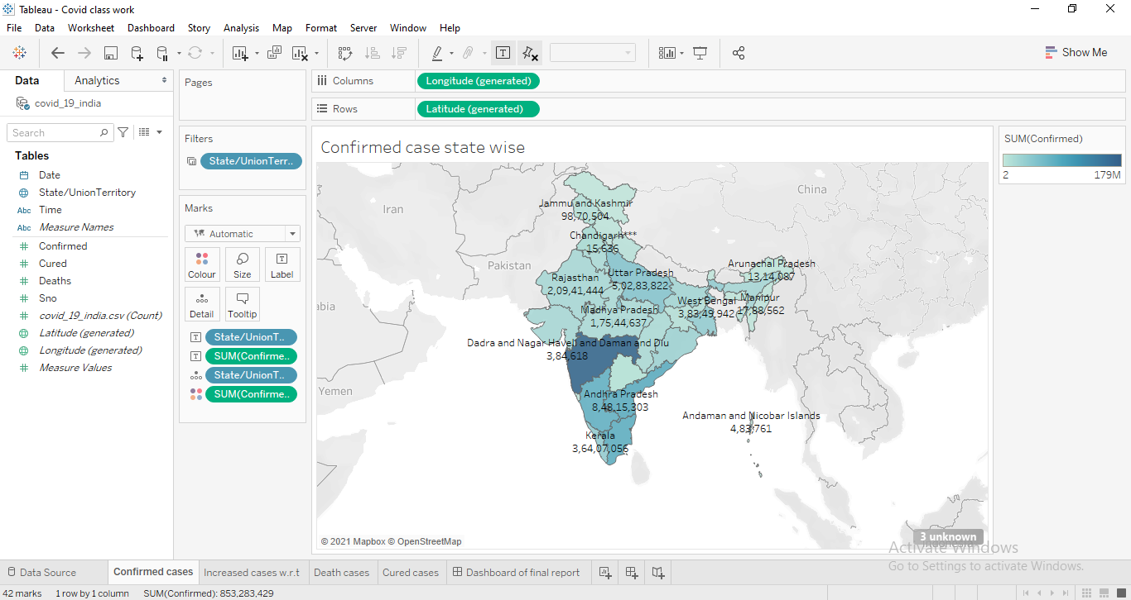

Increased cases with respect to time

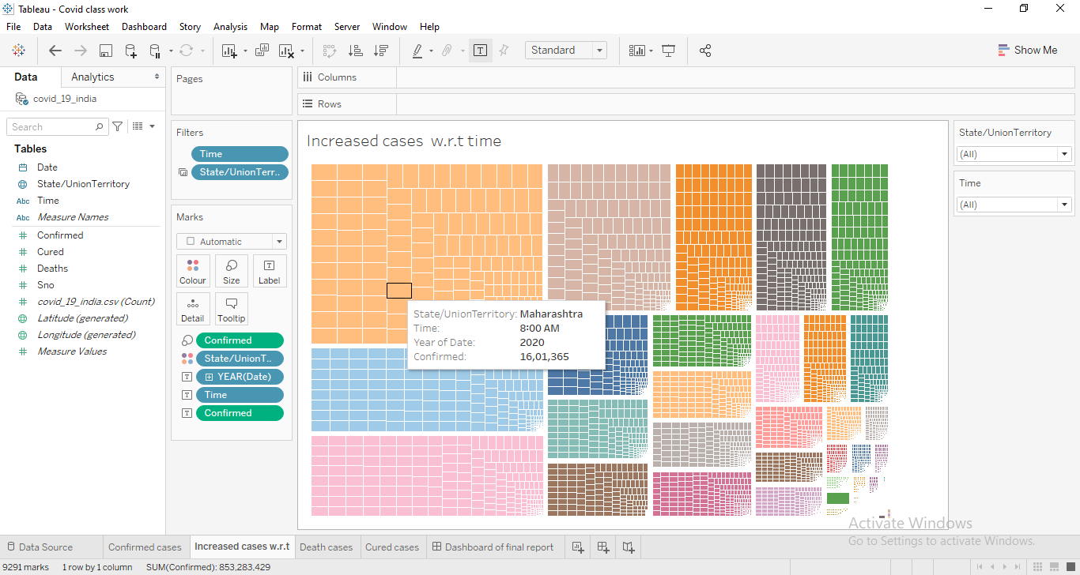

Death cases state wise

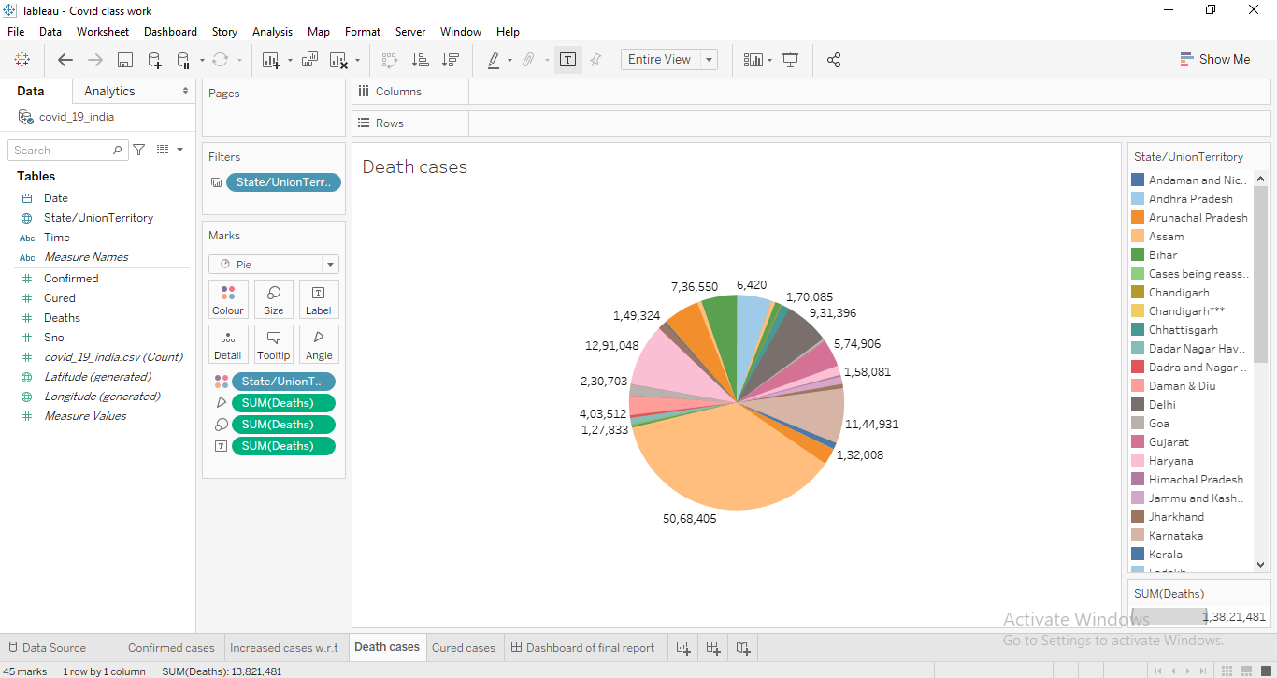

Cured cases state wise

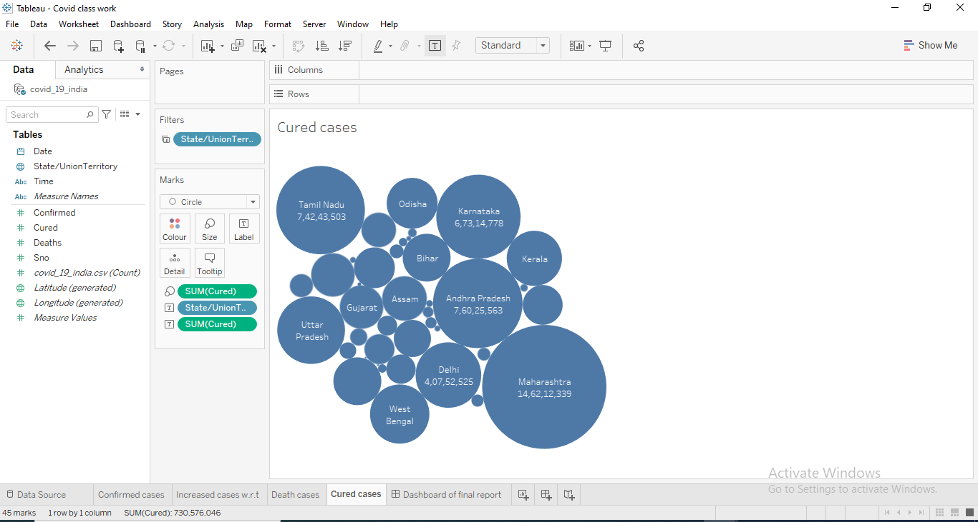

Dashboard of Analysis:->

