**LINK OF PROJECT:-** https://drive.google.com/drive/folders/1CczEXeH0zmC8D-sS26rR6t67OYaEiPKL?usp=sharing

**PROBLEM STATEMENT:-**

In this I have taken dataset from the kaggle.com .Dataset name( udemy_course.csv).

In which more than 3000 column and more than 10 column were present.

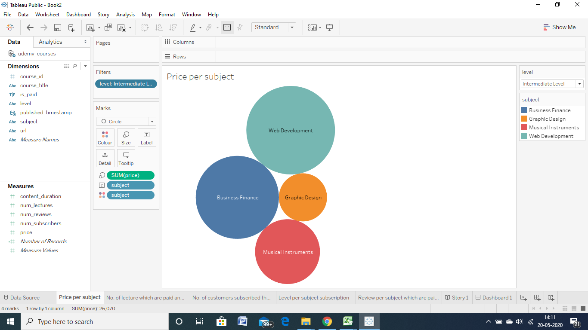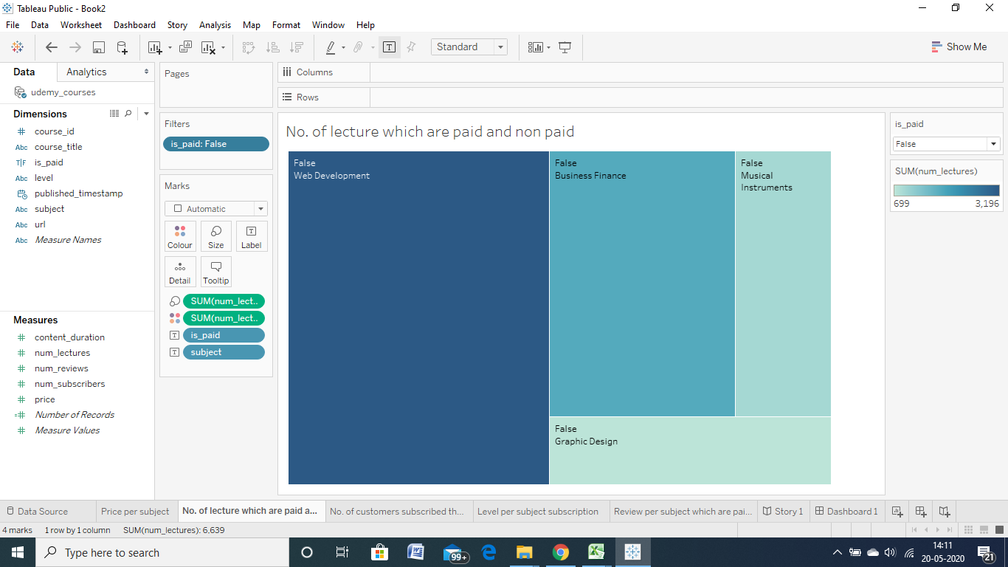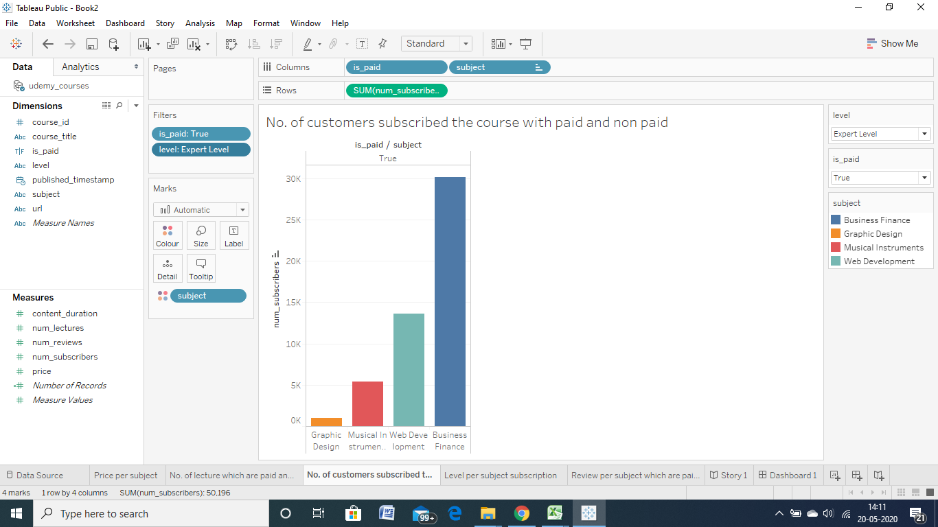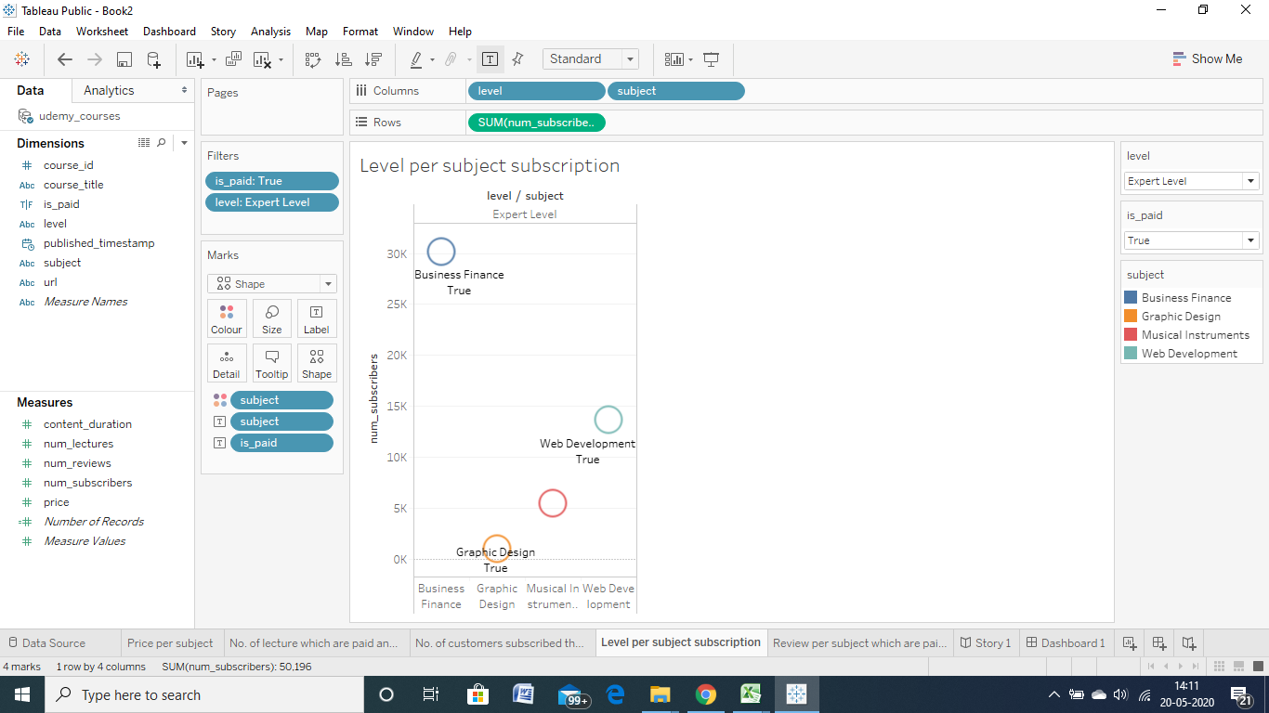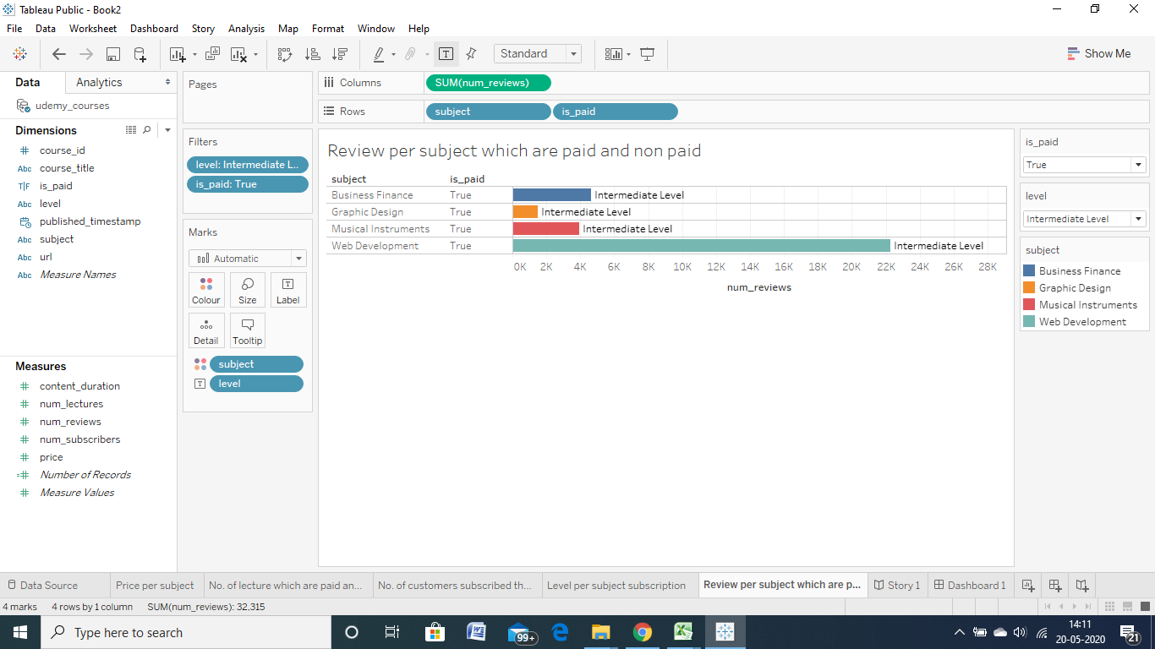

1)In the first graph, I explained about the price of the subject level wise.

2)In the second graph, I showed the lecture which are paid and not paid.

3) In the third graph,I showed the no. of customers subscribed the course by level wise.

4) In the fourth graph,I explained the level per subject subscription.

5)In the fifth and last I explained about the review subject-wise and level-wise.

**Dashboard :-**

