**AP Comp Sci PONG LAB – EXTENDING BLOCK Lab Value - 4**

**Lab Goal :** This lab was designed to teach you more inheritance and object oriented programming while learning more about how to write a very simple game.

**Lab Description :** You will take your working Block class from Lab 19 and create a Pong Game. The paddles and the ball will be extensions of the Block class.

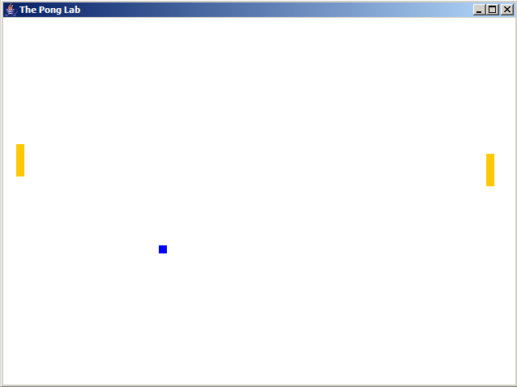

PONG GAME REQUIREMENTS

1. Create the constructors and methods for the Ball class. You will need to create multiple constructors as well as set, get, equals, and toString methods.

2. Create the constructors and methods for the Paddle class. You will need to create multiple constructors as well as set, get, and toString methods. Use the moveAndDraw method in the Ball class to help you write the moveUpandDraw and moveDownAndDraw methods in the paddle class.

3. In the Pong class, you need to instantiate all the instance variables and build the actions of the Ball and Paddles. Pressing the ‘W’ key makes the left paddle go up, the ‘Z’ makes it go down. Pressing the ‘I’ key makes the right paddle go up, andn the ‘M’ key makes it go down. You need to figure out how to handle the ball hitting the top and bottom wall (it bounces off), and how to handle the ball hitting the paddles.