2. Methods
Redundancy-aware Gated Temporal Heterogeneous Graph Intrusion Detection System (RGT-HGIDS)
This section describes RGT-HGIDS, a process-level host intrusion detection framework designed for provenance audit logs. The framework follows a four-stage pipeline: Target-Budget Boundary Redundancy Reduction (TBB-RR), Residual Gated Dilated BiGRU Multi-Channel Behavior Graph encoding (RGD-BiGRU-MCBG), relation- and time-aware Spatial-Temporal Heterogeneous Graph Attention Network propagation (ST-HGAN), and Elastic Hop Aggregation (EHA). The design preserves the provenance structure of audit logs while reducing repetitive event sequences before semantic and graph-level modeling.

2.1. Overview of the RGT-HGIDS framework
RGT-HGIDS operates on formatted host audit events and outputs a maliciousness probability for each process node. A raw event stream is first normalized into typed source-destination interactions. For each process-centric entity, its chronological event sequence is compressed by TBB-RR, which preserves boundary events inside fixed-length temporal blocks to remove high-frequency redundancy without generating synthetic tokens. The compressed event sequences are then embedded and encoded by RGD-BiGRU-MCBG. The resulting semantic node and edge attributes are injected into a heterogeneous provenance graph, where ST-HGAN performs relation- and time-aware message passing. Finally, EHA combines multi-hop node representations adaptively before a node-level classifier predicts malicious process nodes.
The framework is intentionally aligned with prior audit-log-based provenance intrusion detection while replacing the prefix-tree redundancy module and the original multi-kernel convolutional semantic front-end with TBB-RR and RGD-BiGRU-MCBG, respectively. All graph propagation, hop aggregation, and classification components are kept fixed during the principal encoder comparison so that the contribution of the redundancy-aware gated temporal semantic branch can be evaluated under a paired protocol. Figure 1 summarizes the end-to-end workflow and the paired-comparison logic.
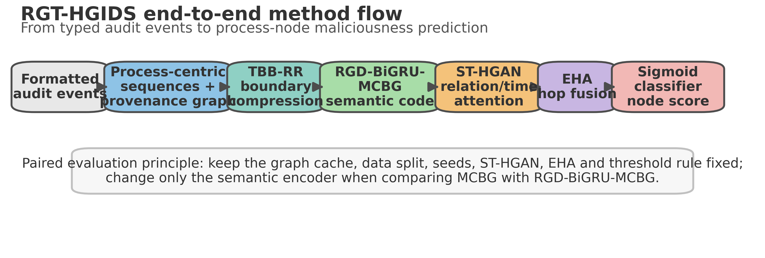
Figure 1. Overall workflow of RGT-HGIDS, including event normalization, TBB-RR compression, RGD-BiGRU-MCBG semantic encoding, ST-HGAN propagation, EHA hop fusion, and process-node classification.
Component | Input | Main operation | Output used by next stage
TBB-RR | Chronological per-node audit-event sequence | Splits a sequence into fixed non-overlapping blocks and retains block boundaries under a target compression budget. | Order-preserving compressed event sequence and event weights
RGD-BiGRU-MCBG | Compressed event-token embeddings | Applies residual gated dilated convolutional blocks, a bidirectional GRU, multi-head self-attention, and weighted attention pooling. | Semantic representation for process nodes and event/edge attributes
ST-HGAN | Typed provenance graph with node, edge, relation, and time features | Performs relation-specific and time-aware attention-based message passing with optional soft top-k pruning. | Layer-wise heterogeneous graph embeddings
EHA | Hidden states from successive ST-HGAN layers | Learns node-dependent hop weights and aggregates multi-hop representations. | Final process-node representation
Classifier | EHA-enhanced process-node representation | Applies a sigmoid classifier optimized with weighted binary cross-entropy on process nodes. | Node-level maliciousness probability
Table 1. Functional decomposition of the RGT-HGIDS pipeline.

2.2. Audit-event normalization and process-centric provenance graph construction
Audit logs are converted into typed provenance events that describe interactions between system entities such as processes, files, sockets, and memory objects. Each event is represented as
e_i = <SrcId_i, SrcType_i, DstId_i, DstType_i, EdgeType_i, Time_i, Tag_i>,
where SrcId and DstId denote endpoint identifiers, SrcType and DstType denote endpoint types, EdgeType denotes the operation category, Time is the event timestamp or time bucket, and Tag denotes the available supervision signal. For a process node v, the incident events are sorted chronologically to form
S_v = [e_1, e_2, ..., e_L].
The heterogeneous provenance graph is denoted by G = (V, E, phi, psi, tau), where V is the set of nodes, E is the set of directed provenance edges, phi(v) is the node type, psi(u,v) is the relation type of an edge, and tau(u,v) is its temporal bucket. Events are attached to both the corresponding edge and the process endpoint so that process behavior can be represented at the node level and edge semantics can also be passed to the graph encoder. A process is assigned a positive label when it participates as an endpoint in an event tagged as malicious; predictions and losses are therefore evaluated over process nodes rather than over the whole graph indiscriminately.
For each event, textual or categorical tokens derived from identifiers, types, relations, and time fields are embedded and averaged to obtain a compact event vector. If event e_t contains m_t tokens {w_t,1, ..., w_t,m_t}, the event embedding is
x_t = (1 / m_t) * sum_{j=1}^{m_t} Emb(w_t,j), X_v = [x_1, x_2, ..., x_L].
This mean-token representation follows the implementation choice in the supplied project package and provides a stable interface between the audit-log parser, the sequence compressor, and the neural semantic encoder. It also avoids dependence on a single token field because the semantics of an audit event are distributed across entity type, operation type, endpoint identifiers, and temporal context.

2.3. Target-Budget Boundary Redundancy Reduction
Host audit logs often contain long bursts of repeated or near-repeated operations. Directly modeling all events in such bursts increases memory cost and may dilute the discriminative events that mark the beginning and end of a behavioral episode. RGT-HGIDS therefore introduces Target-Budget Boundary Redundancy Reduction (TBB-RR), a deterministic sequence compression module controlled by a target compression ratio C*.
For a sequence of length L and a target compression ratio C*, TBB-RR derives a fixed block length
B_TBB = max(2, ceil(2 / (1 - C*) - epsilon)),
where epsilon is a small numerical constant used only to avoid floating-point boundary effects. The sequence is partitioned into non-overlapping blocks of length B_TBB. In each full or partial block, only the first and last events are retained; if a block contains a single event, that event is retained once. The retained index set is
A = union_j {b_j, min(b_j + B_TBB - 1, L)}, S~_v = [e_i | i in A],
where b_j is the first index of block j. The operation preserves temporal order and does not merge, interpolate, or synthesize events. In the recommended RGT-HGIDS profile, C* = 0.90, which yields an aggressive long-sequence budget while retaining the boundary structure of each temporal block. This setting reflects the assumption that boundary events often capture state transitions, whereas the middle of a high-frequency burst is more likely to contain repeated operations.
Compared with a prefix-tree reduction strategy, TBB-RR is independent of symbolic branch construction and has a direct target-budget interpretation. It is therefore suitable for paired comparisons across encoders because the same compressed graph cache can be reused for the baseline MCBG branch and the proposed RGD-BiGRU-MCBG branch. The present implementation returns uniform event weights after compression; however, the downstream weighted attention interface is retained so that non-uniform weights can be introduced without changing the neural encoder. Figure 2 illustrates the block-boundary retention mechanism used by TBB-RR.
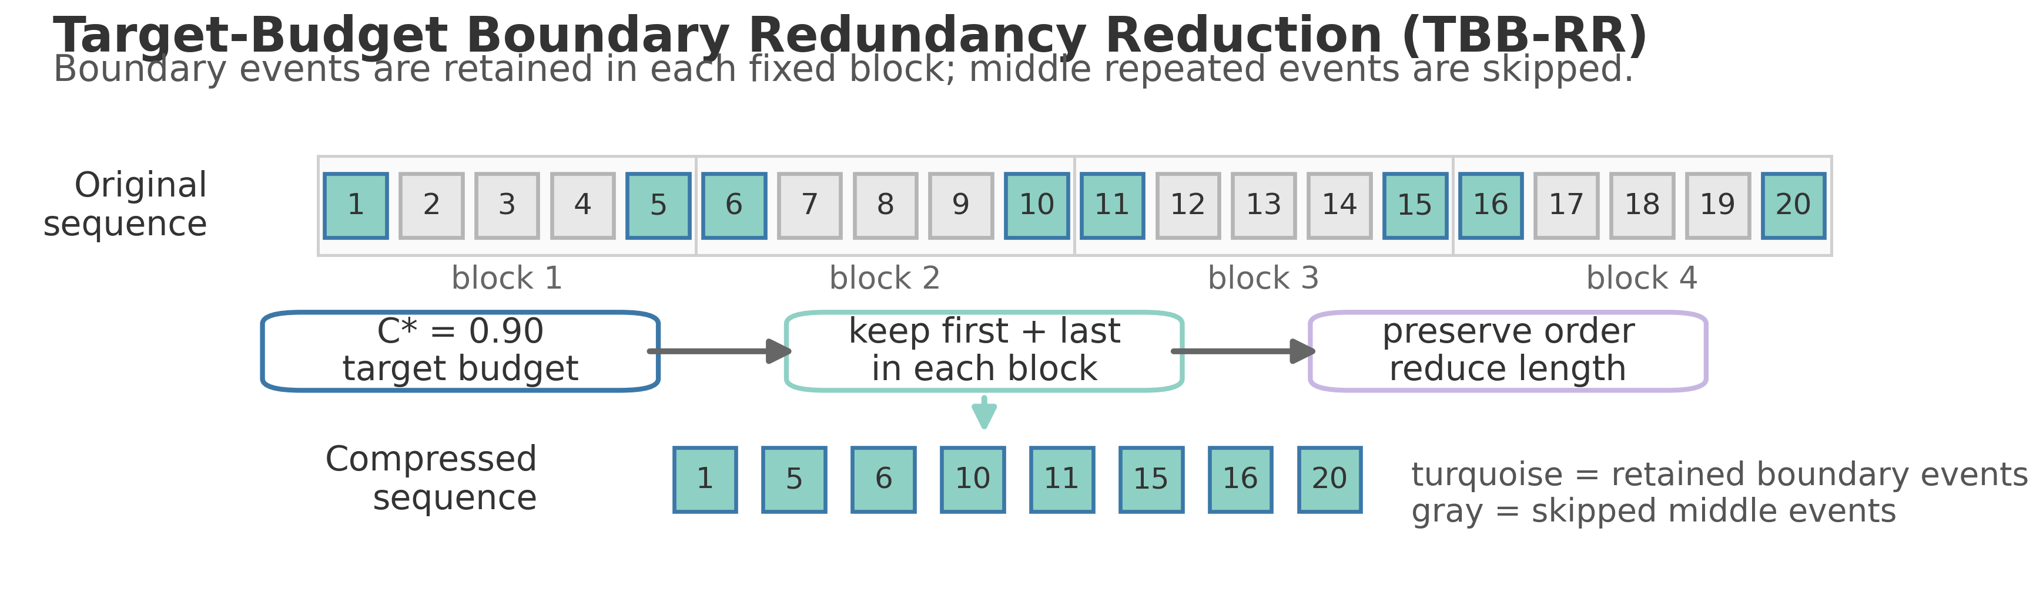
Figure 2. TBB-RR compression schematic. First and last events are retained in each fixed block to preserve order and boundary behavior while reducing repeated middle events.

2.4. RGD-BiGRU-MCBG semantic encoder
The semantic encoder converts each compressed event sequence into a fixed-dimensional representation. The RGT-HGIDS encoder replaces the original multi-kernel convolutional MCBG front-end with residual gated dilated convolutional blocks while retaining the bidirectional GRU and attention-pooling interface. This choice combines three properties: gated convolutions provide local feature selection, dilated convolutions expand the receptive field without increasing sequence length, and the BiGRU models directional temporal dependencies after convolutional denoising.

2.4.1. Residual gated dilated convolutional blocks
Let H^(0) be the projected and normalized event-embedding sequence. For the l-th residual gated dilated block with kernel size k and dilation r_l, the value and gate branches are
A^(l) = Conv_{k,r_l}(H^(l-1)), G^(l) = sigmoid(Conv^g_{k,r_l}(H^(l-1))).
The gated feature is then computed as
U^(l) = GELU(A^(l)) odot G^(l),
and the residual output is
H^(l) = LayerNorm(H^(l-1) + lambda_l * Dropout(U^(l) W_o^(l))).
Here, odot denotes element-wise multiplication, W_o^(l) is the output projection, and lambda_l is a learnable or configured residual scale. The recommended implementation uses kernel size k = 3, dilation rates {1, 2}, dropout 0.20, depthwise-separable convolution, and a residual scale initialized to 0.10. Padding is selected to preserve sequence length, allowing downstream recurrent and attention layers to operate with the original compressed-event alignment.

2.4.2. Bidirectional recurrent modeling and attention pooling
The convolutional output is passed to a bidirectional GRU:
Y_t = [GRU_fwd(H_t^(L_c)); GRU_bwd(H_t^(L_c))],
where L_c denotes the number of convolutional blocks. A residual projection aligns the recurrent output with the convolutional stream, followed by layer normalization:
Ybar_t = LayerNorm(W_y Y_t + W_s H_t^(L_c)).
Multi-head self-attention is then applied to the sequence, and an additive attention-pooling layer computes the node semantic vector. With optional event weight w_t, the pooling score is
a_t = q^T tanh(W_p Ybar_t + b_p) + beta log(w_t + eps),
alpha_t = softmax(a_t), s_v = sum_t alpha_t Ybar_t.
The scalar beta controls the influence of event weights. In the current TBB-RR setting the weights are uniform, so the second term does not bias the ranking of retained events; nevertheless, the formulation preserves compatibility with weighted or importance-aware compression variants. The final vector s_v is used as the semantic representation of process behavior and, where applicable, as an edge/event semantic attribute for the graph encoder. Figure 3 provides the detailed architecture of the semantic encoder.
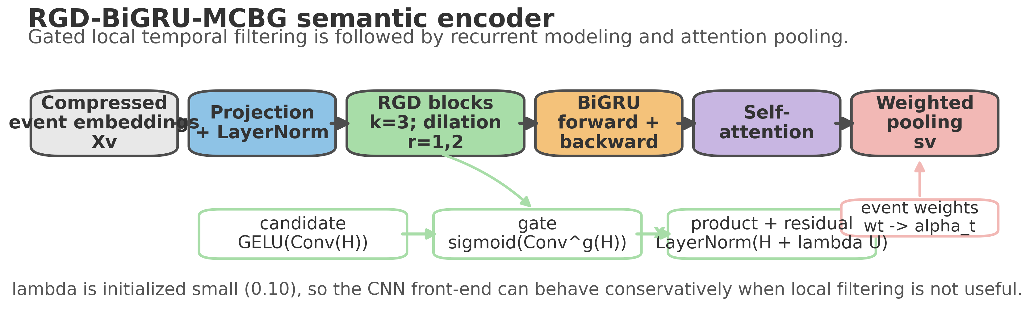
Figure 3. RGD-BiGRU-MCBG semantic encoder. Residual gated dilated convolution, BiGRU modeling, self-attention, and weighted pooling convert compressed events into semantic process features.

2.5. Relation- and time-aware ST-HGAN propagation
The heterogeneous graph encoder propagates semantic information over the typed provenance graph. Each node type has a type-specific input projection,
h_v^(0) = W_{phi(v)} s_v + b_{phi(v)},
which maps node features from different entity types into a common hidden space. For an edge (u, v) with relation type r = psi(u, v), temporal bucket Delta t = tau(u, v), and optional edge semantic attribute c_uv, each attention head computes an unnormalized relation-time attention score of the form
z_{uv}^{r,h} = LeakyReLU(a_{r,h}^T [W_{r,h} h_v || W_{r,h} h_u || e_r || p(Delta t) || c_uv]),
where e_r is a relation embedding, p(Delta t) is a time-bucket embedding, and || denotes concatenation. The score is normalized over the incoming neighborhood of v. The default implementation uses soft top-k pruning: edges outside the top-k set are down-weighted rather than removed, which preserves weak contextual evidence while preventing dense neighborhoods from dominating the aggregation. A single-head message can be written as
m_v^{r,h} = sum_{u in N_r(v)} alpha_{uv}^{r,h} (V_{r,h} h_u + e_r + p(Delta t) + c_uv),
and the outputs of relation-specific heads are concatenated or projected to obtain the layer representation. Residual connections, layer normalization, and attention dropout are used to stabilize training. The recommended configuration uses relation and time features, relation hidden dimension 128, 16 time buckets, top-k = 20, soft pruning, and ST-HGAN layers coupled with EHA.

2.6. Elastic Hop Aggregation
Stacked graph attention layers mix information from progressively larger neighborhoods. However, the optimal hop range is not fixed across process nodes: a process with a direct malicious event may require local evidence, whereas a process involved in multi-stage behavior may require longer-range dependencies. RGT-HGIDS therefore applies Elastic Hop Aggregation (EHA) to combine hidden states from multiple ST-HGAN layers adaptively.
Let g_v^(k) denote the hidden state of node v after the k-th graph layer, including the input projection as k = 0 when used. EHA computes node-specific hop weights
gamma_{v,k} = softmax_k(q_h^T tanh(W_h g_v^(k) + b_h)),
and aggregates the hop representations as
g_v = sum_k gamma_{v,k} g_v^(k).
Only EHA is enabled in the primary RGT-HGIDS configuration. Other elastic mechanisms exposed by the implementation, such as temporal scaling or edge-aware weighting, are disabled in the main comparison to isolate the proposed TBB-RR and RGD-BiGRU-MCBG modifications while preserving the same ST-HGAN backbone. Figure 4 visualizes the ST-HGAN and EHA stages.
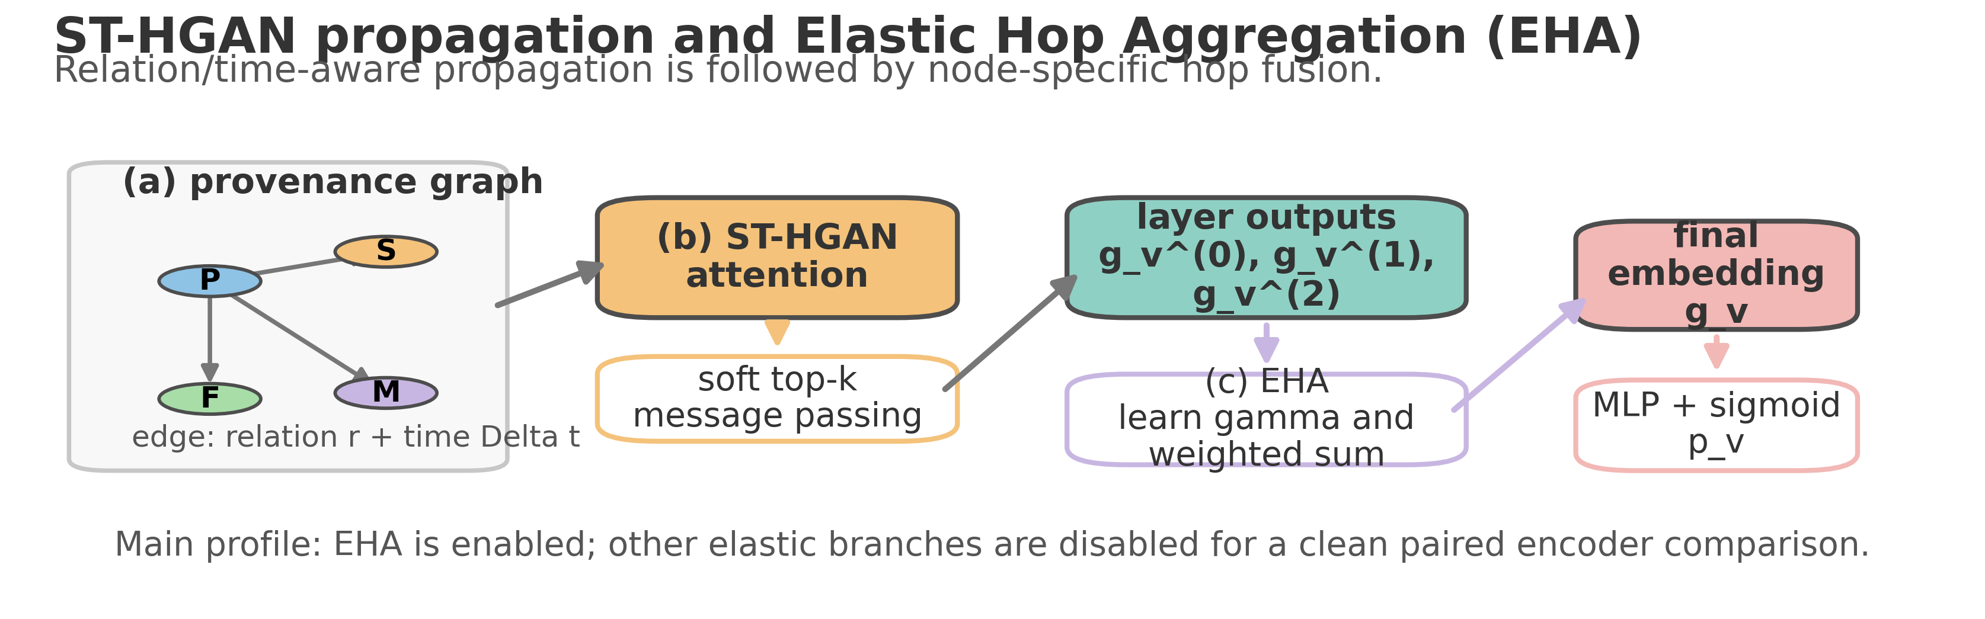
Figure 4. ST-HGAN propagation and EHA fusion. Relation/time-aware graph propagation is followed by node-specific hop weighting and final process-node classification.

2.7. Node-level maliciousness prediction and optimization
The final process-node embedding g_v is passed to a sigmoid classifier,
p_v = sigmoid(MLP(g_v)),
where p_v is the predicted probability that process v is malicious. Training minimizes weighted binary cross-entropy over process nodes:
L = - sum_{v in V_proc} [omega_1 y_v log(p_v) + omega_0 (1 - y_v) log(1 - p_v)],
where V_proc is the set of process nodes and omega_1 and omega_0 compensate for class imbalance. The implementation uses the Adam optimizer with learning rate 1e-3, gradient clipping, validation-based model selection, and a threshold selected on the validation set. The main profile selects checkpoints by validation average precision and chooses a decision threshold that maximizes validation F1 under a minimum recall constraint of 0.95. This thresholding rule is appropriate for intrusion detection because false negatives are operationally costly, while precision, F1, MCC, and average precision are still reported to quantify the trade-off.

2.8. Experimental protocol
The primary experiments are designed as paired comparisons between the original MCBG semantic branch and the proposed RGD-BiGRU-MCBG semantic branch under the same graph construction, redundancy reduction, data split, seeds, and ST-HGAN/EHA backbone. This paired design prevents improvements from being attributed to incidental differences in graph caching, threshold selection, or random initialization. The recommended balanced profile evaluates the CADETS and THEIA datasets with seeds 42, 43, and 44 for eight epochs. A more stringent confirmatory run can extend the protocol to five seeds and fifteen epochs while retaining the same ablation logic.
Data are partitioned into training, validation, and test splits with a 0.60/0.20/0.20 ratio. The node scope is restricted to process nodes, and labels are derived using the process-event-endpoint policy described above. Evaluation metrics include F1 score, recall, precision, Matthews correlation coefficient (MCC), average precision (AP), ROC-AUC, false positives, and false negatives. The main non-inferiority criterion requires the mean F1 of RGT-HGIDS to be within 0.002 of the MCBG baseline, the mean recall to be within 0.005, and the mean number of false negatives not to increase by more than 0.5. Positive evidence is reported when RGT-HGIDS improves paired-seed F1 in at least two of three seeds, reduces false negatives, or improves AP/MCC without recall degradation.
Setting | Recommended value in supplied project package
Main entry point | scripts/run_rgt_hgids_rigorous.sh; quick checks via scripts/run_rgt_hgids_quick.sh
Datasets | CADETS and THEIA, derived from DARPA Transparent Computing Engagement data
Split | Train/validation/test = 0.60/0.20/0.20
Node scope and labels | Process-node prediction; process endpoints of tagged malicious events are labeled positive
Redundancy reduction | TBB-RR target_boundary mode; target compression C* = 0.90
Sequence limits | Maximum node events = 64; maximum edge events = 4
Embedding/hidden size | Default semantic dimension = 64
RGD-BiGRU-MCBG | Kernel size = 3; dilations = 1,2; dropout = 0.20; residual scale = 0.10; depthwise-separable convolution enabled
ST-HGAN/EHA | Relation and time attention enabled; relation hidden dimension = 128; time buckets = 16; top-k = 20; soft pruning; EHA enabled only
Training and model selection | Adam, learning rate = 1e-3; weighted BCE; validation AP checkpoint selection; validation F1 threshold under minimum recall 0.95
Primary metrics | F1, recall, precision, MCC, AP, ROC-AUC, FP, FN
Table 2. Reproducibility settings extracted from the supplied RGT-HGIDS project package.

2.9. Ablation design and diagnostic reporting
The ablation study follows a minimal-change principle. First, the semantic encoder is switched between the original MCBG and RGD-BiGRU-MCBG while all graph and training settings are fixed. Second, the redundancy module is ablated by replacing TBB-RR with prefix-tree reduction or no reduction under the same downstream encoder. Third, ST-HGAN/EHA is compared with simplified graph encoders when required to verify that the gains are not attributable solely to graph propagation. For each ablation, paired seeds are preserved and metrics are summarized by mean, standard deviation, and paired differences.
Diagnostic outputs include per-dataset metric tables, per-seed paired comparisons, threshold summaries, confusion statistics, and selected runtime/compression statistics. Compression diagnostics report original and retained sequence lengths, realized compression ratios, and graph-cache consistency. These diagnostics are necessary because an intrusion detection model may achieve similar F1 values with different false-negative profiles; therefore, the final interpretation prioritizes recall and false-negative behavior alongside F1, AP, and MCC.

2.10. Implementation summary
RGT-HGIDS is implemented as a modular extension of the supplied MalSnif-style audit-log intrusion detection codebase. The main training model selects the semantic encoder by configuration, constructs node and edge semantic attributes from compressed audit-event sequences, propagates these attributes through the elastic ST-HGAN graph encoder, and applies a node-level classifier. The implementation exposes all major method choices through configuration variables, including redundancy mode, TBB-RR compression budget, RGD kernel size, dilation rates, convolution type, residual scale, attention pruning, EHA activation, model-selection metric, and thresholding rule. This configuration-driven design permits exact paired runs and supports reproducible ablation studies.
The complete method can be summarized as follows. First, audit logs are parsed into typed source-destination provenance events. Second, process-centric event sequences are compressed by TBB-RR. Third, compressed event sequences are embedded and encoded by RGD-BiGRU-MCBG to obtain semantic node and edge features. Fourth, ST-HGAN propagates relation- and time-aware messages through the heterogeneous provenance graph. Fifth, EHA combines multi-hop representations. Finally, a sigmoid classifier predicts process-node maliciousness and is evaluated with threshold-dependent and threshold-free metrics.

References for the Methods section
[1] Jiang, J., Chu, H. and Tian, D. A novel host-based intrusion detection approach leveraging audit logs. Future Generation Computer Systems 174, 107995 (2026). doi: 10.1016/j.future.2025.107995.
[2] DARPA Information Innovation Office. Transparent Computing program and public Engagement 5 data release.
[3] Mikolov, T., Chen, K., Corrado, G. and Dean, J. Efficient estimation of word representations in vector space. arXiv:1301.3781 (2013).
[4] Cho, K. et al. Learning phrase representations using RNN encoder-decoder for statistical machine translation. Proceedings of EMNLP, 1724-1734 (2014). doi: 10.3115/v1/D14-1179.
[5] Dauphin, Y. N., Fan, A., Auli, M. and Grangier, D. Language modeling with gated convolutional networks. Proceedings of ICML, PMLR 70, 933-941 (2017).
[6] Bai, S., Kolter, J. Z. and Koltun, V. An empirical evaluation of generic convolutional and recurrent networks for sequence modeling. arXiv:1803.01271 (2018).
[7] Velickovic, P. et al. Graph attention networks. International Conference on Learning Representations (2018).
[8] Wang, X. et al. Heterogeneous graph attention network. The Web Conference (WWW) (2019).
[9] scikit-learn developers. average_precision_score documentation.
[10] scikit-learn developers. matthews_corrcoef documentation.

