Melt-pool geometry and rear phase boundaries in IN625 laser melting: sensitivity to high-temperature property extrapolation

Abstract
Thermal fields calibrated to melt-pool geometry supply inputs to solidification models, yet a change in pool length does not reveal whether the rear freezing interval moves or widens. This study examines that distinction for high-temperature material assumptions with a nonlinear enthalpy model of heat conduction for IN625 bare-plate tracks in a moving frame. The source-power fraction is fitted to one thermographic length from the Additive Manufacturing Metrology Testbed. It is then retained while conductivity and sensible specific heat are changed separately and together between linear and constant high-temperature extrapolation at a common phase law. Paired rear solidus and liquidus positions distinguish displacement of the thermal tail from a change in the freezing interval. The calibrated field and its property variants remain wider and shallower than the metallographic means. Replacing linear conductivity extrapolation by its constant endpoint value lengthens the pool chiefly by moving both rear boundaries downstream, while the specific-heat change partly offsets that extension. Their separation changes on a much smaller scale and depends on the partner function. Matched axial refinement preserves the large displacement but leaves the direction of the smallest separation response unresolved. In a separate fixed-power speed comparison, near-equal rear separations yield a stationary-material passage about one third shorter at the higher speed. These results distinguish melting extent, rear boundary position, interval width and passage time as separate assessment targets for a calibrated conduction field used to supply solidification information.
Keywords: Laser powder bed fusion ; IN625 ; Melt-pool geometry ; Enthalpy model ; High-temperature properties ; Model discrepancy

1. Introduction
Thermal models of laser powder bed fusion connect processing conditions to the extent of melting and the conditions under which material solidifies [1]. Fusion geometry and local thermal information serve different purposes in these calculations: dimensions describe the melted region, whereas temperature gradients and histories supply inputs to solidification models [2]. IN625 thermal fields calibrated to geometry have supported grain and subgrain predictions, although discrepancies in near-surface temperatures also affect those outputs [3]. Assessing such a field therefore requires distinguishing its agreement with a geometric target from the thermal information it provides for subsequent solidification calculations.
The IN625 bare-plate measurements from the Additive Manufacturing Metrology Testbed (AMMT) offer a direct setting for this distinction, with a characterized beam and separate observations of length and cross-sectional dimensions [4]. In the closest nonlinear conduction study, fitting a scalar source-power coefficient reproduced length more closely than width and depth; calibrated directional conductivity then improved the transverse agreement [5]. The transverse dimensions thus supplied constraints beyond the fitted length. That study also identified high-temperature conductivity extrapolation as part of the physical model participating in calibration and restricted the interpretation of temperatures inside the pool. Length calibration therefore establishes a source scale under a specified material description, while the associated rear thermal profile requires its own assessment.
The high-temperature description is needed because conductivity and sensible specific heat govern diffusion and energy storage throughout pool formation and cooling. Yet the IN625 measured conductivity and calculated specific-heat data in the Special Metals bulletin end below its listed melting interval [6]. Extending these data therefore introduces assumptions into the temperature range containing the rear phase boundaries. Composition-based property estimates provide other high-temperature inputs, while the scatter in liquid-state data leaves the estimation route consequential [7]. Local sensitivity analysis has quantified an AMMT model’s response to solid and liquid properties, latent heat and phase thresholds [8]. Those derivatives describe perturbations near selected property values; changing the extrapolation rule instead replaces an entire above-table function sampled by the thermal field. The relevant question is how that prescribed replacement changes the rear region after the source-power fit.
The rear response must also be separated from the assumed freezing path. Wells et al. changed the IN625 solid-fraction–temperature relation and found substantial changes in tail solidification time and thickness with smaller changes in width and depth [9]. Their result shows that latent-heat distribution can alter the thermal information associated with fusion geometry, motivating a common phase law when conductivity and sensible storage are compared. At that common law, a length change can still arise from downstream displacement of the rear solidus and liquidus, a change in their separation, or both. These alternatives have different meanings for solidification: the boundary positions locate the adopted freezing interval, whereas its separation and the material trajectory determine passage through it. For stationary material in a steady moving field, that passage also depends on scan speed.
This study examines those distinctions in a length-calibrated IN625 conduction field. Conductivity and sensible specific heat are changed separately and together at the retained fitted source-power fraction and a common phase law to assess dependence on the high-temperature material description. Paired rear solidus and liquidus positions distinguish displacement of the freezing interval from a change in its width; a separate fixed-power speed comparison relates that spatial interval to passage time for stationary material.

2. Methods
Single-track laser melting of an IN625 bare plate is represented by a quasi-steady conduction field in the laser frame. The AMMT measurements supply the operating conditions and geometric reference quantities: thermographic length [4] is used to fit the source-power fraction, and metallographic width and depth [10] assess the fusion shape obtained at that fraction.

2.1. Experimental data
Of the three operating conditions in Table 1, B and C share applied power and differ in speed, providing the fixed-power speed comparison; A changes both power and speed and supplies a separate operating condition. Speed changes both the absorbed line-energy scale and the beam passage scale. These input scales are retained separately because conduction geometry depends on heating and diffusion as well as energy per unit length [11]; the rear-interval duration is subsequently obtained from the solved field.
Table 1. AMMT operating conditions and model input scales. $P$ and $v$ are applied laser power and scan speed. The line-energy scale $E_{ℓ}=ηP/v$ uses the B-length-fitted source-power fraction, and $w/v$ is the beam passage scale.
Condition | $P$ (W) | $v$ (m/s) | $E_{ℓ}$ (J/m) | $w/v$ ($μs$)
A | 137.9 | 0.4 | 99.65 | 212.50
B | 179.2 | 0.8 | 64.75 | 106.25
C | 179.2 | 1.2 | 43.17 | 70.83
The axial calibration uses Lane et al.’s thermographic length data: AMMT-20 $μs$ class means based on 19, 10 and 7 video frames for A, B and C [4]. The transverse comparison uses the metallographic dimensions: current NIST AMMT-100 $μs$ width and depth means from three tracks each for A and B and four for C [10]. Lane’s later microscopy compilation combines the 100 and 20 $μs$ classes [4]. Length, width and depth thus provide condition-level constraints from separate sampling populations, rather than jointly observed dimensions of one pool.
Condition B’s thermographic mean length estimates an effective source-power fraction $η$, which scales the model input to $ηP$. The fraction is then retained for B width and depth and all A/C dimensions, leaving those comparisons to assess the geometry associated with the length fit. All geometric targets were available during model development, making this a retrospective assessment. Signed differences are $δ=Q_{model}−Q_{measurement}$, and $δ/U$ reports their size relative to Lane’s expanded measurement uncertainties with coverage factor $k=2$ [4]. For width and depth, these $U$ values come from Lane’s combined-class microscopy analysis, while the target means come from the NIST 100 $μs$ classes. The ratios describe the residual scale; they include no model, input or calibration uncertainty and do not form a formal uncertainty test of those target means.

2.2. Enthalpy model
Separating transport from sensible storage requires a formulation in which changing specific heat leaves the latent-heat relation intact. The adopted conservative enthalpy formulation provides that separation within established moving-source conduction treatments [12]:
$$\frac{∂H}{∂t}=∇⋅[k(T)∇T], H(T)=ρ\left[\int_{T_{0}}^{T}{c_{p}}(s) ds+Lf(T)\right].$$ (1)
Here $T$ is temperature, $H$ is volumetric enthalpy relative to $T_{0}$, $ρ$ is constant density, $k$ is conductivity, $c_{p}$ is sensible specific heat, $L$ is latent heat per unit mass and $f$ is liquid fraction. The fixed inputs and their sources are given in Table 2. The bulletin’s listed melting range supplies the solidus and liquidus [6]; a linear phase-fraction approximation distributes latent heat uniformly between these thresholds:
$$f(T)=\left\{\begin{matrix}0, & T<T_{s}, \\ (T−T_{s})/(T_{l}−T_{s}), & T_{s}≤T<T_{l}, \\ 1, & T≥T_{l}.\end{matrix}\right.$$ (2)
This closure fixes the latent-heat release relation for the material-function comparison. Within the phase interval, differentiating Eq. (1) gives $dH/dT=ρ[c_{p}+L/(T_{l}−T_{s})]$. A specific-heat change therefore modifies sensible storage while retaining the same latent contribution. A linear phase relation is also used in an IN625 continuum model with different freezing endpoints [13]; the endpoints and relation adopted here remain common to all cases.
Table 2. Fixed model inputs. The phase thresholds and linear liquid fraction define the adopted phase law; the circular Gaussian reconstructs the measured second-moment beam diameter.
Quantity | Symbol | Value | Source or selection
Density | $ρ$ | 8440 kg m$​^{−3}$ | IN625 bulletin [6]
Solidus | $T_{s}$ | 1290 $​^{∘}$C | Listed melting-range lower endpoint [6]
Liquidus | $T_{l}$ | 1350 $​^{∘}$C | Listed melting-range upper endpoint [6]
Latent heat | $L$ | 280000 J kg$​^{−1}$ | Earlier AMMT model [5]
Reference temperature | $T_{0}$ | 25 $​^{∘}$C | Prescribed cold-material reference
Second-moment diameter | $D_{4σ}$ | 170 $μm$ | AMMT beam measurement [4]
Gaussian radius | $w$ | 85 $μm$ | Circular reconstruction: $D_{4σ}=2w$
A quasi-steady moving frame supplies the spatial cooling profile needed to relate rear positions to the history of stationary material. This construction follows moving-source heat-flow theory [14]. With $ξ=x−vt$, steady translation gives $∂_{t}H=−v∂_{ξ}H$, transforming the laboratory balance into
$$∇⋅(uH−k∇T)=0, u=(−v,0,0).$$ (3)
The term $uH$ is the passage of stationary material through the laser frame. No liquid momentum, evaporation or free-surface deformation is solved. Those processes introduce recoil and Marangoni transport and evaporative cooling in more detailed models [15]. The velocity in Eq. (3) consequently defines a material-coordinate history under steady translation.
The source representation must keep beam shape fixed while the scalar fit changes total input power. The measured beam provides a two-dimensional intensity map [4]; here a circular Gaussian preserves its second-moment diameter, and $η$ sets its integral:
q(ξ,y)=2ηPπw2exp​−2(ξ2+y2)w2, R2​q dξ dy=ηP. (4)
This normalization uses the same circular-Gaussian $D_{4σ}$ convention as the IN625 source formulation in Ref. [13]. With outward normal $n$, $−k∇T⋅n=−q$ supplies inward heat at the top surface. Incoming material at positive $ξ$ has $H=0$; the negative-$ξ$ boundary has zero diffusive gradient and permits coordinate enthalpy outflow. The symmetry plane, outer transverse boundary and bottom are adiabatic. Radiation and ambient convection are omitted from the solved balance.
Because $η$ scales this prescribed source under the stated loss description, its length fit estimates a model source-power fraction. Independent energy-coupling measurements constrain related but distinct quantities: calorimetry measures coupling that varies with surface state and operating conditions [16], and time-resolved reflectometry resolves optical absorptance during melting [17]. IN625 reflectometry further distinguishes unreflected power from retained energy when plume interactions or evaporative losses intervene [18]. These distinctions prevent assigning the fitted fraction an optical or calorimetric identity.

2.3. Property extrapolation
The solution traverses temperatures beyond the available property tables, so the comparison requires an explicit definition of their unmeasured extensions. The Special Metals bulletin provides typical measured conductivity data and calculated values of sensible specific heat for IN625 [6]. Both data groups are retained in Table A.1 and interpolated independently and linearly between their knots. Their endpoints lie below the adopted solidus, leaving part of the solid-temperature range and the melting range dependent on extrapolation. This material-description issue is recognized in the earlier AMMT conduction model [5] and belongs to the wider need for temperature- and state-dependent inputs in additive-manufacturing thermal modeling [19].
Linear extrapolation (L) continues the final tabulated slope above each endpoint; constant extrapolation (H) retains the endpoint value. Both rules join continuously to the same interpolated data below that endpoint. For $p∈\{k,c_{p}\}$, let $(T_{n−1},p_{n−1})$ and $(T_{n},p_{n})$ be its final two pairs. Above $T_{n}$, the rules are
$$p_{L}(T)=p_{n}+\frac{p_{n}−p_{n−1}}{T_{n}−T_{n−1}}(T−T_{n}), p_{H}(T)=p_{n}, T>T_{n}.$$ (5)
Figure 1 places the extrapolations against the common phase interval. Each rule starts at its own table endpoint, including the solid-temperature range before melting. The same conductivity function is used in $k$, its primitive $K$ and the inverse for surface recovery; the same specific-heat function is used in $c_{p}$, $H$ and $T(H)$. The comparison thus uses each function consistently in the field solution and in the recovered observations.
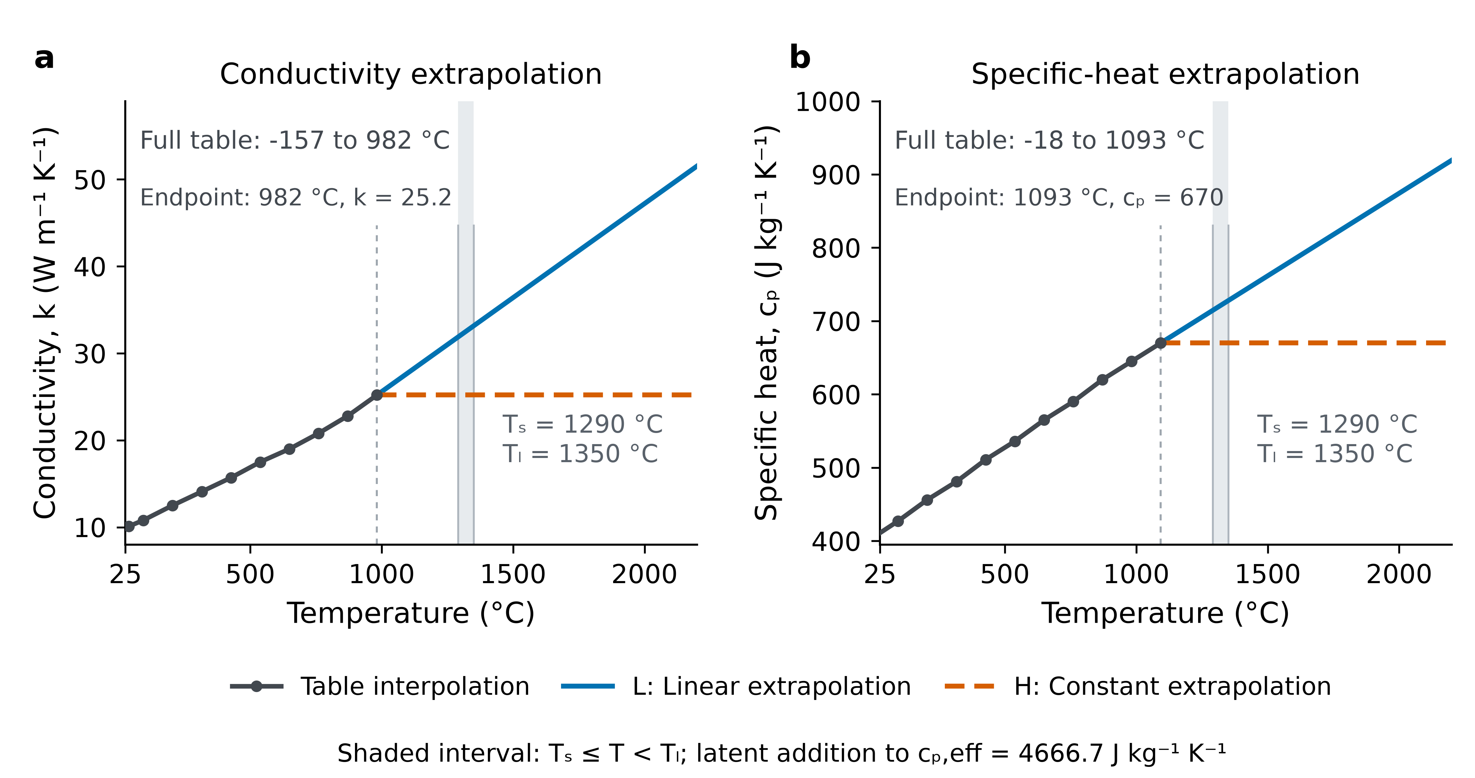
Figure 1. Tabulated IN625 properties and the two extrapolation rules. (a) Conductivity and (b) sensible specific heat use the complete inputs in Table A.1, with common linear interpolation below their respective endpoints. L extends the final secant and H holds the endpoint value, following Eq. (5). Shading denotes the adopted phase interval. Panel (b) shows sensible specific heat; the latent contribution enters separately through Eq. (1). The IN625 conductivity data are measured and the sensible-specific-heat data calculated [6]; the extrapolations are prescribed study functions.

2.4. Geometry and passage
The axial fit and tail comparison require the front and rear boundaries to be retained separately. The surface centerline profile is the recovered temperature at $z=0$ and $y=0$. Model length $L$ is the distance between its front and rear solidus crossings. Linear interpolation locates crossings bounding the single source-containing interval, with all intervals checked for domain truncation. Surface and symmetry-plane recovery precede threshold extraction, as specified in the appendix. The two positions then assign a length change to its front or rear contribution.
The transverse comparison instead concerns the fusion extent left by source passage. Width and depth are therefore extracted from the source-connected maximum-temperature envelope,
$$T_{\text{max}}(y,z)=\underset{ξ}{\text{max}}T(ξ,y,z)≥T_{s}.$$ (6)
Each $ξ$ slice is reconstructed at the surface and symmetry plane and bilinearly interpolated onto observation coordinates before passage maximization. Width is twice the positive-$y$ extent and depth the negative of the lowest $z$. This order makes the envelope a maximum over reconstructed passage fields; maximizing nodal values before interpolation would define a different observer. The surface maximum is taken over recovered top-surface temperatures at axial and positive-$y$ cell centers, before the $y=0$ extension. Its sampling therefore differs from that of the surface centerline profile.
These model observers correspond to different experimental constraints. Thermographic length locates a rear freezing feature through a radiance-profile second-derivative minimum and a front position after emittance-based conversion [4], whereas the model length uses two temperature solidus crossings. The fitted fraction therefore depends on this boundary definition as well as the source and material law. Fusion-envelope width and depth are compared with the metallographic dimensions defined in Section 2.1.
The rear solidus and liquidus positions $ξ_{s}^{−}$ and $ξ_{l}^{−}$ locate freezing relative to the source, while their difference measures the spatial interval. Converting that interval to a duration requires a material trajectory. At a fixed laboratory point, $dξ/dt=−v$, giving the stationary-material definitions
$$ℓ_{m}=ξ_{l}^{−}−ξ_{s}^{−}, τ_{m}=\frac{ℓ_{m}}{v}, \overline{|\dot{T}|}=\frac{T_{l}−T_{s}}{τ_{m}}.$$ (7)
Passage time and interval-mean cooling-rate magnitude are transformations of the same separation and speed. AMMT thermography also uses constant-speed space-to-time conversion, but its exemplar cooling estimates cover a below-solidus interval and are not recommended as calibration references [4]. The present definitions cover the adopted liquidus-to-solidus interval and follow stationary material through the conduction field.

2.5. Comparison design
The comparison holds source strength fixed so that a material-function response remains visible instead of being absorbed by a new length fit. With both functions linearly extrapolated, a safeguarded scalar fit first adjusts $η$ to B’s thermographic mean length of 359 $μm$. Conditions A and C retain this fraction, beam and phase law. At B, the conductivity and sensible-specific-heat choices form a complete $2×2$ comparison (Table 3). Single-property cases distinguish their finite transport and storage responses at the baseline; the joint case tests addition and supplies each property’s response at the other level of its partner. Retaining the phase law prevents a change in latent-heat release from entering that contrast.
Table 3. Property comparison schemes at B. Above-table functions follow Eq. (5); each case retains the source-power fraction fitted with the linear extrapolation baseline, the B operating condition, beam, density, phase law, mesh and observation definitions.
Scheme (case code) | Above-table $k$ | Above-table $c_{p}$ | Comparison role
Linear extrapolation baseline (LL) | Linear | Linear | Calibration and finite-effect reference
Constant conductivity (HL) | Constant | Linear | Conductivity change at baseline storage
Constant specific heat (LH) | Linear | Constant | Storage change at baseline conductivity
Joint constant extrapolation (HH) | Constant | Constant | Joint and conditional property effects
The case codes give conductivity first and sensible specific heat second. The three-condition geometry comparison uses LL; its B solution also enters the property comparison. These comparisons therefore use six combinations: A, B and C with LL, plus HL, LH and HH at B. The three additional B cases retain the LL-fitted source fraction and are compared through common observations. For any output $Q$, the locally defined finite effects are
$$δ_{k}=Q_{HL}−Q_{LL}, δ_{c_{p}}=Q_{LH}−Q_{LL},$$ (8)
$$I_{k,c_{p}}=Q_{HH}−Q_{HL}−Q_{LH}+Q_{LL}, Δ_{joint}=Q_{HH}−Q_{LL}=δ_{k}+δ_{c_{p}}+I_{k,c_{p}}.$$ (9)
The contrasts also give each property’s effect at the other level of its partner. With H specific-heat extrapolation, the conductivity effect is $Q_{HH}−Q_{LH}=δ_{k}+I_{k,c_{p}}$; with H conductivity extrapolation, the specific-heat effect is $Q_{HH}−Q_{HL}=δ_{c_{p}}+I_{k,c_{p}}$. The interaction measures departure from adding the two baseline effects. These contrasts quantify finite responses to prescribed functions. Bayesian adaptation of an analytical melt-pool model inferred apparent absorptivity while explicitly excluding thermophysical-property uncertainty [20]; the present comparisons retain one fitted source fraction and give deterministic responses rather than posterior uncertainty bounds.

2.6. Numerical assessment
The changed material functions must satisfy the same conservative balance before their responses are compared. The baseline grid has near-source cell widths of $4×3×1$ $μm$; the refined grid changes only the axial width to 2 $μm$. Gaussian power is integrated over each top-face rectangle and supplied to its adjacent control volume, with surface-temperature recovery using the matching conductivity primitive. The appendix gives the graded domain, scaled-enthalpy discretization and recovery relations. Nonlinear acceptance retains the sum of absolute cell residuals, signed global energy balance and a further frozen-coefficient correction separately, so a small global sum does not conceal opposing local errors.
Numerical assessment addresses the quantities on which the interpretation depends. A separate constant-property moving-Gaussian problem tests source integration, frame transport and geometry extraction against a semi-infinite analytical reference. It omits phase change and verifies implementation in that regime, following the distinction between verification and physical validation [21]. Conditions B and C with LL are solved on both grids at the retained source-power fraction; separate A and B comparisons enlarge the domain. All four property cases at B are also compared on the two grids with the domain, source fraction, phase law and observers retained. The change in each finite contrast between grids measures its axial sensitivity, separately from common shifts in the quantities themselves. Transverse and depth spacings remain fixed.
Auxiliary diagnostics examine whether the tail response is accompanied by the anticipated change in transport. On the baseline grid, the Péclet median compares coordinate enthalpy transport with diffusion on internal axial faces adjacent to at least one cell with $T_{s}≤T<T_{l}$. It is an unweighted median of the face ratios defined in the appendix. Net diffusion power is the signed outward conductive power across the boundary of cells with $T≥T_{s}$ and $ξ<0$. Both sampling sets follow each solved field, so these diagnostics are interpreted alongside matched-coordinate phase crossings. The appendix also reports two separate checks: approximate local steady consistency from an earlier transient B calculation at a different calibration stage, and fixed-field top-loss estimates that do not solve loss feedback.

3. Results and Discussion
The length fit constrains one axial extent. Fusion shape, rear-boundary displacement and rear phase separation are assessed separately below, using retained-source property and speed comparisons to determine how those responses are related.

3.1. Geometry after calibration
At B, the fitted source-power fraction $η≈0.28905$ gives a length of 359.16 $μm$ against the thermographic mean of 359 $μm$. Width exceeds its metallographic mean by 19.54 $μm$, while depth is 4.88 $μm$ smaller; the descriptive differences relative to their published expanded scales are +3.10 and $−1.23$. At C, the width and depth residuals grow to +23.05 and $−7.56$ $μm$, and length is 49.37 $μm$ shorter than the thermographic mean. All three A differences fall within their respective published scales. The retained source thus gives wider, shallower B/C envelopes, with a larger transverse discrepancy at C. Figure 2 shows the calculated envelopes and dimensional comparisons; Table A.2 retains the exact values and measurement identities.
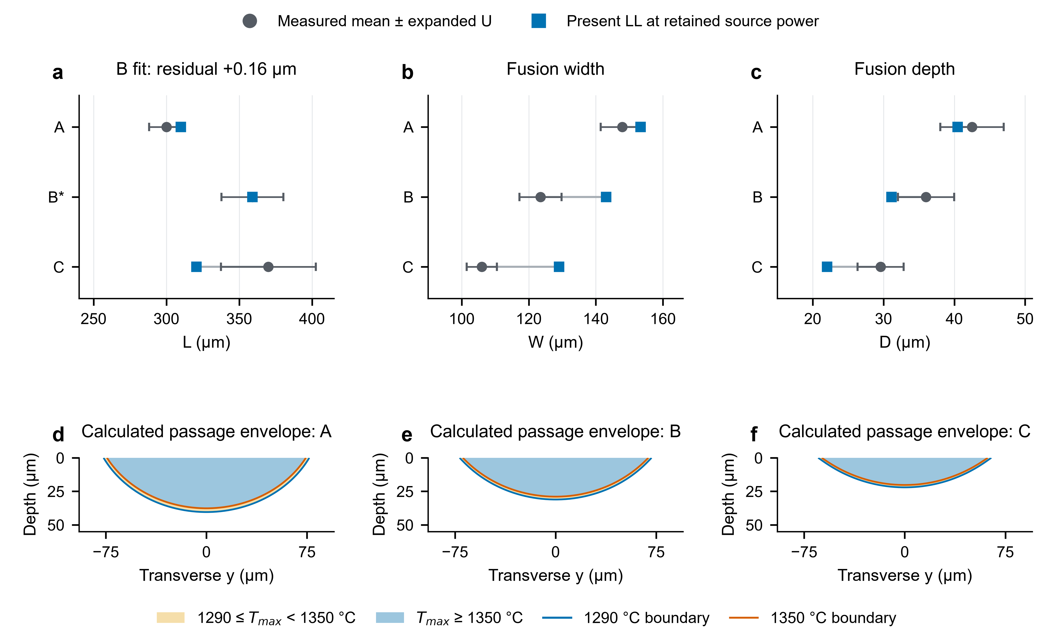
Figure 2. Geometry at the retained source-power fraction. Top row: calculated dimensions and condition-level measured means; the B thermographic length is the calibration target. Bars show the separately sourced Lane expanded measurement scales $U(k=2)$, with the population distinctions specified in Methods. Bottom row: calculated fusion envelopes for A, B and C, reconstructed at each axial slice before passage maximization. Blue and orange boundaries mark $T_{\text{max}}=1290$ and $1350$ $​^{∘}$C. These envelopes are numerical fields; measured widths and depths do not define an observed contour. All calculated views use the baseline grid, with near-source spacings of $4×3×1$ $μm$.
The numerical sensitivities are small relative to these dimensional residuals. The separate constant-property Gaussian problem gives dimensions within 0.50% of the semi-infinite analytical reference. Moving from the baseline to the refined grid changes lengths at conditions B and C by at most 0.37 $μm$, widths by less than 0.03 $μm$ and depths by less than 0.05 $μm$, at the retained source fraction. Enlarging the domain for A and B changes dimensions by less than $3×{10}^{−6}$ $μm$. The appendix reports these checks and the separate assessments of rear intervals.
The residual direction differs from the closest AMMT modeling comparison. Kollmannsberger et al.’s measured-beam isotropic calculation gave narrower and deeper cross sections; calibrating directional conductivity improved transverse agreement [5]. The opposite residual here cannot inherit that transport explanation. Beam representation, property tables, phase law and calibration differ between the studies. Other source representations also change geometric agreement [22, 13], but the dynamic IN625 comparison uses a distinct calibration across spot sizes and a Scheil-based freezing interval. These comparisons establish relevant model choices without selecting a correction for the present field.
A shape residual cannot distinguish energy deposition from material transport or omitted liquid processes. Absorption and vapor-depression observations, together with preheated-alloy fluid calculations, expose several routes to depth changes [23, 24, 25]. Regime, beam and conduction assumptions also condition depth comparisons [26, 27], as do surface/depth observation methods and scan history [28, 29]. The following comparison therefore retains the source representation and phase law to isolate the response to the two prescribed above-table functions.

3.2. Property-dependent thermal tail
At the retained source power, the crossed comparison distinguishes extension of the tail from a change in rear phase separation. Figure 3 places the four surface phase regions on common coordinates and compares paired rear solidus and liquidus positions on the original and matched refined grids.
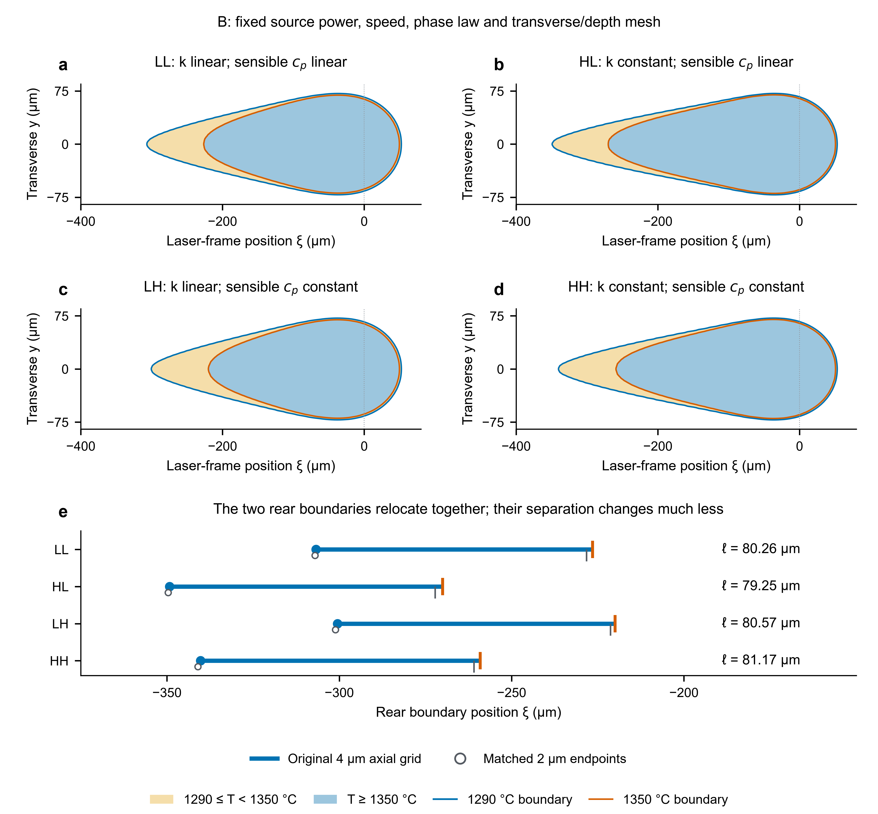
Figure 3. Property comparison at condition B. The four phase maps show the property cases defined in Table 3 on common surface coordinates and the baseline grid. Conductivity varies across columns and sensible specific heat across rows. In (e), blue solidus circles and orange liquidus marks bound the baseline-grid intervals. Grey open circles and vertical marks give the refined-grid positions, offset only along the categorical axis for readability. The positions are compared at the same source-power fraction; the refined grid changes only near-source axial spacing from 4 to 2 $μm$. Tables A.5 and A.6 give the refined quantities and changes in the finite contrasts.
Both conductivity contrasts move the rear boundaries downstream. On the refined grid, HL–LL increases length by 43.32 $μm$, with rear solidus and liquidus displacements of 42.56 and 43.93 $μm$. The front solidus moves by only 0.76 $μm$, so rear motion accounts for 98.2% of the length increase. In HH–LH, length increases by 40.61 $μm$ and the rear boundaries move by 39.88 and 39.62 $μm$. The length response is dominated by relocation of the pair rather than a change in its separation.
At 1320 $​^{∘}$C, the prescribed change lowers $k$ from 32.51 to 25.20 W m$​^{−1}$ K$​^{−1}$, or 22.48%; at common sensible and latent storage it lowers local diffusivity. For HL–LL on the baseline grid, the Péclet median rises from 4.44 to 5.77, while net diffusion power rises from 14.724 to 14.913 W. These increases oppose a simple reduced-escape explanation for the longer tail. Gradients, selected faces, hot-region boundaries and conductivity-dependent surface recovery all change between fields, so the diagnostics constrain the explanation without isolating those contributions. This finite whole-function replacement differs from analytical parameter comparisons and local derivatives [30, 8]; it tests the prescribed high-temperature dependence recognized in the earlier AMMT conduction model [5].
Both specific-heat contrasts shorten the pool on the refined grid: by 5.87 $μm$ for LH–LL and 8.58 $μm$ for HH–HL. Partial compensation leaves a joint length increase of 34.74 $μm$ and an interaction of $−2.71$ $μm$. At 1320 $​^{∘}$C, this intervention reduces sensible $c_{p}$ by 7.09%, but latent-inclusive $c_{p}+L/(T_{l}−T_{s})$ by only 0.95%. Its local storage perturbation is therefore smaller than the conductivity perturbation. Because extrapolation starts below solidus, it also changes pre-melting storage through the conservative enthalpy relation [12]. The midpoint values provide context for these unequal interventions; they do not determine the full-field response. All four refined cases remain wider and shallower than the B metallographic means (Table A.5).
Rear separation changes by the difference between the two boundary displacements: $Δℓ_{m}=Δξ_{l}^{−}−Δξ_{s}^{−}$. On the refined grid, HL–LL reduces it by 1.37 $μm$, whereas HH–LH gives a nominal increase of 0.27 $μm$. Specific-heat changes increase it by 1.05 and 2.69 $μm$ at linear and constant-extrapolated conductivity, respectively, giving an interaction of +1.63 $μm$. The four refined lengths span 353.65–402.84 $μm$, but separations span only 77.44–80.12 $μm$: large rear displacements largely cancel, leaving a smaller response conditional on the partner function. This occurs at a common latent-release law. Wells et al.’s phase-fraction-path replacement changes that law and the resulting tail time and thickness [9]; the two interventions address different material-model assumptions.
The smaller separation effects require their own numerical assessment. For the two conductivity contrasts, the rear-position changes differ by less than 0.49 $μm$ between grids, preserving the 40–44 $μm$ movement. The HH–LH separation effect instead falls from +0.60 to +0.27 $μm$; its $−0.33$ $μm$ drift exceeds the refined effect, leaving the continuum direction unresolved. LH–LL rises from +0.31 to +1.05 $μm$, while the separation interaction changes by only +0.02 $μm$. The two grids distinguish persistent large displacement from relatively sensitive small interval effects; unchanged transverse and depth spacings provide no full three-dimensional error bound. Tables A.5 and A.6 retain the matched quantities and contrasts.
On the baseline grid, the surface maximum rises from 2697 to 3507 $​^{∘}$C for LL to HL and from 2756 to 3721 $​^{∘}$C for LH to HH. Its sampling is defined in Section 2.4. Evaporation, liquid motion and surface deformation are omitted, so these rises characterize the prescribed conduction fields. Two-color measurements have distinguished surface profiles from parameter combinations giving similar 316L cross sections [31]. Physically informed nickel-superalloy estimates provide other candidate high-temperature functions, with uncertainty in the liquid data used to construct them [7]. The evidence route also matters: pulse heating of IN718 measures enthalpy and specific heat but derives conductivity from resistivity through the Wiedemann–Franz relation [32]. Here an independent thermal observation would be needed to select among the high-temperature descriptions, whose distinct temperatures accompany a persistent transverse geometry residual.

3.3. Spatial interval and passage time
At fixed applied power, the B-to-C comparison raises scan speed from 0.8 to 1.2 m/s while retaining LL and the source-power fraction. Figure 4 places surface phase regions beside rear separation and stationary-material passage time, separating the spatial response from the speed contribution to duration.
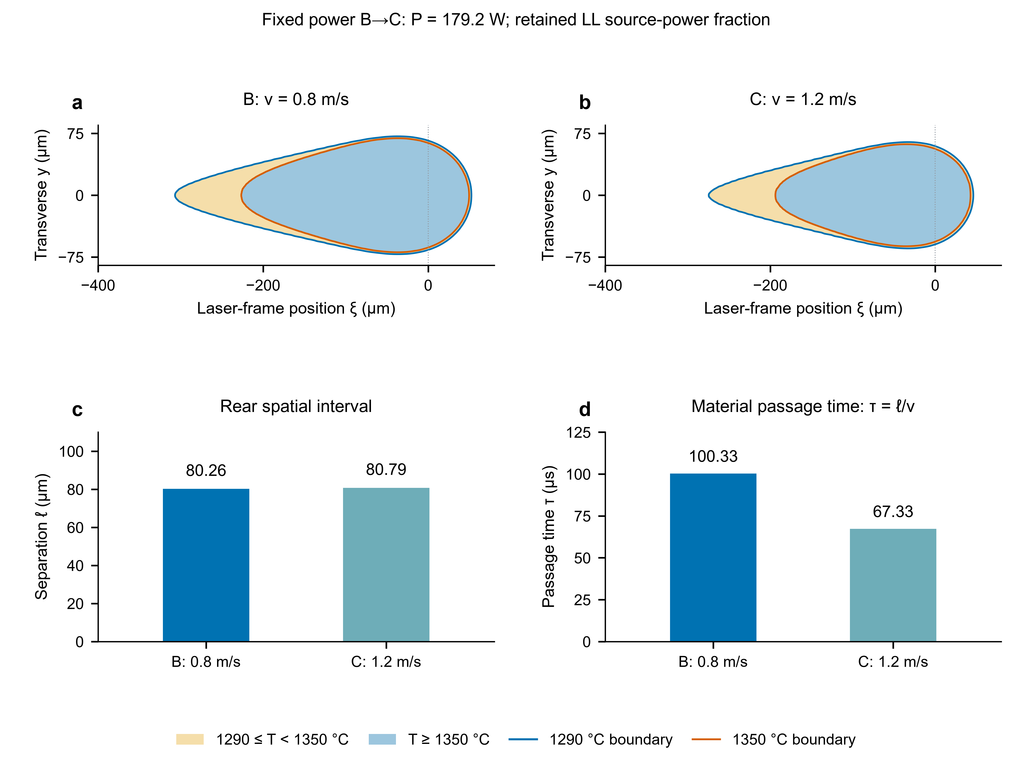
Figure 4. B-to-C speed comparison at fixed applied power on the baseline grid (4 $μm$ near-source axial spacing). (a,b) Surface phase regions use common coordinates and linear extrapolation of both properties. (c,d) Rear solidus–liquidus separation $ℓ_{m}$ and stationary-material passage time $τ_{m}=ℓ_{m}/v$ are displayed as distinct quantities. Passage time is derived from the calculated separation and prescribed speed. The matched refined-grid comparison, with 2 $μm$ axial spacing, is reported in the text and Table A.4.
The rear interval changes little, while passage becomes approximately one third shorter at the higher speed on both grids. On the baseline grid, B and C have separations of 80.26 and 80.79 $μm$ and passage times of 100.33 and 67.33 $μs$, respectively. On the refined grid, the corresponding values are 78.80/79.62 $μm$ and 98.50/66.35 $μs$. The mean cooling-rate magnitude over the phase interval rises by 48.46% on the refined grid, expressing the same separation-and-speed relation through the common liquidus-to-solidus drop. These are related descriptors rather than independent assessments. Likewise, the property-induced pair displacement affects passage at fixed speed only through the smaller change in separation, so longer pool extent need not imply a longer phase-interval duration.
The near-equal intervals accompany a changed fusion shape. Modeled width and depth fall by 9.78% and 29.16%, compared with 14.17% and 17.78% for the metallographic class means. The modeled width-to-depth ratio rises from 4.60 to 5.85, whereas the ratio of measured means changes from 3.43 to 3.58. Model length decreases by 38.53 $μm$, while thermographic means differ by +11 $μm$. The zero-correlation quadrature of their published expanded scales is 38.89 $μm$, larger than the mean change. Unknown cross-condition covariance prevents interpreting that change as a resolved increase. Whole-pool geometry and the local rear interval therefore assess different responses to the speed change.
Assessment of the derived duration requires a record covering the same phase interval and material trajectory. Lane et al.’s constant-speed conversion supports position-to-time mapping, but their exemplar cooling estimate uses a below-solidus interval [4]. Fixed-location histories resolve successive heating events [33]; comparisons with morphology require spatial and temporal registration [34]. Fluid-tracer histories follow moving parcels [35], rather than the stationary-material trajectory used here. The centerline interval also supplies only part of the thermal information used by grain calculations, which require local gradients, undercooling and interface speed and can respond to convection [3, 36]. These window, trajectory and input requirements bound the present single-track descriptor.

4. Conclusions
The prescribed extrapolations change melting extent and rear separation on different scales in the length-calibrated IN625 conduction field. At the retained fitted source power, replacing linear conductivity extrapolation by a constant endpoint value lengthens the pool chiefly through downstream displacement of the rear solidus and liquidus together. Changing sensible specific heat partly offsets that extension, while all four property schemes remain wider and shallower than the metallographic means. The much smaller change in rear separation depends on the partner function. Axial refinement preserves the large boundary displacement but leaves the continuum direction of the small HH–LH separation increase unresolved. A substantial increase in pool length therefore need not represent a comparable widening of the adopted freezing interval.
The fixed-power speed comparison further separates that spatial interval from its material-time meaning. Nearly equal rear separations produce a stationary-material passage through the adopted phase interval about one third shorter at the higher speed. Melting extent, freezing position, interval width and passage time consequently convey distinct information about the calibrated field. Geometry comparisons assess the fusion shape; physical assessment of the rear crossings and their time mapping requires thermal observations with corresponding temperature intervals and trajectories. These distinct assessment targets clarify the thermal information that must be evaluated when a geometry-calibrated conduction field supplies inputs to subsequent solidification calculations.

Data and code availability
Baseline numerical tables, vector figures and evidence-inspection records are available in the manuscript package. The current manuscript revision, editable sources and compact supplementary axial comparisons accompany the local review package. The complete retained fields and originating solver environment remain in the original case archive; their public deposition remains to be arranged. Experimental sources are the cited NIST challenge and Lane study. Third-party full-text reading copies are supplied for local review and excluded from the public project. The package README specifies the available assets and the original case locators.

Declaration of generative AI use in manuscript preparation
OpenAI Codex was used to assist literature and evidence organization, manuscript drafting and automated pre-review. Figures were generated from numerical results by deterministic plotting.

Appendix A. Material data and numerical verification

A.1. Material-property inputs
Table A.1. IN625 conductivity and sensible-specific-heat data from the Special Metals bulletin [6]. The independent temperature columns describe the measured conductivity and calculated sensible-specific-heat data groups; each function is interpolated independently.
$T_{k}$ ($​^{∘}$C) | $k$ (W m$​^{−1}$ K$​^{−1}$) | $T_{c}$ ($​^{∘}$C) | $c_{p}$ (J kg$​^{−1}$ K$​^{−1}$)
$−157$ | 7.2 | $−18$ | 402
$−129$ | 7.5 | 21 | 410
$−73$ | 8.4 | 93 | 427
$−18$ | 9.2 | 204 | 456
21 | 9.8 | 316 | 481
38 | 10.1 | 427 | 511
93 | 10.8 | 538 | 536
204 | 12.5 | 649 | 565
316 | 14.1 | 760 | 590
427 | 15.7 | 871 | 620
538 | 17.5 | 982 | 645
649 | 19.0 | 1093 | 670
760 | 20.8
871 | 22.8
982 | 25.2
The conductivity measurements were made at Battelle on material annealed at 2100 $​^{∘}$F for 1 h.
The linear-extrapolation slopes from the final tabulated pairs are $0.0216216$ W m$​^{−1}$ K$​^{−2}$ for conductivity and $0.225225$ J kg$​^{−1}$ K$​^{−2}$ for sensible specific heat. The enthalpy integral is evaluated piecewise analytically and inverted using the corresponding property extrapolation.

A.2. Complete geometry and baseline property comparisons
The condition-level geometry comparisons in Fig. 2 are listed below with their separately sourced uncertainty scales. The second table retains the original-mesh material responses; the refined quantities and matched effect drifts follow in Tables A.5 and A.6.
Table A.2. Geometry comparison in $μm$ at retained source power. Measurement columns use the thermographic length data and metallographic dimensions defined in Section 2.1; $U$ denotes the separately sourced Lane expanded uncertainty scales ($k=2$). B length is fitted. $δ/U$ describes differences relative to these scales, with the population and uncertainty distinctions specified in Methods.
Condition | Quantity | Model | Measured mean | $U$ | $δ/U$
A | $L$ | 309.89 | 300 | 11.91 | +0.83
 | $W$ | 153.36 | 147.9 | 6.42 | +0.85
 | $D$ | 40.47 | 42.5 | 4.49 | $−0.45$
B | $L$ (fitted) | 359.16 | 359 | 21.26 | +0.01
 | $W$ | 143.04 | 123.5 | 6.30 | +3.10
 | $D$ | 31.12 | 36 | 3.97 | $−1.23$
C | $L$ | 320.63 | 370 | 32.57 | $−1.52$
 | $W$ | 129.05 | 106 | 4.48 | +5.14
 | $D$ | 22.04 | 29.6 | 3.26 | $−2.32$
Table A.3. Baseline property responses at B in $μm$, for the schemes in Table 3 and effects in Eq. (9). The near-source mesh is $4×3×1$ $μm$. Tables A.5 and A.6 give the matched axial-refinement comparisons.
Case or effect | $L$ | $W$ | $D$
LL | 359.16 | 143.04 | 31.12
HL | 402.37 | 143.15 | 30.09
LH | 352.99 | 143.72 | 31.61
HH | 393.44 | 143.79 | 30.80
$δ_{k}$ | +43.21 | +0.11 | $−1.03$
$δ_{c_{p}}$ | $−6.17$ | +0.68 | +0.49
$I_{k,c_{p}}$ | $−2.76$ | $−0.04$ | +0.21
$Δ_{joint}$ | +34.28 | +0.75 | $−0.32$

A.3. Spatial discretization and observation recovery
The domain is $ξ∈[−1,0.35]$ mm, $y∈[0,0.36]$ mm and $z∈[−0.30,0]$ mm. A graded orthogonal mesh contains 902664 cells. Near-source cell widths are $4×3×1$ $μm$ within $ξ∈[−0.48,0.16]$ mm, $y∈[0,0.12]$ mm and $z∈[−0.06,0]$ mm. Outer widths increase by a factor of 1.22 up to 25 $μm$. The half-domain mesh has $199×56×81$ cells. The solved problem is steady; retained warm fields provide nonlinear initial guesses.
The Gaussian source is integrated rectangle-wise using error functions to supply each top-face power, which is deposited in the adjacent top control volume. Its full-plane integral is $ηP$ and the transverse half-domain receives $ηP/2$.
Surface recovery satisfies
$$K(T_{surf})−K(T_{cell})=q Δz/2, K′(T)=k(T),$$ (A.1)
and the symmetry-plane value uses the even quadratic extension $T(0)=T(y_{1})+[T(y_{1})−T(y_{2})]y_{1}^{2}/(y_{2}^{2}−y_{1}^{2})$ from the first two positive-$y$ cell centers. The recovered surface temperatures and symmetry extension are applied before the threshold crossings are extracted.
The observation pitch is 0.5 $μm$; it samples the interpolated geometry rather than changing the heat-field resolution.

A.4. Scaled enthalpy diffusion and diagnostic definitions
The scaled unknown is $U_{H}=H/C_{0}$, with $C_{0}=ρ(402 J {kg}^{−1} K^{−1})=3.39288×{10}^{6}$ J m$​^{−3}$ K$​^{−1}$. On an internal face,
$$D_{f}=\frac{k_{f}}{C_{0}}\frac{ΔT}{ΔU_{H}},$$ (A.2)
where $k_{f}$ is the harmonic face conductivity and $D_{f}$ has units of m$​^{2}$ s$​^{−1}$. For $|ΔU_{H}|≤{10}^{−8}$ K, the derivative limit is $ΔT/ΔU_{H}=C_{0}/[ρ(c_{p}+Lf′)]$ at the first adjacent cell. This coefficient recovers conductive flux in the conservative equation for scaled enthalpy $U_{H}$. Coordinate enthalpy transport uses an exponentially fitted finite-volume convection flux. Material coefficients and the diffusion–transport stencil are updated with each nonlinear iterate; Anderson acceleration solves the fixed-point residual and preconditioned GMRES solves the inner linear system. FiPy assembles the finite-volume terms and SciPy provides the nonlinear and linear solution routines [37, 38]. Software versions and iterative controls are given in the accompanying numerical reproduction notes.
The retained face transport diagnostic is
$$|{Pe}_{f}|=\frac{|u⋅n_{f}|d_{f}}{D_{f}},$$ (A.3)
where $d_{f}$ is the adjacent cell-center separation. Unweighted medians are taken over internal axial faces adjacent to at least one cell with $T_{s}≤T<T_{l}$. The diagnostic compares coordinate transport with diffusion in the discretized field; its selected face population can change between solved branches.
The discrete rear hot-region budget selects cells with $T≥T_{s}$ and $ξ<0$. Net outward diffusive power is the sum of signed conductive face powers on the boundary of this selected cell set; internal face contributions cancel. The region is selected separately in each field, so its boundary and sampled faces change with the property extrapolation. This accounting diagnostic is interpreted alongside the matched-coordinate centerline thresholds rather than as a fixed-region causal contrast.

A.5. Scalar calibration and solution acceptance
A safeguarded secant solves $L_{B}(η)−359 μm=0$ in the initial bracket $[0.2,0.4]$, with proposals restricted to the inner 90% of the current bracket and an accepted absolute length residual below 0.5 $μm$. It yields $η=0.2890548519203547$, with a residual of +0.158 $μm$. The calibration record below gives trial values and the local sensitivity conversion. A and C retain the final value, the same beam and phase law, and the same extrapolation rules.
Nonlinear acceptance requires the sum of absolute assembled cell residuals, normalized by absorbed half-power, to be below $2×{10}^{−5}$, the signed global balance magnitude below the same scale, and a further frozen-coefficient solve to change temperature by less than 0.002 $​^{∘}$C. Local residual and global balance are retained separately because opposing local errors can cancel in a global sum.
The six production solutions have finite temperatures, bounded phase fractions, nontruncated extracted geometry and the prescribed integrated source power. Normalized absolute residuals are $6.90×{10}^{−8}$–$1.31×{10}^{−7}$, signed global balance magnitudes are below $6.1×{10}^{−11}$, and full-solve temperature corrections are below $2.7×{10}^{−5}$ $​^{∘}$C.
An earlier transient B comparison at a different calibration stage provides approximate local steady consistency. Fixed-field blackbody estimates put B-case top losses at 0.099–0.180% of absorbed power; feedback from these losses is not solved. These checks have different roles from the constant-property verification and the calibrated-mesh comparisons.

A.6. Separate constant-property verification problem
The Gaussian verification uses $P=179.2$ W, $η=0.2$, $v=0.8$ m/s and $w=85$ $μm$, with $ρ=8440$ kg m$​^{−3}$, constant $c_{p}=410.94444$ J kg$​^{−1}$ K$​^{−1}$, constant $k=9.870588$ W m$​^{−1}$ K$​^{−1}$ and no latent heat. Thus $a_{0}=k/(ρc_{p})=2.845886×{10}^{−6}$ m$​^{2}$/s. Its finite-domain mesh contains 178992 cells ($113×33×48$), with near-source spacings of $8×6×2$ $μm$. Domain extents follow the production geometry, but the adiabatic transverse and bottom boundaries truncate the semi-infinite analytical referent.
A constant-property moving-Gaussian reference is constructed from the semi-infinite heat kernel, in the moving-source formulation [12]. With $Q=ηP$, convolving the surface Gaussian with the Neumann kernel gives
$$T−T_{0}=\frac{Q}{ρc_{p}π\sqrt{πa_{0}}}\int_{0}^{∞}{\frac{\text{exp}​\left[−\frac{(ξ+vτ)^{2}+y^{2}}{w^{2}/2+4a_{0}τ}−\frac{z^{2}}{4a_{0}τ}\right]}{\sqrt{τ}(w^{2}/2+4a_{0}τ)}} dτ.$$ (A.4)
The implementation removes the surface singularity by $τ=(w/v)s^{2}$ and uses adaptive quadrature. Solidus geometry is extracted at 1290 $​^{∘}$C, with uniform-core face-average source recovery for the numerical surface. Width/depth use the monotone constant-property maximum-temperature envelope; they do not replace the general production passage observer. The associated recipes and reports are identified in the numerical reproduction notes. The quoted differences combine discretization, reconstruction and finite-domain effects, and do not bound nonlinear phase-change or physical-model error.

A.7. Calibration record and retained sensitivities
The calibration bracket $η∈[0.2,0.4]$ has retained endpoint lengths of 234.57 and 511.68 $μm$. Subsequent retained trial pairs $(η,L/μm)$ are $(0.2898051,359.96)$ and $(0.2853148,354.22)$, followed by the final $(0.2890548519,359.16)$. They establish a sampled local bracket, not global identifiability. The local secant sensitivity is approximately 1276.79 $μm$ per unit $η$. Dividing B’s 21.26 $μm$ expanded uncertainty by this slope gives a scale $Δη=0.01665$; it is not a posterior interval and is not propagated into the geometry comparisons. Table A.4 reports the retained axial-refinement responses at the calibrated source-power fraction.
Table A.4. Retained axial sensitivities at the calibrated source-power fraction, calculated as fine minus baseline. Spatial differences are in $μm$ and passage-time differences in $μs$. Only the near-source axial spacing changes from 4 to 2 $μm$; transverse and depth spacings remain 3 and 1 $μm$. These contrasts measure inspected sensitivities rather than an asymptotic error bound.
Condition | $ΔL$ | $ΔW$ | $ΔD$ | $Δξ_{s}^{−}$ | $Δξ_{l}^{−}$ | $Δℓ_{m}$ | $Δτ_{m}$
B | +0.361 | $−0.009$ | +0.041 | $−0.310$ | $−1.771$ | $−1.461$ | $−1.826$
C | +0.199 | $−0.029$ | +0.045 | $−0.288$ | $−1.459$ | $−1.171$ | $−0.976$

A.8. Matched property comparisons under axial refinement
To assess the property responses at their own spatial scales, the four B combinations were compared on the same refined mesh. The near-source axial spacing is 2 $μm$, giving $365×56×81=1655640$ cells; transverse/depth spacing, domain, source-power fraction and phase law retain their baseline values. The refined linear baseline (LL) and additional HL, LH and HH solutions use the same temperature recovery and geometric extraction as their baseline counterparts. Table A.5 reports their quantities, and Table A.6 compares the finite property contrasts between the two axial meshes.
Table A.5. B property combinations on the refined $2×3×1$ $μm$ near-source mesh, at the source-power fraction fitted on the baseline LL mesh. Spatial quantities are in $μm$ and passage time in $μs$. The schemes are defined in Table 3. LL is the retained refined field; HL, LH and HH are additional matched solutions at identical source and phase inputs.
Case | $L$ | $W$ | $D$ | $ξ_{s}^{−}$ | $ξ_{l}^{−}$ | $ℓ_{m}$ | $τ_{m}$ | $\overline{|\dot{T}|}$
 |  |  |  |  |  |  |  | (MK/s)
LL | 359.518 | 143.032 | 31.161 | -307.072 | -228.269 | 78.803 | 98.504 | 0.609
HL | 402.840 | 143.149 | 30.141 | -349.633 | -272.197 | 77.437 | 96.796 | 0.620
LH | 353.646 | 143.705 | 31.651 | -301.128 | -221.272 | 79.856 | 99.820 | 0.601
HH | 394.257 | 143.785 | 30.842 | -341.011 | -260.887 | 80.124 | 100.155 | 0.599
Table A.6. Matched finite property contrasts at B. Subscripts 4 and 2 denote near-source axial spacing in $μm$. Length and rear-position changes use the refined mesh; separation changes are shown at both spacings. Axial drift is the refined contrast minus its baseline counterpart. All entries are in $μm$. Interaction uses HH–HL–LH+LL; a negative rear-position change denotes downstream movement. These two levels assess observed axial sensitivity.
Contrast | $ΔL_{2}$ | $Δξ_{s,2}^{−}$ | $Δξ_{l,2}^{−}$ | $Δℓ_{m,4}$ | $Δℓ_{m,2}$ | Axial drift
HL–LL | +43.321 | -42.561 | -43.928 | -1.013 | -1.367 | -0.353
LH–LL | -5.872 | +5.944 | +6.997 | +0.307 | +1.053 | +0.746
HH–LH | +40.611 | -39.883 | -39.615 | +0.599 | +0.268 | -0.331
HH–HL | -8.583 | +8.623 | +11.310 | +1.919 | +2.687 | +0.768
Interaction | -2.710 | +2.678 | +4.313 | +1.612 | +1.634 | +0.022
HH–LL | +34.739 | -33.939 | -32.618 | +0.906 | +1.320 | +0.415
For the three additional solutions, normalized absolute cell residuals are $5.03×{10}^{−8}$–$1.08×{10}^{−7}$, global balance magnitudes are below $9.17×{10}^{−11}$, and further temperature corrections are below $2.18×{10}^{−5}$ $​^{∘}$C. All three receive 25.8993 W in the half-domain. The observed contrast drift separates the effect of axial spacing from the much smaller final iterative corrections. The unchanged transverse/depth spacing leaves their discretization sensitivity for a separate assessment.
The uncertainty-scale reporting and distinct observation populations are defined in Section 2.1; $U$ is an expanded measurement scale, not a specimen standard deviation. All finite contrasts use full-precision outputs before rounding for display.

References
[1] W. E. King, A. T. Anderson, R. M. Ferencz, N. E. Hodge, C. Kamath, S. A. Khairallah, A. M. Rubenchik, Laser powder bed fusion additive manufacturing of metals; physics, computational, and materials challenges, Appl. Phys. Rev. 2 (4) (2015) 041304. doi:10.1063/1.4937809.
[2] A. Plotkowski, M. M. Kirka, S. S. Babu, Verification and validation of a rapid heat transfer calculation methodology for transient melt pool solidification conditions in powder bed metal additive manufacturing, Addit. Manuf. 18 (2017) 256–268. doi:10.1016/j.addma.2017.10.017.
[3] L. Yuan, J.-L. Fattebert, C. Sun, A. S. Sabau, Uncovering grain and subgrain microstructure at the scale of additive manufacturing melt tracks with a scalable cellular automaton solidification model, Addit. Manuf. 92 (2024) 104401. doi:10.1016/j.addma.2024.104401.
[4] B. Lane, J. Heigel, R. Ricker, I. Zhirnov, V. Khromschenko, J. Weaver, T. Phan, M. Stoudt, S. Mekhontsev, L. Levine, Measurements of melt pool geometry and cooling rates of individual laser traces on IN625 bare plates, Integr. Mater. Manuf. Innov. 9 (1) (2020) 16–30. doi:10.1007/s40192-020-00169-1.
[5] S. Kollmannsberger, M. Carraturo, A. Reali, F. Auricchio, Accurate prediction of melt pool shapes in laser powder bed fusion by the non-linear temperature equation including phase changes, Integr. Mater. Manuf. Innov. 8 (2) (2019) 167–177. doi:10.1007/s40192-019-00132-9.
[6] Special Metals Corporation, INCONEL alloy 625, Special Metals Corporation, technical bulletin, August 2013 edition. Typical material properties; not specification values (2013). https://www.specialmetals.com/documents/technical-bulletins/inconel/inconel-alloy-625.pdf
[7] K. C. Mills, Y. M. Youssef, Z. Li, Y. Su, Calculation of Thermophysical Properties of Ni-based Superalloys, ISIJ Int. 46 (5) (2006) 623–632. doi:10.2355/isijinternational.46.623.
[8] J.-S. Rincon-Tabares, M. Aristizabal, M. Balcer, A. Montoya, H. Millwater, D. Restrepo, Efficient sensitivity analysis of the thermal profile in powder bed fusion of metals using hypercomplex automatic differentiation finite element method, Addit. Manuf. 94 (2024) 104488. doi:10.1016/j.addma.2024.104488.
[9] S. Wells, A. Plotkowski, J. Coleman, M. Krane, Influence of alloy solidification path on melt pool behavior in additive manufacturing, Int. J. Heat Mass Transf. 229 (2024) 125632. doi:10.1016/j.ijheatmasstransfer.2024.125632.
[10] National Institute of Standards and Technology, CHAL-AMB2018-02-MP-xsection: Melt pool geometry—width and depth, section 2, Table 2. Created May 30, 2018; updated May 20, 2025; accessed October 1, 2026 (2018). https://www.nist.gov/ambench/chal-amb2018-02-mp-xsection
[11] A. M. Rubenchik, W. E. King, S. S. Wu, Scaling laws for the additive manufacturing, J. Mater. Process. Technol. 257 (2018) 234–243. doi:10.1016/j.jmatprotec.2018.02.034.
[12] M. Van Elsen, M. Baelmans, P. Mercelis, J.-P. Kruth, Solutions for modelling moving heat sources in a semi-infinite medium and applications to laser material processing, Int. J. Heat Mass Transf. 50 (23-24) (2007) 4872–4882. doi:10.1016/j.ijheatmasstransfer.2007.02.044.
[13] J. Coleman, G. L. Knapp, B. Stump, M. Rolchigo, K. Kincaid, A. Plotkowski, A dynamic volumetric heat source model for laser additive manufacturing, Addit. Manuf. 95 (2024) 104531. doi:10.1016/j.addma.2024.104531.
[14] D. Rosenthal, The Theory of Moving Sources of Heat and Its Application to Metal Treatments, Trans. ASME 68 (8) (1946) 849–865, original 1946 article; Crossref retrospectively labels the archive as Journal of Fluids Engineering. doi:10.1115/1.4018624.
[15] S. A. Khairallah, A. T. Anderson, A. Rubenchik, W. E. King, Laser powder-bed fusion additive manufacturing: Physics of complex melt flow and formation mechanisms of pores, spatter, and denudation zones, Acta Mater. 108 (2016) 36–45. doi:10.1016/j.actamat.2016.02.014.
[16] J. Trapp, A. M. Rubenchik, G. Guss, M. J. Matthews, In situ absorptivity measurements of metallic powders during laser powder-bed fusion additive manufacturing, Appl. Mater. Today 9 (2017) 341–349. doi:10.1016/j.apmt.2017.08.006.
[17] B. J. Simonds, J. Sowards, J. Hadler, E. Pfeif, B. Wilthan, J. Tanner, C. Harris, P. Williams, J. Lehman, Time-Resolved Absorptance and Melt Pool Dynamics during Intense Laser Irradiation of a Metal, Phys. Rev. Appl. 10 (4) (2018) 044061. doi:10.1103/PhysRevApplied.10.044061.
[18] B. Lane, I. Zhirnov, S. Mekhontsev, S. Grantham, R. Ricker, S. Rauniyar, K. Chou, Transient laser energy absorption, co-axial melt pool monitoring, and relationship to melt pool morphology, Addit. Manuf. 36 (2020) 101504. doi:10.1016/j.addma.2020.101504.
[19] D. Sarkar, A. Kapil, A. Sharma, Advances in computational modeling for laser powder bed fusion additive manufacturing: A comprehensive review of finite element techniques and strategies, Addit. Manuf. 85 (2024) 104157. doi:10.1016/j.addma.2024.104157.
[20] B. J. Whalen, J. Ma, P. V. Balachandran, A Bayesian Approach to the Eagar–Tsai Model for Melt Pool Geometry Prediction with Implications in Additive Manufacturing of Metals, Integr. Mater. Manuf. Innov. 10 (4) (2021) 597–609. doi:10.1007/s40192-021-00238-z.
[21] W. L. Oberkampf, T. G. Trucano, Verification and validation in computational fluid dynamics, Prog. Aerosp. Sci. 38 (3) (2002) 209–272. doi:10.1016/S0376-0421(02)00005-2.
[22] M. Kusano, M. Watanabe, Heat Source Model Development for Thermal Analysis of Laser Powder Bed Fusion Using Bayesian Optimization and Machine Learning, Integr. Mater. Manuf. Innov. 13 (1) (2024) 288–304. doi:10.1007/s40192-023-00334-2.
[23] J. Ye, S. A. Khairallah, A. M. Rubenchik, M. F. Crumb, G. Guss, J. Belak, M. J. Matthews, Energy Coupling Mechanisms and Scaling Behavior Associated with Laser Powder Bed Fusion Additive Manufacturing, Adv. Eng. Mater. 21 (7) (2019) 1900185. doi:10.1002/adem.201900185.
[24] R. Cunningham, C. Zhao, N. Parab, C. Kantzos, J. Pauza, K. Fezzaa, T. Sun, A. D. Rollett, Keyhole threshold and morphology in laser melting revealed by ultrahigh-speed x-ray imaging, Science 363 (6429) (2019) 849–852. doi:10.1126/science.aav4687.
[25] Q. Chen, Y. Zhao, S. Strayer, Y. Zhao, K. Aoyagi, Y. Koizumi, A. Chiba, W. Xiong, A. C. To, Elucidating the effect of preheating temperature on melt pool morphology variation in inconel 718 laser powder bed fusion via simulation and experiment, Addit. Manuf. 37 (2021) 101642. doi:10.1016/j.addma.2020.101642.
[26] M. Naderi, J. Weaver, D. Deisenroth, N. Iyyer, R. McCauley, On the Fidelity of the Scaling Laws for Melt Pool Depth Analysis During Laser Powder Bed Fusion, Integr. Mater. Manuf. Innov. 12 (1) (2023) 11–26, published online 27 December 2022; volume publication 2023. doi:10.1007/s40192-022-00289-w.
[27] G. Hong, J. Cho, H. Cho, Fitting-Free Diagnosis of Conduction-Model Breakdown in Laser Powder Bed Fusion, Materials 19 (15) (2026) 3290. doi:10.3390/ma19153290.
[28] M. D. A. Soares, D. Campion, A. Leclercq, A. Kreitcberg, V. Brailovski, Reliability of Thermal Conduction-Based Melt Pool Simulations Using In-Process Thermal Camera and Post-Process Single-Track Measurements, Appl. Sci. 16 (12) (2026) 5850. doi:10.3390/app16125850.
[29] J. S. Weaver, D. Deisenroth, S. Mekhontsev, B. M. Lane, L. E. Levine, H. Yeung, Cross-Sectional Melt Pool Geometry of Laser Scanned Tracks and Pads on Nickel Alloy 718 for the 2022 Additive Manufacturing Benchmark Challenges, Integr. Mater. Manuf. Innov. 13 (2) (2024) 363–379. doi:10.1007/s40192-024-00355-5.
[30] Z. Yang, S. Zhang, X. Ji, S. Y. Liang, Model-Based Sensitivity Analysis of the Temperature in Laser Powder Bed Fusion, Materials 17 (11) (2024) 2565. doi:10.3390/ma17112565.
[31] A. J. Myers, G. Quirarte, F. Ogoke, B. M. Lane, S. Z. Uddin, A. B. Farimani, J. L. Beuth, J. A. Malen, High-resolution melt pool thermal imaging for metals additive manufacturing using the two-color method with a color camera, Addit. Manuf. 73 (2023) 103663. doi:10.1016/j.addma.2023.103663.
[32] H. Hosaeus, A. Seifter, E. Kaschnitz, G. Pottlacher, Thermophysical properties of solid and liquid Inconel 718 alloy, High Temp. High Press. 33 (4) (2001) 405–410. doi:10.1068/htwu340.
[33] P. A. Hooper, Melt pool temperature and cooling rates in laser powder bed fusion, Addit. Manuf. 22 (2018) 548–559. doi:10.1016/j.addma.2018.05.032.
[34] H. Zhang, C. K. P. Vallabh, X. Zhao, Registration and fusion of large-scale melt pool temperature and morphology monitoring data demonstrated for surface topography prediction in lpbf, Addit. Manuf. 58 (2022) 103075. doi:10.1016/j.addma.2022.103075.
[35] W. Hou, T. Stubbs, L. DeBeer-Schmitt, Y.-T. Chang, M.-A. Charpagne, T. M. Smith, A. Huang, Z. C. Cordero, Dissolution zone model of the oxide structure in additively manufactured dispersion-strengthened alloys, Addit. Manuf. 96 (2024) 104554. doi:10.1016/j.addma.2024.104554.
[36] F. Xiong, Z. Gan, J. Chen, Y. Lian, Evaluate the effect of melt pool convection on grain structure of IN625 in laser melting process using experimentally validated process-structure modeling, Journal of Materials Processing Technology 303 (2022) 117538. doi:10.1016/j.jmatprotec.2022.117538. https://doi.org/10.1016/j.jmatprotec.2022.117538
[37] J. E. Guyer, D. Wheeler, J. A. Warren, FiPy: Partial differential equations with Python, Comput. Sci. & Eng. 11 (3) (2009) 6–15. doi:10.1109/MCSE.2009.52.
[38] P. Virtanen, R. Gommers, T. E. Oliphant, M. Haberland, T. Reddy, D. Cournapeau, E. Burovski, P. Peterson, W. Weckesser, J. Bright, S. J. van der Walt, M. Brett, J. Wilson, K. J. Millman, N. Mayorov, A. R. J. Nelson, E. Jones, R. Kern, E. Larson, C. J. Carey, İ. Polat, Y. Feng, E. W. Moore, J. VanderPlas, D. Laxalde, J. Perktold, R. Cimrman, I. Henriksen, E. A. Quintero, C. R. Harris, A. M. Archibald, A. H. Ribeiro, F. Pedregosa, P. van Mulbregt, SciPy 1.0 Contributors, SciPy 1.0: fundamental algorithms for scientific computing in Python, Nat. Methods 17 (3) (2020) 261–272. doi:10.1038/s41592-019-0686-2.

