《基于Java EE平台的软件开发》作业报告

作业1：对象和类

学号 | 1190201420 | 姓名 | 马立凡 | 得分

程序运行步骤及截图：
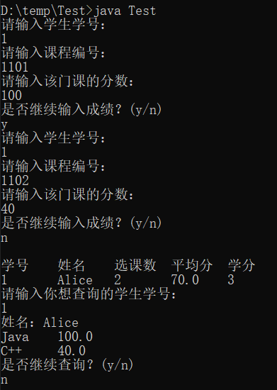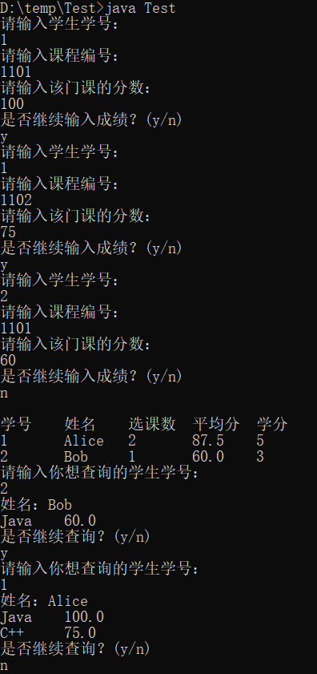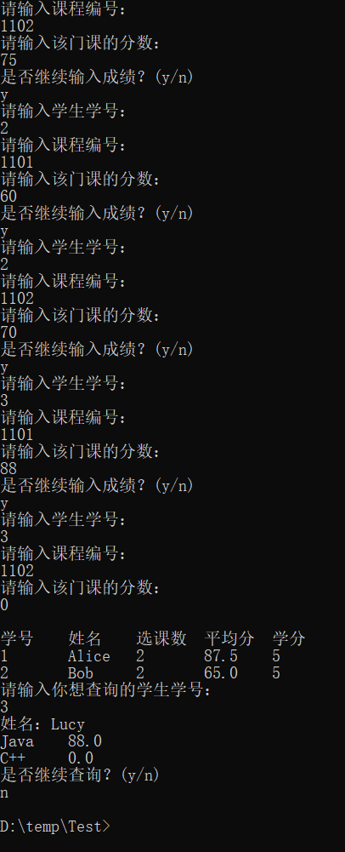

程序源代码：
import java.util.Scanner;
//课程类
class Course
{
private int cid;
private String cname;
private int credits;
private int num;
private double avgScore;
//计算课程的平均分
public void addStudent(double score) {
avgScore = (avgScore * (num++) + score) / num;
}
public Course(int cid, String cname, int credits) {
this.cid = cid;
this.cname = cname;
this.credits = credits;
}
public int getCid() {
return cid;
}
public String getCname() {
return cname;
}
public int getCredits() {
return credits;
}
public int getNum() {
return num;
}
public void setNum(int num) {
this.num = num;
}
public double getAvgScore() {
return avgScore;
}
public void setAvgScore(double avgScore) {
this.avgScore = avgScore;
}
}
//学生类
class Student {
private int sid;
private String sname;
private int num;
private double avgScore;
private int totelCredits;
private static int nextId = 1;
//计算学生的平均分
public void addCourse(double score) {
avgScore = (avgScore * (num++) + score) / num;
}
public Student(String sname) {
this.sname = sname;
sid = nextId ++;
}
public int getSid() {
return sid;
}
public String getSname() {
return sname;
}
public int getNum() {
return num;
}
public void setNum(int num) {
this.num = num;
}
public double getAvgScore() {
return avgScore;
}
public void setAvgScore(double avgScore) {
this.avgScore = avgScore;
}
public int getTotelCredits() {
return totelCredits;
}
public void setTotelCredits(int totelCredits) {
this.totelCredits += totelCredits;
}
}
//选课类
class SelectScore {
private int sid;
private int cid;
private double score;
public SelectScore(int sid, int cid, double score) {
this.sid = sid;
this.cid = cid;
this.score = score;
}
public int getSid() {
return sid;
}
public int getCid() {
return cid;
}
public double getScore() {
return score;
}
}
//测试主类
public class Test {
public static void main(String[] args) {
Scanner input = new Scanner(System.in);

Student[] s = new Student[3];
s[0] = new Student("Alice");
s[1] = new Student("Bob");
s[2] = new Student("Lucy");
Course[] c = new Course[2];
c[0] = new Course(1101, "Java", 3);
c[1] = new Course(1102, "C++", 2);
SelectScore[] ss = new SelectScore[6];
//录入数据
int msg = 0;
for(int i=0; i<ss.length; i++) {
msg++;
System.out.println("请输入学生学号：");
int sid = input.nextInt();
System.out.println("请输入课程编号：");
int cid = input.nextInt();
System.out.println("请输入该门课的分数：");
double score = input.nextDouble();
ss[i] = new SelectScore(sid, cid, score);
if(i != ss.length - 1){
System.out.println("是否继续输入成绩？(y/n)");
String temp = input.next();
if(temp.equals("y")) {
}else {
break;
}
}
}
for(int i=0; i<msg; i++){
//课程平均分计算
for(int j=0; j<c.length; j++){
if(ss[i].getCid() == c[j].getCid()){
c[j].addStudent(ss[i].getScore());
}
}
//学生平均分计算以及学分计算
for(int j=0; j<s.length; j++){
if(ss[i].getSid() == s[j].getSid()){
s[j].addCourse(ss[i].getScore());
if(ss[i].getScore()>=60) {
for(int k=0; k<c.length; k++){
if(ss[i].getCid() == c[k].getCid()){
s[j].setTotelCredits(c[k].getCredits());
}
}
}
}
}

}
System.out.println();
//输出学生信息
System.out.println("学号\t姓名\t选课数\t平均分\t学分");
for(int i=0; i<s.length; i++) {
if(s[i].getAvgScore() >= 60) {
System.out.println(s[i].getSid() + "\t" + s[i].getSname() + "\t" + s[i].getNum() + "\t" + s[i].getAvgScore() + "\t" + s[i].getTotelCredits());
}
}
//查询学生信息
while(true) {
System.out.println("请输入你想查询的学生学号：");
int sid = input.nextInt();
for(int i=0; i<s.length; i++) {
if(s[i].getSid() == sid) {
System.out.println("姓名：" + s[i].getSname());
}
}
for(int i=0; i<msg; i++) {
if(ss[i].getSid() == sid) {
for(int j=0; j<c.length; j++) {
if(c[j].getCid() == ss[i].getCid()) {
System.out.println(c[j].getCname() + "\t" + ss[i].getScore());
}
}
}
}
System.out.println("是否继续查询？(y/n)");
String temp = input.next();
if(temp.equals("y")) {
}else {
break;
}
}
}
}

