《基于Java EE平台的软件开发》作业报告

作业2：面向抽象（接口）编程

学号 | 1190201420 | 姓名 | 马立凡 | 得分

类图：
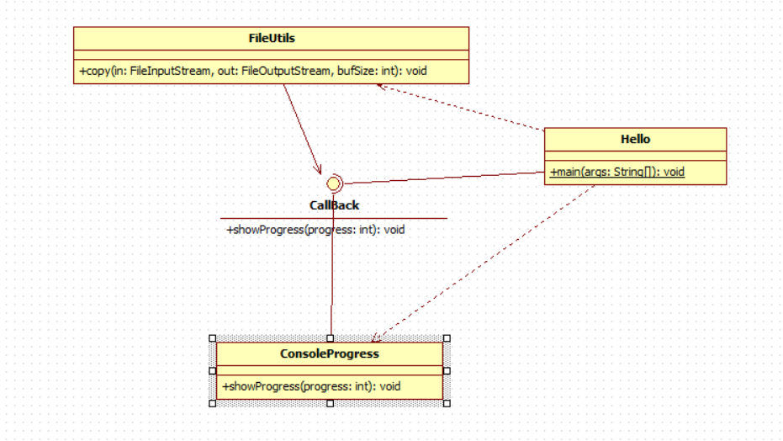

程序运行步骤及截图：
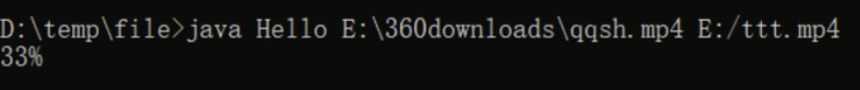
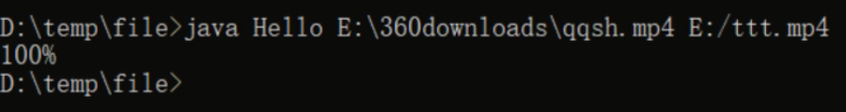
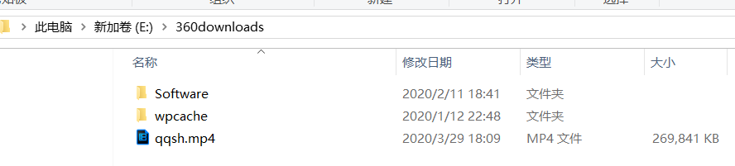
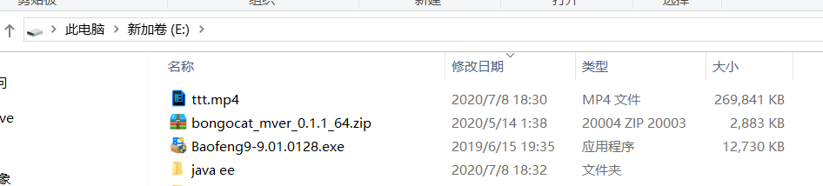

程序源代码：

interface CallBack
{
void showProgress(int progress);
}

//实现callback接口的子类
class ConsoleProgess implements CallBack
{
public void showProgress(int progress)
{
System.out.print("\b\b\b\b" + progress + "%");
}
}

import java.io.*;

class FileUtils
{
private CallBack cb;
public FileUtils(CallBack cb)
{
this.cb = cb;
}
public void copy(FileInputStream in, FileOutputStream out, int bufSize)
throws IOException
{
int total = in.available();
int copied = 0;
byte[] buf = new byte[bufSize];
int len = in.read(buf);
while(len > 0)
{
out.write(buf, 0,len);
copied += len;
cb.showProgress((int)(100.0 * copied / total));
len = in.read(buf);
}
}
}

import java.io.*;

public class Hello
{
public static void main(String[] args) throws IOException
{
if(args.length !=2)
{
System.out.println("命令格式错误！");
return;
}
FileInputStream fis = new FileInputStream(args[0]);
FileOutputStream fos = new FileOutputStream(args[1]);
CallBack cb = new ConsoleProgess();
FileUtils fu = new FileUtils(cb);
fu.copy(fis, fos, 1024 * 1024);
fos.close();
fis.close();
}
}

