《基于Java EE平台的软件开发》作业报告

作业3：数据库程序设计

学号 | 1190201420 | 姓名 | 马立凡 | 得分

类图：
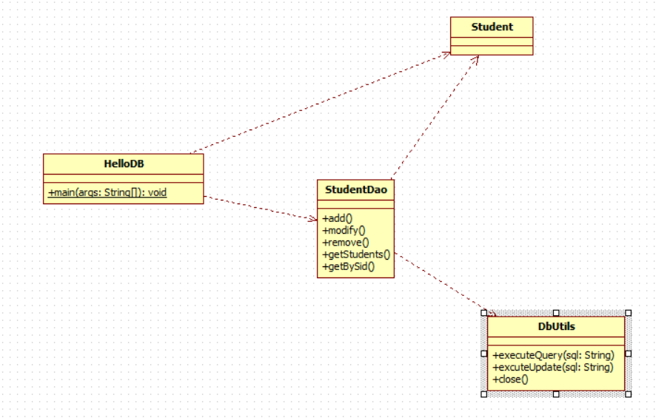
程序运行步骤及截图：
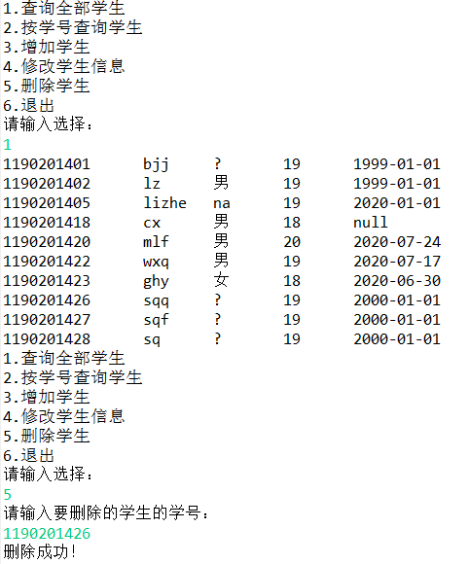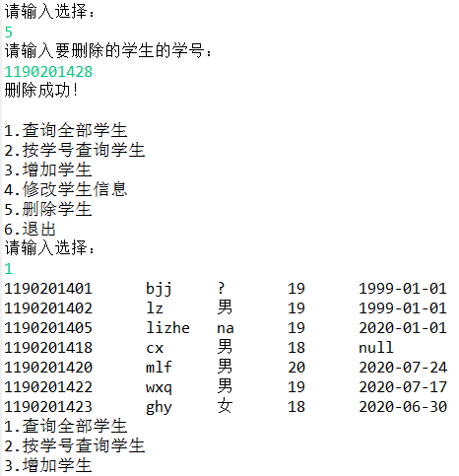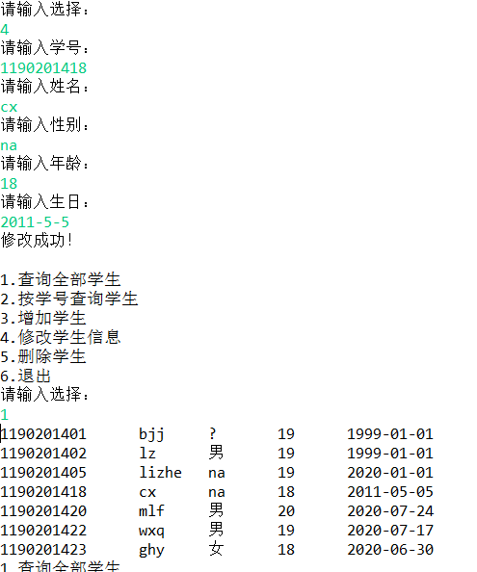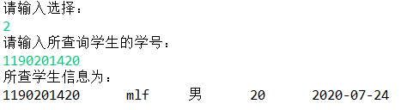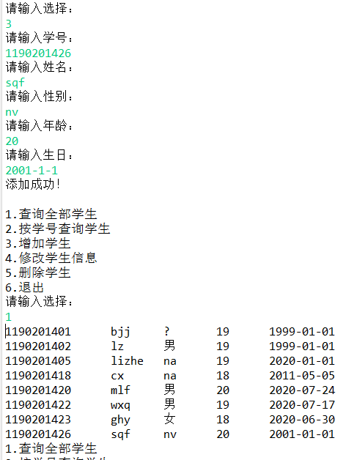
程序源代码：
package cn.edu.hit;

import java.util.*;

import cn.edu.hit.dao.StudentDao;
import cn.edu.hit.entity.Student;

public class HelloDB
{
public static void main(String[] args)
{
StudentDao dao = new StudentDao();
Scanner input = new Scanner(System.in);

while(true) {
System.out.println("1.查询全部学生\n2.按学号查询学生\n3.增加学生\n4.修改学生信息\n5.删除学生\n6.退出");
System.out.println("请输入选择：");
int choice = input.nextInt();
if(choice == 1) {
List<Student> stuList = dao.getStudents("select * from student");
for(int i=0; i<stuList.size(); i++) {
String sid = stuList.get(i).getSid();
String sname = stuList.get(i).getSname();
String gender = stuList.get(i).getGender();
int age = stuList.get(i).getAge();
String birthday = stuList.get(i).getBirthday();
System.out.println(sid + "\t" + sname + "\t" + gender + "\t" + age + "\t" + birthday);
}
}else if(choice == 2) {
System.out.println("请输入所查询学生的学号：");
String sid = input.next();
Student s = dao.getBySid(sid);
System.out.println("所查学生信息为：\n" + sid + "\t" + s.getSname() + "\t" + s.getGender() + "\t" + s.getAge() + "\t" + s.getBirthday() + "\n");
}else if(choice == 3) {
System.out.println("请输入学号：");
String sid = input.next();
System.out.println("请输入姓名：");
String sname = input.next();
System.out.println("请输入性别：");
String gender = input.next();
System.out.println("请输入年龄：");
int age = input.nextInt();
System.out.println("请输入生日：");
String birthday = input.next();
Student s = new Student(sid, sname, gender, age, birthday);
dao.add(s);
System.out.println("添加成功！\n");
}else if(choice == 4) {
System.out.println("请输入学号：");
String sid = input.next();
System.out.println("请输入姓名：");
String sname = input.next();
System.out.println("请输入性别：");
String gender = input.next();
System.out.println("请输入年龄：");
int age = input.nextInt();
System.out.println("请输入生日：");
String birthday = input.next();
Student s = new Student(sid, sname, gender, age, birthday);
dao.modify(s);
System.out.println("修改成功！\n");
}else if(choice == 5) {
System.out.println("请输入要删除的学生的学号：");
String sid = input.next();
dao.remove(sid);
System.out.println("删除成功！\n");
}else if(choice == 6){
break;
}else {
System.out.println("请输入正确数字！\n");
}
}
}
}

package cn.edu.hit.dao;

import java.sql.ResultSet;
import java.sql.SQLException;
import java.util.ArrayList;
import java.util.List;

import cn.edu.hit.entity.Student;
import cn.edu.hit.utils.DbUtils;

public class StudentDao {
public void add(Student s) {
String sid = s.getSid();
String sname = s.getSname();
String gender = s.getGender();
int age = s.getAge();
String birthday = s.getBirthday();
String sql = "insert into student values('" + sid +"','" + sname +"','" + gender +"','" + age +"','" + birthday + "')";
DbUtils du = new DbUtils();
du.excuteUpdate(sql);
du.close();

}
public void remove(String sid) {
String sql = "delete from student where sid = '" + sid + "'";
DbUtils du = new DbUtils();
du.excuteUpdate(sql);
du.close();
}
public void modify(Student s) {
String sid = s.getSid();
String sname = s.getSname();
String gender = s.getGender();
int age = s.getAge();
String birthday = s.getBirthday();
String sql = "update student set sname = '" + sname + "', gender = '" + gender + "', age = " + age + ", birthday = '" + birthday + "' where sid = '" + sid + "'";
DbUtils du = new DbUtils();
du.excuteUpdate(sql);
du.close();
}
public List<Student> getStudents(String sql){
DbUtils du = new DbUtils();
ResultSet rs = du.executeQuery(sql);
List<Student> stuList = new ArrayList<>();
String sid = null;
String sname = null;
String gender = null;
int age = 0;
String birthday = null;

try {
while(rs.next())
{
sid = rs.getString(1);
sname = rs.getString(2);
gender = rs.getString(3);
age = rs.getInt(4);
birthday = rs.getString(5);
stuList.add(new Student(sid, sname, gender, age, birthday));
}
du.close();
return stuList;
} catch (SQLException e) {
// TODO Auto-generated catch block
e.printStackTrace();
return null;
}

}
public Student getBySid(String sid) {
DbUtils du = new DbUtils();
String sql = "select * from student where sid = '" + sid + "'";
ResultSet rs = du.executeQuery(sql);

String sname = null;
String gender = null;
int age = 0;
String birthday = null;

try {
if(rs.next())
{
sname = rs.getString(2);
gender = rs.getString(3);
age = rs.getInt(4);
birthday = rs.getString(5);

}
du.close();
return new Student(sid, sname, gender, age, birthday);
} catch (SQLException e) {
// TODO Auto-generated catch block
e.printStackTrace();
return null;
}
}
}

package cn.edu.hit.utils;

import java.sql.*;

public class DbUtils {
private Connection con;
public DbUtils() {
try {
Class.forName("com.mysql.jdbc.Driver");
con = DriverManager.getConnection("jdbc:mysql://localhost:3306/hit?useSSL=false&characterEncoding=UTF-8","root","suiyi134679");
} catch (ClassNotFoundException e) {
// TODO Auto-generated catch block
e.printStackTrace();
} catch (SQLException e) {
// TODO Auto-generated catch block
e.printStackTrace();
}
}

public void close() {
try {
con.close();
} catch (SQLException e) {
// TODO Auto-generated catch block
e.printStackTrace();
}
}

public ResultSet executeQuery(String sql) {
try {
Statement stmt = con.createStatement();
ResultSet rs = stmt.executeQuery(sql);
return rs;
} catch (SQLException e) {
// TODO Auto-generated catch block
e.printStackTrace();
return null;
}
}

public void excuteUpdate(String sql) {
try {
Statement stmt = con.createStatement();
stmt.executeUpdate(sql);
} catch (SQLException e) {
// TODO Auto-generated catch block
e.printStackTrace();
}

}
}

package cn.edu.hit.entity;

public class Student {
private String sid;
private String sname;
private String gender;
private int age;
private String birthday;

public Student() {
super();
}

public Student(String sid, String sname, String gender, int age, String birthday) {
super();
this.sid = sid;
this.sname = sname;
this.gender = gender;
this.age = age;
this.birthday = birthday;
}

public String getSid() {
return sid;
}

public void setSid(String sid) {
this.sid = sid;
}

public String getSname() {
return sname;
}

public void setSname(String sname) {
this.sname = sname;
}

public String getGender() {
return gender;
}

public void setGender(String gender) {
this.gender = gender;
}

public int getAge() {
return age;
}

public void setAge(int age) {
this.age = age;
}

public String getBirthday() {
return birthday;
}

public void setBirthday(String birthday) {
this.birthday = birthday;
}

}

