《基于Java EE平台的软件开发》作业报告

作业4：Web程序设计

学号 | 1190201420 | 姓名 | 马立凡 | 得分

程序运行步骤及截图：
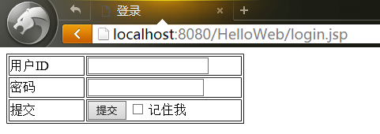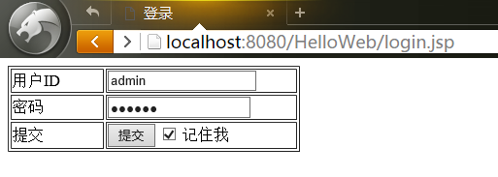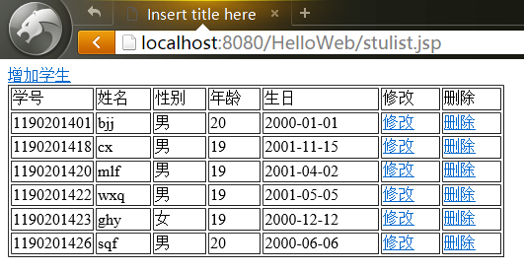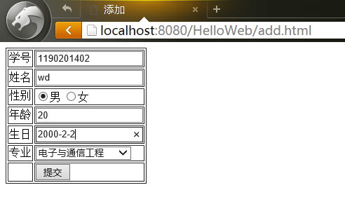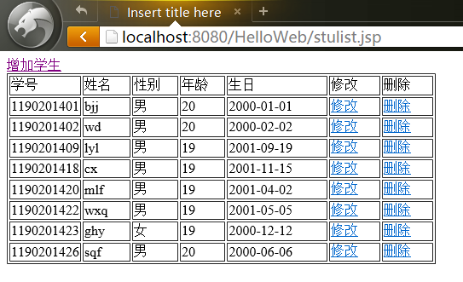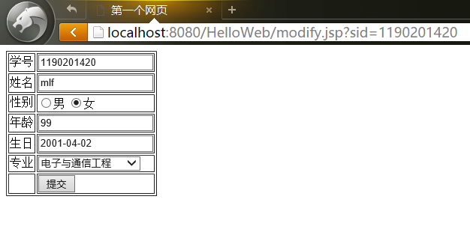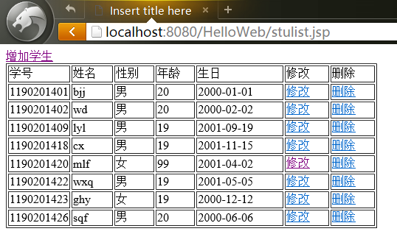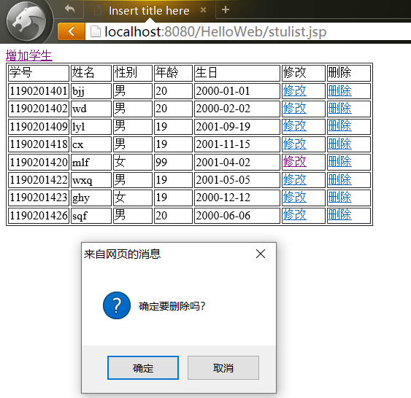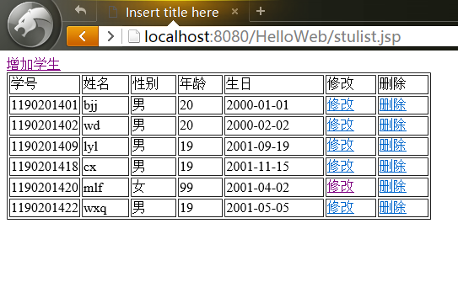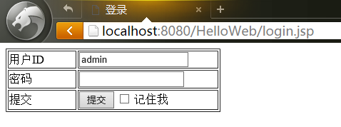

程序源代码：
package cn.edu.hit.controller;

import java.io.IOException;

import javax.servlet.ServletException;
import javax.servlet.annotation.WebServlet;
import javax.servlet.http.Cookie;
import javax.servlet.http.HttpServlet;
import javax.servlet.http.HttpServletRequest;
import javax.servlet.http.HttpServletResponse;
import javax.servlet.http.HttpSession;

import cn.edu.hit.dao.LoginDao;

/**
* Servlet implementation class LoginServlet
*/
@WebServlet("/LoginServlet")
public class LoginServlet extends HttpServlet {
private static final long serialVersionUID = 1L;

/**
* @see HttpServlet#HttpServlet()
*/
public LoginServlet() {
super();
// TODO Auto-generated constructor stub
}

/**
* @see HttpServlet#doGet(HttpServletRequest request, HttpServletResponse response)
*/
protected void doGet(HttpServletRequest request, HttpServletResponse response) throws ServletException, IOException {
String userid = request.getParameter("userid");
String pwd = request.getParameter("pwd");
LoginDao dao = new LoginDao();
boolean flag = dao.login(userid, pwd);
if(flag) {
HttpSession session = request.getSession();
session.setAttribute("userid", userid);
if(request.getParameter("me") != null && request.getParameter("me").equals("1")) {
Cookie c = new Cookie("userid", userid);
c.setMaxAge(60*60*24*7);
response.addCookie(c);
}else {}

response.sendRedirect("stulist.jsp");
}else {
response.getWriter().print("Error");
}
}

/**
* @see HttpServlet#doPost(HttpServletRequest request, HttpServletResponse response)
*/
protected void doPost(HttpServletRequest request, HttpServletResponse response) throws ServletException, IOException {
// TODO Auto-generated method stub
doGet(request, response);
}

}

package cn.edu.hit.controller;

import java.io.IOException;
import javax.servlet.ServletException;
import javax.servlet.annotation.WebServlet;
import javax.servlet.http.HttpServlet;
import javax.servlet.http.HttpServletRequest;
import javax.servlet.http.HttpServletResponse;
import javax.servlet.http.HttpSession;

import cn.edu.hit.dao.StudentDao;
import cn.edu.hit.entity.Student;

/**
* Servlet implementation class StudentServlet
*/
@WebServlet("/StudentServlet")
public class StudentServlet extends HttpServlet {
private static final long serialVersionUID = 1L;

/**
* @see HttpServlet#HttpServlet()
*/
public StudentServlet() {
super();
// TODO Auto-generated constructor stub
}

/**
* @see HttpServlet#doGet(HttpServletRequest request, HttpServletResponse response)
*/
protected void doGet(HttpServletRequest request, HttpServletResponse response) throws ServletException, IOException {
// TODO Auto-generated method stub
request.setCharacterEncoding("UTF-8");
HttpSession session = request.getSession();
String userid = (String)session.getAttribute("userid");
if(userid == null){
response.sendRedirect("login.jsp");
return;
}
String from = request.getParameter("from");
if(from.equals("add")) {
String sid = request.getParameter("sid");
String sname = request.getParameter("sname");
String gender= request.getParameter("gender");
int age = Integer.parseInt(request.getParameter("age"));
String birthday = request.getParameter("birthday");
String major = request.getParameter("major");
StudentDao dao = new StudentDao();
dao.add(new Student(sid, sname, gender, age, birthday));
response.sendRedirect("stulist.jsp");
}else if(from.equals("modify")) {
String sid = request.getParameter("sid");
String sname = request.getParameter("sname");
String gender= request.getParameter("gender");
int age = Integer.parseInt(request.getParameter("age"));
String birthday = request.getParameter("birthday");
String major = request.getParameter("major");
StudentDao dao = new StudentDao();
dao.modify(new Student(sid, sname, gender, age, birthday));
response.sendRedirect("stulist.jsp");
}else if(from.equals("remove")) {
String sid = request.getParameter("sid");
StudentDao dao = new StudentDao();
dao.remove(sid);
response.sendRedirect("stulist.jsp");
}
}

/**
* @see HttpServlet#doPost(HttpServletRequest request, HttpServletResponse response)
*/
protected void doPost(HttpServletRequest request, HttpServletResponse response) throws ServletException, IOException {
// TODO Auto-generated method stub
doGet(request, response);
}

}

package cn.edu.hit.dao;

import java.sql.ResultSet;
import java.sql.SQLException;

import cn.edu.hit.utils.DbUtils;

public class LoginDao {
public boolean login(String userid, String pwd) {
int count = 0;
DbUtils du = new DbUtils();
ResultSet rs = du.executeQuery("select count(*) from sysuser where userid ='" + userid + "' and pwd = '" + pwd + "'");
try {
rs.next();
count = rs.getInt(1);
} catch (SQLException e) {
// TODO Auto-generated catch block
e.printStackTrace();
}
return count > 0?true:false;
}
}

package cn.edu.hit.dao;

import java.sql.ResultSet;
import java.sql.SQLException;
import java.util.ArrayList;
import java.util.List;

import cn.edu.hit.entity.Student;
import cn.edu.hit.utils.DbUtils;

public class StudentDao {
public void add(Student s) {
String sid = s.getSid();
String sname = s.getSname();
String gender = s.getGender();
int age = s.getAge();
String birthday = s.getBirthday();
String sql = "insert into student values('" + sid +"','" + sname +"','" + gender +"','" + age +"','" + birthday + "')";
DbUtils du = new DbUtils();
du.excuteUpdate(sql);
du.close();

}
public void remove(String sid) {
String sql = "delete from student where sid = '" + sid + "'";
DbUtils du = new DbUtils();
du.excuteUpdate(sql);
du.close();
}
public void modify(Student s) {
String sid = s.getSid();
String sname = s.getSname();
String gender = s.getGender();
int age = s.getAge();
String birthday = s.getBirthday();
String sql = "update student set sname = '" + sname + "', gender = '" + gender + "', age = " + age + ", birthday = '" + birthday + "' where sid = '" + sid + "'";
DbUtils du = new DbUtils();
du.excuteUpdate(sql);
du.close();
}
public List<Student> getStudents(String sql){
DbUtils du = new DbUtils();
ResultSet rs = du.executeQuery(sql);
List<Student> stuList = new ArrayList<>();
String sid = null;
String sname = null;
String gender = null;
int age = 0;
String birthday = null;

try {
while(rs.next())
{
sid = rs.getString(1);
sname = rs.getString(2);
gender = rs.getString(3);
age = rs.getInt(4);
birthday = rs.getString(5);
stuList.add(new Student(sid, sname, gender, age, birthday));
}
du.close();
return stuList;
} catch (SQLException e) {
// TODO Auto-generated catch block
e.printStackTrace();
return null;
}

}
public Student getBySid(String sid) {
DbUtils du = new DbUtils();
String sql = "select * from student where sid = '" + sid + "'";
ResultSet rs = du.executeQuery(sql);

String sname = null;
String gender = null;
int age = 0;
String birthday = null;

try {
if(rs.next())
{
sname = rs.getString(2);
gender = rs.getString(3);
age = rs.getInt(4);
birthday = rs.getString(5);

}
du.close();
return new Student(sid, sname, gender, age, birthday);
} catch (SQLException e) {
// TODO Auto-generated catch block
e.printStackTrace();
return null;
}
}
}

package cn.edu.hit.entity;

public class Student {
private String sid;
private String sname;
private String gender;
private int age;
private String birthday;

public Student() {
super();
}

public Student(String sid, String sname, String gender, int age, String birthday) {
super();
this.sid = sid;
this.sname = sname;
this.gender = gender;
this.age = age;
this.birthday = birthday;
}

public String getSid() {
return sid;
}

public void setSid(String sid) {
this.sid = sid;
}

public String getSname() {
return sname;
}

public void setSname(String sname) {
this.sname = sname;
}

public String getGender() {
return gender;
}

public void setGender(String gender) {
this.gender = gender;
}

public int getAge() {
return age;
}

public void setAge(int age) {
this.age = age;
}

public String getBirthday() {
return birthday;
}

public void setBirthday(String birthday) {
this.birthday = birthday;
}

}

package cn.edu.hit.utils;

import java.sql.*;

public class DbUtils {
private Connection con;
public DbUtils() {
try {
Class.forName("com.mysql.jdbc.Driver");
con = DriverManager.getConnection("jdbc:mysql://localhost:3306/hit?useSSL=false&characterEncoding=UTF-8","root","suiyi134679");
} catch (ClassNotFoundException e) {
// TODO Auto-generated catch block
e.printStackTrace();
} catch (SQLException e) {
// TODO Auto-generated catch block
e.printStackTrace();
}
}

public void close() {
try {
con.close();
} catch (SQLException e) {
// TODO Auto-generated catch block
e.printStackTrace();
}
}

public ResultSet executeQuery(String sql) {
try {
Statement stmt = con.createStatement();
ResultSet rs = stmt.executeQuery(sql);
return rs;
} catch (SQLException e) {
// TODO Auto-generated catch block
e.printStackTrace();
return null;
}
}

public void excuteUpdate(String sql) {
try {
Statement stmt = con.createStatement();
stmt.executeUpdate(sql);
} catch (SQLException e) {
// TODO Auto-generated catch block
e.printStackTrace();
}

}
}

<!DOCTYPE html>
<html>
<head>
<meta charset="UTF-8">
<title>添加</title>
</head>
<body>
<form action="StudentServlet" method="post">
<table border="1">
<tr>
<td>学号</td>
<td><input type="text" name="sid"/></td>
</tr>
<tr>
<td>姓名</td>
<td><input type="text" name="sname"/></td>
</tr>
<tr>
<td>性别</td>
<td>
<input name="gender" type="radio" value="男" checked="checked"/>男
<input name="gender" type="radio" value="女"/>女
</td>
</tr>
<tr>
<td>年龄</td>
<td><input type="text" name="age"/></td>
</tr>
<tr>
<td>生日</td>
<td><input type="text" name="birthday"/></td>
</tr>
<tr>
<td>专业</td>
<td>
<select name="major">
<option>电子与通信工程</option>
<option>计算机科学与技术</option>
<option>软件工程</option>
<option>网络信息安全</option>
<option>化学工艺</option>
</select>
</td>
</tr>
<tr>
<td></td>
<td><input type="submit" value="提交"></td>
</tr>
</table>
<input type="hidden" name="from" value="add"/>
</form>
</body>
</html>

<%@ page language="java" contentType="text/html; charset=UTF-8" pageEncoding="UTF-8"%>
<%@ page import="cn.edu.hit.dao.*,java.util.*,cn.edu.hit.entity.*" %>
<!DOCTYPE html>
<head>
<meta charset="UTF-8" />
<title>登录</title>
</head>

<body>
<%
Cookie[] cookies = request.getCookies();
String userid = "";
for(int i=0;i<cookies.length;i++){
if(cookies != null){
Cookie c = cookies[i];
if(c.getName().equals("userid")){
userid = c.getValue();
}
}
}
%>
<form name="form1" method="post" action="LoginServlet">
<table width="301" border="1">
<tr>
<td width="92">用户ID</td>
<td width="193"><label>
<input name="userid" type="text" id="userid" value="<%=userid%>">
</label></td>
</tr>
<tr>
<td>密码</td>
<td><label>
<input name="pwd" type="password" id="pwd">
</label></td>
</tr>
<tr>
<td>提交</td>
<td><label>
<input type="submit" name="Submit" value="提交">
<input name="me" type="checkbox" id="me" value="1">
记住我</label></td>
</tr>
</table>
</form>
</body>
</html>

<%@ page language="java" contentType="text/html; charset=UTF-8" pageEncoding="UTF-8"%>
<%@ page import="cn.edu.hit.dao.*,java.util.*,cn.edu.hit.entity.*" %>
<%
String userid = (String)session.getAttribute("userid");
if(userid == null){
response.sendRedirect("login.jsp");
return;
}
%>
<!DOCTYPE html>
<html>
<head>
<meta charset="UTF-8">
<title>第一个网页</title>
</head>
<body>
<%
String sid = request.getParameter("sid");
StudentDao dao = new StudentDao();
Student stu = dao.getBySid(sid);
String sname = stu.getSname();
String gender = stu.getGender();
int age = stu.getAge();
String birthday = stu.getBirthday();
%>
<form action="StudentServlet" method="post">
<table border="1">
<tr>
<td>学号</td>
<td><input type="text" name="sid" value="<%=sid %>" readonly/></td>
</tr>
<tr>
<td>姓名</td>
<td><input type="text" name="sname" value="<%=sname %>"/></td>
</tr>
<tr>
<td>性别</td>
<td>
<input name="gender" type="radio" value="男" <%if(gender.equals("男")) out.print("checked=\"checked\""); %>/>男
<input name="gender" type="radio" value="女" <%if(gender.equals("女")) out.print("checked=\"checked\""); %>/>女
</td>
</tr>
<tr>
<td>年龄</td>
<td><input type="text" name="age" value="<%=age %>"/></td>
</tr>
<tr>
<td>生日</td>
<td><input type="text" name="birthday" value="<%=birthday %>"/></td>
</tr>
<tr>
<td>专业</td>
<td>
<select name="major">
<option>电子与通信工程</option>
<option>计算机科学与技术</option>
<option>软件工程</option>
<option>网络信息安全</option>
<option>化学工艺</option>
</select>
</td>
</tr>
<tr>
<td></td>
<td><input type="submit" value="提交"></td>
</tr>
</table>
<input type="hidden" name="from" value="modify"/>
</form>
</body>
</html>

<%@ page language="java" contentType="text/html; charset=UTF-8" pageEncoding="UTF-8"%>
<%@ page import="cn.edu.hit.dao.*,java.util.*,cn.edu.hit.entity.*" %>
<%
String userid = (String)session.getAttribute("userid");
if(userid == null)
response.sendRedirect("login.jsp");
%>
<!DOCTYPE html>
<html>
<head>
<meta charset="UTF-8">
<title>Insert title here</title>
</head>
<body>
<a href="add.html">增加学生</a>
<table width="503" border="1">
<tr>
<td width="71">学号</td>
<td width="57">姓名</td>
<td width="57">性别</td>
<td width="56">年龄</td>
<td width="129">生日</td>
<td width="64">修改</td>
<td width="64">删除</td>
</tr>
<%
StudentDao dao = new StudentDao();
List<Student> stuList = dao.getStudents("select * from student");
String sid, sname, gender, birthday;
int age;
for(int i=0;i<stuList.size();i++)
{
sid = stuList.get(i).getSid();
sname = stuList.get(i).getSname();
gender = stuList.get(i).getGender();
age = stuList.get(i).getAge();
birthday = stuList.get(i).getBirthday();
%>
<tr>
<td><%=sid%></td>
<td><%=sname%></td>
<td><%=gender%></td>
<td><%=age%></td>
<td><%=birthday%></td>
<td><a href="modify.jsp?sid=<%=sid%>">修改</a></td>
<td><a href="StudentServlet?from=remove&sid=<%=sid%>" onclick="return confirm('确定要删除吗？')">删除</a></td>
</tr>
<%
}
%>
</table>
</body>
</html>

