**Price comparison website**

**END TERM REPORT**

**Group :22**

**K.BALA SURENDRA REDDY ,11911474**

**K.NAGA MUNI REDDY ,11911684.**

**B.SURENDHAR KUMAR ,11911639.**

**K19LC**

**UNDER THE GUIDANCE OF**

**(Dr. Moin Hasan)**



**DEPARTMENT OF INTELLIGENT SYSTEMS**

**SCHOOL OF COMPUTER SCIENCE ENGINEERING**

**LOVELY PROFESSIONAL UNIVERSITY, JALANDHAR**

**OCTOBER-2020**

**INDEX**

**• ACKNOWLEDGEMENT**

**• ABSTRACT**

**• INTRODUCTION**

**• OBJECTIVE OF THE PROJECT**

**• Technology**

**• Major websites**

**• PROJECT CONTRIBUTIONS**

**1. METHODS**

**2. RESULTS**

**• CONCLUSION**

**Github link:_**

**ACKNOWLEDGEMENT**

I k.bala surendra .one-third member of group number 18 writing this synopsis on behalf of our group. Our group consists of three members I myself i.e. Naga Muni reddy,B.Surendhar kumar.

We express our deep sense of gratitude to our beloved Lecturer Dr.

Moin Hasan for the valuable guidance and for permitting us to carry out

this project**.**

We consider ourselves lucky enough to get such a good project. This project would add as an asset to our academic profile.

We express our thanks to all those who contributed for the successful completion of our project work.

With my friends,

K.BALA SURENDRA REDDY

K.NAGA MUNI REDDY

B.SURENDHAR KUMAR

**ABSTRACT**

**Price comparison website**

**Introduction:**

For someone who wants to save money, and receive the best value for money, they may meditate comparison shopping. Though it sounds deadening, but it can actually be challenging and rewarding. Analysing brands to find out the best value for the price will be helpful to everyone. It’s not just for to get the best products for their family, but will also help to save money long term. Even if they don’t exactly exercise frugal living in all areas of your life, they can still practice comparison shopping to get the most of money when certain purchases have been made.

Three steps to a price comparison site

1: Universal data feed importer with Data handling, auto categorisation, data ruleset manager, character manipulation, find and replace, delete and merge facilities. interface, administrator accounts/admins

2: Advertiser login and reporting services, universal product data services, universal site scraping services to collect feeds for merchants that cant/won’t provide them

3: Marketing tools, traffic managers to monitor incoming outgoing traffic to make sure purchased traffic is equal or less than the money/sales we are making from our own site for those purchased keywords.

**OBJECTIVE OF THE PROJECT :**

Agree aim with supervisor and develop set of objectives.

Build a solid understanding of web developing and database management.

Discuss and agree initial design approach with supervisor.

Background research on web development tools such as HTML, SQL, PHP , JAVASCRIPT and ASP.NET

Discuss prototype design with supervisor and agree implement

Implement website.

**Technology:**

The most challenging part of comparison website is how to collect date from merchants. One way is to contact with them and collect data directly from them. Retailers will supply their own lists of products and prices. Then these are matched against original database. This can be done by mixture of human labour and information extraction. [5]

Another common way is to collect data thorough a data feed file. Merchants provide information electronically in a set format. Comparison website then imports data. Consolidation of data feeds can be found from some third party businesses so we do not have to import data from many different merchants. Affiliate networks like Linkshare and Commission Junction also add up data feeds from various merchants and provide it comparison sites.

**Major websites:**

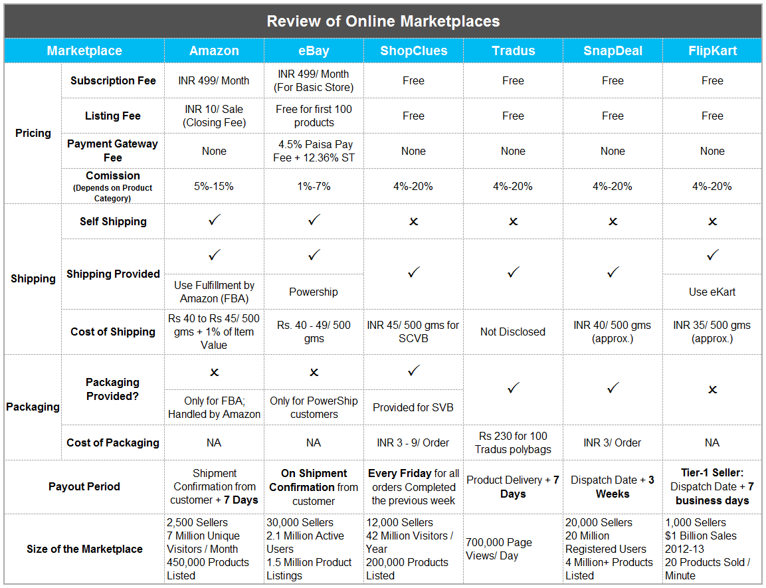

**PROJECT CONTRIBUTIONS**

**Methods:**

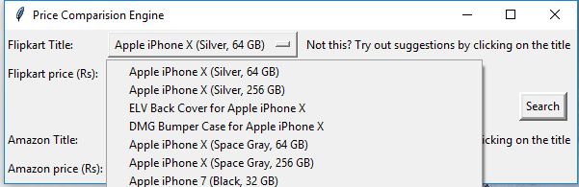

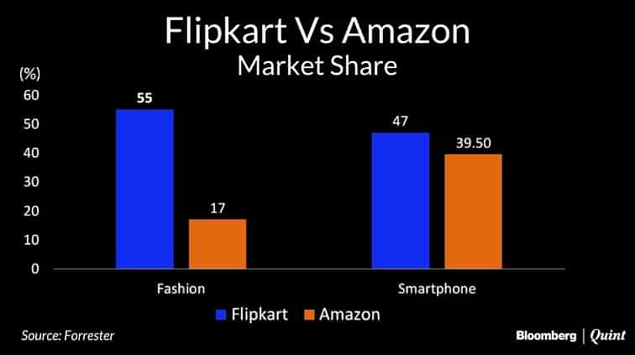

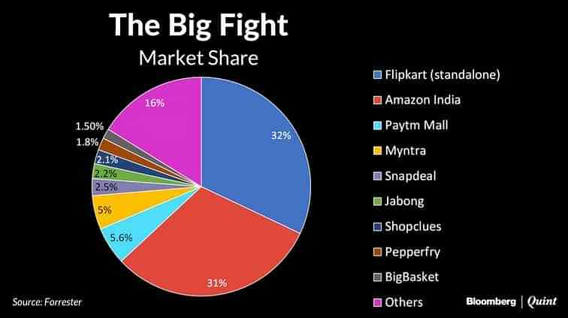

**Conclusion:**

We try to spend as much time as we can, to check whether or not we are buying a right thing? And the most important; whether we are buying it at a reasonable rate or not? Providing the ability to compare products is at the heart of what comparison sites are trying to achieve. However, those sites are achieving this with varying levels of success. My target of website is simply log on to my website, learn about the products, search and browse the options and shop with satisfaction of trust and all these at your door step

**See also:**

Discovery shopping

Gasoline price website

Consumer switching

**References:**

1. [*"Shopping Comparison Engines market worth £120m-£140m in 2005, says E-consultancy"*](http://www.ukprwire.com/Detailed/Computers_Internet/Shopping_Comparison_Engines_market_worth_120m-_140m_in_2005_says_E-consultancy_1648.shtml). Ukprwire.com. 2006-04-12*. Retrieved 2013-10-17*
2. [*"Price Comparison Shopping In UK"*](https://web.archive.org/web/20160912193044/http:/www.phonesandyou.co.uk/blog/price-comparison-shopping-in-uk/). 2016-08-17. Archived from [*the original*](http://www.phonesandyou.co.uk/blog/price-comparison-shopping-in-uk/) on 2016-09-12*. Retrieved 2016-08-19*
3. [*"50 Best Websites 2008 - TIME"*](http://content.time.com/time/specials/2007/article/0,28804,1809858_1809955_1811450,00.html). Time. 2008-06-17. [*ISSN*](https://en.wikipedia.org/wiki/ISSN_(identifier)) [*0040-781X*](https://www.worldcat.org/issn/0040-781X)*. Retrieved 2017-03-22*