# LIBRARY MANAGEMENT SYSTEM

END TERM REPORT

***by***

# NAME OF THE CANDIDATE(S)

Velpuri Satya Nagendra (reg 11911592)

K.Bala Surendra Reddy( reg 11911474)

Dudala Suresh (Reg 11911455)

**(Section: K19LC) (Roll Number(s): 59, 05, 20)**



**Department of Intelligent Systems School of Computer Science Engineering Lovely Professional University, Jalandhar**

2019-2020

# Student Declaration

This is to declare that this report has been written by us. No part of the report is copied from other sources. All information included from other sources have been duly acknowledged. We aver that if any part of the report is found to be copied, we are shall take full responsibility for it.

<<Signature of Student>>

<< Velpuri Satya Nagendra >>

<<Roll number: 59>>

<<Signature of Student>>

<< K.Bala Surendra Reddy >>

<<Roll number: 05>>

Place: Date:

<<Signature of Student>>

<< Dudala Suresh >>

<<Roll number: 20>>

# TABLE OF CONTENTS

TITLE PAGE NO.

1. Introduction 4
2. Description of project 5
3. Work division in group 6
4. Website screenshots 7-11
5. Technology used 12

# BONAFIDE CERTIFICATE

Certified that this project report “SHOPPING WEBSITE” is the bona fide work of “Velpuri Satya Nagendra (59); K.Bala Surendra Reddy (05); and Dudala Suresh (05)” who carried out the project work under my supervision.

<<Signature of the Supervisor>>

<<Dr Dhanapartap Singh>>

<<Assistant Professor>>

<<UID: 25706>>

<<School of Computer Science and Engineering>>

This project “Shopping website” is made for mainly providing online shopping to get products like camera ,phones ,shoes etc… we can by in the online only.

This project is two mode admin and user. The role of admin is to provide all shopping things like camera,phpnes,bags ,shoes etc….. the role of user is to called his /her shopping things comfortable manner

Technology used to make this project are HTML, CSS, JAVASCRIPT, BOOTSTRAP.

This shopping website software is used to develop the online sector ,this website creates a page with full of online things such as phones,laptops,books ,shoes,cameras etc… so many products. This project gets you complete information for online .

|  |  |  |  |
| --- | --- | --- | --- |
| **Name** | **Reg no.** | **Roll no.** | **Work done** |
| satya | 11911592 | 59 | Website coding and implementation |
| surendra | 11911474 | 05 | Website report making |
| Dudala Suresh | 11911455 | 20 | Made website feedback form |

1.Index Page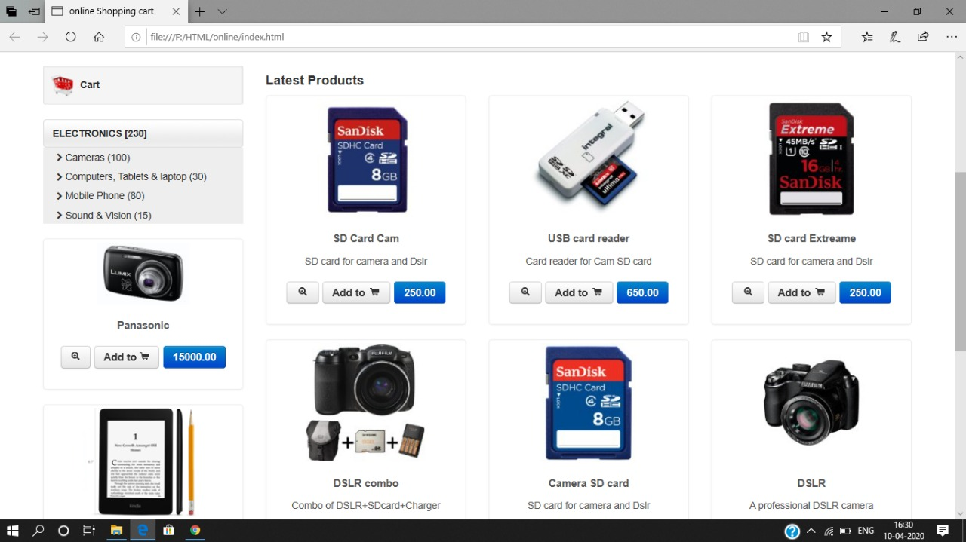

2.Few More Products

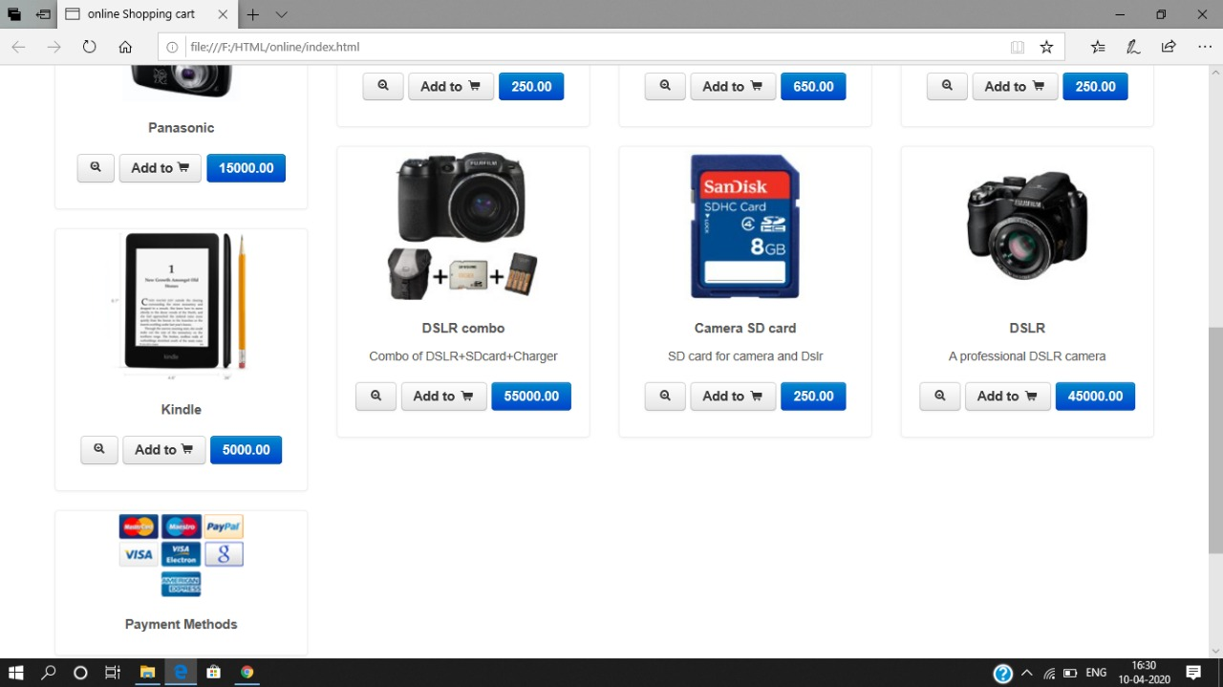

3.Product Information

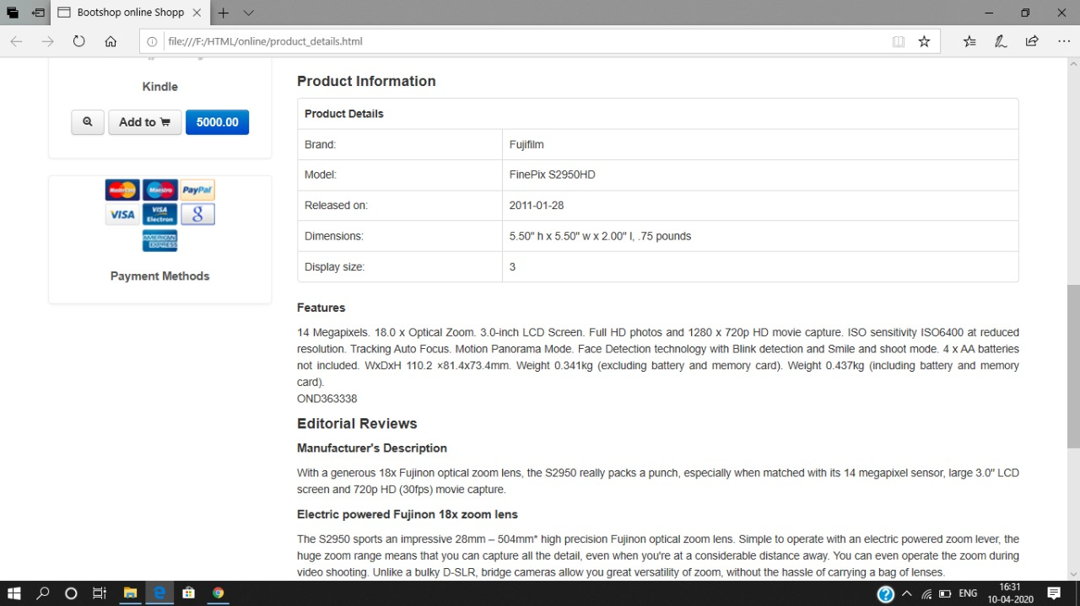

4.Product Details

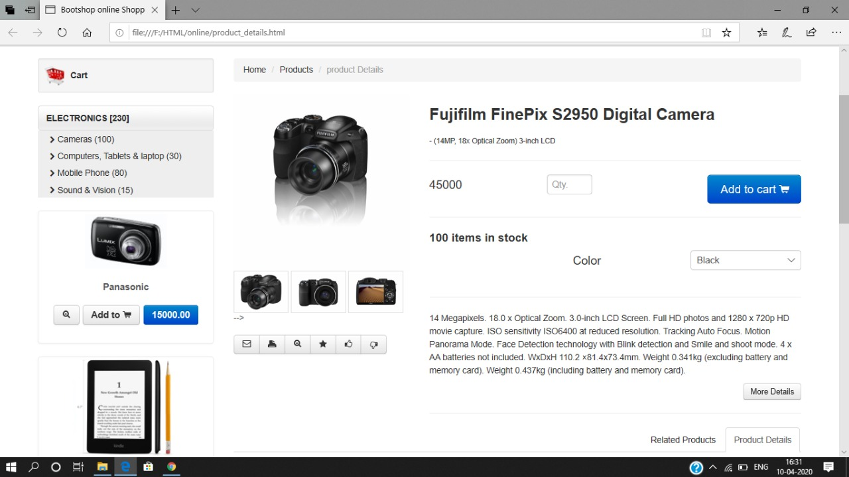

5. Address Fill Up

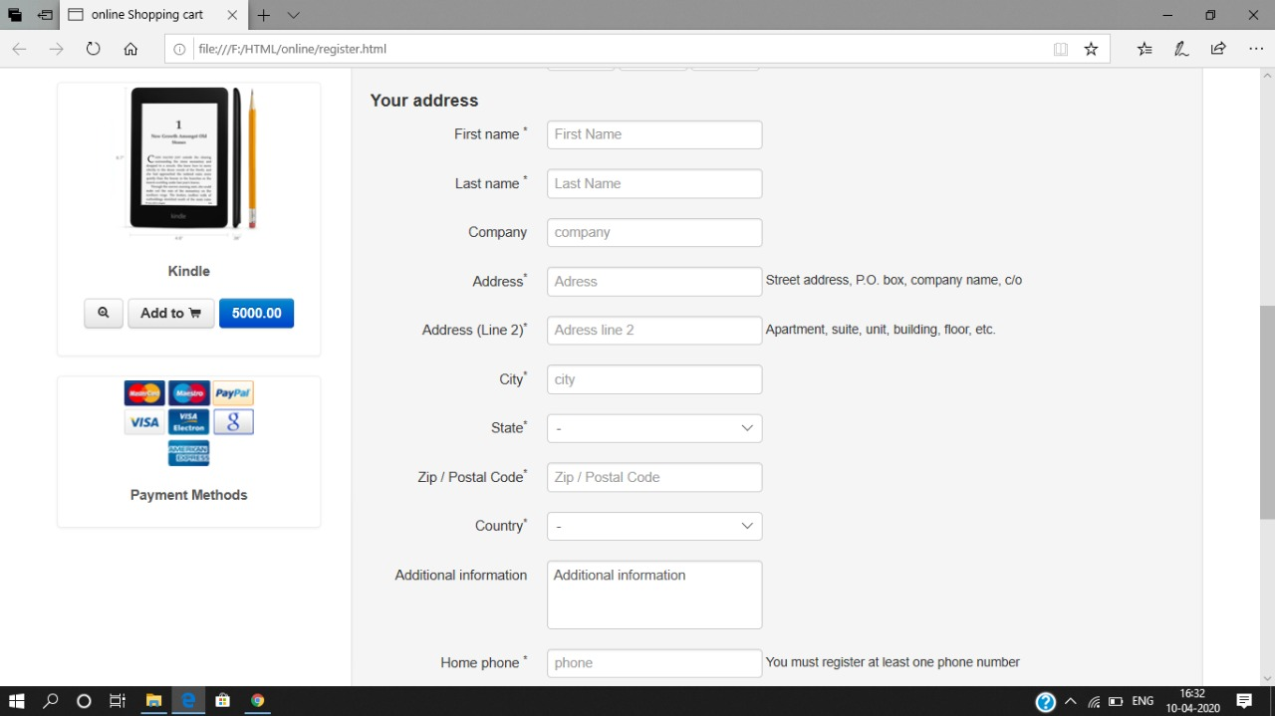

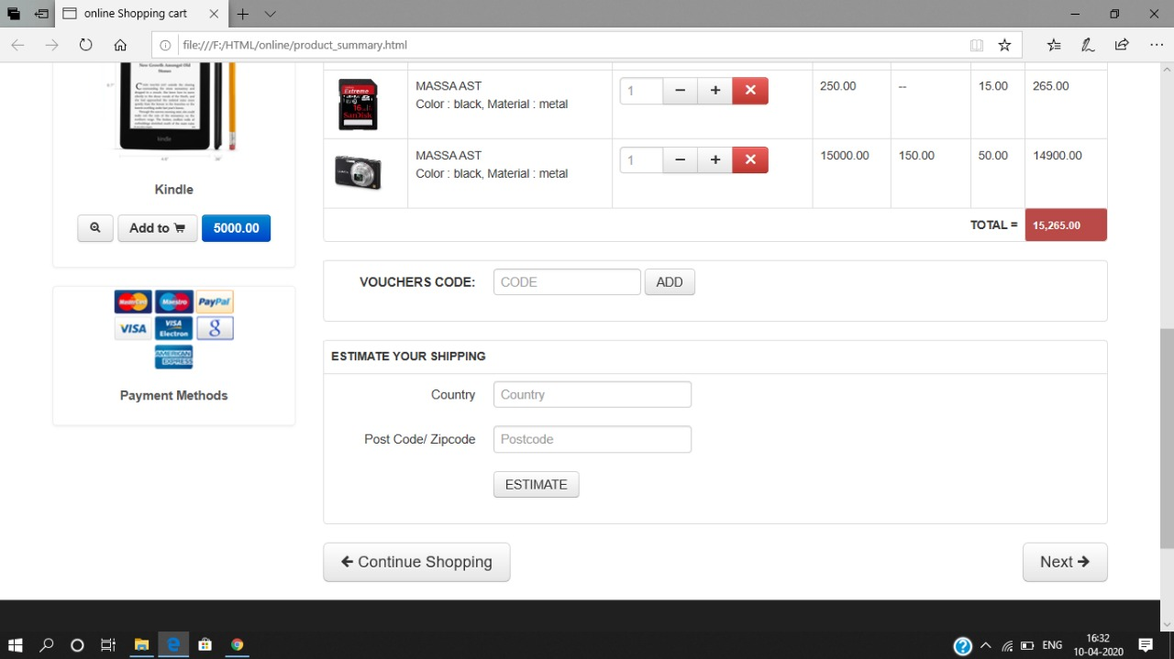

1. Code For The Website

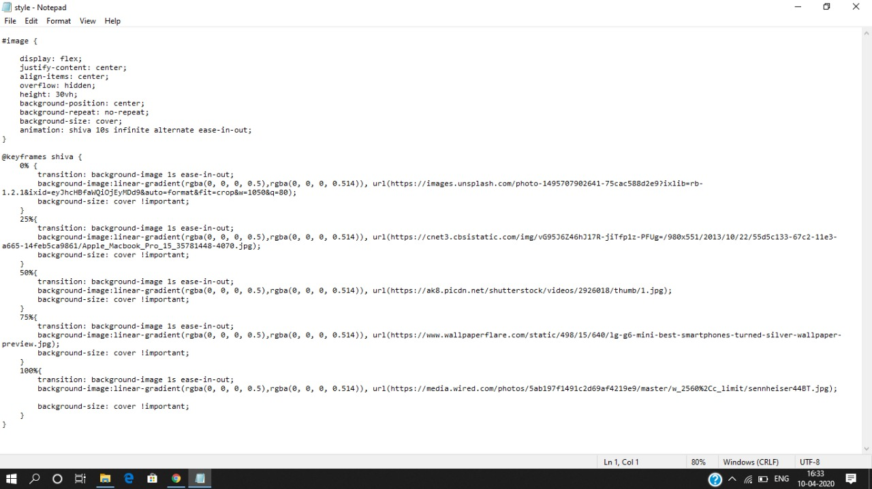

# TECHNOLOGY USED

1. HTML
2. CSS
3. JAVASCRIPT
4. BOOTSTRAP 3