- The ‘SedTypes’ freeware is designed and developed in Visual Basic to plot sediment classification ternary diagrams, to retrieve sediemnt type details and to extract the conditional strings pertaining to different ternary classifications.
Step:1
Open ‘Sed Tpes’ freeware.
Copy data from excel in the following format.

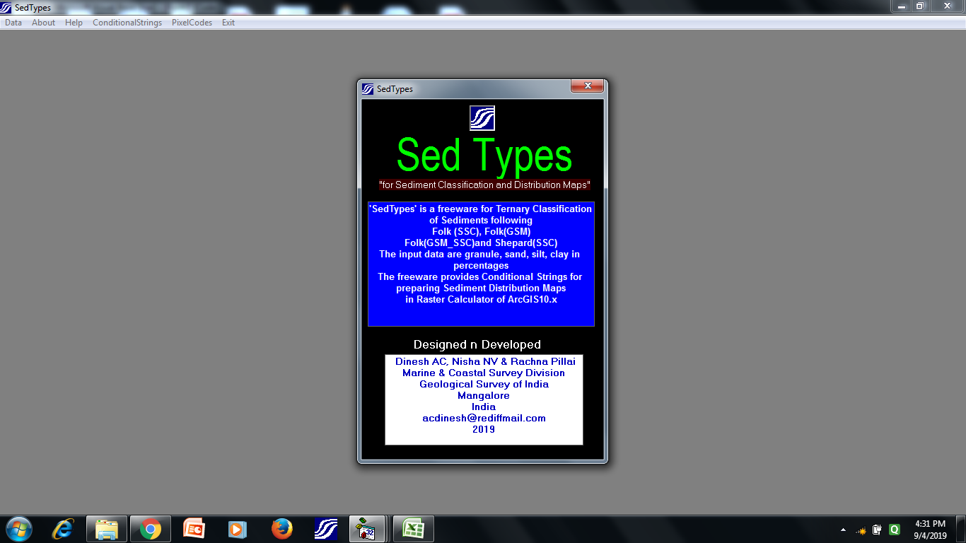
Fig.1: Opening window of ‘SedTypes’ Freeware

- The data format for the freeware is shown below. The data pertaining to granule, sand, silt and clay are to be pasted in the freeware with header.
Input Data Format of ‘Sed Types’
SampleNo. | Granule(%) | Sand(%) | Silt(%) | Clay(%)
VC-01 | 0.316073 | 99.366 | 0.317528 | 0
VC-02 | 1.474041 | 98.319 | 0.207184 | 0.000005
VC-03 | 0.457382 | 99.495 | 0.048546 | 0.000002
VC-04 | 8.931256 | 90.932 | 0.136231 | 0.000003
VC-05 | 0.885645 | 98.775 | 0.338745 | 0
VC-06 | 0.293715 | 99.654 | 0.051414 | 0.000001
VC-07 | 0.168666 | 99.717 | 0.115227 | 0
VC-08 | 0.084789 | 96.69 | 3.217628 | 0
VC-09 | 0.27365 | 99.027 | 0.70076 | 0
VC-10 | 1.227002 | 98.647 | 0.125542 | 0.000006


Step:2
Go to ‘Data’ menu and click ‘Paste Data’ and then
Click ‘Plot Data’

Fig.2: Submenu for Pasting and Plotting Data
- In the opening window of ‘SedTypes’, there is a ‘Data’ menu with three sub menus: ‘Data Format’, ‘Paste Data’ and ‘Plot Data’.
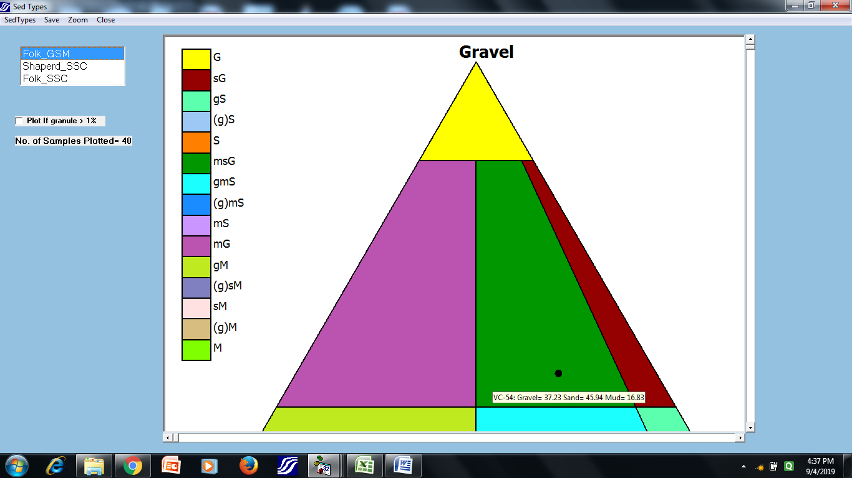
Step:3
Window for Ternary Classification Scheme pops up.
Select the classification scheme
Save the ternary plot as image

Fig.3: ‘SedTypes’ window for Plotting Sample Data in different Ternary Diagrams

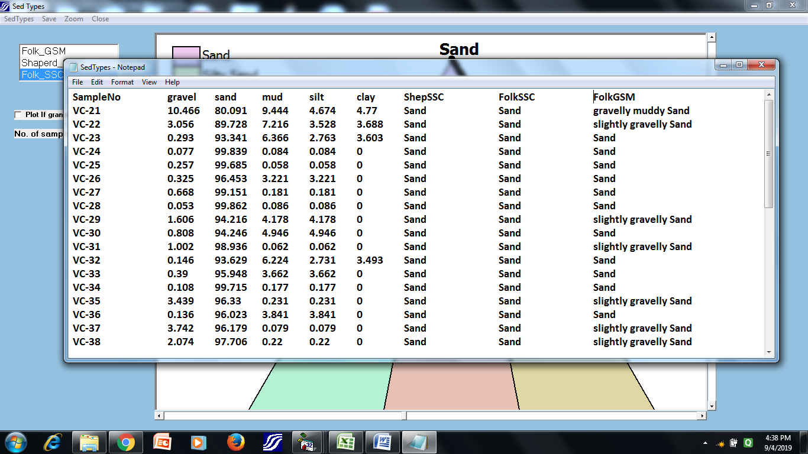
Step:4
Click ‘Sed types’. Opens the notepad with sediment type details

Fig.4: Sediment details are retrieved by clicking on ‘SedTypes’ menu
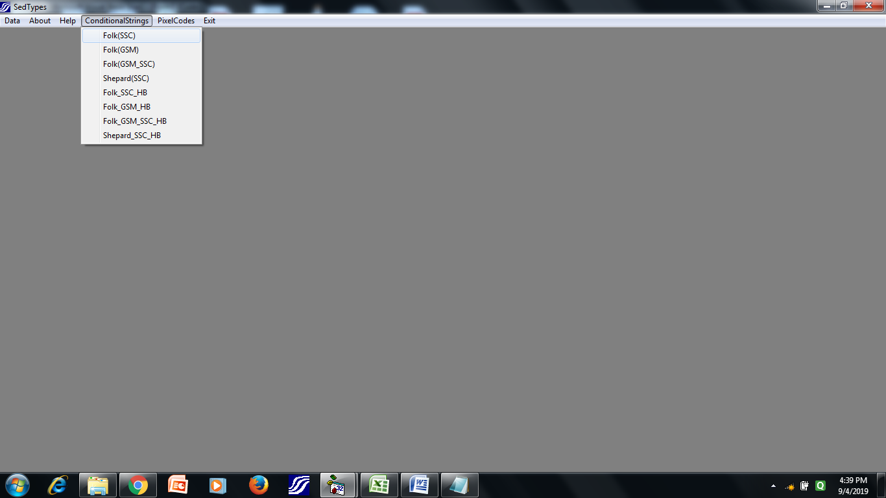
Step:5
Go to Main Window. Click ‘Conditional Strings’ Tab.
Select the conditional from the drop down list as per user choice.

Fig.5: Conditional strings pertaining to different sediment classifications

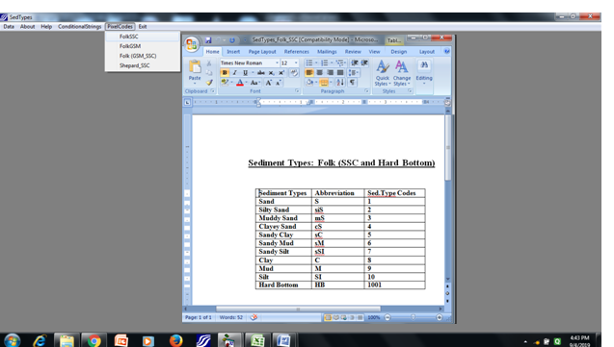
Step:6
Go to Main Window. Click ‘Pixel Codes’ menu,
Select the pixel codes from the drop down list as per user choice.

Fig.6: Conditional String of Folk SSC classification
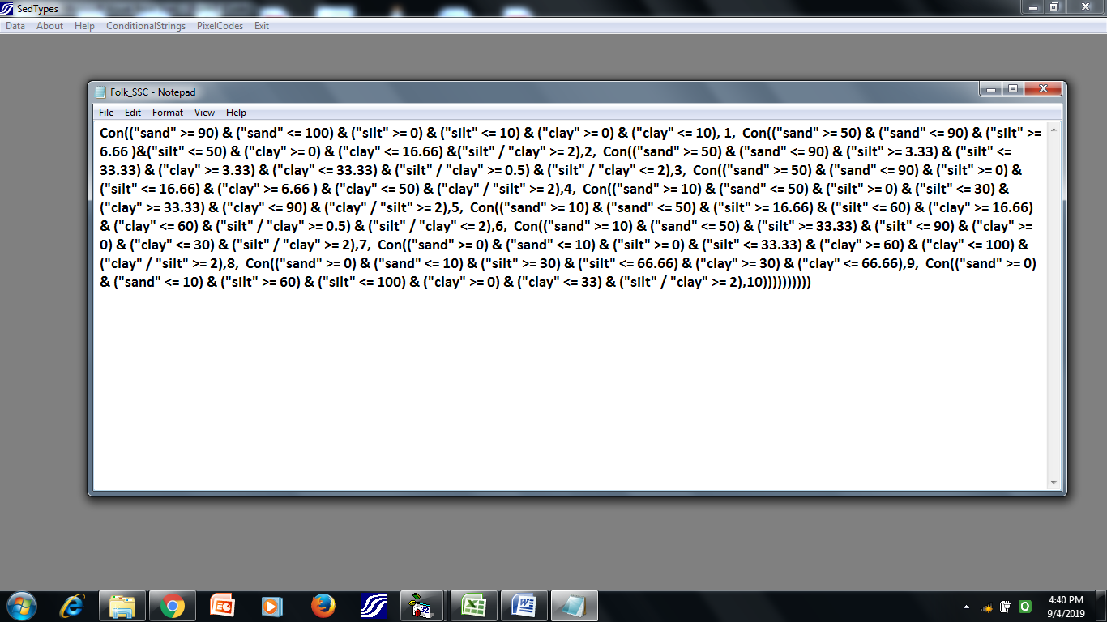
Fig.7: Retrieving Pixel codes (sediment type codes) pertaining to different sediment classification
____________________

