Report

This Application is for Movie Rental System. Customers can take movies on rent. I have made this application for Window Desktop.

Code:-

using System;

using System.Collections.Generic;

using System.ComponentModel;

using System.Data;

using System.Drawing;

using System.Linq;

using System.Text;

using System.Threading.Tasks;

using System.Windows.Forms;

using System.Data.SqlClient;

namespace MoviesRentalSystems

{

public partial class Form1 : Form

{

public SqlConnection conn = null;

public bool con;

public Form1()

{

InitializeComponent();

string connect = "Server=localhost\\SQLEXPRESS;Database=master;Trusted_Connection=True;";

try {

con = false;

conn = new SqlConnection(connect);

conn.Open();

con = true;

SqlCommand cmd;

String sqlMov = "Select MovieID,Title,Genre,Rental_Cost,Year From Movies";

String sqlRen = "Select RMID, C.FirstName as FirstName, C.LastName as LastName, C.Address as Address,M.Title as Title, M.Rental_Cost as Rental_Cost, R.DateRented, R.DateReturned From RentedMovies R join Customer C on R.CustIDFK=C.CustID join Movies M on R.MovieIDFK=M.MovieID";

String sqlCus = "Select CustID,FirstName,LastName, Address, Phone From Customer";

cmd = new SqlCommand(sqlMov,conn);

SqlDataAdapter adpMov = new SqlDataAdapter(cmd);

DataTable dtGrd = new DataTable();

adpMov.Fill(dtGrd);

moviesGrid.DataSource = dtGrd;

cmd = new SqlCommand(sqlRen, conn);

SqlDataAdapter adpRen = new SqlDataAdapter(cmd);

DataTable dtGrd1 = new DataTable();

adpRen.Fill(dtGrd1);

RentalGrid.DataSource = dtGrd1;

cmd = new SqlCommand(sqlCus, conn);

SqlDataAdapter adpCus = new SqlDataAdapter(cmd);

DataTable dtGrd2 = new DataTable();

adpCus.Fill(dtGrd2);

CustGrid.DataSource = dtGrd2;

// dataReader = cmd.ExecuteReader();

}

catch(Exception e)

{

conn = null;

MessageBox.Show("Error");

}

}

private void Form1_Load(object sender, EventArgs e)

{

}

private void AddressCust_TextChanged(object sender, EventArgs e)

{

}

private void Cust_ID_TextChanged(object sender, EventArgs e)

{

}

String frstName = "", lstName = "",Title="";

String issDate = "", RetnDate = "";

DateTime iDate,rDate;

private void RentalGrid_CellContentClick(object sender, DataGridViewCellEventArgs e)

{

String mobl = "";

frstName = (string)RentalGrid[1, e.RowIndex].Value;

lstName = (string)RentalGrid[2, e.RowIndex].Value;

Title = (string)RentalGrid[4, e.RowIndex].Value;

String phne = "Select Phone From Customer Where FirstName='"+frstName+"' and LastName='"+lstName+"'";

SqlCommand cmd = new SqlCommand(phne, conn);

SqlDataReader dataReader= cmd.ExecuteReader();

if(dataReader.Read())

{

mobl = dataReader.GetString(0);

}

dataReader.Close();

Cust_ID.Text = RentalGrid[0, e.RowIndex].Value.ToString();

FirstNameCust.Text = frstName;

LastName_Cust.Text = lstName;

AddressCust.Text = (string)RentalGrid[3, e.RowIndex].Value;

PhoneCust.Text = mobl;

issDate = RentalGrid[6, e.RowIndex].Value.ToString();

iDate = Convert.ToDateTime(issDate);

RetnDate = RentalGrid[7, e.RowIndex].Value.ToString();

rDate = Convert.ToDateTime(RetnDate);

IssueMovieDate.Text = issDate;

ReturnedDate.Text = RetnDate;

}

private void radioButton_Allrented_CheckedChanged(object sender, EventArgs e)

{

tabControl1_movisRenatl.SelectedTab = RenatlTAb;

String sqlRen = "Select RMID, C.FirstName as FirstName, C.LastName as LastName, C.Address as Address,M.Title as Title, M.Rental_Cost as Rental_Cost, R.DateRented, R.DateReturned From RentedMovies R join Customer C on R.CustIDFK=C.CustID join Movies M on R.MovieIDFK=M.MovieID";

SqlCommand cmd = new SqlCommand(sqlRen, conn);

SqlDataAdapter adpRen = new SqlDataAdapter(cmd);

DataTable dtGrd1 = new DataTable();

adpRen.Fill(dtGrd1);

RentalGrid.DataSource = dtGrd1;

}

String CstId = "";

private void CustGrid_CellContentClick(object sender, DataGridViewCellEventArgs e)

{

CstId = CustGrid[0, e.RowIndex].Value.ToString();

Cust_ID.Text = CstId;

FirstNameCust.Text= (string)CustGrid[1, e.RowIndex].Value;

LastName_Cust.Text = (string)CustGrid[2, e.RowIndex].Value;

AddressCust.Text = (string)CustGrid[3, e.RowIndex].Value;

PhoneCust.Text = (string)CustGrid[4, e.RowIndex].Value;

}

private void button2_Click(object sender, EventArgs e)

{

String delQuery = "Delete From Customer where CustID ="+CstId+"";

SqlCommand cmd = new SqlCommand(delQuery, conn);

SqlDataReader dataReader = cmd.ExecuteReader();

MessageBox.Show("Customer deleted sucessfully");

dataReader.Close();

}

private void button1_Click(object sender, EventArgs e)

{

tabControl1_movisRenatl.SelectedTab = customersTab;

String sqlCus = "Select * From Customer";

SqlCommand cmd = new SqlCommand(sqlCus, conn);

SqlDataAdapter adpRen = new SqlDataAdapter(cmd);

DataTable dtGrd1 = new DataTable();

adpRen.Fill(dtGrd1);

CustGrid.DataSource = dtGrd1;

}

private void button_Deletemovie_Click(object sender, EventArgs e)

{

String delQuery = "Delete From Movies where MovieID =" + MovId + "";

SqlCommand cmd = new SqlCommand(delQuery, conn);

SqlDataReader dataReader = cmd.ExecuteReader();

MessageBox.Show("Movie Deleted sucessfully");

dataReader.Close();

}

private void button_updatemovie_Click(object sender, EventArgs e)

{

tabControl1_movisRenatl.SelectedTab = MoviesTab;

String sqlCus = "Select * From Movies";

SqlCommand cmd = new SqlCommand(sqlCus, conn);

SqlDataAdapter adpRen = new SqlDataAdapter(cmd);

DataTable dtGrd1 = new DataTable();

adpRen.Fill(dtGrd1);

moviesGrid.DataSource = dtGrd1;

}

private void button_AddCustomer_Click(object sender, EventArgs e)

{

String fstName = FirstNameCust.Text;

String lstName = LastName_Cust.Text;

String Addrss = AddressCust.Text;

String phne = PhoneCust.Text;

String insQry = "Insert into Customer ([FirstName], [LastName], [Address], [Phone]) Values('" + fstName+"','"+lstName+"','"+Addrss+"','"+phne+"')";

SqlCommand cmd = new SqlCommand(insQry, conn);

SqlDataReader dataReader = cmd.ExecuteReader();

MessageBox.Show("Customer Added sucessfully");

dataReader.Close();

}

private void button_Addmovie_Click(object sender, EventArgs e)

{

String Titlemov = TitleMovie.Text;

String genre = GenreMovie.Text;

String Rentalmov = RentalCostMovie.Text;

String RelDate = ReleaseDate.Text;

String insQry = "Insert into Movies ( [Title], [Genre], [Rental_Cost], [Year]) Values('" + Titlemov + "','" + genre + "','" + Rentalmov + "','" + RelDate + "')";

SqlCommand cmd = new SqlCommand(insQry, conn);

SqlDataReader dataReader = cmd.ExecuteReader();

MessageBox.Show("Movie Added sucessfully");

dataReader.Close();

}

private void button3_Click(object sender, EventArgs e)

{

String insQuery = "Insert into RentedMovies ( [MovieIDFK], [CustIDFK], [DateRented], [DateReturned]) Values("+MovId+","+CstId+",'"+ iDate + "','"+rDate+"')";

SqlCommand cmd = new SqlCommand(insQuery, conn);

SqlDataReader dataReader = cmd.ExecuteReader();

dataReader.Close();

String sqlRen = "Select RMID, C.FirstName as FirstName, C.LastName as LastName, C.Address as Address,M.Title as Title, M.Rental_Cost as Rental_Cost, R.DateRented, R.DateReturned From RentedMovies R join Customer C on R.CustIDFK=C.CustID join Movies M on R.MovieIDFK=M.MovieID";

MessageBox.Show("Movie issued sucessfully");

cmd = new SqlCommand(sqlRen, conn);

SqlDataAdapter adpRen = new SqlDataAdapter(cmd);

DataTable dtGrd1 = new DataTable();

adpRen.Fill(dtGrd1);

RentalGrid.DataSource = dtGrd1;

}

String MovId = "";

private void moviesGrid_CellContentClick(object sender, DataGridViewCellEventArgs e)

{

MovId= moviesGrid[0, e.RowIndex].Value.ToString();

MovieID.Text = MovId;

TitleMovie.Text = (string)moviesGrid[1, e.RowIndex].Value;

GenreMovie.Text = moviesGrid[2, e.RowIndex].Value.ToString();

RentalCostMovie.Text = moviesGrid[3, e.RowIndex].Value.ToString();

ReleaseDate.Text = moviesGrid[4, e.RowIndex].Value.ToString();

}

private void button4_Click(object sender, EventArgs e)

{

String delQuery = "Delete From RentedMovies where CustIDFK =(Select CustID from Customer where FirstName ='"+frstName+"') and MovieIDFK =(Select MovieID from Movies where Title = '"+Title+"')";

SqlCommand cmd = new SqlCommand(delQuery, conn);

SqlDataReader dataReader = cmd.ExecuteReader();

MessageBox.Show("Customer Rented Information deleted sucessfully");

String sqlRen = "Select RMID, C.FirstName as FirstName, C.LastName as LastName, C.Address as Address,M.Title as Title, M.Rental_Cost as Rental_Cost, R.DateRented, R.DateReturned From RentedMovies R join Customer C on R.CustIDFK=C.CustID join Movies M on R.MovieIDFK=M.MovieID";

dataReader.Close();

cmd = new SqlCommand(sqlRen, conn);

SqlDataAdapter adpRen = new SqlDataAdapter(cmd);

DataTable dtGrd1 = new DataTable();

adpRen.Fill(dtGrd1);

RentalGrid.DataSource = dtGrd1;

}

}

}

Output :

1. When We Start to Run Application. Below screen will come.

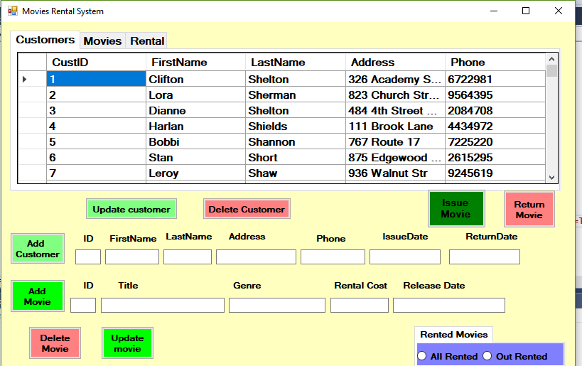

2. Adding Customer in database.

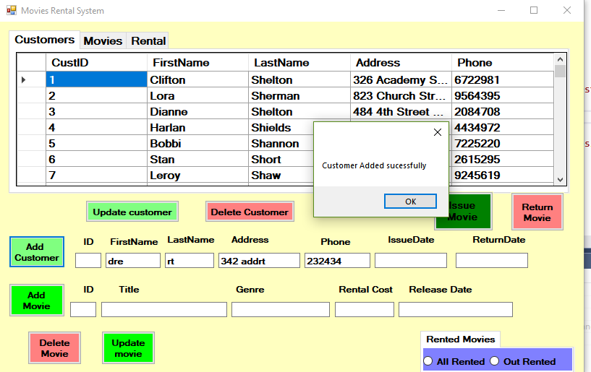

3. Updated the customer Database.

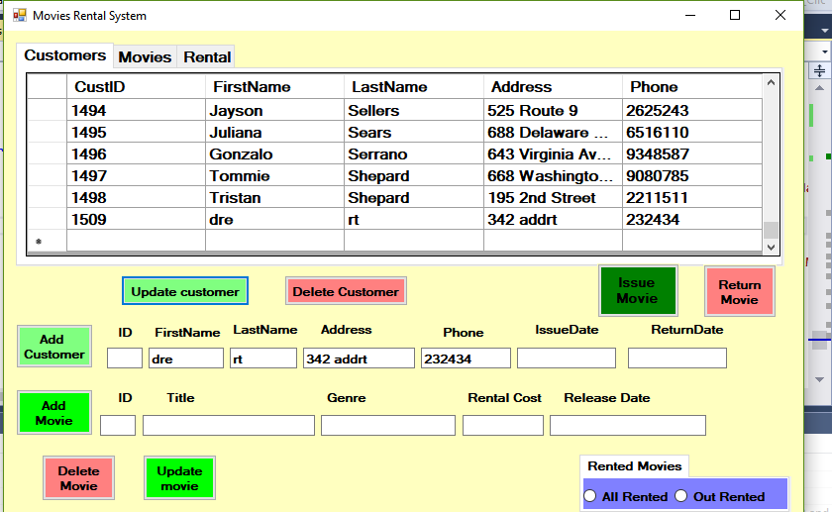

4. Delete the Customer information from Database.

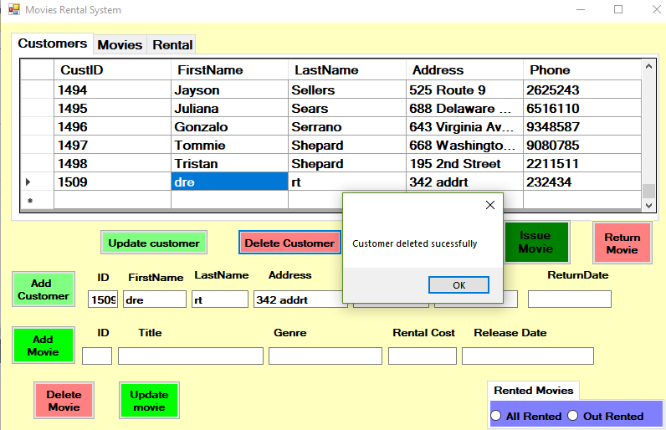

5. Issue the movies on rent to customer. 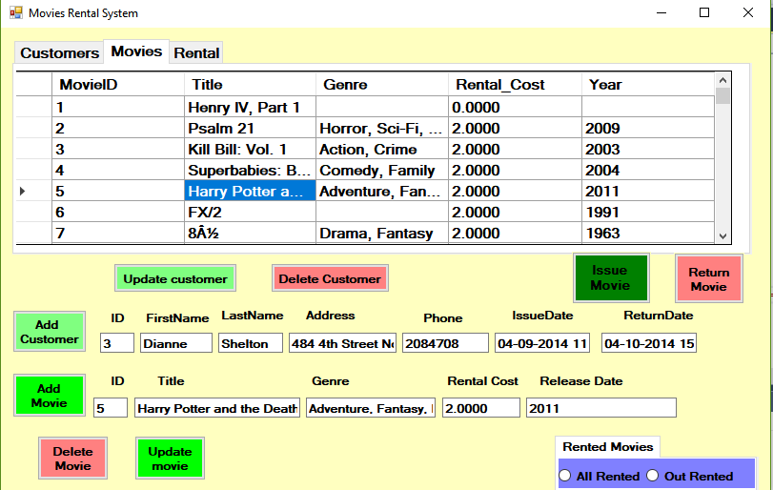

6. Movie issued and database added information.

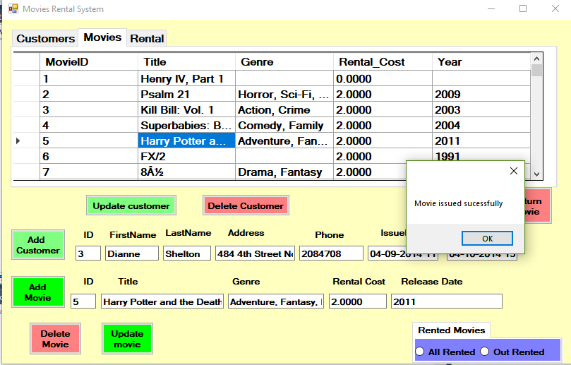

7. Movie Rented information deleted.

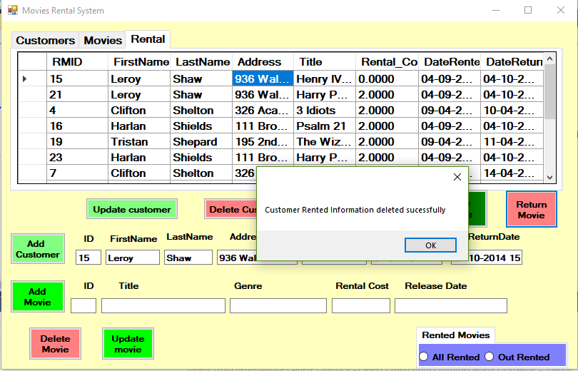

8. Add movies to Database.

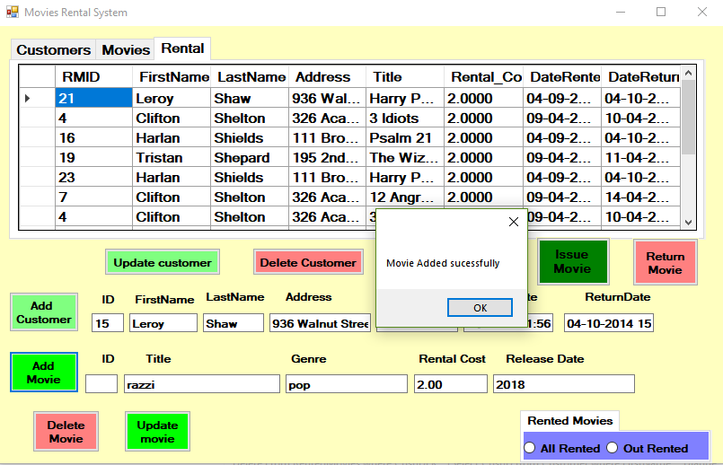

9. Update movie from Database.

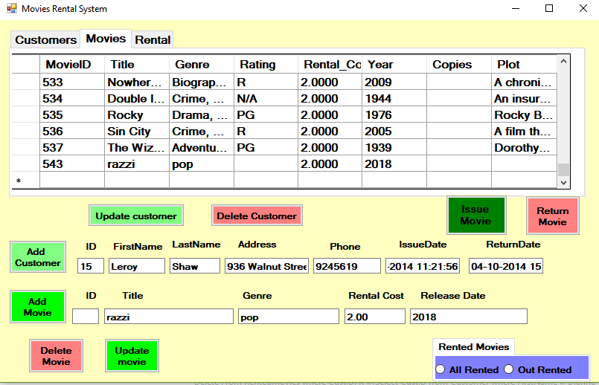

10. Delete movie from Database.

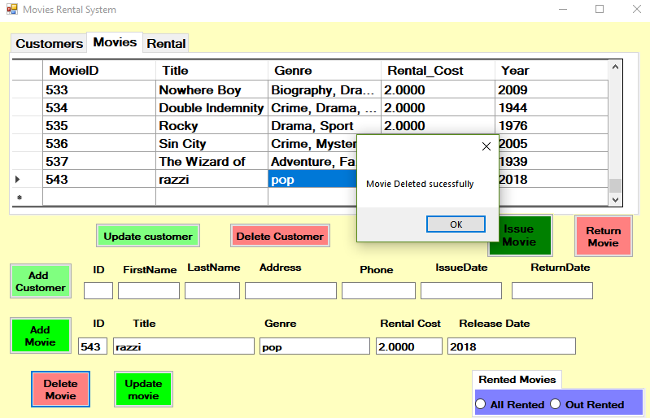

11. Update Movies database after deleting movie.

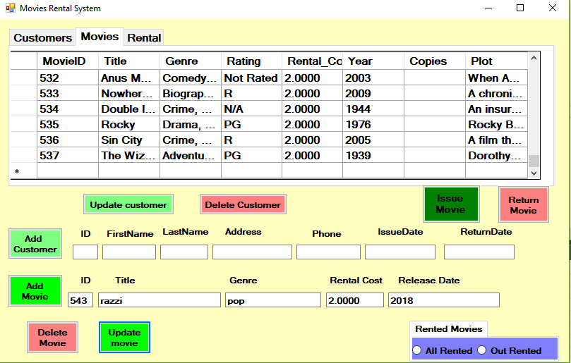

12. Unit Testing.

a). To test the connection of Database

code :-

using Microsoft.VisualStudio.TestTools.UnitTesting;

using MoviesRentalSystems;

namespace moviRentalSystemTest

{

[TestClass]

public class UnitTest1

{

[TestMethod]

public void TestMethod1()

{

Form1 obj = new Form1();

if(obj.conn ==null)

{

obj.con = false;

}

else

{

obj.con = true;

}

Assert.IsTrue(obj.con);

}

}

}

Test result :-

When test completed successfully

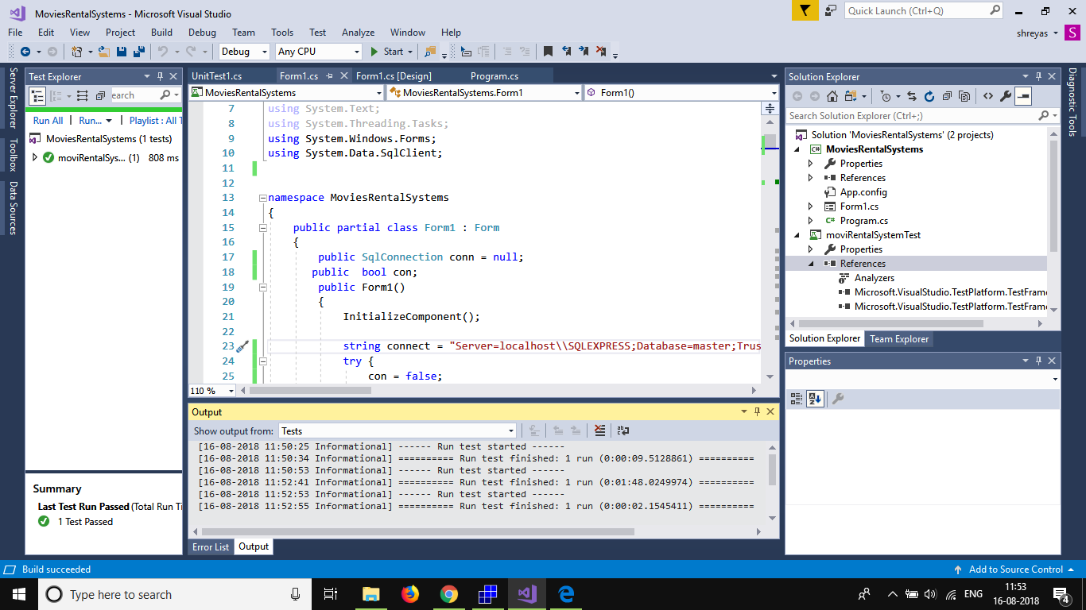

If there is error in connection.

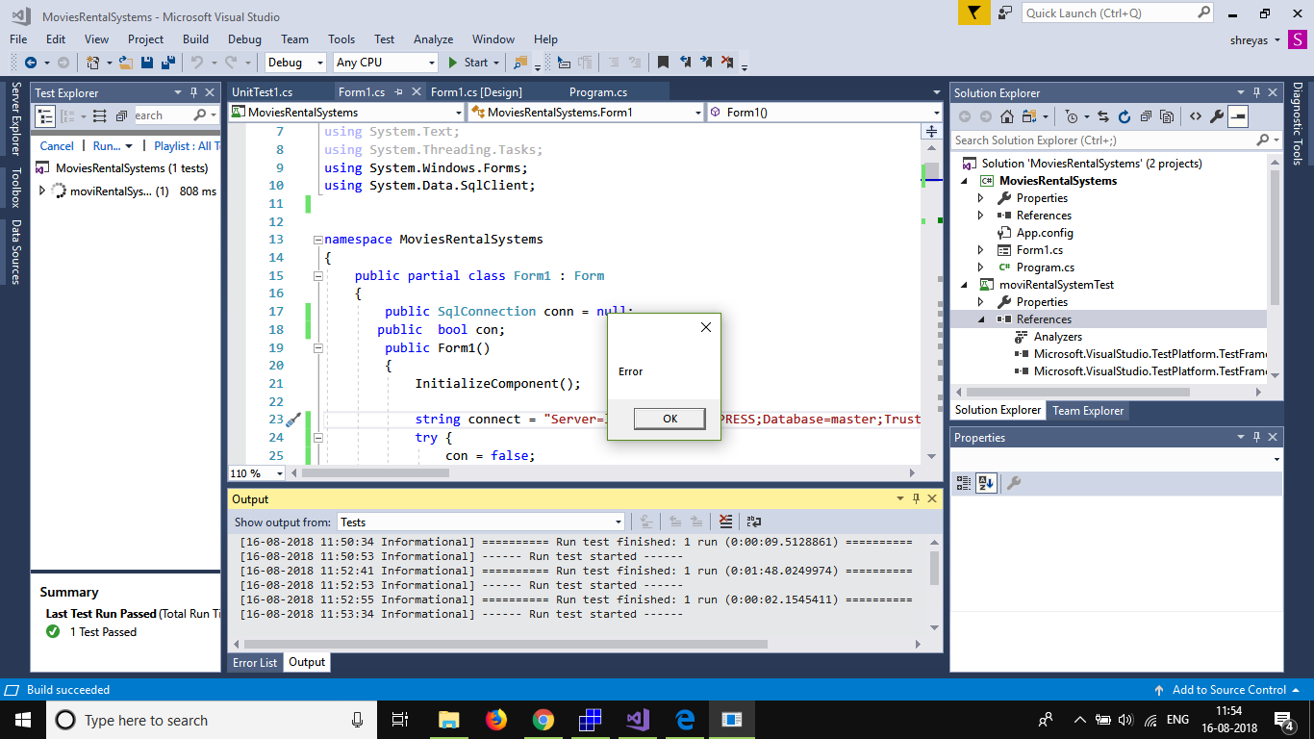

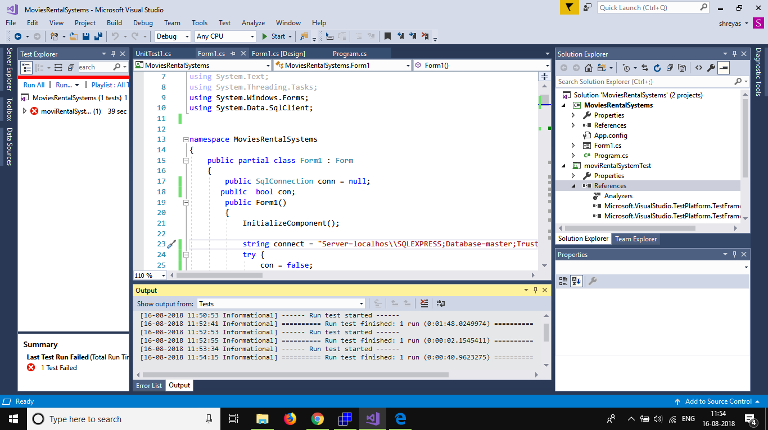

b). Test for Show Data

code: -

[TestMethod]

public void ShowData_Test()

{

bool rtrnMov = obj.showData;

Assert.IsTrue(rtrnMov);

}

Test Result:-

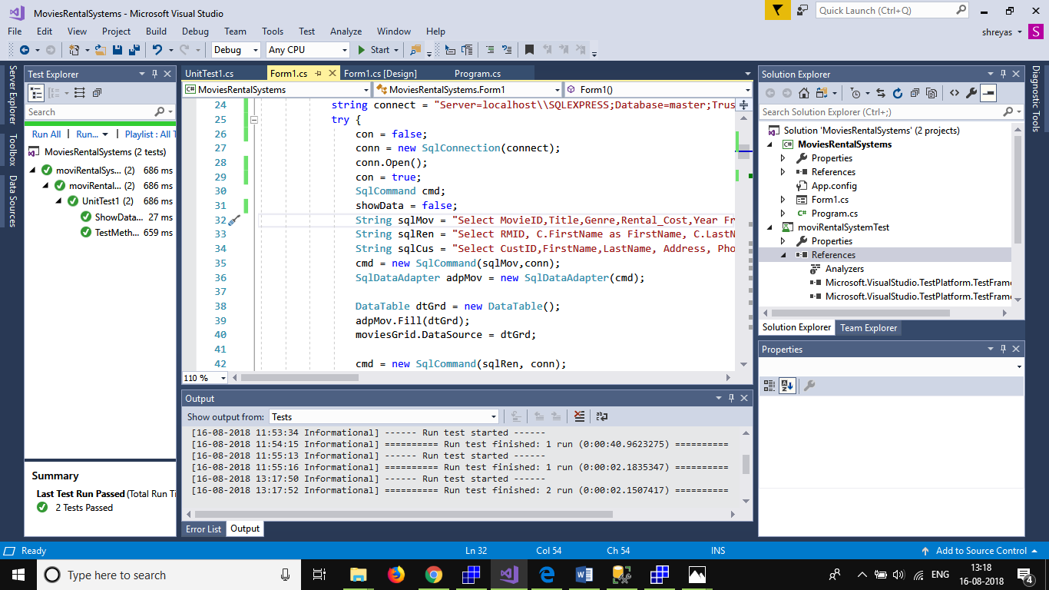

Relational Model Design: -

