**PRATICAL: 1**

**Operators and Expressions**

**1.1 Write a java program to find the area of rectangle.**

import java.util.*;

class Ractangle

{

public static void main(String args[])

{

int l,b;

Scanner sc=new Scanner(System.in);

System.out.println("Enter lenght and Wigth of Ractangle");

l=sc.nextInt();

b=sc.nextInt();

System.out.println("Area of Ractangle is "+(l*b));

}

}

**Output:**

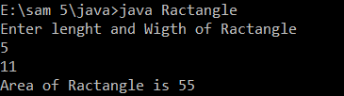

**1.2 Write a java program to convert rupees to dollar. 60 rupees=1 dollar**

import java.util.*;

class RupeesToDollar

{

public static void main(String args[])

{

float Rs,D;

Scanner sc=new Scanner(System.in);

System.out.println("Enter Ruppes");

Rs=sc.nextFloat();

D=Rs/60;

System.out.println(Rs+" Ruppes is equal to "+D+" Dollar");

}

}

**Output:**

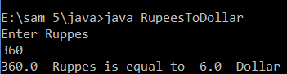

**1.3 Write a java program that calculates percentage marks of the student if marks of 6 subjects are given.**

import java.util.*;

class Student

{

int regno;

String NAME;

int mark[]=new int[6];

int totle;

int per;

void getMark()

{

System.out.println("Enter student Regno And Name");

Scanner sc= new Scanner(System.in);

regno=sc.nextInt();

NAME=sc.nextLine();

System.out.println("Enter the 5 Subject Mark");

mark[0]=sc.nextInt();

mark[1]=sc.nextInt();

mark[2]=sc.nextInt();

mark[3]=sc.nextInt();

mark[4]=sc.nextInt();

mark[5]=sc.nextInt();

}

void display()

{

System.out.println("Regno = \t"+regno+"\nName =\t"+NAME);

for(int i=0;i<5;i++)

System.out.println("Subject[i] \t"+mark[i]);

System.out.println("----------------------");

System.out.println("Totle \t\t"+totle);

System.out.println("Percentage \t"+per+"%");

}

void result()

{

totle=mark[0]+mark[1]+mark[2]+mark[3]+mark[4]+mark[5];

per=totle/5;

}

};

class result

{

public static void main(String[] args)

{

Student s1=new Student();

/*Student s2=new Student();

Student s3=new Student();

Student s4=new Student();

Student s5=new Student();*/

s1.getMark();

s1.result();

/*

s2.getMark();

s2.result();

s3.getMark();

s3.result();

s4.getMark();

s4.result();

s5.getMark();

s5.result();

s1.display();

s2.display();

s3.display();

s4.display();

s5.display();*/

}

}

**Output:**

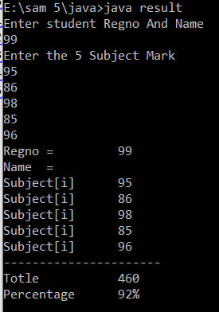

**PRATICAL: 2**

**Looping Statements**

**2.1Generate following patterns:**

1. **(B) (C)** 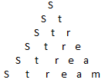 

import java.util.*;

class Pattern1

{

public static void main(String[] args)

{

char s[]={'s','t','r','a','m','e'};

for(int i=0;i<s.length;i++)

{

for(int j=i;j<s.length;j++)

System.out.print(" ");

for(int j=0;j<=i;j++)

System.out.print(s[j]+" ");

System.out.println();

}

}

}

import java.util.*;

class Pattern2

{

public static void main(String[] args)

{

int n;

Scanner sc= new Scanner(System.in);

System.out.println("Enter n");

n=sc.nextInt();

for(int i=0;i<n;i++)

{

for(int j=i;j<i;j++)

System.out.print(" ");

for(int j=i;j<n;j++)

System.out.print("* ");

System.out.println();

}

}

}

import java.util.*;

class Pattern3

{

public static void main(String[] args)

{

int n,k=0;

Scanner sc= new Scanner(System.in);

System.out.println("Enter n");

n=sc.nextInt();

for(int i=0;i<n;i++)

{

for(int j=k;j<n;j++)

System.out.print(" ");

for(int j=0;j<k;j++)

System.out.print("* ");

if(i>=n/2)

k--;

else

k++;

System.out.println();

}

}

}

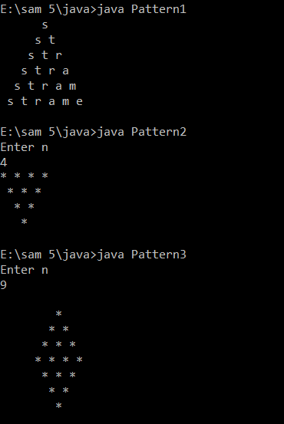

**2.2 Write a program to make a Calculator using switch case.**

**2.3 Write a program to find that given number is palindrome or not.**

import java.util.*;

class pelin1

{

public static void main(String[] args)

{

int i,j,flag,n,l;

Scanner s=new Scanner(System.in);

System.out.print("Enter digit numbe\n");

n=s.nextInt();

l=1;

int digit[]=new int[l];

i=0;

do

{

digit = Arrays.copyOf(digit, digit.length+1);

digit[i]=n%10;

n=n/10;

i++;

l++;

}while(n!=0);

flag=0;

for(i=0;i<l;i++)

{

if(digit[i]==digit[l-2-i])

flag++;

System.out.println("i"+digit[i]+"j"+digit[l-2-i]);

}

if(flag==l)

System.out.println("IS pelindrom");

}

}

**Output:**

