1.Screenshot from GitHub showing that I have created a repository

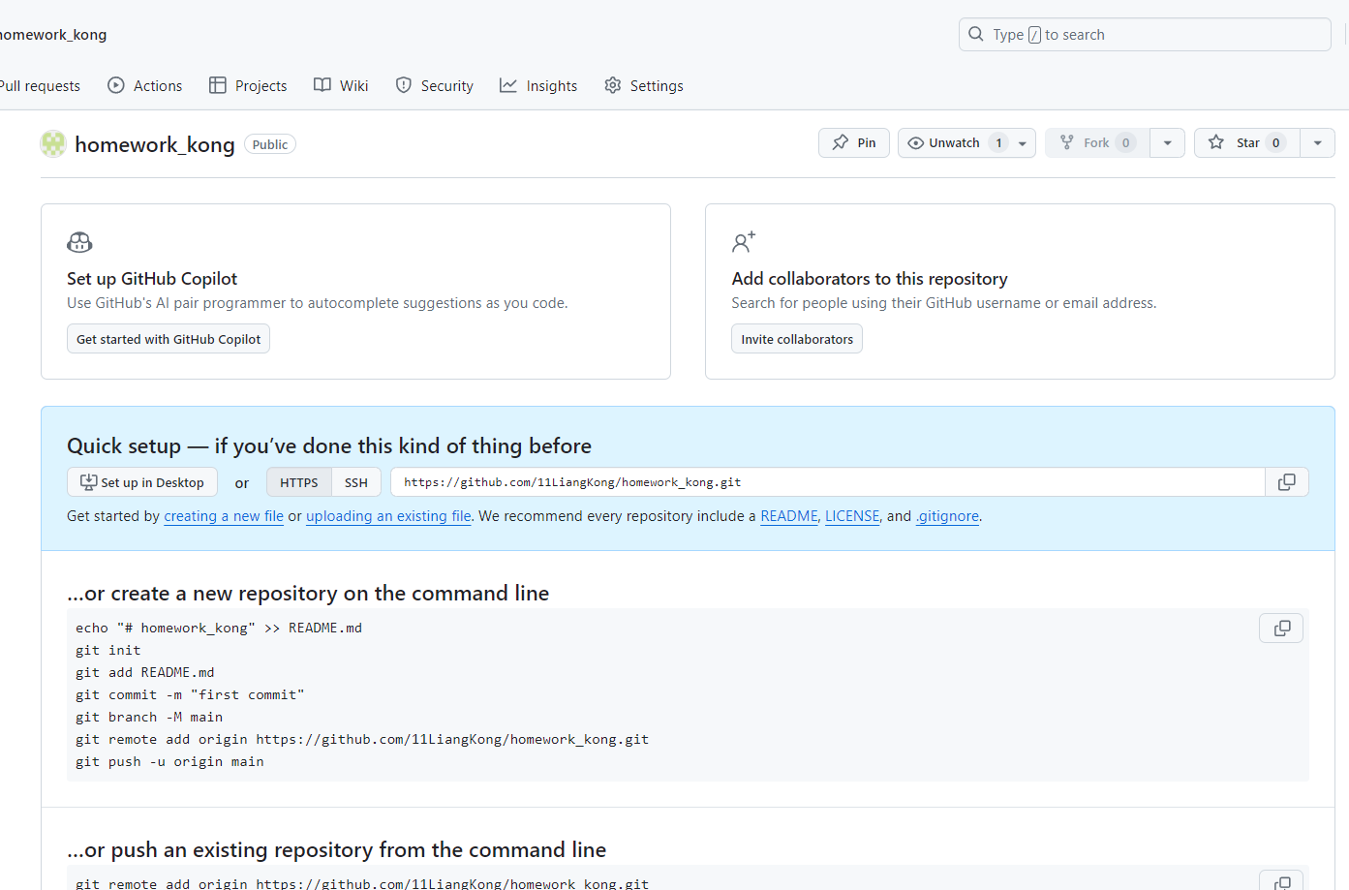

1. Post the URL of your GitHub page

URL: https://github.com/11LiangKong/homework_kong

1. A screenshot of your GitHub that shows the Solution to the assignment is in the GitHub

