International Islamic University Chittagong
Department of Computer Science and Engineering
B. Sc. in CSE Final Examination, Autumn 2022
Course Code: CSE-2425 Theory of Computing
Total marks: 50 Time: 2 hours 30 minutes
[Figures in the right-hand margin indicate full marks
Course Outcomes and Bloom’s taxonomy levels are mentioned in additional columns]

Bloom’s Taxonomy Levels (Cognitive Domain)
Letter Symbols | R | U | A | N | E | C
Meaning | Remember | Understand | Apply | Analyze | Evaluate | Create

 | Group-A
 |  |  | CO | DL
1.
a) | Describe the components of context-free grammar.  OR  Define parse tree and derivation. | 3 | CO1 | U
b) | What is ambiguity? Determine whether this grammar is ambiguous.  S → iEtS | iEtSeS | a  E → b | 3 | CO2 | N
c) | Consider the following grammar  S → aSb | bY | Ya  Y → bY | aY | ε  Show how to derive the string abbab using this grammar using a left-most derivation. Draw the parse tree for the string.  OR  Show how to derive the string abbab using this grammar using a right-most derivation. Draw the parse tree for the string. | 4 | CO2 | A
2.
a) | How do you use the pumping lemma to determine if a language is context-free?  OR  Can you describe a regular language using context-free grammar? Illustrate using an example. | 3 | CO1 | N
b) | Can you give a context-free grammar (CFG) for the following languages over the alphabet Σ ={a,b}:-  All strings in the language L: {a^{n}b^{2n}c^{4n} | n ≥ 0}  If you cannot, justify the reason. | 3 | CO2 | E
c) | Give a context-free grammar (CFG) for each of the following languages over the alphabet Σ ={a,b}:-  - All strings in the language L: {a^{n}b^{2n} | n ≥ 0}  - All nonempty strings that read the same from left or right. | 4 | CO2 | C
 | Group-B
3.
a) | What are ε-rule and unit rules? | 2 | CO2 | U
b) | Construct a pushdown automaton that recognizes the following language L: {a^{n}b^{2n} | n ≥ 0}  OR  Construct a pushdown automaton that recognizes all even nonempty palindromes. | 4 | CO3 | C
c) | Convert any one of the following context-free grammar (CFG) to an equivalent pushdown automaton  S → aSb | bY | Ya  Y → bY | aY | c | ε  OR  S → aXbX  X → aY | bY | ε  Y → X | c | 4 | CO1 | N
4.
a) | Consider the following Turing machine.  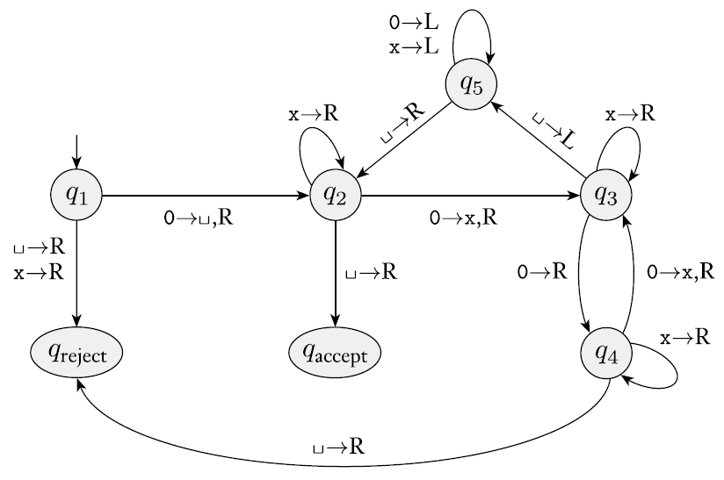  Give the sequence of configurations that the machine enters when started with the following strings.  - 0000  - 000000 | 4 | CO3 | A
b) | Give the implementation-level description of a Turing machine that decides the following languages (any two)  - L: {a^{n}b^{2n}c^{4n} | n ≥ 0}  - {w | w is a non-empty odd palindrome} | 6 | CO3 | C
5.
a) | Convert any one of the following CFG into an equivalent CFG in Chomsky normal form.  S → aSb | bY | Ya  Y → bY | aY | c | ε  OR  S → aXbX  X → aY | bY | ε  Y → X | c | 4 | CO2 | A
b) | Find out whether the following problem is decidable or not:  Is a number ‘m’ prime? | 3 | CO4 | E
c) | What are NP-complete and NP-Hard problems? How can you show that a problem is NP-complete? | 3 | CO5 | U

