
Department of Computer Science

University of Gujrat

Air Pollution Monitoring System

Submitted By:

Meerab Irfan | 20021519-009
Hassan Tahir | 20021519-083
Sheraz Ahmed | 20021519-100

Supervised By:
Dr. Abdur Rehman

DECLARATION

I certify that project title ____________________________________________ _________ is under my supervision with students of ______________________________________, Faculty of Computing & Information Technology, University of Gujrat, Pakistan, worked under my supervision.

__________________________________
Supervisor’s Name
Department of Computer Science
Faculty of Computing & Information Technology
University of Gujrat, Punjab, Pakistan.
Email: _____________@uog.edu.pk

Dated: ________________________________

FInal Year Project Proposal

Abstract
This proposal introduces "Air Pollution Monitoring System," a comprehensive project designed to monitor various environmental parameters such as temperature, humidity, dust, LPG, & Carbon Monoxide. The system combines cutting-edge sensor technology and data processing to provide real-time insights for environmental conditions.

Introduction
This proposal aims to develop and present a final year project outlining a comprehensive system for real-time monitoring of environmental parameters. It defines functional and non-functional requirements, scopes the project's timeline, and highlights the methods, tools, and platforms to be utilized.

Project Title:
Air Pollution Monitoring System

Project Overview statement:
The advancement of smart technologies is crucial in addressing environmental concerns. The proposed "Air Pollution Monitoring System" aims to offer real-time monitoring for parameters like temperature, humidity, dust, LPG, Natural Gas, Ammonia, Smoke & Carbon Monoxide. By integrating advanced sensors, and user-friendly interfaces, the project seeks to provide insights into conditions for various applications. This proposal contextualizes the project, introduces core modules, discusses potential advantages and drawbacks, and outlines pathways for future advancements.

Targeted Audience:
"Air Pollution Monitoring System" caters to a diverse audience including urban planners, environmental agencies, and individuals interested in maintaining optimal conditions for health, planning, and decision-making.

Project Goals & Objectives:
Goals:
- Develop a comprehensive environment monitoring and forecasting system.
- Provide accurate real-time data on environmental parameters.
Objectives:
- Integrate sensor hardware for seamless data collection.
- Process and preprocess sensor data to derive meaningful insights.
- Design an intuitive interface for data visualization and user interaction.

Application Architecture:
The system requires sensors for temperature, humidity, dust, LPG, Natural Gas, Ammonia, Smoke & Carbon Monoxide and an Arduino and a Wi-Fi module to read input data from sensors and push it online. The Flutter framework will be used for mobile application development. The system will operate on an Arduino platform.
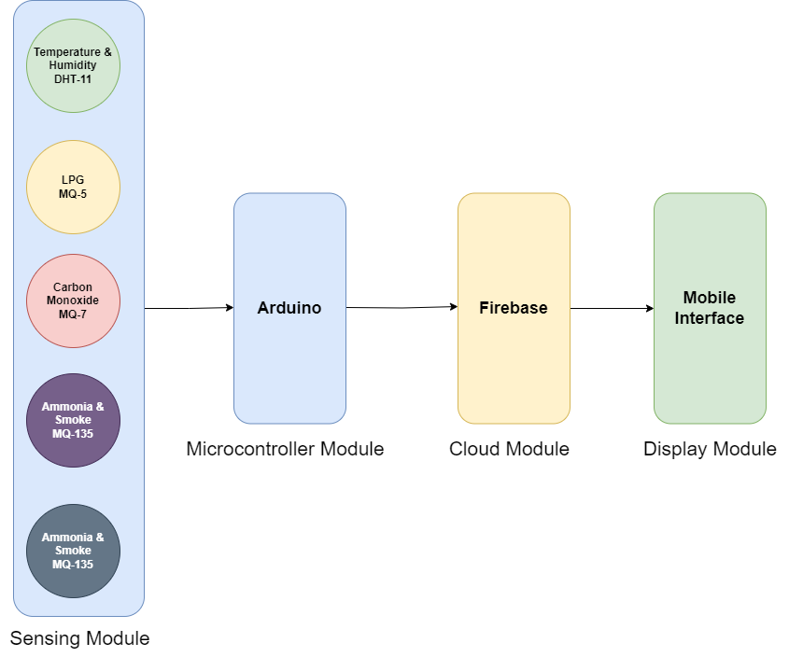
System Architecture

Hardware and Software Specification:
Hardware:
- MQ5
- MQ7
- MQ135
- DHT11
- GP2Y101AU0F
- Arduino Uno
- ESP8266 Wi-Fi Module
Software:
- Arduino IDE
- Flutter
- Firebase

Estimated Cost:
- IoT sensors: PKR 15,000
- Development hardware and software: PKR 5,000
- Total Estimated Cost: PKR 20,000

Tools and technologies used with reasoning:
- Arduino for data collection.
- Wi-Fi Module to push data online.
- Various sensors for temperature, humidity, dust, LPG, Natural Gas, Ammonia, Smoke & Carbon Monoxide.
- Flutter framework for mobile application development.
- Git for version control and collaboration.

Project milestones and deliverables
- Sensor Integration
- Sensor Calibration
- Sensor Data Integration
- Mobile App UI/UX Design
- Mobile App Development
- System testing, documentation, and final deliverables.
Gantt Chart:
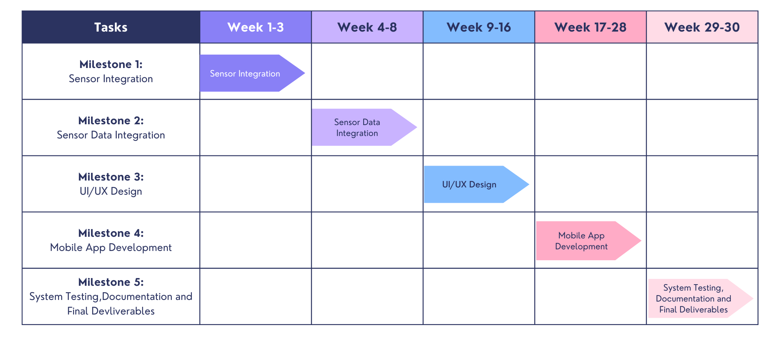

Work division among Group members
The division of responsibilities among the team members is outlined as follows:
- Sheraz Ahmed:
  - Role: Sensor Integration
  - Integrate sensors into the system.
  - Ensure proper hardware connectivity and calibration.
- Meerab Irfan:
  - Role: UI/UX Design and Project Coordination
  - Design the overall UI/UX of the mobile application.
  - Create visually appealing and intuitive user interfaces.
  - Work on user experience enhancements.
  - Coordinate overall project activities.
  - Ensure timely progress and task completion.
- Hassan Tahir:
  - Role: Mobile Application Development
  - Develop the mobile application interface.
  - Develop user-friendly controls for user interaction.
  - Integrate Sensor Data into the mobile application.
  - Ensure seamless communication between the app and data processing modules.
  - Optimize the mobile application for performance and responsiveness.
By distributing responsibilities based on strengths and skills, the team aims to ensure efficient progress and successful completion of the "Air Pollution Monitoring System" project. Collaboration among team members will be maintained for a seamless integration of all components.

