CC Lab

Akanksha N Shenoy

1905373

Ques:

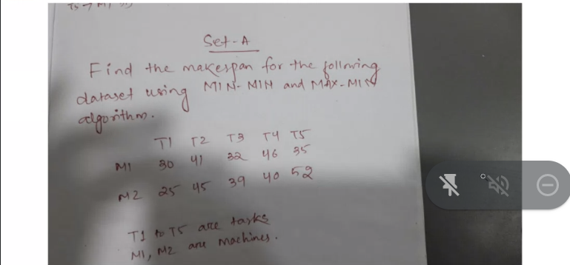

Solution:

Ans1)

Min-Min:

#include <stdio.h>

#include <string.h>

int main()

{

int n, m, r, c, min, a, b, t, val = 9999;

printf("Enter ETC MATRIX size: ");

scanf("%d %d", &n, &m);

int etc_max[m][n], brr[n];

t = n;

for (int i = 0; i < m; i++)

{

printf("Machine %d\n", i + 1);

for (int j = 0; j < n; j++)

{

printf("Task %d: ", j + 1);

scanf("%d", &etc_max[i][j]);

}

printf("\n");

}

while (t > 0)

{

min = val;

memset(brr, 9999, sizeof(brr));

for (c = 0; c < n; c++)

{

for (r = 0; r < m; r++)

{

if (brr[c] > etc_max[r][c])

brr[c] = etc_max[r][c];

}

if (brr[c] < min)

{

min = brr[c];

b = c;

}

}

for (int i = 0; i < m; i++)

{

if (etc_max[i][b] == min)

{

printf("Task %d(%d) will be assigned to Machine %d\n", b + 1, min, i + 1);

a = i;

}

}

t--;

for (int i = 0; i < m; i++)

{

for (int j = 0; j < n; j++)

{

if (i == a)

etc_max[i][j] += min;

if (j == b)

etc_max[i][j] = val;

}

}

}

printf("Make Span time - %d", min);

return (0);

}

O/p:

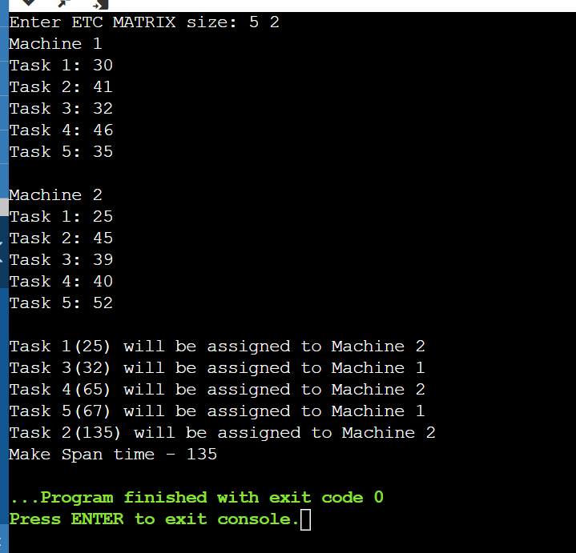

Ans 2)

Max - min :

#include <stdio.h>

#include <limits.h>

int main()

{

int nT, nM;

printf("\nEnter number of machines and tasks\n");

scanf("%d%d", &nM, &nT);

int maxMin[nM][nT];

int tmp[nM][nT];

int makespan = 0;

printf("\nFillData\n");

for (int i = 0;i < nM; i++)

for (int j = 0; j < nT; j++)

{

scanf("%d", &maxMin[i][j]);

tmp[i][j] = max;

Min[i][j];

}

printf("\nOriginal Data\n");

for (inti = 0; i < nM; i++)

{

for (int j = 0; j < nT; j++)

printf("%d", maxMin[i][j]);

printf("\n");

}

int resultTask[nT];

int resultMa

chine[nT];

int resultTi

me[nT];

int ptr = -1;

while (ptr < nT - 1)

{

int time[nT], machine[nT];

for (int j = 0; j < nT; j++)

{

int

minimum =

INT_MAX;

int pos = -1;

for (int i = 0; i < nM; i++)

{

if (maxMin[i][j] < minimum)

{

minimum = maxMin[i][j];

pos = i;

}

}

time[j] = minimum;

machine[j] = pos;

}

int maximum = INT_MIN;

int pos = -1;

for (int j = 0; j < nT; j++)

{

if (time[j] > maximum &&

time[j] != INT_MAX)

{

maximum = time[j];

pos = j;

}

}

resultTask[++ptr] = pos;

resultMachine[ptr] = machine[pos];

resultTime[ptr] = tmp[machine[pos]][pos];

if (maximum > makespan)

makespan = maximum;

for (int i = 0; i < nM; i++)

{

for (int j = 0; j < nT; j++)

{

if (j == resultTask[ptr])

maxMin[i][j] = INT_MAX;

else if (i == resultMachine[ptr] &&

maxMin[i][j] != INT_MAX)

maxMin[i][j] += maximum;

else

continue;

}

}

}

printf("\nScheduled Task are :\n");

for (int i = 0; i < nT; i++)

{

printf("\nTask %d Runs on Machine %d with Time %d units\n", resultTask[i] + 1, resultMachine[i] + 1, resultTime[i]);

}

printf("\nTotal elapsed time : %d units\n", makespan);

return 0;

}

O/p:

