FrontYard Fairways LLC Website

Designed and created by Alexander Grimes

Storyboard & Layout

3/26/2015

Website Purpose:

FrontYard Fairways is a growing and competitive lawn service and is now looking to expand its’ horizons by commissioning a website to gain more business. The websites purpose is to function as a commercial grade promotional tool as well as a place to advertise competitive prices and services. The intended audience if for potential customers to view services and request services.

Site Concepts:

The site will have five pages. The home page will introduce the user to FrontYard Fairways and give them a reason why they want this company for them. A second page will also include a little bio about the company and how it was started and the CEO story. The services page will explain the types of services that are specialized, priced, and bundles or deals. There will also be a customer appreciation page that will showcase the great value of the customers they service and the great work they do for their customers. The last page will be a contact/request page for potential customers to book consultations, call the company for questions, ext.

Theme:

The theme of course will that of a fairway in your front yard. A detailed back drop of very nice grass or fairway. Something that the user wants in their front yard. There will be a nice picture for the header that will suit the background. Multi-media: images for the customer page and a slide show of images in the header. I will use Jquery and javascript to make the site more interactive and visually appealing. If possible I will also include a java application that estimates the cost of services a customer may want into the website.

Style:

The style is as follows. The headers, footers, and navigation will stay the same throughout the web pages. The site itself will be contained within an 800x600 block style unit centered in the middle of the screen. The site will also be accessible to disabled users as this may be a great source of income. There will also be need to allow the site to be viewed in different screen sizes as well as mobile screens. The use for mobile screens may be implemented later. Header and navigation layout will be key for this.

Color Palette: 

**FrontYard Fairways website layout**

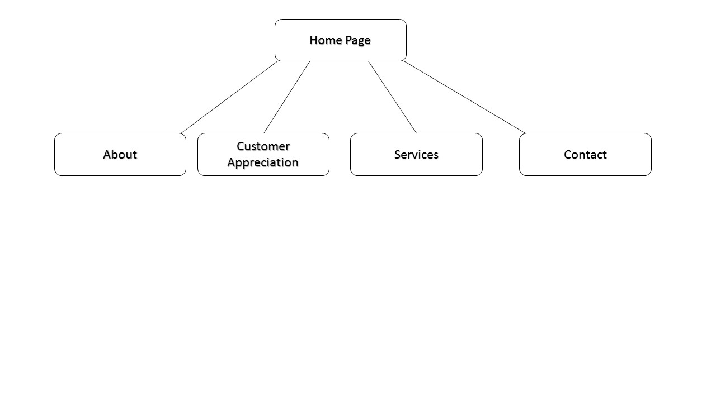

**Home Page**

**Title:**

**FrontYard Fairways**

**Purpose:**

**The first page the costumer will see that will draw them into the rest of the site.**

**Main Heading:**

**FrontYard Fairways brings the resort life style to your front lawn!**

**Links:**

**Standard navigation under header.**

* **Home**
* **About**
* **Services**
* **Customer Appreciation**
* **Contact**

**Services**

**Title:**

**FrontYard Fairways Services**

**Purpose:**

**This page provides the potential customer view of the types of services provided as well as prices, deals, and locations.**

**Main Heading:**

**Service begins with an affordable price!**

**Links:**

**Standard navigation under header.**

* **Home**
* **About**
* **Services**
* **Customer Appreciation**
* **Contact**

**Customer Appreciation Page**

**Title:**

**FrontYard Fairways for our customers**

**Purpose:**

**The purpose of this page is to showcase the work FrontYard Fairways has done for its customers as well as a chance for the costumers to show off their great looking lawns.**

**Main Heading:**

**You could have a happy lawn like our happy customers**

**Links:**

**Standard navigation under header.**

* **Home**
* **About**
* **Services**
* **Customer Appreciation**
* **Contact**

**Contact**

**Title:**

**FrontYard Fairways Contact**

**Purpose:**

**This page will provide a list of contact options for customers and a description of the process for which to begin services. There will also be a form element for customers to request services.**

**Main Heading:**

**There is only a few east steps to get that perfect lawn!**

**Links:**

**Standard navigation under header.**

* **Home**
* **About**
* **Services**
* **Customer Appreciation**
* **Contact**

**Consultation Process:**

**A description of the process.**

**Form Element:**

* **Name**
* **Address**
* **Email**
* **Phone number**
* **Description of service request**

**Contact:**

* **Phone**
* **E-Mail**
* **Location**
* **Address**