Front Yard Fairways

# Project Overview

The purpose of this project is for the user to easily and quickly access account data and information. Employees will be able to manage their accounts and assignments. This will allow them to easily find what they do and charge customers after the work is completed. Customers will be able to easily access account data. They will also be able to change services and info, as well as set an automatic payment method.

This will be a complete redesign of course. This is a real local company startup who has yet to have a site up and running. This company is slowly growing and I feel like a website would add a great advantage over other local businesses, as well as bring in a lot more customers. This project will be a great way to launch my career and show my abilities as a professional web developer.

Reviews

Contact

Services

About

Home

Customer Account

Employee Dashboard

Sign up/Login

Main site

# Story Board

Customer Account Sign up / Details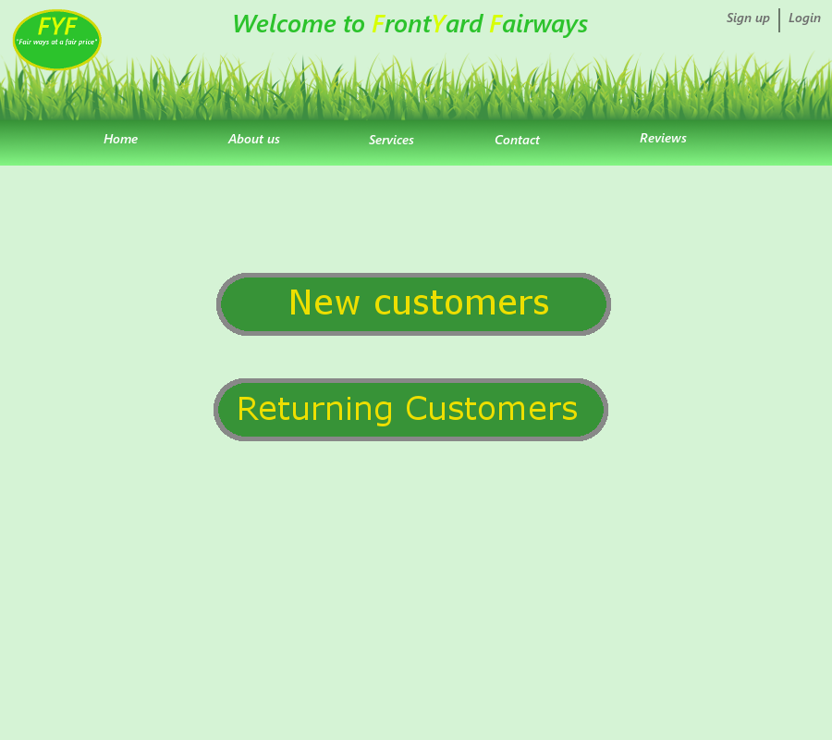

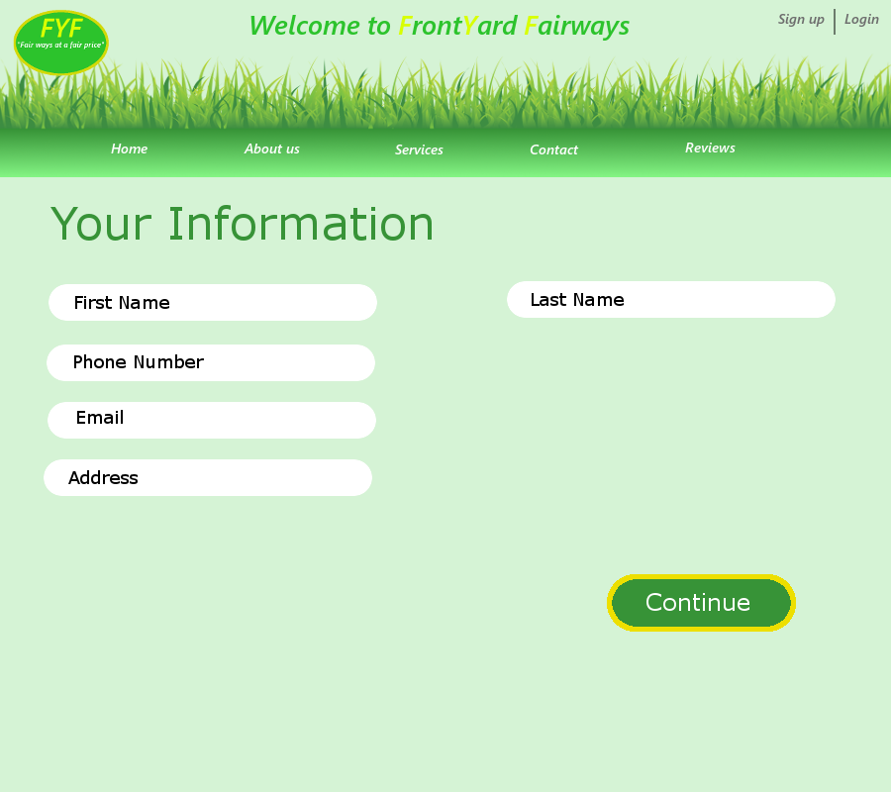

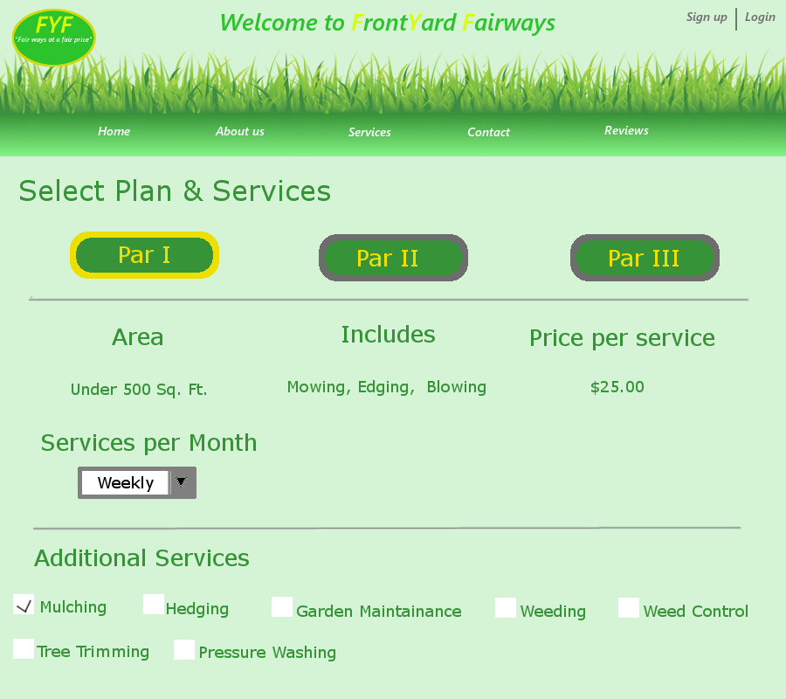

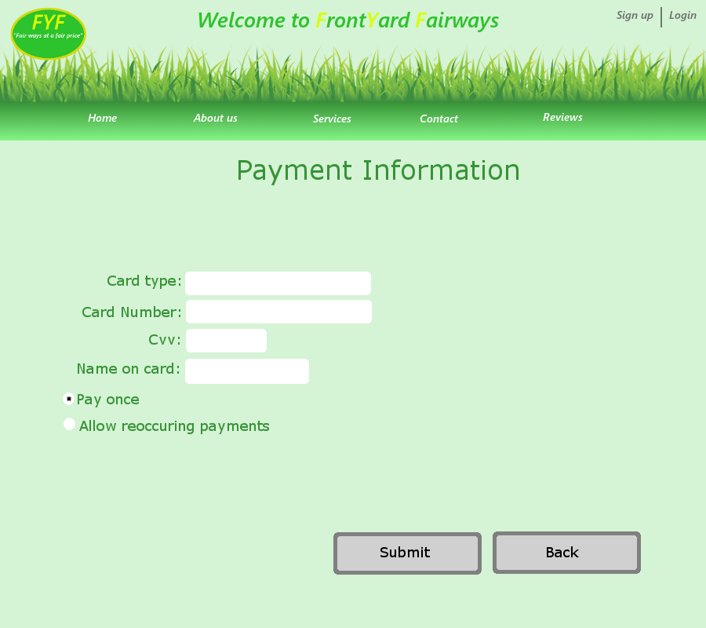

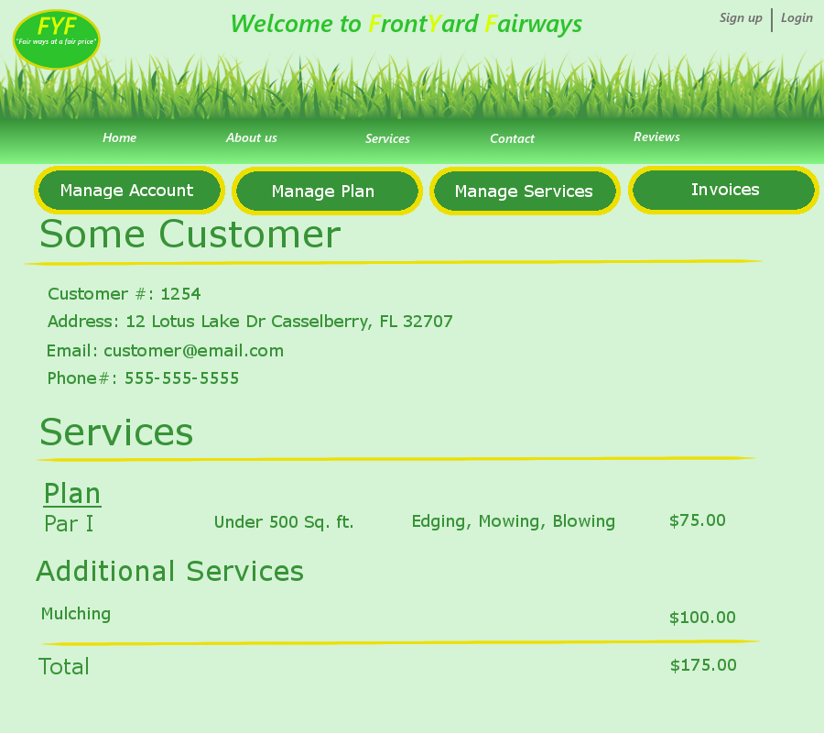

Event Flow

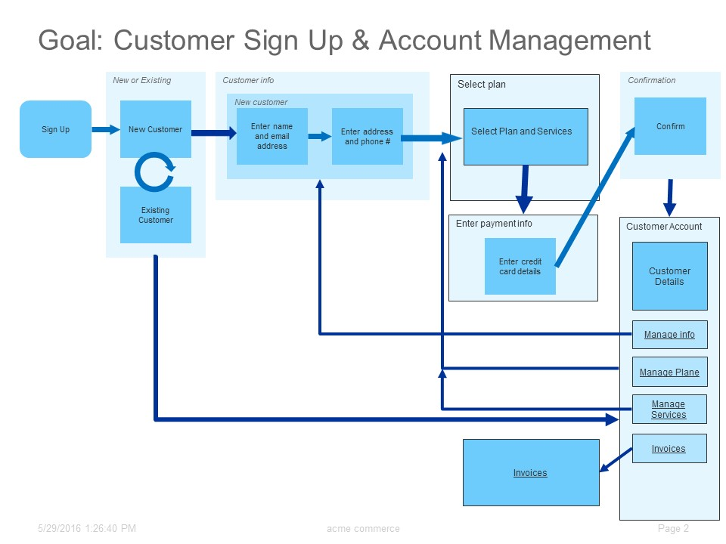

Employee Dashboard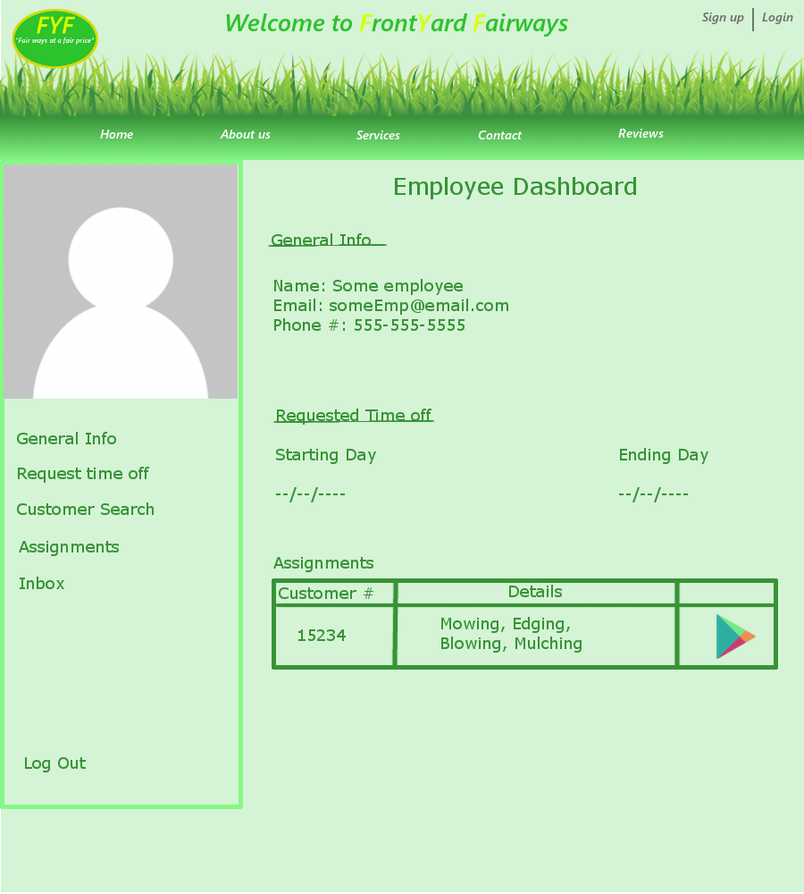

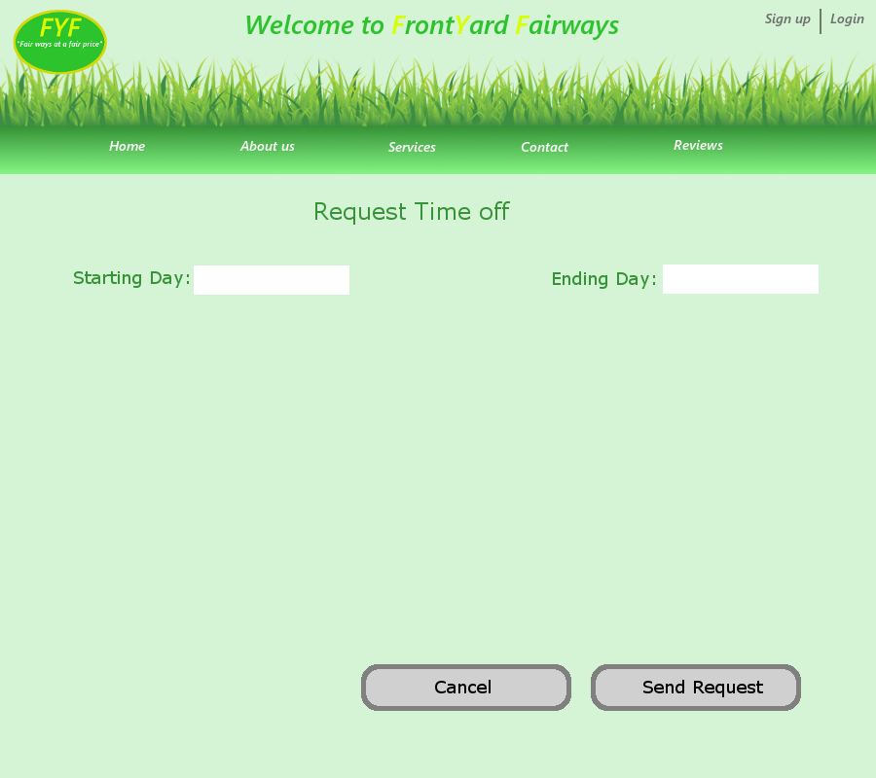

|  |  |  |  |
| --- | --- | --- | --- |
| Customer # | Details | Address |  |
| 15234 | Mowing, Edging, Blowing, Mulching | 12 Lotus Lake Dr Casselberry Fl 32707 |  |

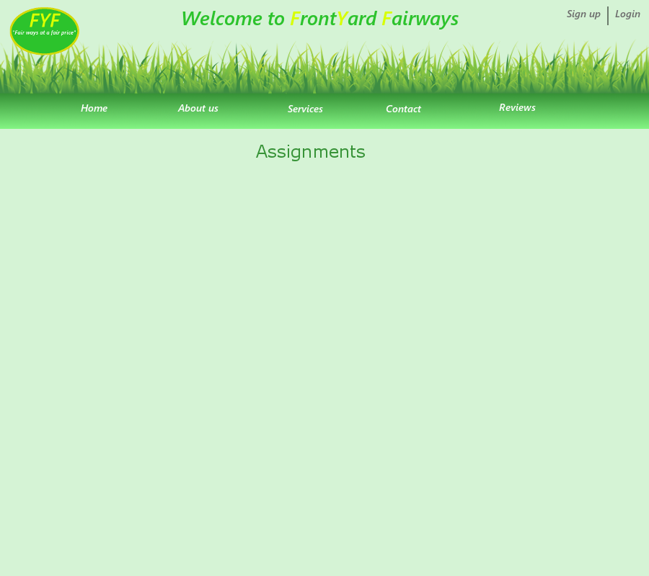

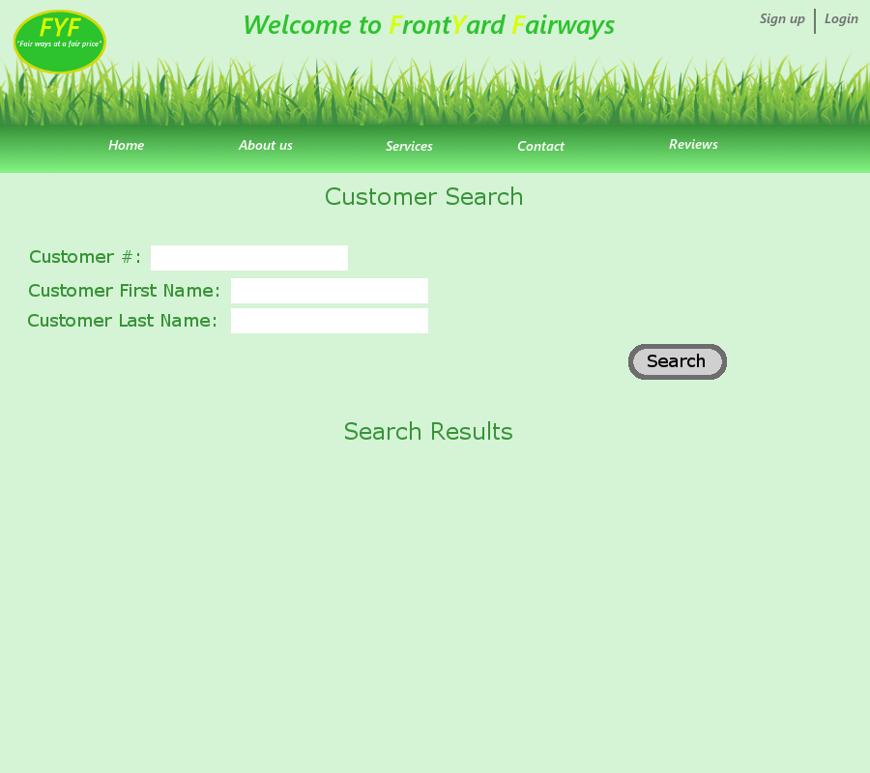

|  |  |  |  |
| --- | --- | --- | --- |
| Customer # | Details | Address |  |
| 15234 | Edging, Mowing, Blowing, Mulching | 12 Lotus Lake Dr Casselberry FL 32707 | View Account |

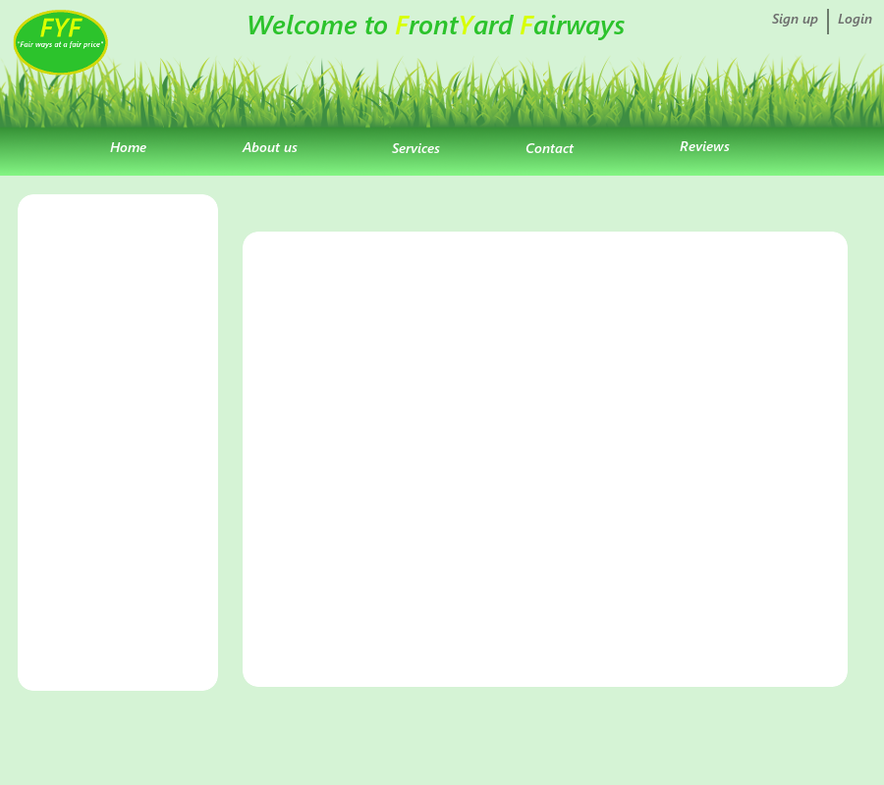

|  |
| --- |
| User May,16  Message: …… |
| User May,17  Message: …… |
| User May,18  Message: …… |
| User May,19  Message: …… |
| User May,20  Message: …… |

User2125 May 16, 2016

Lorem ipsum dolor sit amet, consectetur adipiscing elit. Vivamus purus nisl, vestibulum sed augue ac, mattis congue justo. Etiam nunc dui, ultrices quis dapibus et, porta vestibulum leo. Maecenas eget viverra ante. Vestibulum ante ipsum primis in faucibus orci luctus et ultrices posuere cubilia Curae; Mauris in ante id lectus varius scelerisque id a purus. Nunc cursus at nulla ac placerat. Proin vulputate, nisi nec mattis pretium, lacus dolor maximus turpis, ornare dignissim tellus nulla sed odio. Aenean fermentum massa a leo mattis, sit amet convallis purus vulputate.

Delete

Compose

Employee/Admin Event Flow

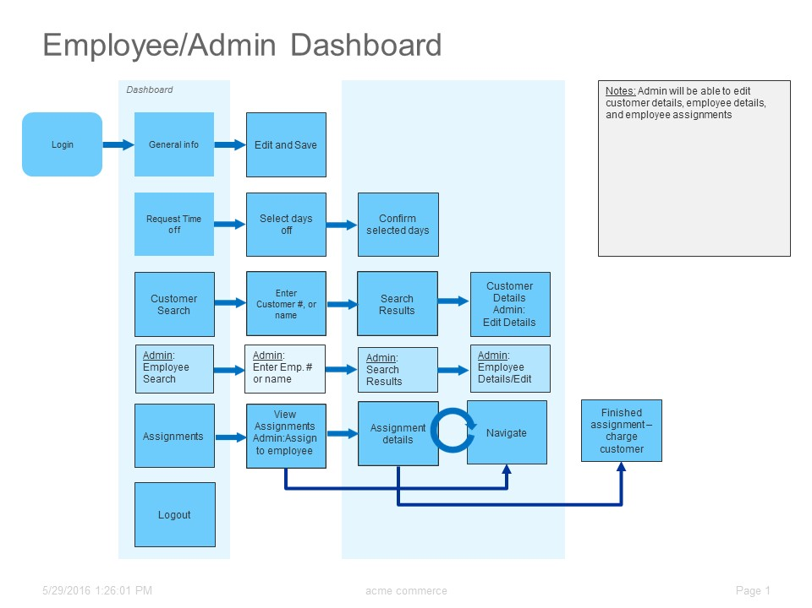

|  |  |
| --- | --- |
| Feature | Description |
| Sign up | Allows a customer to create a new account |
| Authenticate | Verifies login data |
| Manage Info | Customer can view/edit his/her info |
| Manage plan | Customer can add or remove plans |
| Manage services | Customer can add or remove services to plan |
| Invoices | Customer can review receipt/statements of previous services |
| Login | Allows users to login and view account info |
| Request time off | Allows employees to request time off |
| Search Customer | Allows employee to search for a customer |
| Search Employee(Admin) | Admin can search employees and view/edit info |
| Assignments | Employee can view assignments |
| Navigate | Sends user to google navigation of specific location |
| In box | User can send message to other employees |
| Payment | Customers inputs payment info |

Application Partition

|  |  |  |  |
| --- | --- | --- | --- |
| Feature | Presentation | Logic | Data |
| Sign up | x | x | x |
| Login | x | x |  |
| Authenticate |  | x |  |
| Manage info | x |  | x |
| Manage Plan | x | x | x |
| Manage Services | x | x | x |
| Invoices | x |  |  |
| Request Time off | x |  | x |
| Search Customer/employee |  | x |  |
| Assignments | x |  | x |
| Navigate | x |  |  |
| Inbox | x | x | x |
| Payment | x | x | x |
| Total | x | x | x |

Documentation overview

This application will allow to access important and helpful data quickly and easily.

For the customers they can sign up. After they log in they can view their account data and services. Change services, add services, and set up a method of payment for when each service is completed.

The employees will be able to edit their general info and include contact information. From their dashboard they can request time off, look at their assignments, search for customers in the database, check and write messages to other employees, makes notes to customer accounts, check to see if assignments are completed and charge customers after they are completed.

The admins will have access to all accounts, and can edit all accounts. They will have the same dashboard as employees with an additional feature to search and view employees. They will also assign employees assignments.