**Department of Information Technology**

**Academic Year: 2024-25 Name of Student: Omkar Chandgaonkar**

**Semester: VI Student ID: 22104121**

**Class / Branch / Div: TE- IT A Roll No. 16**

**Subject: MAD & PWA Lab Date of Submission: 04/04/25 Name of Instructor: prof. Saylee Lapelikar**

**Experiment No.:9**

**Aim:** To Construct meta data for PWA in a Web app manifest file to enable “add to homescreen feature”

**Prerequisites:** HTML, JavaScript, JSON**.**

**Software:** VS code, Browser**.**

**Code:**

**Index.html**

<!DOCTYPE html>

<html lang="en">

<head>

<meta charset="UTF-8">

<meta name="viewport" content="width=device-width, initial-scale=1">

<title>E-Commerce PWA</title>

<!-- jQuery Mobile CSS & JS -->

<link rel="stylesheet" href="https://code.jquery.com/mobile/1.4.5/jquery.mobile-1.4.5.min.css">

<script src="https://code.jquery.com/jquery-3.6.0.min.js"></script>

<script src="https://code.jquery.com/mobile/1.4.5/jquery.mobile-1.4.5.min.js"></script>

<!-- PWA Manifest -->

<link rel="manifest" href="manifest.json">

</head>

<body style="background-color: rgb(255, 211, 222);">

<center>

<!-- Home Page -->

<div data-role="page" id="home" style="display: flex;justify-content: center;align-items: center;">

<div data-role="header">

<h1>GoBasket</h1>

<a href="#cart" class="ui-btn ui-btn-right ui-icon-shopping-cart ui-btn-icon-notext"></a>

</div>

<div data-role="content">

<ul data-role="listview" data-inset="true">

<li><a href="#product1">📱 Apples</a></li>

</ul>

</div>

<div data-role="footer">

<h4>&copy; 2025 ShopEasy</h4>

</div>

</div>

<!-- Product Page -->

<div data-role="page" id="product1">

<div data-role="header">

<a href="#home" class="ui-btn ui-icon-back ui-btn-icon-left" style="width: fit-content;">Back</a>

<h1>My Basket</h1>

</div>

<div data-role="content">

<img src="images/apple.jpeg" alt="apple" style="width:20%;border-radius: 50px;">

<h3>Price: Rs.450</h3>

<button class="add-to-cart ui-btn ui-btn-b" style="width: fit-content;">Add to Cart</button>

</div>

</div>

<!-- Shopping Cart Page -->

<div data-role="page" id="cart">

<div data-role="header">

<h1 style="width: fit-content;">Shopping Cart</h1>

</div>

<div data-role="content">

<ul id="cart-items" data-role="listview"></ul>

<a href="#" class="ui-btn ui-btn-b" style="width: fit-content;">Checkout</a>

</div>

</div>

<script src="js/script.js"></script>

</center>

</body>

</html>

**serviceworker.js**

var staticCacheName = "pwa";

self.addEventListener("install", function (e) {

e.waitUntil(

caches.open(staticCacheName).then(function (cache) {

return cache.addAll(["/"]);

})

);

});

self.addEventListener("fetch", function (event) {

console.log(event.request.url);

event.respondWith(

caches.match(event.request).then(function (response) {

return response || fetch(event.request);

})

);

});

**Manifest.json**

{

"name":"PWA Tutorial",

"short_name":"PWA",

"start_url":"index.html",

"display":"standalone",

"background_color":"#5900b3",

"theme_color":"black",

"scope": ".",

"description":"This is a PWA tutorial.",

"icons":[

{

"src":"images/icon-192x192.png",

"sizes":"192x192",

"type":"image/png"

},

{

"src":"images/icon-512x512.png",

"sizes":"512x512",

"type":"image/png"

}

]

}

**Output:**

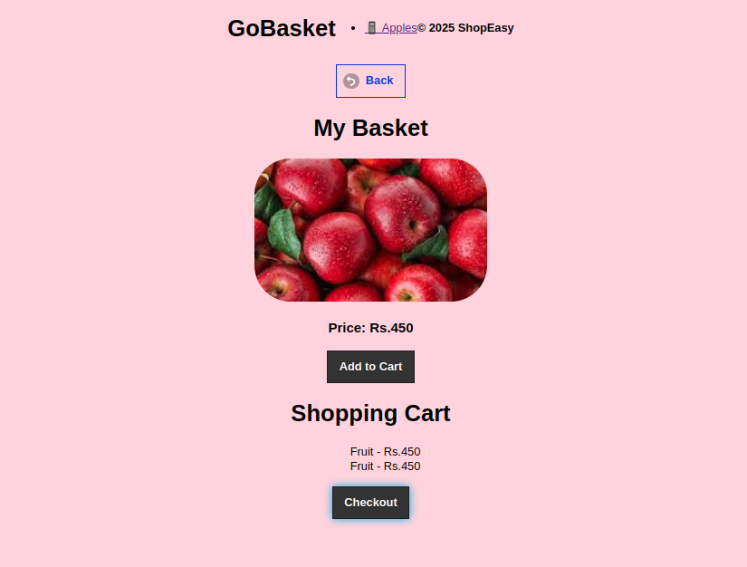

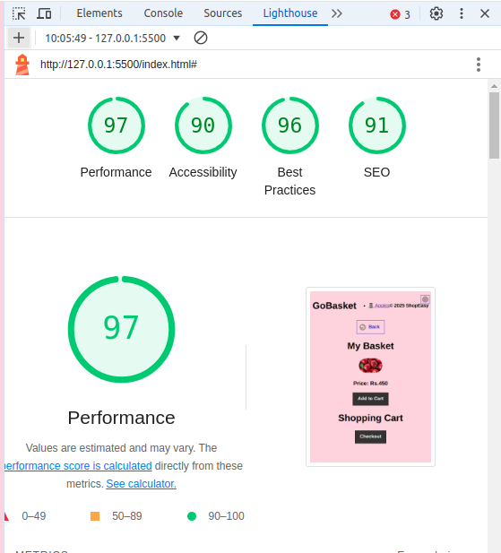

**Conclusion:** In this experiment we have designed PWA in a Web app manifest file to enable “add to homescreen feature”