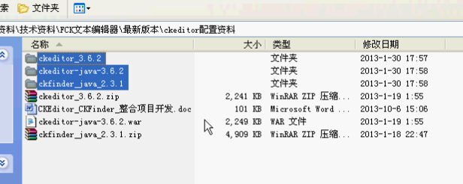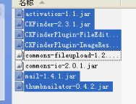

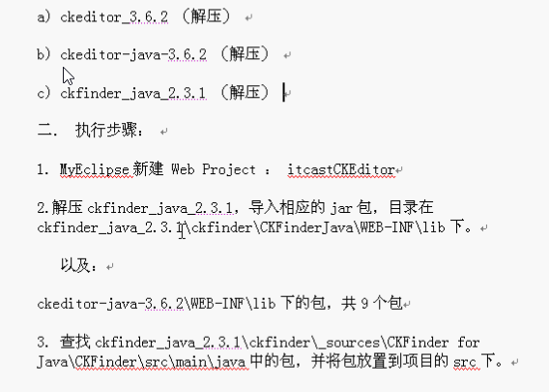

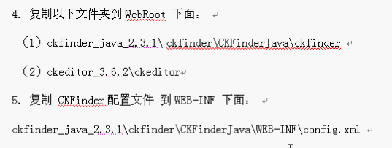

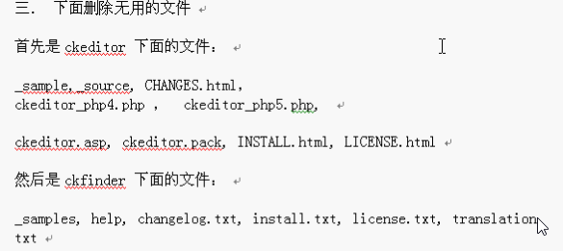

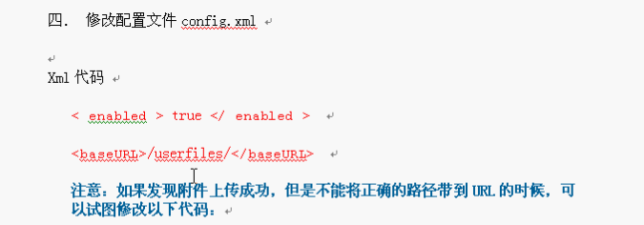

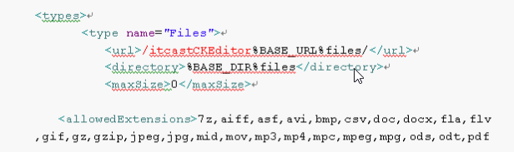

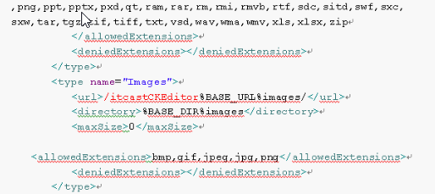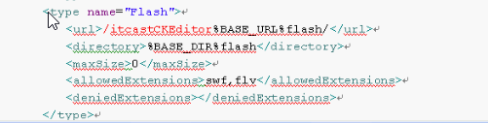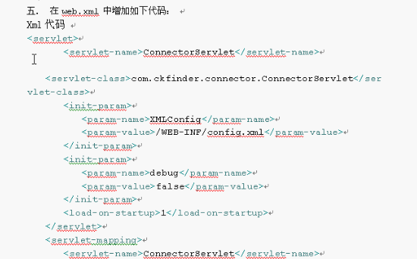

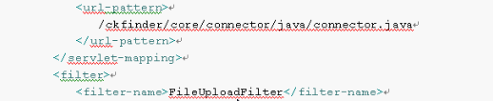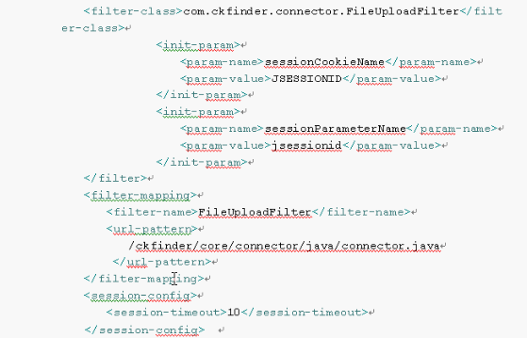

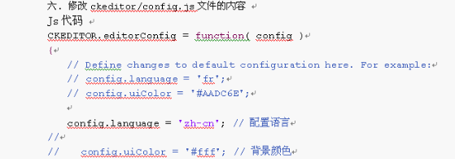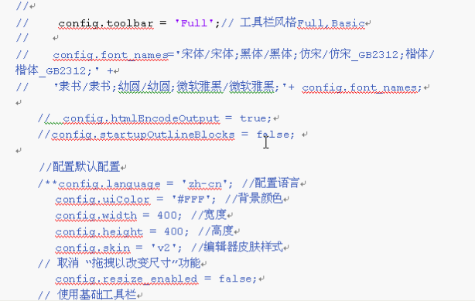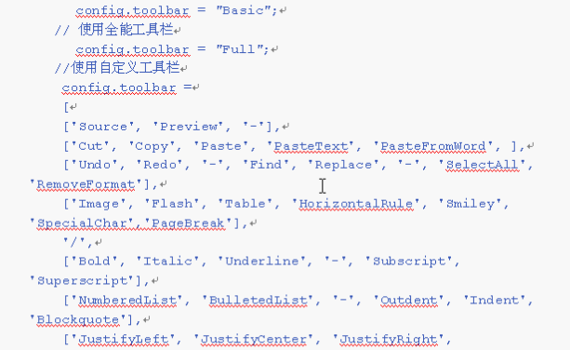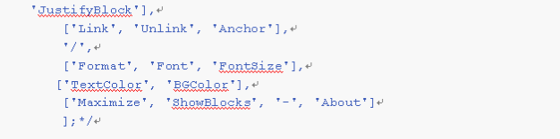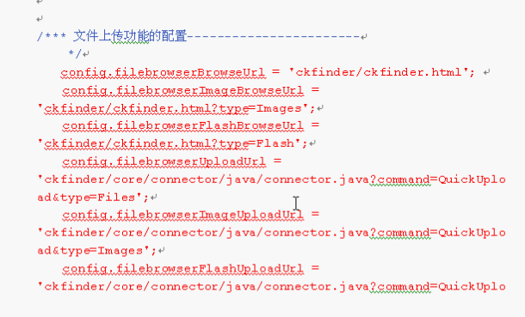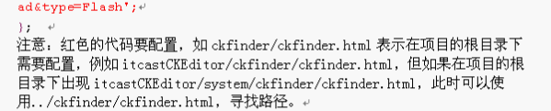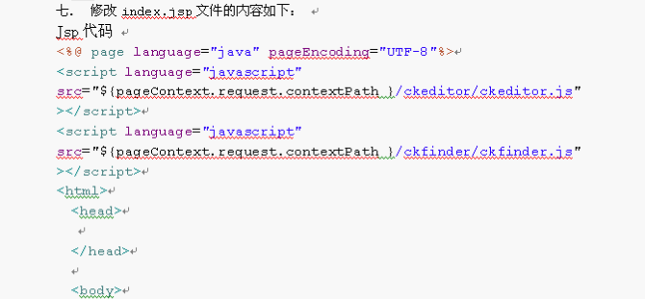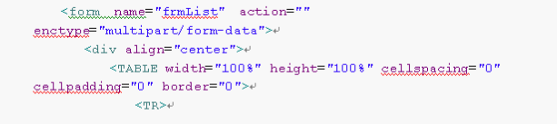 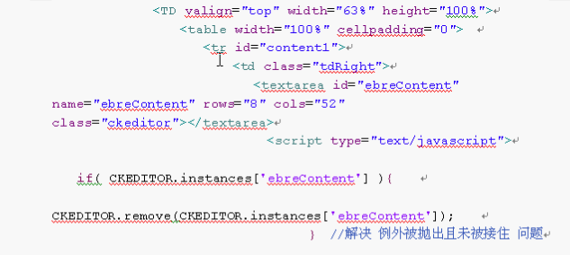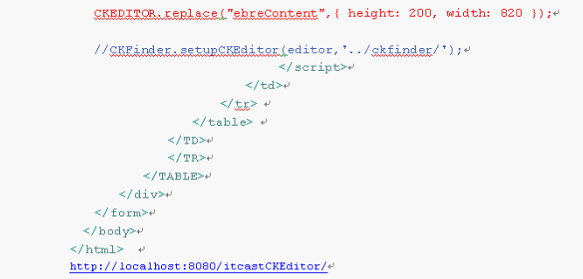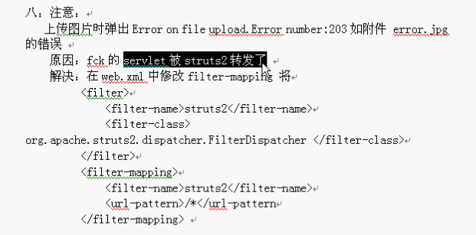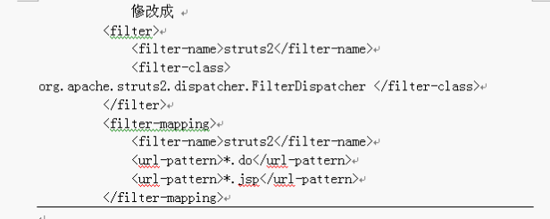

本篇文章主要介绍ckeditor_3.6.4+ckfinder_java_2.3

CKEditor下载地址：<http://ckeditor.com/download>            在线演示地址：<http://ckeditor.com/demo>

ckeditor-java-core-3.5.3.zip 下载地址：<http://ckeditor.com/download>

CKFinder下载地址： <http://cksource.com/ckfinder/trial>

 1、解压ckeditor_3.6.4.zip，然后打开ckeditor文件夹，只需保留：images、lang、plugins、skins、themes、ckeditor_basic.js、ckeditor.js、config.js、contents.css即可

其他的文件可以删除。然后将整个ckeditor放在web工程下，与WEB-INF处于同一级目录。

2、将ckeditor-java-core-3.5.3.zip解压，然后将ckeditor-java-core-3.5.3.jar包拷贝至web项目的lib下。

3、将ckfinder_java_2.3.zip解压，然后将CKFinderJava.war解压后，将WEB-INF里面的lib下面所有的jar包拷贝至web项目的lib下，将ckfinder\_sources\CKFinder for Java\WebApp\src\main\webapp下的ckfinder文件夹拷贝至web工程下，与ckeditor保持同级，将其下的WEB-INF下面的config.xml文件拷贝至web项目的WEB-INF下，并根据自己的项目稍作调整即可，如下：

<config>

<enabled>true</enabled> <!--注意：这里默认为false，必须修改为true-->

<baseDir></baseDir> <!--此处空着，不建议填写任何值-->

<baseURL>http://127.0.0.1:8088/sitenav/uploadFiles/</baseURL> <!---注意：必须改成自己项目的，不然上传图片找不到具体的网络路径-->

<licenseKey></licenseKey>

<licenseName></licenseName>

<imgWidth>1600</imgWidth>

<imgHeight>1200</imgHeight>

<imgQuality>80</imgQuality>

<uriEncoding>UTF-8</uriEncoding>

...... ......

</config>

4、然后在web.xml下添加上传用的配置如下：

<!-- ckfinder文件上传配置 start -->  

<servlet>

<servlet-name>ConnectorServlet</servlet-name>

<servlet-class>com.ckfinder.connector.ConnectorServlet</servlet-class>

<init-param>

<param-name>XMLConfig</param-name>

<param-value>/WEB-INF/config.xml</param-value>

</init-param>

<init-param>

<param-name>debug</param-name>

<param-value>false</param-value>

</init-param>

<load-on-startup>2</load-on-startup>

</servlet>

<servlet-mapping>

<servlet-name>ConnectorServlet</servlet-name>

<url-pattern>

/ckfinder/core/connector/java/connector.java

</url-pattern>

</servlet-mapping>

<filter>

<filter-name>FileUploadFilter</filter-name>

<filter-class>com.ckfinder.connector.FileUploadFilter</filter-class>

<init-param>

<param-name>sessionCookieName</param-name>

<param-value>JSESSIONID</param-value>

</init-param>

<init-param>

<param-name>sessionParameterName</param-name>

<param-value>jsessionid</param-value>

</init-param>

</filter>

<filter-mapping>

<filter-name>FileUploadFilter</filter-name>

<url-pattern>

/ckfinder/core/connector/java/connector.java

</url-pattern>

</filter-mapping>

<!-- ckfinder文件上传配置 end -->

5、然后修改ckeditor下面的config.js，如下：

CKEDITOR.editorConfig = function( config )

{

config.filebrowserBrowseUrl = '../ckfinder/ckfinder.html';

config.filebrowserImageBrowseUrl = '../ckfinder/ckfinder.html?type=Images';

config.filebrowserFlashBrowseUrl = '../ckfinder/ckfinder.html?type=Flash';

config.filebrowserUploadUrl = '/ckfinder/core/connector/java/connector.java?command=QuickUpload&type=Files';

config.filebrowserImageUploadUrl = '/ckfinder/core/connector/java/connector.java?command=QuickUpload&type=Images';

config.filebrowserFlashUploadUrl = '/ckfinder/core/connector/java/connector.java?command=QuickUpload&type=Flash' ;

config.language = "zh-cn";

config.image_previewText=' '; //预览区域显示内容

config.skin = 'kama';//默认皮肤

//config.skin = 'v2';

//config.skin = 'office2003';

config.toolbar = 'Full';

config.toolbar_Full =

[

['Source','-','Save','NewPage','Preview','-','Templates'],

['Cut','Copy','Paste','PasteText','PasteFromWord','-','Print', 'SpellChecker', 'Scayt'],

['Undo','Redo','-','Find','Replace','-','SelectAll','RemoveFormat'],

['Form', 'Checkbox', 'Radio', 'TextField', 'Textarea', 'Select', 'Button', 'ImageButton', 'HiddenField'],

'/',

['Bold','Italic','Underline','Strike','-','Subscript','Superscript'],

['NumberedList','BulletedList','-','Outdent','Indent','Blockquote'],

['JustifyLeft','JustifyCenter','JustifyRight','JustifyBlock'],

['Link','Unlink','Anchor'],

['Image','Flash','Table','HorizontalRule','Smiley','SpecialChar','PageBreak'],

'/',

['Styles','Format','Font','FontSize'],

['TextColor','BGColor'],

['Maximize', 'ShowBlocks','-','About']

];

config.toolbar_Basic =

[

['Bold', 'Italic', '-', 'NumberedList', 'BulletedList', '-', 'Link', 'Unlink','-','About']

];

};

6、然后就是CKEditor+CKFinder在jsp页面中应用，如下

       a、在jsp文件中加入：

            <%@ taglib uri = "[http://ckfinder.com](http://ckfinder.com/)" prefix="ckf" %>  
           <%@ taglib uri="[http://ckeditor.com](http://ckeditor.com/)" prefix="ck" %>

      b、需要添加编辑组件如下编写

         <s:textarea id="txt" name="company.txt" rows="5" cols="120"></s:textarea>  
           <ckf:setupCKEditor  basePath="/sitenav/ckfinder/"  editor="txt"/>

          <!---注意：这里的sitenav为我的项目名称，请换成自己的项目名--->  
           <ck:replace replace="txt" basePath="${path}/ckeditor"></ck:replace>

          <!---注意：这里的${path}需要自己定义一个，如：pageContext.setAttribute("path",request.getContextPath());--->