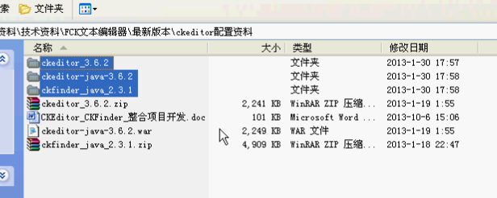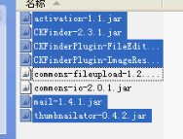

# 配置帮助文档

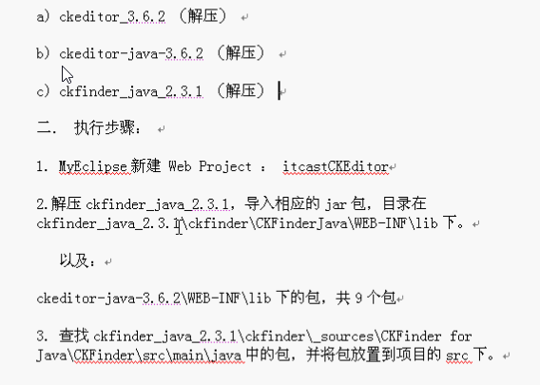

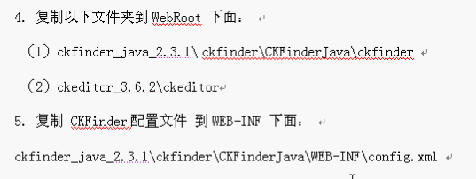

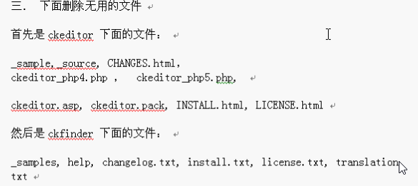

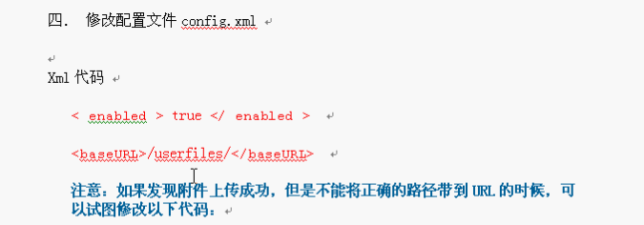

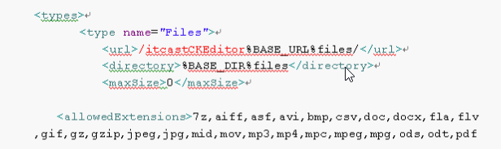

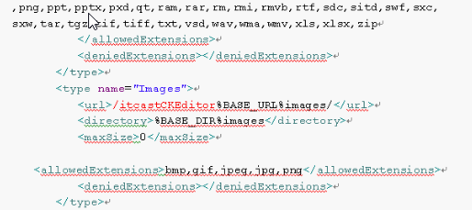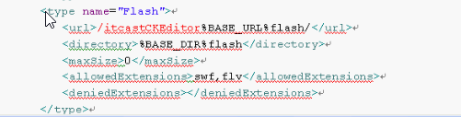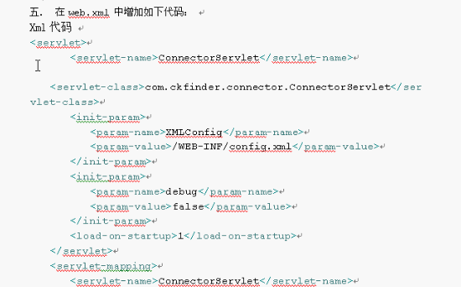

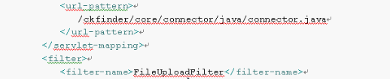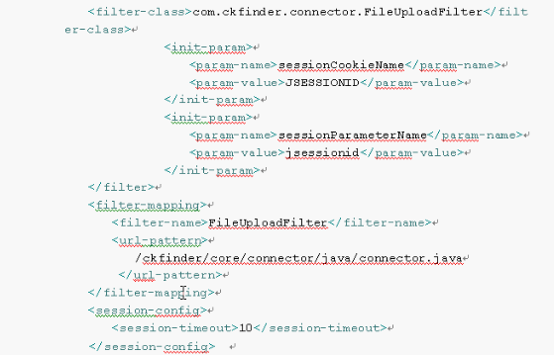

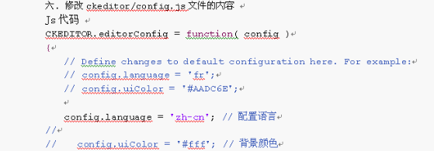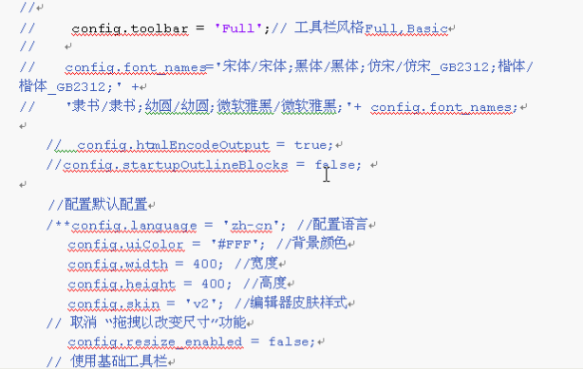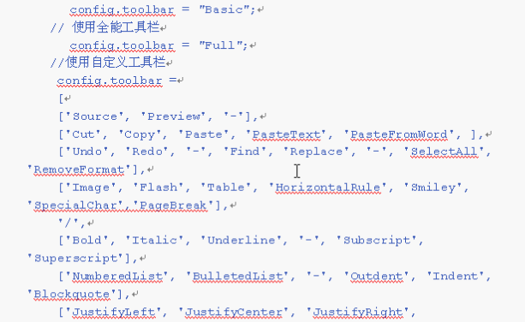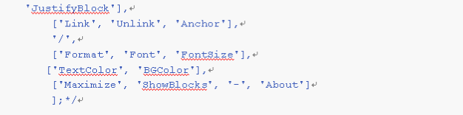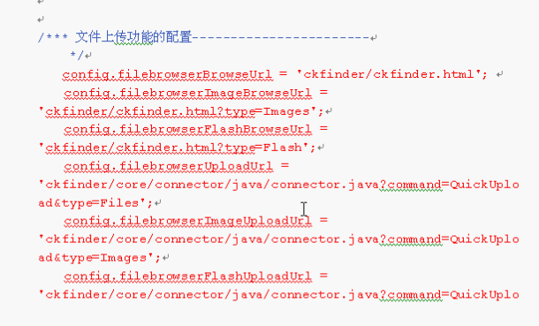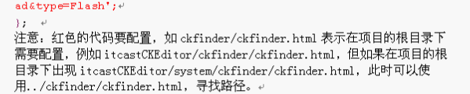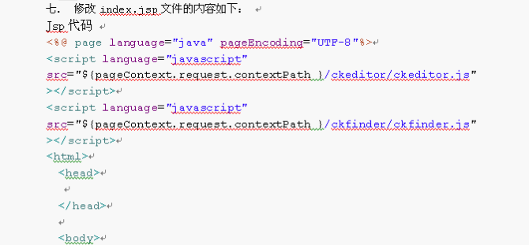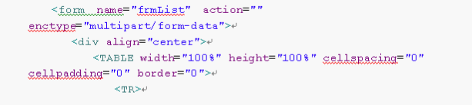 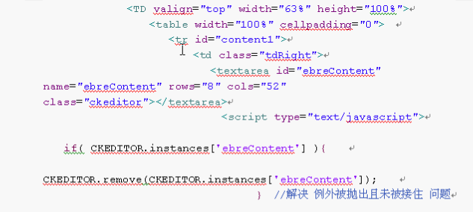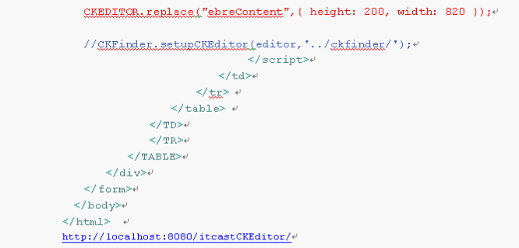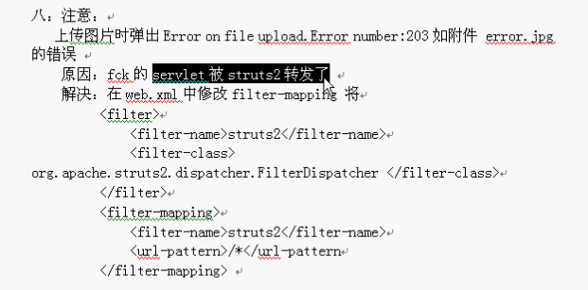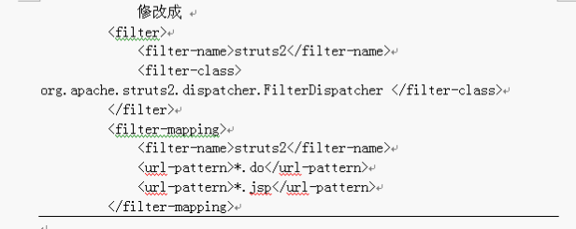

## [工具栏自定义配置](http://www.cnblogs.com/samsonhuang/articles/2631932.html)

**注意工具按钮是分组的，一个name内的大括号就是一个工具按钮分组，items后边是具体的按钮，“/”表示工具栏换行，“-”表示工具图标之间的中隔线“|”**

（特别说明：config.js中没有下面的代码，默认就是显示全部按钮，但如果对工具栏进行自定义，最好的办法还是把下面的代码全部复制到config.js，然后再删除一个个不需要的按钮）

### config.toolbar = 'Full';

config.toolbar = 'Full';

config.toolbar_Full =

[

{ name: 'document', items : [ 'Source','-','Save','NewPage','DocProps','Preview','Print','-','Templates' ] },

{ name: 'clipboard', items : [ 'Cut','Copy','Paste','PasteText','PasteFromWord','-','Undo','Redo' ] },

{ name: 'editing', items : [ 'Find','Replace','-','SelectAll','-','SpellChecker', 'Scayt' ] },

{ name: 'forms', items : [ 'Form', 'Checkbox', 'Radio', 'TextField', 'Textarea', 'Select', 'Button', 'ImageButton',

'HiddenField' ] },

'/',

{ name: 'basicstyles', items : [ 'Bold','Italic','Underline','Strike','Subscript','Superscript','-','RemoveFormat' ] },

{ name: 'paragraph', items : [ 'NumberedList','BulletedList','-','Outdent','Indent','-','Blockquote','CreateDiv',

'-','JustifyLeft','JustifyCenter','JustifyRight','JustifyBlock','-','BidiLtr','BidiRtl' ] },

{ name: 'links', items : [ 'Link','Unlink','Anchor' ] },

{ name: 'insert', items : [ 'Image','Flash','Table','HorizontalRule','Smiley','SpecialChar','PageBreak','Iframe' ] },

'/',

{ name: 'styles', items : [ 'Styles','Format','Font','FontSize' ] },

{ name: 'colors', items : [ 'TextColor','BGColor' ] },

{ name: 'tools', items : [ 'Maximize', 'ShowBlocks','-','About' ] }

];

config.toolbar_Basic =

[

['Bold', 'Italic', '-', 'NumberedList', 'BulletedList', '-', 'Link', 'Unlink','-','About']

];

### 下面是经删除过后的工具条代码

config.toolbar = 'Full';

config.toolbar_Full = [

{name: 'document',items: ['Source', '-', 'DocProps', 'Preview', 'Print', '-']},

{name: 'clipboard',items: ['Cut', 'Copy', 'Paste', 'PasteText', 'PasteFromWord', '-', 'Undo', 'Redo']},

{name: 'editing',items: ['Find', 'Replace', '-', 'SelectAll', '-']},

{ name: 'basicstyles',items: ['Bold', 'Italic', 'Underline', 'Strike', 'Subscript', 'Superscript', '-', 'RemoveFormat']},

'/',

{name: 'paragraph',items: ['NumberedList', 'BulletedList', '-', 'Outdent', 'Indent', '-', 'Blockquote', 'CreateDiv', '-', 'JustifyLeft', 'JustifyCenter', 'JustifyRight', 'JustifyBlock', '-', 'BidiLtr', 'BidiRtl']},

{name: 'links',items: ['Link', 'Unlink', 'Anchor']},

{name: 'insert',items: ['Image', 'Flash', 'Table', 'HorizontalRule', 'Smiley', 'SpecialChar', 'PageBreak']},

'/',

{ name: 'styles',items: ['Styles', 'Format', 'Font', 'FontSize']},

{ name: 'colors',items: ['TextColor', 'BGColor']},

{ name: 'tools',items: [ 'ShowBlocks', '-']}

];

config.toolbar_Basic = [['Bold', 'Italic', '-', 'NumberedList', 'BulletedList', '-', 'Link', 'Unlink', '-', 'About']];

### 工具栏的定义英汉对照说明：

Source = 源码模式

-

Save = 保存(提交表单)

NewPage = 新建

Preview = 预览

- = 分割线

Templates = 模板

Cut = 剪切

Copy = 复制

Paste = 粘贴

PasteText = 粘贴为无格式文本

PasteFromWord = 从 MS WORD 粘贴

-

Print = 打印

SpellChecker = 拼写检查

Scayt = 即时拼写检查

Undo = 撤销

Redo = 重做

-

Find = 查找

Replace = 替换

-

SelectAll = 全选

RemoveFormat = 清除格式

Form = 表单

Checkbox = 复选框

Radio = 单选框

TextField = 单行文本

Textarea = 多行文本

Select = 列表/菜单

Button = 按钮

ImageButton = 图片按钮

HiddenField = 隐藏域

/

Bold = 加粗

Italic = 倾斜

Underline = 下划线

Strike = 删除线

-

Subscript = 下标

Superscript = 上标

NumberedList = 编号列表

BulletedList = 项目列表

-

Outdent = 减少缩进量

Indent = 增加缩进量

Blockquote = 块引用

CreateDiv = 创建DIV容器

JustifyLeft = 左对齐

JustifyCenter = 居中

JustifyRight = 右对齐

JustifyBlock = 两端对齐

BidiLtr = 文字方向从左到右

BidiRtl = 文字方向从右到左

Link = 插入/编辑超链接(上传文件)

Unlink = 取消超链接

Anchor = 插入/编辑锚点链接

Image = 图像(上传)

Flash = 动画(上传)

Table = 表格

HorizontalRule = 插入水平线

Smiley = 插入表情

SpecialChar = 插入特殊符号

PageBreak = 插入分页符

/

Styles = 样式快捷方式

Format = 文本格式

Font = 字体

FontSize = 文字大小

TextColor = 文字颜色

BGColor = 背景颜色

Maximize = 全屏编辑模式

ShowBlocks = 显示区块

-

About = 显示关于

#### 官网对CKEditor Toolbar Definition的说明

<http://doc.cksource.com/CKEditor_3.x/Developers_Guide/Toolbar>

# 文字版

本篇文章主要介绍ckeditor_3.6.4+ckfinder_java_2.3

CKEditor下载地址：<http://ckeditor.com/download>            在线演示地址：<http://ckeditor.com/demo>

ckeditor-java-core-3.5.3.zip 下载地址：<http://ckeditor.com/download>

CKFinder下载地址： <http://cksource.com/ckfinder/trial>

 1、解压ckeditor_3.6.4.zip，然后打开ckeditor文件夹，只需保留：images、lang、plugins、skins、themes、ckeditor_basic.js、ckeditor.js、config.js、contents.css即可

其他的文件可以删除。然后将整个ckeditor放在web工程下，与WEB-INF处于同一级目录。

2、将ckeditor-java-core-3.5.3.zip解压，然后将ckeditor-java-core-3.5.3.jar包拷贝至web项目的lib下。

3、将ckfinder_java_2.3.zip解压，然后将CKFinderJava.war解压后，将WEB-INF里面的lib下面所有的jar包拷贝至web项目的lib下，将ckfinder\_sources\CKFinder for Java\WebApp\src\main\webapp下的ckfinder文件夹拷贝至web工程下，与ckeditor保持同级，将其下的WEB-INF下面的config.xml文件拷贝至web项目的WEB-INF下，并根据自己的项目稍作调整即可，如下：

<config>

<enabled>true</enabled> <!--注意：这里默认为false，必须修改为true-->

<baseDir></baseDir> <!--此处空着，不建议填写任何值-->

<baseURL>http://127.0.0.1:8088/sitenav/uploadFiles/</baseURL> <!---注意：必须改成自己项目的，不然上传图片找不到具体的网络路径-->

<licenseKey></licenseKey>

<licenseName></licenseName>

<imgWidth>1600</imgWidth>

<imgHeight>1200</imgHeight>

<imgQuality>80</imgQuality>

<uriEncoding>UTF-8</uriEncoding>

...... ......

</config>

4、然后在web.xml下添加上传用的配置如下：

<!-- ckfinder文件上传配置 start -->  

<servlet>

<servlet-name>ConnectorServlet</servlet-name>

<servlet-class>com.ckfinder.connector.ConnectorServlet</servlet-class>

<init-param>

<param-name>XMLConfig</param-name>

<param-value>/WEB-INF/config.xml</param-value>

</init-param>

<init-param>

<param-name>debug</param-name>

<param-value>false</param-value>

</init-param>

<load-on-startup>2</load-on-startup>

</servlet>

<servlet-mapping>

<servlet-name>ConnectorServlet</servlet-name>

<url-pattern>

/ckfinder/core/connector/java/connector.java

</url-pattern>

</servlet-mapping>

<filter>

<filter-name>FileUploadFilter</filter-name>

<filter-class>com.ckfinder.connector.FileUploadFilter</filter-class>

<init-param>

<param-name>sessionCookieName</param-name>

<param-value>JSESSIONID</param-value>

</init-param>

<init-param>

<param-name>sessionParameterName</param-name>

<param-value>jsessionid</param-value>

</init-param>

</filter>

<filter-mapping>

<filter-name>FileUploadFilter</filter-name>

<url-pattern>

/ckfinder/core/connector/java/connector.java

</url-pattern>

</filter-mapping>

<!-- ckfinder文件上传配置 end -->

5、然后修改ckeditor下面的config.js，如下：

CKEDITOR.editorConfig = function( config )

{

config.filebrowserBrowseUrl = '../ckfinder/ckfinder.html';

config.filebrowserImageBrowseUrl = '../ckfinder/ckfinder.html?type=Images';

config.filebrowserFlashBrowseUrl = '../ckfinder/ckfinder.html?type=Flash';

config.filebrowserUploadUrl = '/ckfinder/core/connector/java/connector.java?command=QuickUpload&type=Files';

config.filebrowserImageUploadUrl = '/ckfinder/core/connector/java/connector.java?command=QuickUpload&type=Images';

config.filebrowserFlashUploadUrl = '/ckfinder/core/connector/java/connector.java?command=QuickUpload&type=Flash' ;

config.language = "zh-cn";

config.image_previewText=' '; //预览区域显示内容

config.skin = 'kama';//默认皮肤

//config.skin = 'v2';

//config.skin = 'office2003';

config.toolbar = 'Full';

config.toolbar_Full =

[

['Source','-','Save','NewPage','Preview','-','Templates'],

['Cut','Copy','Paste','PasteText','PasteFromWord','-','Print', 'SpellChecker', 'Scayt'],

['Undo','Redo','-','Find','Replace','-','SelectAll','RemoveFormat'],

['Form', 'Checkbox', 'Radio', 'TextField', 'Textarea', 'Select', 'Button', 'ImageButton', 'HiddenField'],

'/',

['Bold','Italic','Underline','Strike','-','Subscript','Superscript'],

['NumberedList','BulletedList','-','Outdent','Indent','Blockquote'],

['JustifyLeft','JustifyCenter','JustifyRight','JustifyBlock'],

['Link','Unlink','Anchor'],

['Image','Flash','Table','HorizontalRule','Smiley','SpecialChar','PageBreak'],

'/',

['Styles','Format','Font','FontSize'],

['TextColor','BGColor'],

['Maximize', 'ShowBlocks','-','About']

];

config.toolbar_Basic =

[

['Bold', 'Italic', '-', 'NumberedList', 'BulletedList', '-', 'Link', 'Unlink','-','About']

];

};

6、然后就是CKEditor+CKFinder在jsp页面中应用，如下

       a、在jsp文件中加入：

            <%@ taglib uri = "[http://ckfinder.com](http://ckfinder.com/)" prefix="ckf" %>  
           <%@ taglib uri="[http://ckeditor.com](http://ckeditor.com/)" prefix="ck" %>

      b、需要添加编辑组件如下编写

         <s:textarea id="txt" name="company.txt" rows="5" cols="120"></s:textarea>  
           <ckf:setupCKEditor  basePath="/sitenav/ckfinder/"  editor="txt"/>

          <!---注意：这里的sitenav为我的项目名称，请换成自己的项目名--->  
           <ck:replace replace="txt" basePath="${path}/ckeditor"></ck:replace>

          <!---注意：这里的${path}需要自己定义一个，如：pageContext.setAttribute("path",request.getContextPath());--->