**DATA ANALYTICS USING TABLEAU**

**Exploring World’s top You Tube Channels**

**D.Sarumathi ,** B.Jayashree , N.Gurusri ,

K.Kalaiselvi , S.Ramya

**DEPARTMENT OF MATHEMATHICS**

**Krishnasamy College of Science, Arts &Management for Women, Cuddalore**

**CONENTS**:

* **INTRODUCTIPON**

**Overview**

A Brief description about tour project

**Purpose**

The use of project. What can be achieved using this

.

* **PROBLEM DEFINITION & DESIGN THINKING**

**Empathy Map**

Paste the empathy map screenshot

**Ideation & Brainstorming Map**

Paste the ideation &brainstorming map screenshot

* **RESULT**

Final findings(output) of the project along with screenshot

* **ADVANTAGES & DISADVANTAGES**

List of advantages and disadvantages of the proposed solution

* **APPLICATIONS**

The areas where the solution can be applied

* **CONCLUSION**

Conclusion summarizing the entire work and findings.

* **FUTURE SCOPE**

Enhancements that can be made in the future.

**INTRODUCTION**

**OVERVIEW**

You tube is an online video sharing and social media platform headquartered in San Bruno , California, United states . It was launched on February 14 2005 by Steve Chen , Chad Hurley, and Jawed Karim. It was owned by Google. In October 2006 . You Tube was bought by Google for $1.65 billion. Google ownership of You Tube expanded the sites business model, expanding from generating revenue from advertisements alone to offering paid content such as movies and exclusive content produced by You Tube Premium, a paid subscription option for watching content without ads You Tube also approved creators to participate in GOOGLE’S ADSENSE program, which seeks to generate more revenue increased to $28.8 billion, an increase in revenue of $9 billion of $29.2 billion in 2022. Since its purchase by Google, You Tube has expanded beyond the core website into mobile apps, network television. You Tube has had unprecedented social impact, influencing popular culture, internet trends and creating multimillionaire celebrities. Despite its growth and success it has been widely criticized for allegedly facilitating the spread.

**PURPOSE**

The purpose of You Tube is to provide a platform where users can upload, share, and watch videos. The platform was founded in 2005 with the goal of making it easy for people to share videos with one another, and it has since become one of the most popular websites in the world. You Tube allows users to upload a wide range of video content, including music videos, movie trailers, educational videos, comedy skits, and more. Users can watch these videos for free, and they can also upload their own videos and share them with others. In addition to providing a space for users to watch and share videos, YouTube also serves as a platform for businesses, organizations, and individuals to promote their products, services, and ideas. Many content creators and influencers have built their careers on the platform, and some of them have become incredibly successfully and well-known. Overall the purpose of YouTube is to provide a space where people can easily watch and share videos with one another. It has become an incredibly popular and influential part of the internet, and it continues to evolve and grow to this day.

**PROBLEM DEFINITION & DESIGN THINKING**

**EMPATHY MAP**

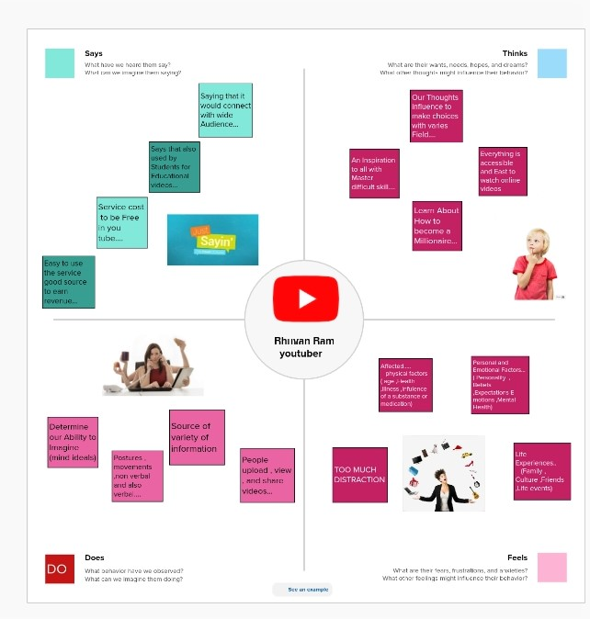

**IDEATION &BRAINSTROM MAP**

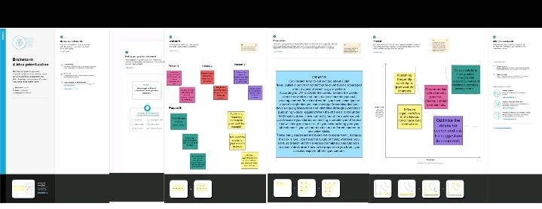

**RESULTS:**

**DASHBOARD**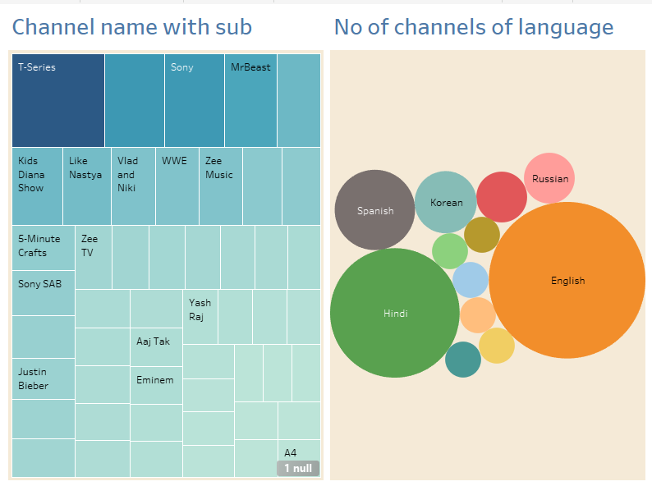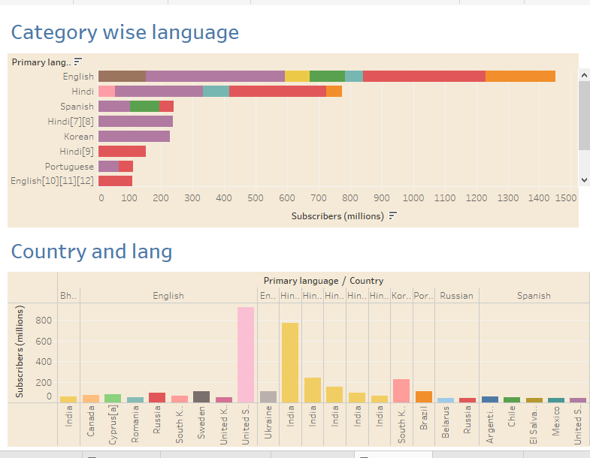

**STORY**

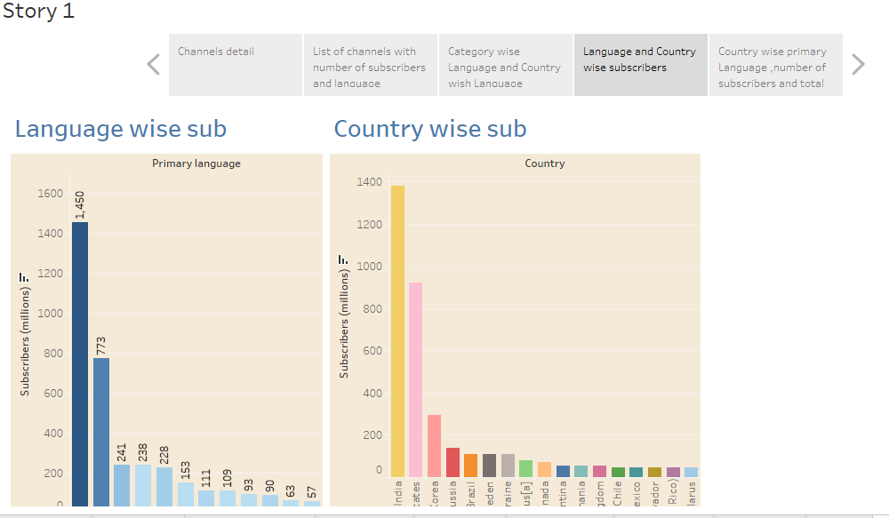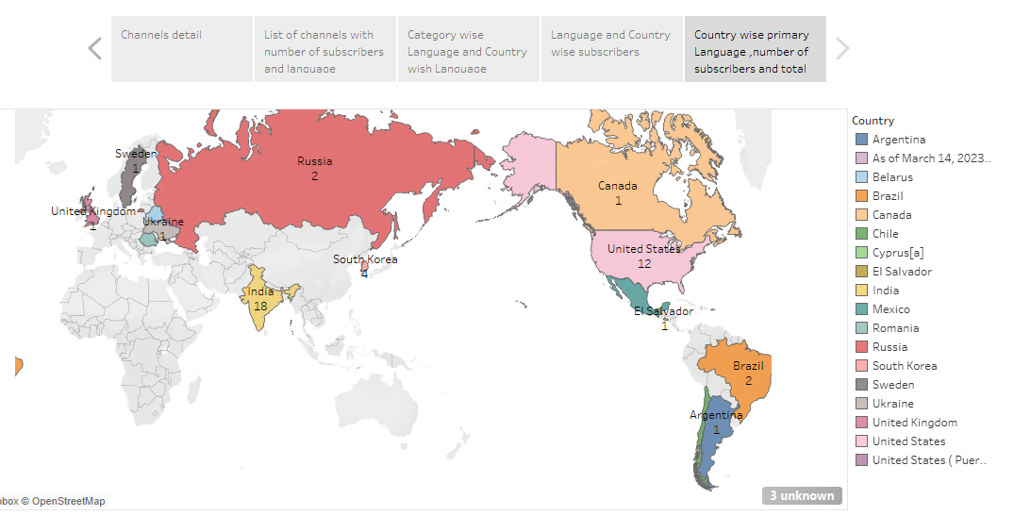

**ADVANTAGES AND DISADVANTAGES**

**ADVANTAGES:**

**You Tube as information disseminating platform for students**

* It’s the perfect place to learn and gain expertise. With online videos and “how to do” tricks, gaining knowledge is simple.
* In the process, You Tube is now the second largest source of information after google.
* According to the most recent data, YouTube has around 2.3 billion active users as of 2021.
* Millions of viewers watch YouTube videos daily, and more than 70percent of YouTube watching is on mobile devices.
* There are many You Tube benefits for students in the automotive, IT engineering, financial and medical fields.
* There is an expert YouTube channel for every area.

**YouTube’s user-friendliness**

* If you are not interested in food, religion, culture, or parenting tips, there’s a channel on You Tube that will offer online help.
* It’s not just for professionals or pupils; You Tube is made for anyone to find what they enjoy.
* From pet lovers to homemakers, anyone can find content suitable to their interests.
* You Tube will keep the content informative and stimulating.

**You Tube for Brand Promotion**

* You Tube videos have been an effective branding method for many businesses, especially during the lockdown.
* There are a lot of promotional videos from major business companies such as Red Bull, shopping mode, Apple, BMW, Motorola, and many more.
* With thousands of people using the platform, they are potential buyers too. Building a brand is the simplest method on the top platform.
* Millions of companies use this method, whether directly or through collaboration with influencers.

**You Tube benefits talented people**

* If you are thinking that you’re specializing in something, then you are worthy of attention.
* The time is right to launch our own channel and be awestruck by viewers from all over the world.
* DIY and craft projects are searched for constantly. You Tubers with millions of subscribers show off their expertise by creating stunning projects, whether it’s wood working or scotty Kilmer’s automotive techniques.
* All you need to do is focused on your passions ans then roll out your ideas in videos that demonstrate how your work is beneficial in everyday life.

**Easy Earning is at the very top of the list of You Tube benefits for vloggers**

* Everyone is interested in the opportunity to turn their passion into profit.
* This is exactly the kind of thing You Tube can offer any creator who has viewers and interesting content, you’ll benefit the most from a You Tube channel.
* You can make money through your You Tube channel after it had reached the point of eligibility.
* It’s easy to upload your content on the platform, and you can handle it all on your own.
* It is not necessary to invest in expensive equipment or accessories.

**DISADVANTAGES**

**Ads- a drawback of You Tube for the audience**

* There are some distinct disadvantages of watching You Tube videos, which include a lot commercials
* It is possible to skip your main stream . However, you’re often required to watch commercials lasting between 15 and 20 seconds
* This is not just a time –waster , but it can be irritating at times.

**A Lot of distraction**

* The platform is updated with new content each minute, making it difficult to avoid engaging and interesting videos , when you begin viewing You Tube videos , You ‘llbe able to continue watching more videos in the “related videos” section
* According to research done by the collective , the issue of distraction while driving can be a World wide problem that kills and injures thousands of people each year.

* There are fatal outcomes of driving while being distracted by videos that depict a negative image of Youu Tube.

* Distraction is one of the most common disadvantages of You Tube for drivers, students, or even workers.
* Obscenity-one of the biggest drawbacks that You Tube has

**The kind of content that is uploaded on You Tube is largely in control today.**

* The amount of people uploading videos has grown in the past five years, and it’s becoming challenging for parents, as well as YouTube, to review the content.
* Since You Tube is a no-cast and accessible platform for anyone, children are attracted to watching videos with explicit language and obscenity.
* In general, You Tube acts faster against copyright issues that are reported.
* There are many negatives when the viewers are children as they are merely aware of how to report the issue.

**Defamation and Bullying**

* It’s a tool that helps the public notice you; untrustworthy people may use You Tube to harm other people’s image in public.
* The public has begun to consider You Tube as a potential social media , particularly over the past five years.
* However, You Tube also enables people to do socially interaction.
* The easiest method to reach someone on You Tube is via the comment area.
* This is even when google requests that users e resceptful intheir comments.

**Making money is’t that easy**

* You can sign up for a
* You Tube affiliate or partner program to earn.
* However, to be eligible for these programs, you’ll need to have at minimum 1000 subscribers as well as 4000 watching hours over the last twelve months.
* While it’s an easy and efficient method of earning money, it won’t be as if it’s growing on trees.
* If you decide to play in a way that is not legitimate, You Tube has the algorithm to catch such actives too.

**APPLICATION**:

* Age restrictions: Under the new E.U General Data Protection Regulation(GDPR), Ireland has now set the digital age of consent to 16 years old. This means young people under the age of 16 in Ireland are not allowed to access this platform.
* Inappropriate contant: You Tube has over a billion users and with an estimated 300 hours of footage uploaded per minute, not all of it is appropriate for children.
* Cyber Bullying: Unfortunately, people can experience negative comments and bullying on the service particularly through the comments function (You Tube users can comment on other users videos).If your child has a You Tube channel/profile it might be a good idea to recommend they disable comments on their own profile/channel.
* Managing privacy settings: when a user uploads a video to you Tube, by default the video is set to public, which means anyone can see the video depending on the age of your child, you should discuss what settings are best to use if your child is uploading footage to You Tube .
* Set up parental controls: parents should set up age restrictions and parental controls on You Tube. See how to set up parental controls.
* Disable Comments on You Tube : YouTube allows you to disable comments entirely on videos or users have the options to approve each comment before they are published, this can help avoid risks of experiencing Cyber bullying. See how to disable comments.
* **Use safety mode**: You Tube has a safety mode, a setting which gives users the opportunity to bar mature content. It is an “opt-in” setting, which means that it won’t take effect until you switch it on. The settings filters search results to remove videos with mature content or videos that have been age-restricted, meaning that search content will not show up in video searches, related videos, playlists, shows or movie sections. While no filtering system is 100 Percent Accurate, we recommend that parents of young children enable this feature.
* Useful Links: You Tube family link allows you to control settings on You Tube kids including the content level setting you want for your child, and if you want your child to use the search function.
* **CONCLUSION:**

You Tube is a very strong growing platform creating lots of opportunities for entrepreneurs and motivated people. After reviewing the results from the survey, I was not really surprised with the responses that I received. Majority of the people that I surveyed are on You Tube all the time and its to watch homemade or uploaded videos. I was shocked to learn that only one person has heard of YouTube EDU. I have heard of You Tube EDU, but I have never used it. This shows that many universities don’t use You Tube EDU in their classrooms. I learned that many people believe that You Tube should be used more in classrooms. This could be because You Tube has more to offer that just uploaded videos by users. You Tube has contracts with certain networks and many educational videos are being put on You Tube everyday. I was not expecting to learn that majority of the people are on You Tube less than an hour a week. I believe this is due to students being full time students and parents working full time jobs and taking care of their kids which gives no time for them to watch You Tube videos.

If I were to follow up on this research I would definitely like to get survey responses from younger students, such as middle schoolers and high schoolers. This would give me more of a understanding on what younger student thing about You Tube in the educational sense. Also, I would like to survey just teachers and find out their thoughts on You Tube and if their responses are similar or different than the college students responses. You Tube has an important part in education, because it allows students to learn more about a particular topic or subject just by watching a short videos. You Tube is full of different types of videos that can easily be incorporated and used in classrooms that will give students a better insight on a particular subject. Many online classes today are using You Tube as a source for students to learn. One course that uses You Tube a lot is history. History courses have documentary clips and videos that can be found on You Tube. Having You Tube be a part of education can help students get the one-on-one time with their teachers and ask questions that they may have. Students can watch and take notes from the lecture on You Tube and work on their homework at home. Then come to class the next day and ask their teacher any particular questions that they may have regarding the assignment or the lecture. In the future I predict that schools will no longer be banning You Tube from their computers and You Tube will be used for watching any educational videos at home.

* FUTURE SCOPE:

* More original content: You Tube has been investing heavily in original content though its You Tube originals program. This trend is expected to continue, with You Tube potentially increasing its investment in original content to complete with other streaming services like Netflix and Hulu.
* Increased focus on monetization: As You Tube faces increasing competition from other platforms, its may focus more on monetization to remain competitive. This could mean more advertising on the platform or new monetization options for creators, such as paid subscriptions or merchandise sales.

* **Continued push towards Al and machine learning**: You Tube has been using Al and machine learning to improve the user experience, such as recommending videos and improving search results. This trend is expected to continue, with You Tube investing in more advanced Al technologies to enhance the platform further.