# Figure table

DIAGRAMS

Diagram 1: Domain Model 6

Diagram 2:Data Viewing SSD 7

Diagram 3: Abnormality detection SSD 7

Diagram 4: Sensor Data Struct 9

Diagram 5: Carbon Handler Design Class DiagramDiagram 6: Sensor Data Struct 9

Diagram 7: Carbon Handler Design Class Diagram 9

Diagram 8: LoraWAN Helper Design Class DiagramDiagram 9: Carbon Handler Design Diagram 9

Diagram 10: LoraWAN Helper Design Class Diagram 10

CODE EXAMPLES

Code Example 1: Data Repository Initialization 5

Code Example 2: Fluctuating delay 6

Code Example 3: Movement handler initialization 6

Code Example 4: Movement task function 6

Code Example 5: Temperature and Humidity sensor warm up 7

Code Example 6: CO2 callback function 7

Code Example 7: Light callback function 8

Code Example 8: LoraWAN helper initialization function 8

TEST-CASES

Test Case 1: CO2 Test case 12

Test Case 2: Temperature and Humidity test case 13

Test Case 3: LoraWAN Handler test case 14

TABLES

Table 1: Functional Requirements 5

Table 2: Non-functional requirements 5

# Abstract

The main objective of the project was to build a home monitoring system utilizing an Arduino board to collect data, LoraWAN to communicate between the Arduino and a Java bridge-app, MongoDB to store data collected by the Arduino device, C# and SQL-based DW to analyze said data as well as an Android application to display the analyzed data.

First, the created system should allow the user to view information about their home environment, the data that should be presented to the user is the following:

1. CO2 particles-per-million,
2. Sound levels,
3. Movement statistics,
4. Raw light levels,
5. Temperature in Celsius,
6. Humidity percentage.

Additionally, the system should also notify the user when certain readings (such as CO2, humidity, movement) are too high.

Next, to allow the parts of the system to communicate with each other, various protocols are used, as mentioned previously, the Arduino device uploads data onto a LoRaWAN network server, this data is then retrieved by the Java bridge application using WebSockets and is then uploaded onto MongoDB, which is accessed by the C# application which then relays the data onto an SQL based data warehouse, additionally the C# application exposes various REST-based HTTP endpoints that are accessed by the Android application using Retrofit libraries to retrieve the data that is stored in the SQL warehouse. Finally, Google Firebase is used as the Login and Register backend of the android application.

Further, to display the analyzed data to the user, mpandroidcharts libraries are used. These libraries allow the system to display movement, humidity and light data as line charts while CO2 and temperature readings as bar charts.

Additionally, to test the system various test-cases were written for every part of the system, however every part of the system utilized Z.O.M.B.I.E.S testing principles where applicable, however very few automated tests were written due to a very volatile state of the system.

In conclusion, most requirements were successfully fulfilled in creation of the system, however some of the aforementioned requirements could not be delivered due to limitations in the drivers provided for the sensors.

# Introduction

The aim of the project is to build a system that could allow the user to monitor certain environmental details of their home. Additionally, the system should analyze the data in a way that would provide a detailed overview of the past and present readings. The system should also be able to notify the user about various environmental hazards when critical levels of certain readings are taken as well as when movement is detected if preferences are set accordingly.

First, the importance of such system is quite high due to the health benefits that it can provide. In addition to the health benefits, “SMART” home monitoring systems are gaining popularity with the rise of mobile devices which allow people to monitor their homes much more easily.

Hence the main purpose of such system is clear: to gather as much information about the environment as possible, to analyze the collected data and display it to the user in a concise fashion. The data that is collected by the system is as follows:

1. CO2 particles-per-million,
2. Sound levels,
3. Movement statistics,
4. Raw light level,
5. Temperature in Celsius,
6. Humidity percentage.

However, collecting and presenting data is not enough as the user may not be aware of the current situation, in addition to the aforementioned features the system should also inform the user when the environment is hazardous in as close to real time as possible, so the correct action could be taken to improve it. Thus, the system should support the ability to send notifications to the user’s mobile device in case of emergency.

In addition, the system should also support multiple users as well as multiple devices per user due to the low range that a single device can cover.

In conclusion, the technologies and methodologies that were utilized to achieve these various functional and non-functional requirements will be further touched upon during the latter chapters of this document, however due to the size of the project only the most critical parts of the project will be presented, however the interested reader should refer to the appendices to view diagrams, test-cases as well as actual code.

# Requirements

The first thing to be done was to determine some core functional and non-functional requirements that the system would have to conform to. During the requirement phase of the entire project, most core features were uncovered and added to the functional requirements. Additionally, various non-functional requirements were also written down, both types of requirements will be displayed in the following subsections. The functional requirements were written in form of user stories.

## Functional Requirements

|  |  |
| --- | --- |
| NAME | USER STORIES |
| CO2 GATHER | As a user, I want to see the information gathered by the CO2 sensor so that I can monitor the CO2 level in my living environment. |
| CO2 NOTIFY | As a user, I want to be notified via the android app when the CO2 level becomes too high according to the recommendations of experts in the field so that I can maintain a healthy living environment. |
| SOUND GATHER | As a user, I want to see the information gathered by the sound sensor so that I can monitor the sound level in my living environment and improve the quality of my study and sleep. |
| SOUND NOTIFY | As a user, I want to be notified via the android app when the sound level becomes too high. |
| H / T GATHER | As a user, I want to see the information gathered by the humidity/temperature sensor so that I can monitor the humidity/temperature level in my living environment. |
| H / T NOTIFY | As a user, I want to be notified via the android app when the humidity level becomes too high or too low according to the recommendations of experts in the field so that I can maintain a healthy living environment. |
| MOVEMENT GATHER | As a user, I want to see the information gathered by the movement sensor so that I can monitor the movement history in my living environment. |
| MOVEMET NOTIFY | As a user, I want to be notified via the android app when there is any movement detected by the movement sensor so that I can make sure there are not any intruders in my home while I am away. |
| LIGHT GATHER | As a user, I want to see the information gathered by the light sensor so that I can monitor the light level in my living environment |
| LIGHT NOTIFY | As a user, I want to be notified via the android app when the light level becomes too low. |
| LIGHT TOGGLE | As a user, I want to be able to turn on/off the lights directly by using the android app. |
| MOVEMENT LIGHT TOGGLE | As a user, I want my lights to turn on automatically when there is any movement detected and the light level falls under a specific threshold. |
| TIMED LIGHTS | As a user, I want my lights to turn off automatically after an amount of time specified by me. |
| SENSOR TOGGLE | As a user, I want to turn on/off sensors via the mobile android app. (the lowest priority) |
| REGISTER | As a user, I want to be able to register. |
| LOGIN | As a user, I want to be able to log in/out the app. |

Table : Functional Requirements

Based on these functional requirements, various test-cases were written which can be found in the appendices.

# Non-Functional requirements:

In the following subsection all non-functional requirements will be presented. Most of these non-functional requirements were imposed onto the project by external parties.

Table : Non-functional requirements

|  |  |
| --- | --- |
| ID | DESCRIPTION |
| 1 | The application must be developed using the official Android framework. |
| 2 | The application must be developed with Java. |
| 3 | The application must be able to send data to a web service to interact with actuators. |
| 4 | The project must utilize GitHub as its version control system. |
| 5 | The project must have a demonstration video uploaded on YouTube. |
| 6 | The project must follow SCRUM and AUP for the development process. |
| 7 | A project report must be presented in order to have a detailed documentation of the system. |
| 8 | A process report must be presented in order to have a detailed documentation of the system development process. |
| 9 | Embedded application must be designed and implemented as a FreeRTOS based application in C for an AVR2560 MCU that interfaces to several sensors and actuators. |
| 10 | The system must use LoRaWAN (IoT-Network) for transmitting and receiving data from AVR256. |
| 11 | The Bridge Application for micro-controller must be written in Java for receiving data from Loriot Network Server and storing them in a MongoDB Document database. |
| 12 | The application must have a design and an implementation of the dimensional model and ETL. |
| 13 | The application must design and implement web services. |
| 14 | The project must have paginated reports in Reporting services |
| 15 | The project must contain analyses in Power BI. |
| 16 | The application must have a responsive user interface. |

With the requirements in place it was time to move onto the analysis.

# Analysis:

During the analysis stage of the entire project, the core objects were uncovered alongside the flow of the data. During this phase, a conceptual class diagram was created to give a general overview of what the system should consist of alongside various system sequence diagrams to showcase the interaction between the user and the entire system. These diagrams will be further discussed in this chapter however the interested reader is advised to refer to appendices where they can find the actual diagrams.

Firstly, the main diagram that was created during this phase was the domain model:

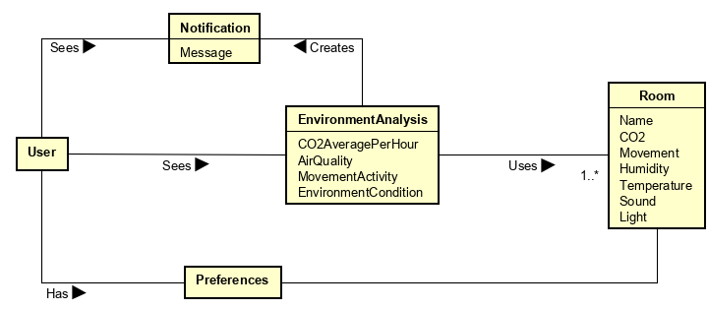

Diagram : Domain Model

The domain model consists of primarily 5 objects: Notifications which the user receives from the environment analysis system, these notifications are generated whenever the data that is taken from the third object, Room, is in a critical state. Additionally, the preferences allow the user to disable these notifications and the environment analysis provides the user with a concise overview of the environment in a specific room.

In addition to the static domain model diagram, several dynamic system sequence diagrams were created to showcase the action flow of the system:

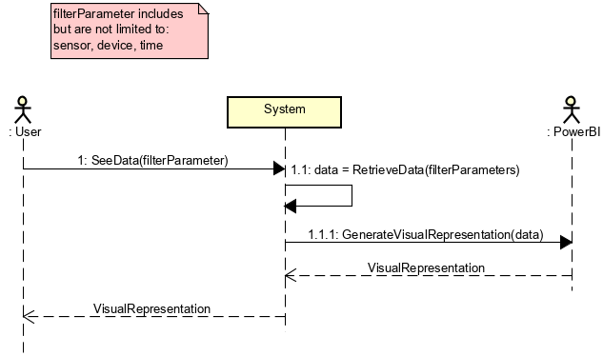

The following diagrams shows how the user can retrieve the data based on various filters such as the sensors (CO2, Light, Movement, Humidity and Temperature), devices (in an event where the user has multiple devices in multiple rooms, the system provides an ability for the user to filter the data by said device) and time. The system then retrieves said data and generates a visual representation by using PowerBI and then returns it to the user. However, due to licensing issues, libraries for android were utilized to generate the visual representation instead of PowerBI, for further information regarding this decision please refer to Implementation: Android section of this document.

Diagram :Data Viewing SSD

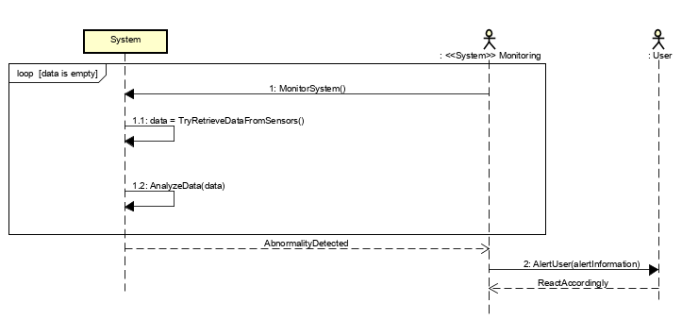The second SSD showcases the actions taken by the system to inform the user of an abnormality. The system first retrieves the data from the sensors, afterwards the collected data is analyzed by passing it through predefined filters to determine whether the readings are normal or abnormal, if an abnormality is detected a notification is pushed to the user informing of the reading.

Diagram : Abnormality detection SSD

Due to the scope of this document some diagrams were excluded, the interested reader can refer to appendices where they can find the full list of diagrams. With these diagrams in place the project was able to proceed to the Design phase, however due to the scope of the project the design, implementation and testing sections are separated into 3 sub-sections each: Embedded, Data and Android.

# Design

## Embedded Design:

During the design phase of the project, various design-oriented classes were created based on the conceptual classes as well as system sequence diagrams that were defined throughout the course of the analysis phase. Due to the low-level nature of the system, it was difficult to decide on a single architecture for the entire system, in the end it was decided to utilize a microservice-based architecture, the decision was made due to the fact that the non-functional requirements could be separated into three different services:

1. Data-Repository service;
   1. *The data repository service was later further separated into four different data-handlers to make the system more maintainable and to avoid having classes that employ the god-object anti-pattern, the handlers that were created were as follows:*
      1. CO2 Handler,
      2. Temperature and Humidity handler,
      3. Light handler,
      4. Movement handler.
2. LoraWAN Helper service;
   1. *The main responsibility of this service is to handle data send-off as well retrieval-of the data that is sent to the device through loraWAN. Further details of the implementation will be discussed in the Implementation part of this document.*
3. Event Reactor service;
   1. *The purpose of this service is to handle such tasks as enabling the lights when movement is detected based on the preferences of the user which are handled by the loraWAN helper service.*

Additionally, it was decided to utilize FreeRTOS to handle these services to improve the efficiency of the system, this decision allowed scheduling of various parts of the system, to save battery-life the data-repository service performs the measurements every minute while the LoraWAN would send out the average every 5 minutes.

Furthermore, due to the requirements the device code was written in C programming language, while the bridge-app that communicates with the device was written in Java programming language.

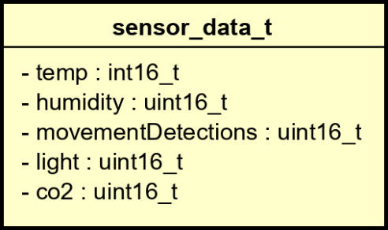Next, while designing the data repository service it was decided to utilize dependency injection by passing a pointer to the struct which contains most of the necessary information in uint16 format, it was decided to use this format to save memory space as the readings would never reach a higher value than 65535 and lower value than 0, however due to the fact that temperature is measured in Celsius and not Kelvin the temperature reading could reach a negative value, thus a signed version of uint16 was used instead, the reason why int16 was used instead of int8 for temperature, humidity, light and movement even though the sensors are not able to return a value larger than the max value of int8 is because the system calculates the average, thus adding 5 readings together produces a value outside of the limit of int8, however LoraWAN helper service sends out an average instead of the sum thus the information that is sent out is in int8 format due to the limitation of the driver. In addition to the pointer to the struct, a pointer to a semaphore is also passed to data repository service initializer to ensure data safety.

Diagram 4: Sensor Data Struct

Diagram 5: Carbon Handler Design Class DiagramDiagram 6: Sensor Data Struct

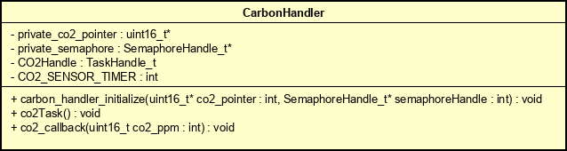As mentioned previously, the data repository service was separated into five handlers that are initialized by the data repository, this improves the separation of concerns of the system as each of the handlers deal with one specific type of data. All handlers follow the same general structure:

Diagram 7: Carbon Handler Design Class Diagram

Diagram 8: LoraWAN Helper Design Class DiagramDiagram 9: Carbon Handler Design Class Diagram

1. An initialization function:
   1. *This function receives a pointer to a specific value of the sensor data as well as a pointer to a semaphore which ensures data safety, these pointers are saved in a static variable that is only accessible by the class itself. The reason why it is static is the fact that there is only a single instance of each handler during runtime.*
2. A task function:
   1. *This function is continuously executed by a FreeRTOS task.*
3. Optional: A callback function:
   1. *This function is called by the driver.*

In addition to this structure, due to the use of FreeRTOS, each handler contains a TaskHandle, pointer to a semaphore as well as a specific timer which determines the interval at which the task should be executed. During this phase it was decided that the interval at which the tasks would execute would be 1 minute for every sensor apart from movement, as it would not make much sense to gather data every minute, the task that collects movement data executes every 1 second instead. To make sure that other sensors can perform readings as well, movement task has the lowest priority, while the LoraWAN helper has the highest priority, this ensures that even if something goes wrong within one of the tasks and the semaphore is not given away, the LoraWAN helper can still perform its task every 5 minutes.

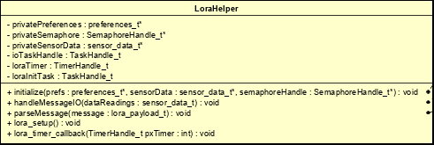 Furthermore, the LoraWAN helper retrieves a pointer to the preference, semaphore as well as the aforementioned struct, the reason why it retrieves a pointer to the preference is so that when a message is retrieved it can immediately modify the preferences. The preferences….. . The same pointer to the semaphore allows FreeRTOS to easily control the flow of the system thanks to the task priorities. In addition, it was decided to include a timer which would delay the LoraWAN Helper at startup so that the sensors would have enough time to collect data for the initial send-off. For more information on how exactly do the functions work please refer to the Implementation:Embedded C section of this document.

Diagram 10: LoraWAN Helper Design Class Diagram

In order to connect the bridge-app and the actual device, a very simple 6-byte long data protocol was designed, the first byte of this protocol contains the low byte of the CO2 reading, this is due to limitation in the driver which only allows 8-bit values and the CO2 reading being above the 8-bit threshold, while the second byte contains the high byte of the CO2 reading, the following 4 bytes contain temperature, humidity, light and movement respectively which are all 8-bit long, as security was not a concern at this part of the entire project, no further steps were taken to encrypt the data. With design choices finalized, the project was able proceed with the implementation phase.

# Embedded C: Implementation

During the implementation phase the diagrams, which were created during the design phase, were materialized(?). Due to the size of the project, in this section only the main concepts will be described, the interested reader can refer to <https://www.freertos.org/> to read more about FreeRTOS as well as <http://havns.dk/IoT/> to learn more about how exactly does each sensor work.

One thing to note about the execution of each of the tasks is that they are delayed using vTaskDelayUntil function, this allows the system to be executed in specific time intervals ignoring what actions does the task perform itself, unlike vTaskDelay function which adds a specific amount of delay on top of the amount of time taken to perform the task’s actions.

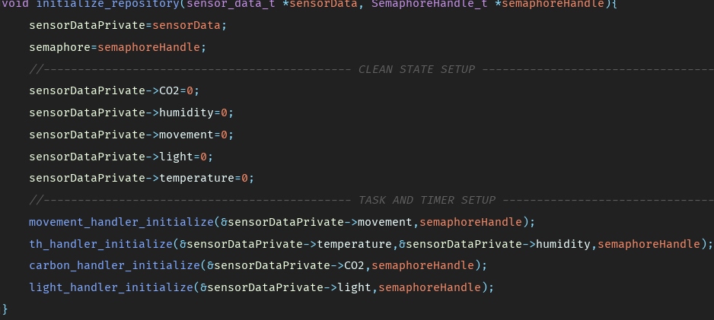The main functionality of the system was the data collection, as mentioned in the design section, the C aspect of the project follows the microservice architecture and utilizes repository design pattern to initialize the data collector, it does this by calling a publicly available method initialize_repository, this method takes in a pointer to a sensor data struct as well as a pointer to the semaphore which is passed along to the specific data handlers. To keep the system maintainable, each sensor has its own data handler which is initialized from the Data Repository class. In addition, each initializer method receives a pointer to a specific sensor-data location, this is done to maintain the separation of concerns and to prevent different data handlers from modifying data that they should not be able to modify, however before they are sent out, data repository ensures that the default values are at 0 by assigning all readings a value of 0, this is done due to the fact that these variables end up storing random values that were present in the memory when the space was allocated by malloc function.

Code Example 1: Data Repository Initialization

Further, due to power-efficiency concerns FreeRTOS tasks were used to toggle sensors between OFF and ON, however because of the decision to use it as the kernel of the device, timing and priorities had to be considered to ensure proper flow of the system, thus every handler have their own priority macro and another one that acts as the time period to wait until performing the task again, the timer is calculated by dividing 954 by the tick rate which is accessed from the portmacro.h header file and then multiplying it be the amount of seconds that the timer should be running for, without multiplying the calculation returns the numbers of ticks required for 1 second, the reason why 954 is divided instead of 1000 is due to the fluctuating crystal oscillator frequencies in the atmega2560 MCU, unfortunately even with modified calculations the amount of delay fluctuates by approximately 50 milliseconds in the absolute worst case, although the average is much lower at approx. 5ms (as tested on two different atmega2560 MCU boards).

Code Example 2: Fluctuating delay

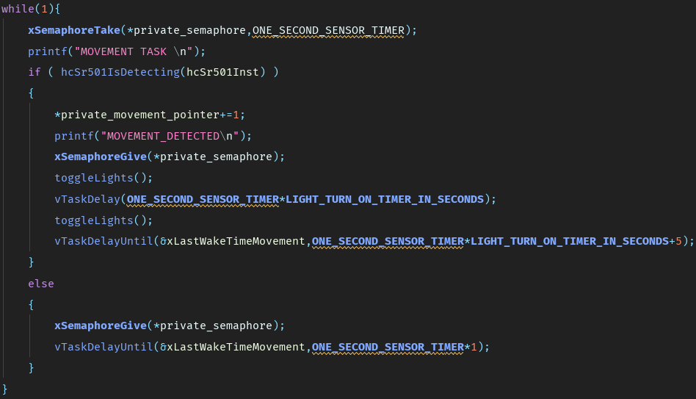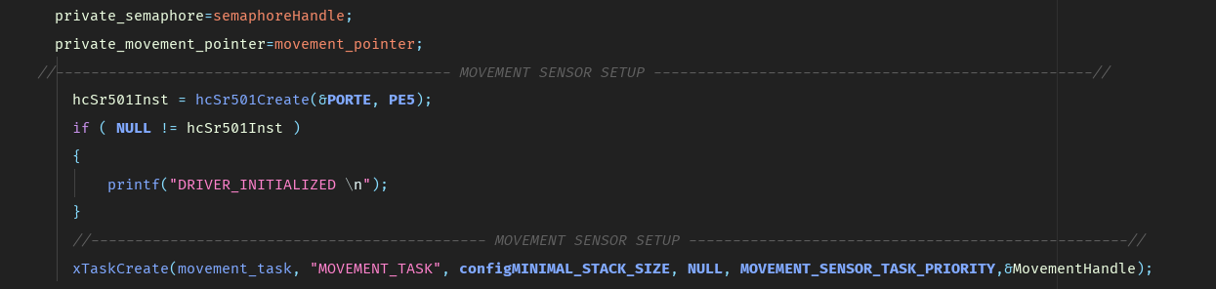Next, as mentioned previously due to the nature of the sensor, the MovementHandler task had the lowest priority available to ensure that if movement is detected and some action is performed by the EventReactor, other sensors could still collect data. Further, the initialization method of the MovementHandler takes care of the driver initialization by calling the hcSr501Create function and passing along the port and the pin that the HC-SR501 sensor is connected to, moreover this function also creates the task that performs the actual reading by passing a reference to the function that the task should perform, name, stack configuration, function parameters, priority macro as well an address of the task handle, which is assigned to NULL by default. Once the task is created and the task scheduler started (which is started after initializing every service in the main function), the function movement_task is then continuously executed every 1 second or every 35 seconds if movement is detected, the reason why there is a 35 second waiting period after a detection is to prevent false detections due to the fact that generally the sensor is checked in such a small period of time. Once the sensor is triggered, the function toggeLights is called twice with a delay in between which determines how long the light should stay turned on which, the light is toggled by moving the servo 90 degrees, waiting a second due to technical limitations of the servo and then moving it back to 0 degrees. … SERVO IMPLEMENTATION DISCUSSION GOES HERE …

Code Example 3: Movement handler initialization

Code Example 4: Movement task function

In order to avoid repetition, every other initialization method will be excluded from this document as they follow the same structure:

1. Initialize private variables to store reading data,
2. Initialize the sensor driver,
3. Create the task.

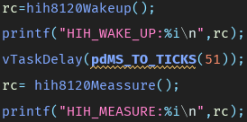Once the temperature and humidity handler is initialized, the function th_task() continuously executes every 1 minute. In this function, the sensor is first woken up and due to technical limitations, the entire task is delayed by 51ms to allow the sensor to warm up before performing a measurement. Once the measurement is taken, functions hih8120GetTemperature_x10() and hih8120GetHumidityPercent_x10() retrieve the actual readings which are then divided by 10 and added to the humidity and temperature values of the sensor data struct, it was decided to ignore the decimal point of the readings because of the low impact that they provide.

Code Example 5: Temperature and Humidity sensor warm up

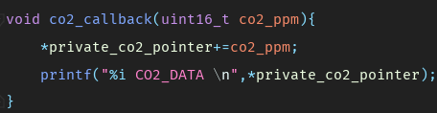 Further, the third data handler that is initialized is the CO2, the main difference between this initializer and the ones mentioned in previous paragraphs is the CO2 driver initialization, unlike most other drivers, this driver requires a reference to a function which is called as a callback whenever a measurement is performed by the sensor, in this case once the callback is executed the ppm is added to the value of co2_ppm in the sensor data struct. once the sensor is initialized the CO2 task is executed continuously every minute.

Code Example 6: CO2 callback function

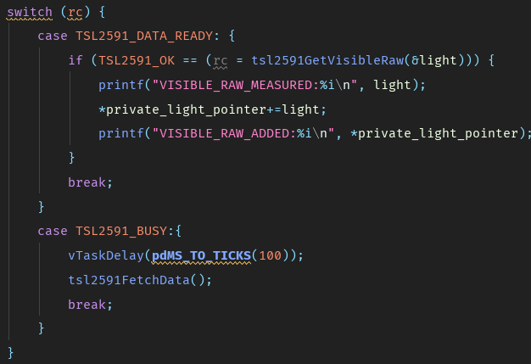 The final data handler that is initialized by the data repository is the light data handler, this handler shares similar characteristics to the CO2 handler as the light sensor driver also requires a callback, however this callback is executed more often, while the CO2 callback is executed only on measurement, the light callback is executed on enable, fetching as well as disabling, more importantly due to shared TWI driver, light sensor has to be disabled while temperature and humidity measurements are being taken and vice-versa. The callback is quite simple, it consists of a variable to store the light reading (whose address is passed to the tsl2591GetVisibleRaw function) and a switch case to determine the return code, when the return code is TSL2591_DATA_READY the value of the reading is added to the value of raw light of the sensor data struct. As with the CO2 and Temperature tasks, the light task is executed every minute during which the sensor is enabled, data is fetched, and it is disabled once again (The busy case will be discussed later in the chapter).

Code Example 7: Light callback function

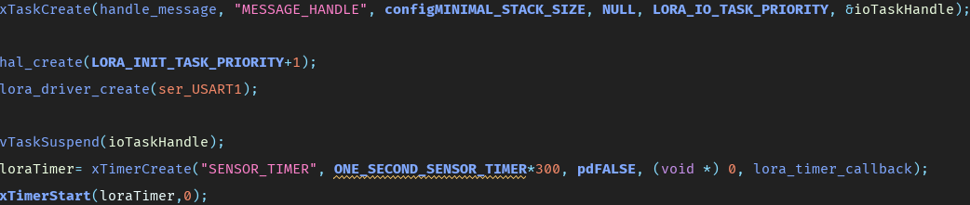 In addition to the data repository service, another core service of the system is the LoraWAN helper service, this service takes care of the communication between the java bridge application. This service takes in a pointer to a semaphore in order to get access to the sensor data struct for send-off, the pointer to said struct as well as a pointer to the preference struct for the downlink message handling. During the initialization process the structure is quite similar to the handler initialization, however one key difference is that the lora helper service task is suspended during the initialization process, this is done to allow the sensor handlers to gather data before connecting and uploading data onto the LoraWAN server. The task is started again once a timer callback is called, the timer in question is also initialized and started in the initialization function of the loraWAN helper, this timer is set to execute once after 300 seconds (5 minutes). Once the task is started, function handle_message is executed continuously every 5 minutes and 1 second (the 1 second is given for data handlers to finish their 5th readings). During the first execution of this function, lora_setup is called to setup the connection. The function performs the following actions in the following order:

Code Example 8: LoraWAN helper initialization function

1. Resets the driver
   1. *It does this by calling lora_driver_reset_rn2483 twice, first by passing the value of 1 and then by passing the value 0.*
2. Reboots the entire sensor and restores all parameters to their default values
   1. *This action is performed by calling lora_driver_rn2483_factory_reset.*
3. Assigns the frequency, data rate, channel, channel frequency, output power
   1. *This action is performed by calling lora_driver_configure_to_eu868. (for more information regarding the values please refer to:*<http://havns.dk/IoT/group__lora__basic__function.html#gad689bb72ab6e665ab420342c16912b82>)
4. Retrieves the HWEUI of the module
   1. *This action is performed by calling lora_driver_get_rn2483_hweui and passing an array of char which is used to store the hweui.*
5. Sets the OTAA identity
   1. *This action is performed by calling lora_driver_set_otaa_identity and passing the HWEUI of the device as well as appEUI and appKEY which are defined as macros in the LoraHelper.c file (40f0e6960ec746d8 and 234cc8845c2087ff6a56deb1f9c1d5b4 respectively)*
6. Joins the LoraWAN network
   1. *This action is performed by calling lora_driver_join function and passing LoRa_OTAA enum, in addition this is put in a for loop and iterated through 4 times.*

In order to prevent battery waste, a switch-case statement is used to prevent pointless attempts to send data when loraWAN network is not joined, this switch case terminates the task if the LoraWAN network has no empty channel available, additionally the task is also terminated if the connection could not be established in 4 attempts. Once the loraWAN connection is established, the data is divided by the amount of minutes that the loraWAN service is delayed for (this is done to send out an average of the readings) and then loaded into a lora_payload_t struct (which consists of an array of bytes) according to the protocol that was designed during the design phase, due to the fact that this array only allows values of 1 byte per index, the CO2 value is separated into two before it is loaded into the array, this is done by using the AND bitwise operator to mask the lower 8 bits of the uint16 value and then right-shifting the higher 8 bits. Once the data is loaded into the struct, lora_driver_sent_upload_message is called in order to upload the struct to lorawan server, when the payload is uploaded to the server the driver also checks if anything was sent to the device, if so parseMessage function is executed which parses the downlink message, however due to limitations in the driver this could not be implemented. Once the uplink/downlink handling is completed, the sensor data struct is reset back to 0.

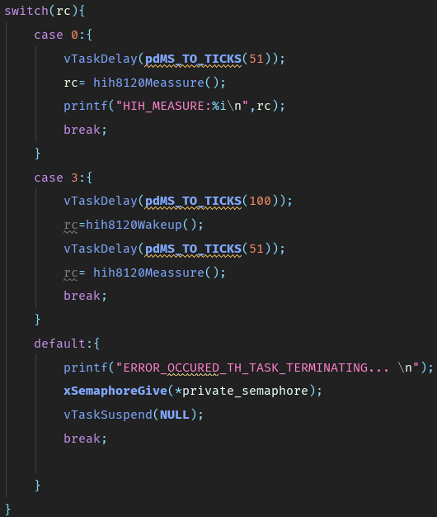 Finally, every task contains switch-cases that take care of critical failures by suspending the tasks, this is done to preserve battery life in an event of a critical failure. In addition to these checks, due to shared TWI bus, extra care is given in order to delay either Light or Temperature/Humidity measurement functions until the bus is freed up, additionally due to expected relatively-high failure rate when joining LoraWAN the process is repeated for a few times, if no free channel is available during the setup process the task simply terminates in order to not waste battery life, however if no-free-channel is detected during data send-off the data is simply reset and the task continues to it’s next cycle.

Code Example : Fail checks

# Embedded C: Testing

The whole system went through an extensive testing process throughout the design and implementation phases of the project. However due to limited access to the driver source, the tests themselves were rather limited. The majority of tests that were performed during the development of the system were white box tests, however these tests were not automated.

During this phase of the project, Z.O.M.B.I.E.S testing practices were used where possible to ensure that each service was tested to its full extent, in doing so, the system is able to inform the user of any fatal error that it encounters by using a serial print out. In the final release of the product, serial print outs should be replaced with error code display on the in-built display on the device itself which would allow all users to view the error codes without having to connect the device to a computer and viewing the serial messages from there.

Finally, as mentioned previously due to the volatile state of the system, all services were tested by hand, thus various test-cases were written to ensure that every data handler behaved as intended. While most test-cases will be covered in the later subsection of this document, the interested reader is advised to refer to the appendices to find the full list of test-cases.

## Test Specifications:

During this subsection of the document, most of the test-cases for the embedded device will be presented, as mentioned previously the full list of test-cases can be found in the appendices.

|  |  |  |  |  |  |
| --- | --- | --- | --- | --- | --- |
| TCID | Scenario | Sensor driver is initialized | Sensor measurement is taken | Expected outcome | Actual outcome |
| 1 | Sensor driver is not initialized | N | N/A | User is informed about the sensor failure and task is terminated | As expected |
| 2 | Sensor driver is initialized, and measurement is taken | Y | Y | Measurement is taken, and callback function is called which adds the ppm to the struct | As expected |
| 3 | Sensor driver is initialized, and measurement is taken but not available | Y | Y | Measurement is taken again | Could not reach state |
| 4 | Sensor driver is initialized, and measurement is taken, and task is re-exectued after 60 seconds | Y | Y | Measurement is taken again after 60s | As expected |

Test Case 1: CO2 Test case

Due to technical limitations in the driver, the measurement was always available due to the fact that there is no real way to check whether the data is available at the moment. Due to similarities in overall structure, the Movement Handler test case will be excluded.

|  |  |  |  |  |  |  |
| --- | --- | --- | --- | --- | --- | --- |
| TCID | Scenario | Sensor driver is initialized | Measurement is taken | Sensor is woken up | Expected outcome | Actual outcome |
| 9 | Sensor driver is not initialized | N | N/A | N/A | User is informed about the sensor failure and task is terminated | As expected |
| 10 | Measurement is taken without waking the sensor | Y | Y | N | System wakes up the sensor and performs a measurement | Old measurement is returned |
| 11 | TWI is busy during wakeup | Y | Y | Y | Task is delayed by 100ms after which sensor is woken up and measurement is taken | As expected |
| 12 | Measurement is taken successfully | Y | Y | Y | Temp and humidity are added to the struct values | As expected |
| 13 | Data cannot be instantiated | Y | Y | Y | Task is terminated | Could not reach state |

Test Case 2: Temperature and Humidity test case

Due to technical limitations of the driver, it is not possible to check if the sensor is awake or not, additionally even if the sensor is asleep, the driver returns the old reading value. Further, during testing of the task, the data instantiation was always available. Due to similarities in structure, the light handler test case will be excluded from this document.

|  |  |  |  |  |  |  |  |  |  |
| --- | --- | --- | --- | --- | --- | --- | --- | --- | --- |
| TCID | Scenario | Sensor driver is initialized | Factory reset performed | EUI configured | HWEUI retrieved | OTAA identity configured | LoraWAN joined | Expected outcome | Actual outcome |
| 18 | Sensor driver is not initialized | N | N/A | N/A | N/A | N/A | N/A | User is informed about the sensor failure and task is terminated | Sensor driver initialization error cannot be detected |
| 28 | LoraWAN send off is performed, downlink is retrieved | Y | Y | Y | Y | Y | Y | User is informed that the send-off was successful and that a downlink is detected. System parses the payload | Driver does not support downlink |
| 20 | EUI configuration failure during setup | Y | Y | N | N/A | N/A | N/A | User is informed about the configuration failure and the task is terminated | Could not reach state |

Test Case 3: LoraWAN Handler test case

Due to the size of this test case, the positive outcome scenarios were excluded. Due to the limitation of LoraHelper driver, it was not possible to determine whether the sensor is created or not before starting the setup process, additionally downlink message retrieval was not supported by the driver thus it could not be tested.