**RC Servo**

To move the light switch when movement is detected DXW90 servo motor (Figure 1) is used. Servo can rotate approximately 180 degrees (90 degrees in each direction). To rotate the servo to the middle position (90 degrees) servo motor needs to receive 2ms pulse. And to rotate it to 0 degrees servo motor needs to receive approximately 1ms pulse (Figure 2). DXW90 servo motor PWM (Figure 3) is connected to Arduino mega 2560 shield connector J15 pin 4 which is OC1A timer pin. VCC (Figure 3) is connected to shield connector J13 pin 2 and Ground (Figure 3) is connected to shield connector J13 pin 1.

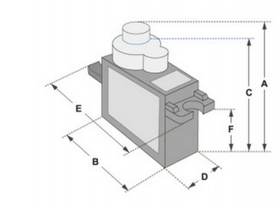

Figure 1 - DXW90 servo motor

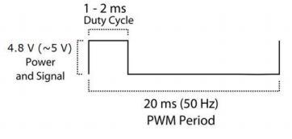

Figure 2 - Signal length

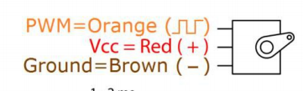

Figure 3 - DWX90 pin out

**RC Servo implementation**

To share servo function declarations servo.h header file consists of 3 methods (Figure 4).

* void initialize_servo_motor()
* void servo_move_to_90()
* void servo_move_to_0()

To implement these methods servo.c file is created (Figure 5). In method void initialize_servo_motor() the servo is being initialized so that the port OC1A can be used (Figure 5). First, the PB5 is set to output, then the top value for the ICR1 is set to 20ms. To move the servo, the pulse of milliseconds needs to be set for the OC1A. At the start it is set to 1ms so that the servo is at 0 degrees. Method void servo_move_to_0() moves the servo to 0 degrees by setting the OC1A to 1ms. Method void servo_move_to_90() moves the servo to 90 degrees by setting the OC1A to 2ms.



Figure 4 - servo.h

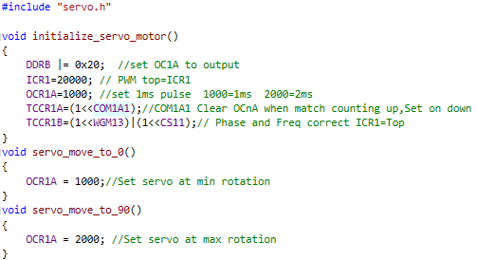

Figure 5 - servo.c