|  |
| --- |
| [Escriba el nombre de la compañía] |
| User Guide: Group 7 |
| **Daniela Koch, 266502**  **Matej Michalek, 266827**  **Michaela Golhova, 266099**  **Michal Karol Pompa, 266494**  **Remedios Pastor Molines, 266100** |
|  |

|  |
| --- |
|  |

**Michael Viuff**

**Mona Wendel Andersen**

1. **CREATE EVENTS:**
2. Click on the button “EVENT”.

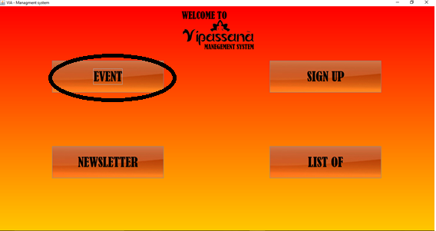

1. Choose the option of the event requested.

Depending on the event which wants to be created, click on the options “Lectures”, “Seminars”, “Workshop” or “Trips”.

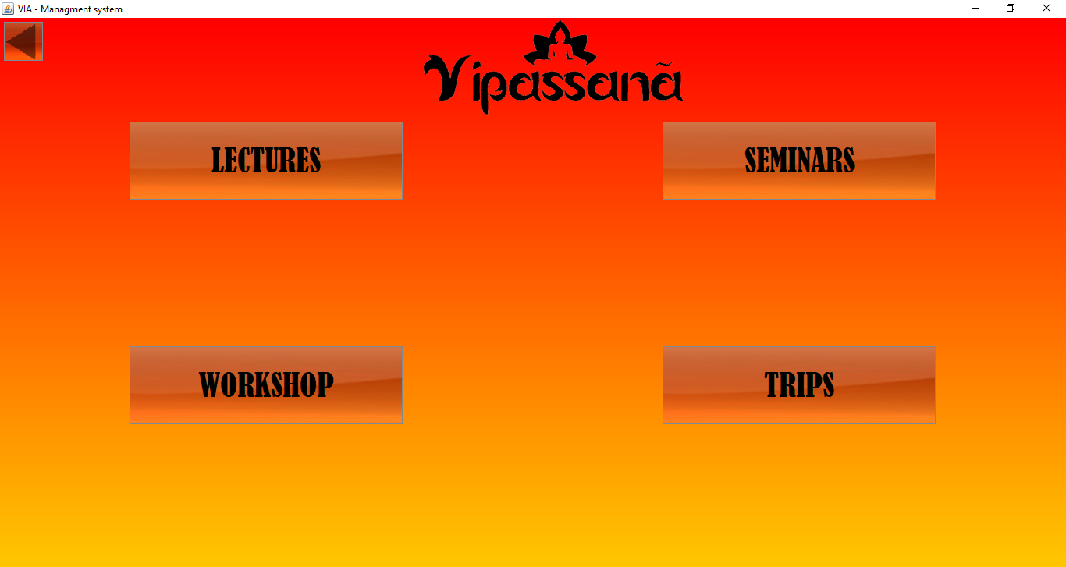

**CREATE LECTURES:**

1. Click on the button “Lectures”.

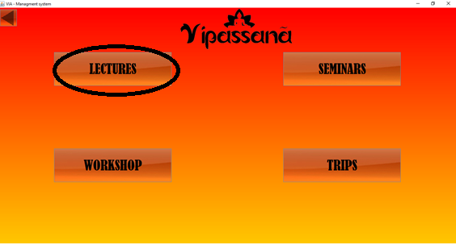

1. Fill the fields “Title”, “Price”, “Nº of Places”, “Start date”, “End date” and “Description”.

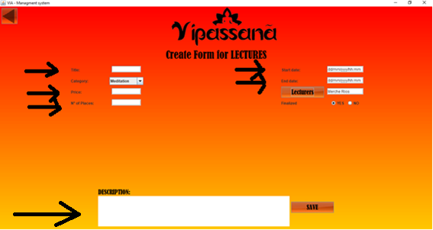

1. In the field Category, choose the option which corresponds to the lecture.

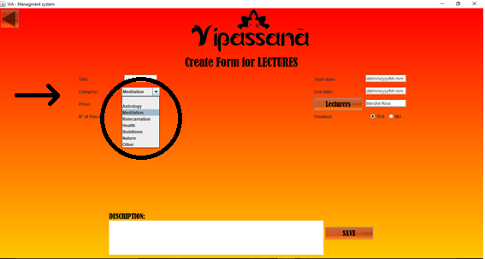

1. In the field “Lecturers”, click the button “Lecturers” to choose the guide.

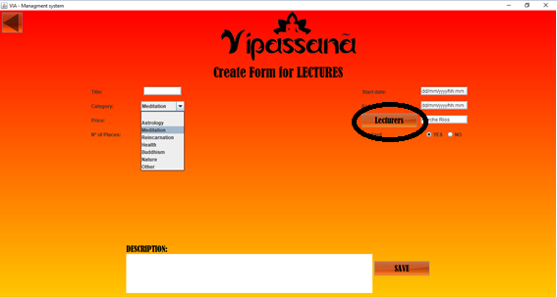

* 1. Once the lecturer is chosen, click on the button “Choose Lecturer”.

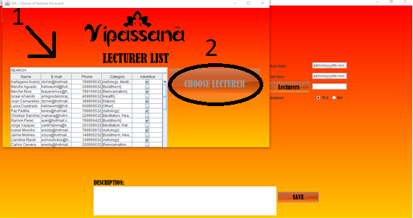

* 1. In the field “Finalized”, click on the option “Yes” or “No”.

https://lh6.googleusercontent.com/0kAh0DQxk01_G-3WmXbyLT5B3A5AOU5pStaDsE-j0MJIgU8YdiAdbEfAsHDi7k4SGaabuGO2rQ8ZVVey0KDHmmOMXBNCO5NhvKr5WOypQe2ldfcNcO51CpoRHOcrhUdRDtLZu1qPlFjyqmNtAw

* 1. Click on the button “Save” to complete the creation of a new Lecture.

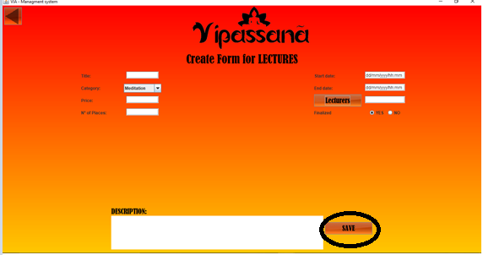

**CREATE SEMINARS:**

1. Click on the button “Seminars”.

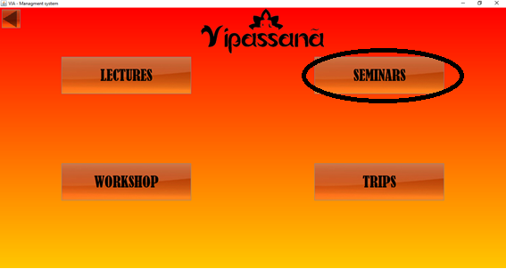

1. Fill the fields “Title”, “Price”, ”Nº Places”, ”Start date”, “End date” and “Description”.

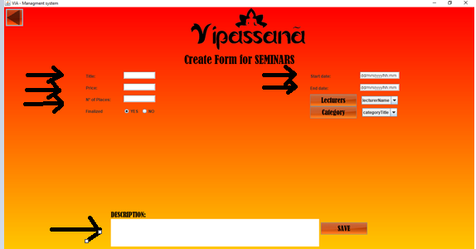

1. In the field “Lecturers”, click the button “Lecturers” to choose the guide.

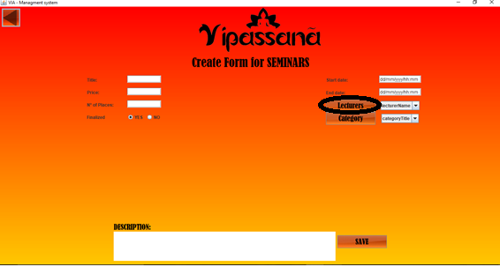

* 1. Once the lecturer is chosen, click on the button “Choose Lecturer”.

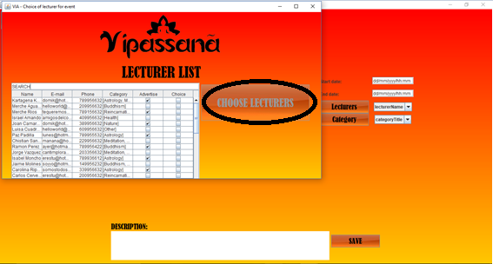

1. In the field “Category”, click the button “Category”.

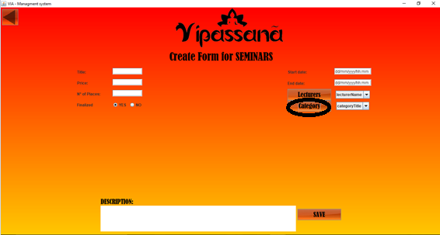

* 1. Choose the categories which will sum up the seminar by clicking on the checkboxes.
  2. Once the categories are chosen, click on the button “Choose Lecturer”.

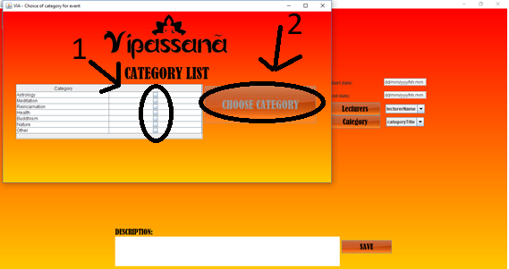

1. In the field “Finalized”, click on the option “Yes” or “No”.

https://lh6.googleusercontent.com/0kAh0DQxk01_G-3WmXbyLT5B3A5AOU5pStaDsE-j0MJIgU8YdiAdbEfAsHDi7k4SGaabuGO2rQ8ZVVey0KDHmmOMXBNCO5NhvKr5WOypQe2ldfcNcO51CpoRHOcrhUdRDtLZu1qPlFjyqmNtAw

1. Click on the button “Save” to complete the creation of a new Seminar.

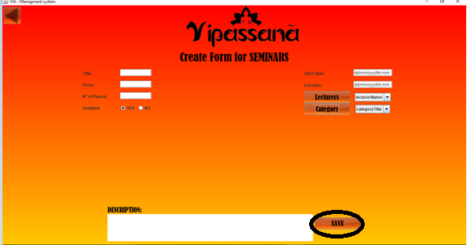

**CREATE WORKSHOP:**

1. Click on the button “Workshop”.

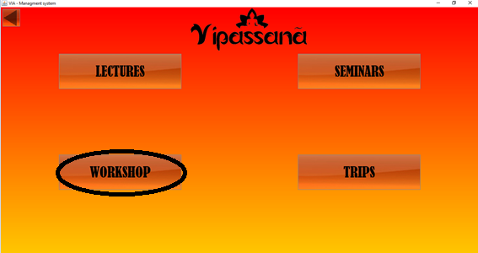

1. Fill the fields “Title”, “Price”, ”Nº of Places”, ”Start date”, “End date” and “Description”.

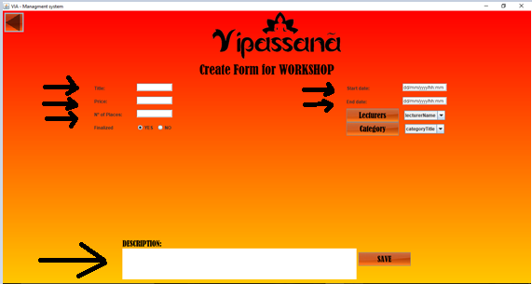

1. In the field “Lecturers”, click the button “Lecturers” to choose the guide.

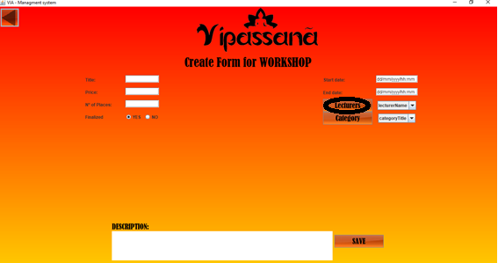

3.1 Once the lecturer is chosen, click on the button “Choose Lecturer”.



1. In the field “Category”, click the button “Category”.

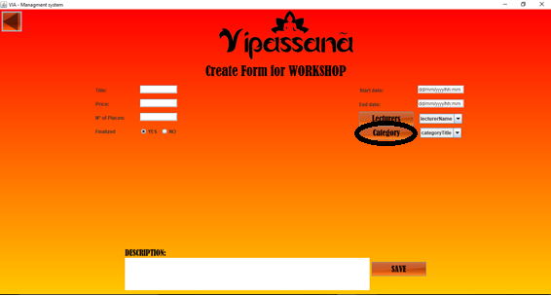

* 1. Choose the categories which will sum up the seminar by clicking on the check boxes.
  2. Once the categories are chosen, click on the button “Choose Lecturer”.



1. In the field “Finalized”, click on the option “Yes” or “No”.

https://lh6.googleusercontent.com/0kAh0DQxk01_G-3WmXbyLT5B3A5AOU5pStaDsE-j0MJIgU8YdiAdbEfAsHDi7k4SGaabuGO2rQ8ZVVey0KDHmmOMXBNCO5NhvKr5WOypQe2ldfcNcO51CpoRHOcrhUdRDtLZu1qPlFjyqmNtAw

1. Click on the button “Save” to complete the creation of a new Workshop.

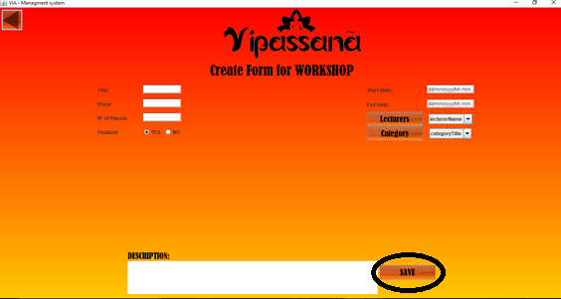

**CREATE TRIPS:**

1. Click on the button “Trips”.

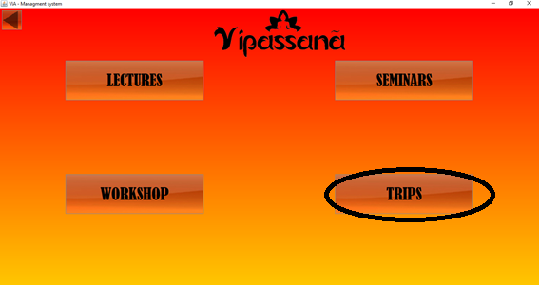

1. Fill the fields “Title”, “Location”, “Price”,  ”Nº of Places”, ”Start date”, “End date” and “Description”.

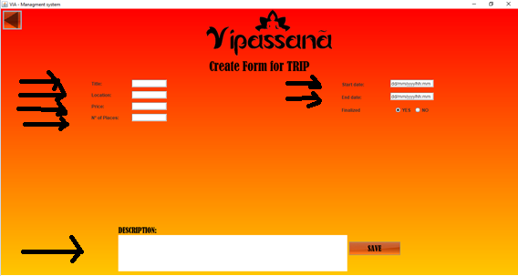

1. In the field “Finalized”, click on the option “Yes” or “No”.

https://lh6.googleusercontent.com/0kAh0DQxk01_G-3WmXbyLT5B3A5AOU5pStaDsE-j0MJIgU8YdiAdbEfAsHDi7k4SGaabuGO2rQ8ZVVey0KDHmmOMXBNCO5NhvKr5WOypQe2ldfcNcO51CpoRHOcrhUdRDtLZu1qPlFjyqmNtAw

1. Click on the button “Save” to complete the creation of a new Workshop.

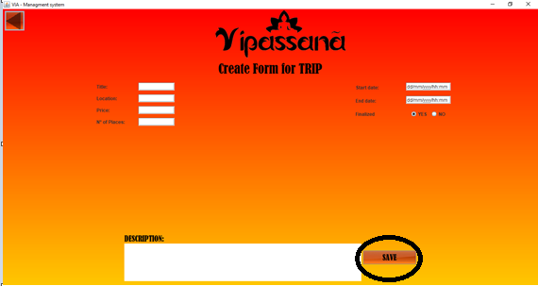

1. **SIGN UP**

**MEMBER:**

1. Click the button “Sign Up”.

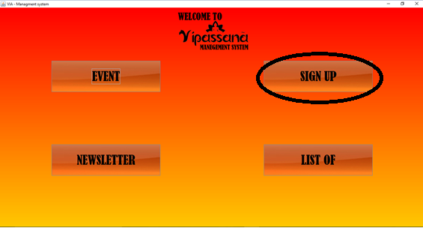

1. Click on the button “Member”.

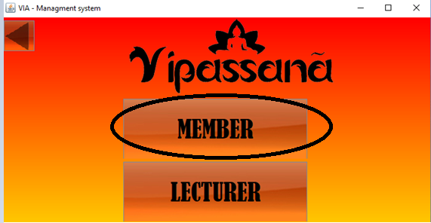

1. Fill the fields “Name”, “E-mail”, “Address”, “Phone” and “Date of Membership” of the person who will joy Vipassana.

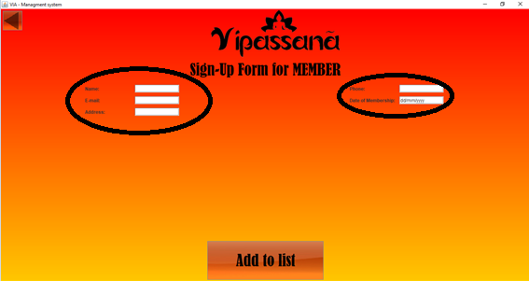

1. Click the button “Add to list” to complete the form of a new member.

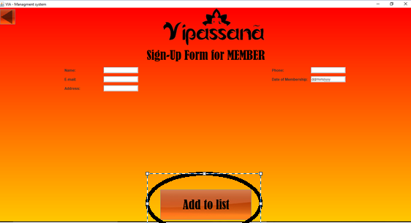

**LECTURER:**

1. Click the button “Sign Up”.



1. Click on the button “Lecturer”.

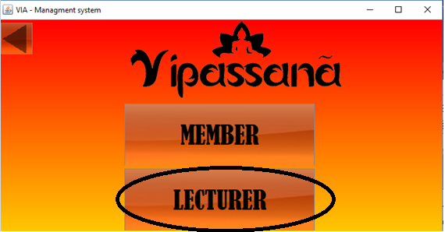

1. Fill the fields “Name”, “E-mail”, and “Phone” of the person who will joy as a lecturer.

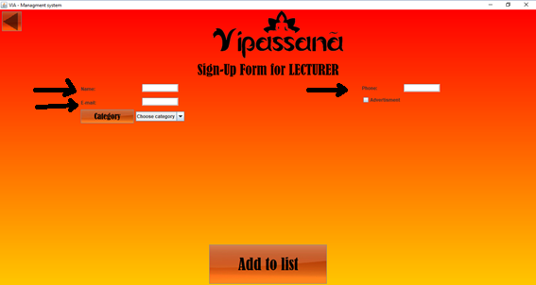

1. In the field “Category”, click the button “Category”.

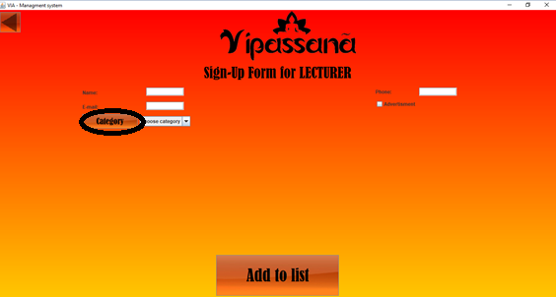

* 1. Choose the categories which the lecturer is specialized at.
  2. Once the categories are chosen, click on the button “Choose Lecturer”.

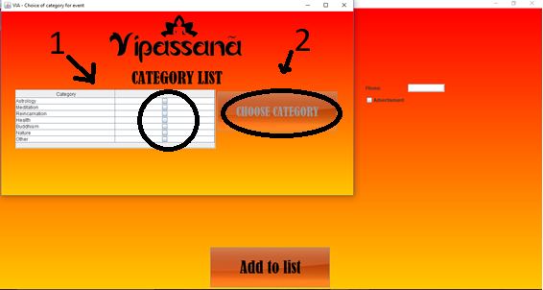

1. Click the checkbox if the lecturer request for receiving advertisement.

https://lh3.googleusercontent.com/twxvgrZo1EmWssENo-PrLi4paGYaA6NQwmCg11_NwHB8lTFjialE6vSwlXlC6kXJI6j2XR-cAikmUGNcuXm1Hwuyxc1NKacXHQ2MuhCeyjKpiKwM_tKoURQ9clFyQ5RsR2SUET6d-uTtQljaTA

1. Click the button “Add to list” to complete the form of a new member.

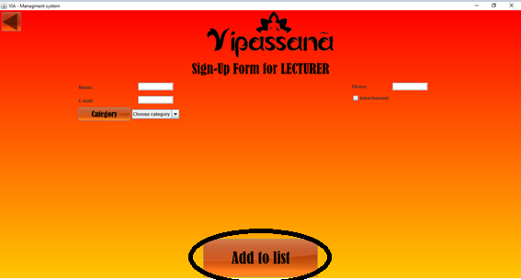

**NEWLETTER:**

1. Click the button “Newsletter”.

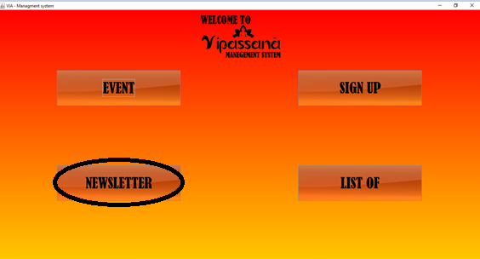

2. To generate a new Newsletter, fill the field “Additional Info”.

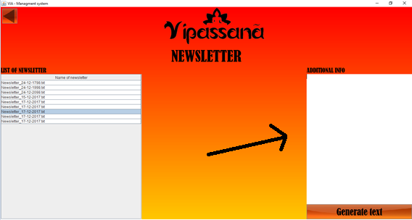

2.1. Click on the button “Generate text” to upload the new information.

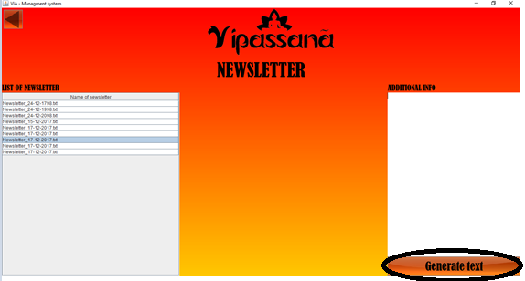

3. Click on one newsletter to see the content in a new browse.

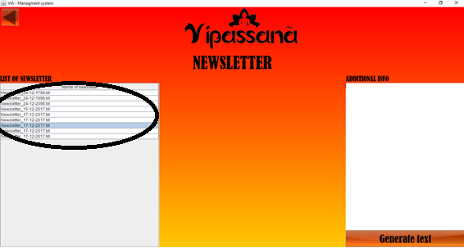

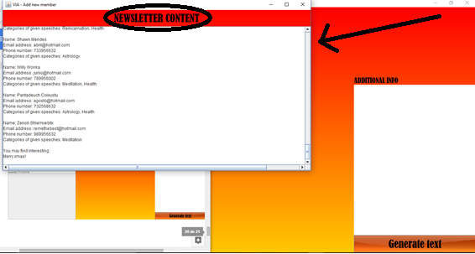

**LIST OF:**

1. Click the button “List of” to look for the participants.

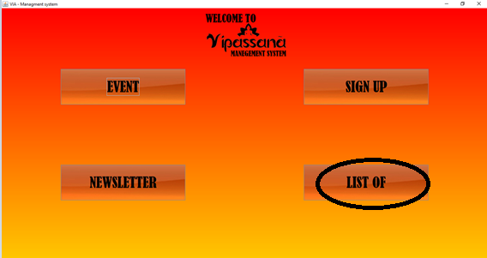

1. Choose the option of the list requested.

Depending on the event which wants to be created, click on the options “Member List”, “Lecturer List”, “Event List” or “Participant List”.

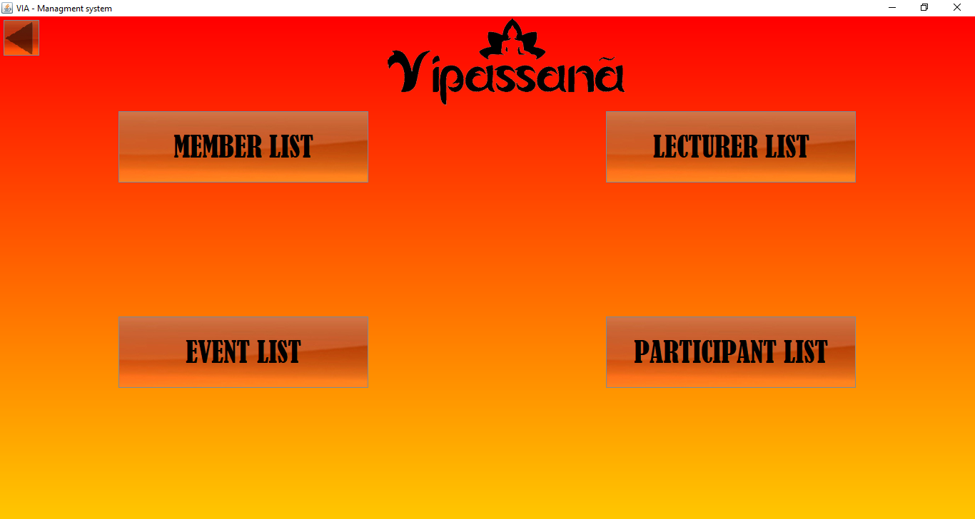

**MEMBER LIST:**

1. Click on the button “Member List” to access to the list of members.

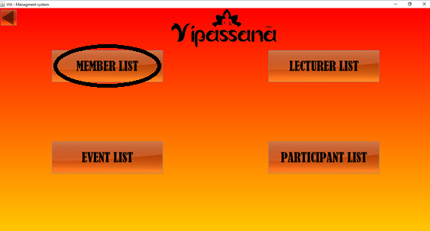

1. Click on the field “Search” to look for members depending on the name or ID number of the member.

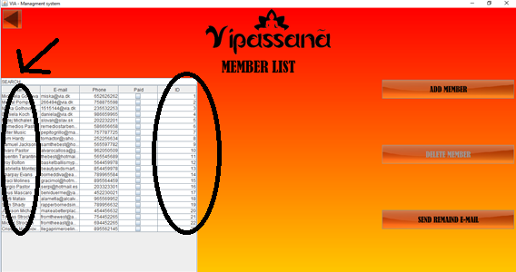

1. To delete a member:
   1. Click on one member.

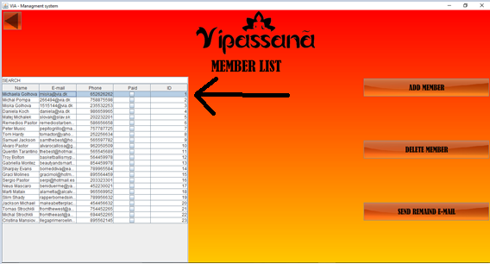

* 1. Click on the button “Delete Member”.

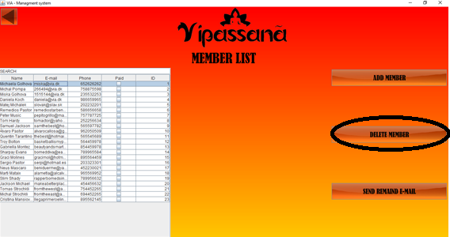

1. To add a member:
   1. CLick on the button “Add member”.

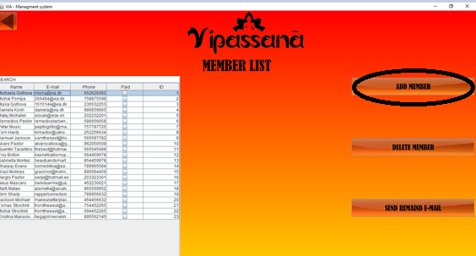

4.2 Add a member (following the instructions explained in “Sign Up-Member”).

1. Click on the check boxes to specify if the member has paid the fee.

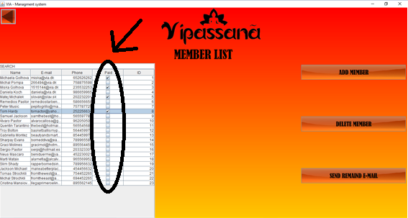

1. To send an e-mail to the members, click on “Send Remaind e-mail”.

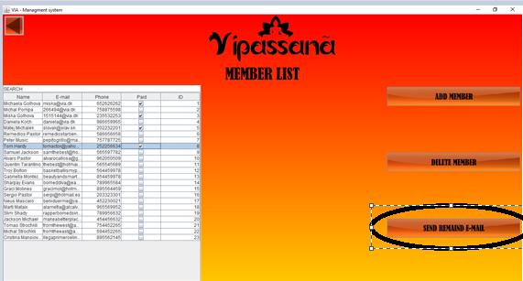

**LECTURER LIST:**

1. Click on the button “Lecturer List” to access to the list of lecturers.

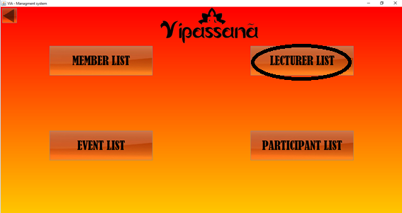

1. Click on the field “Search” to look for lecturers depending on the name or the category that they impart.

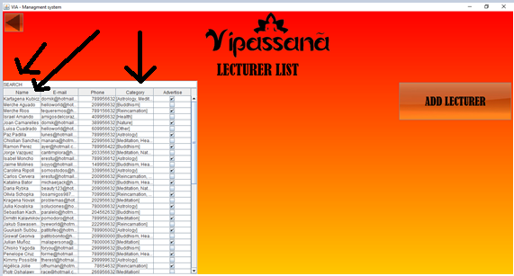

1. To add a lecturer:

3.1. CLick on the button “Add lecturer”.

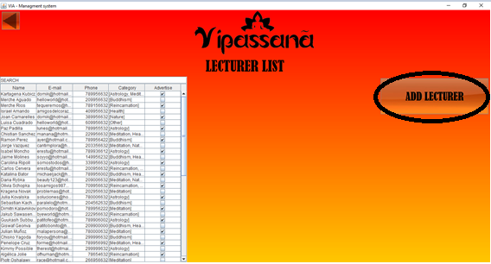

3.2. Add a lecturer (following the instructions explained in “Sign Up-Lecturer”.

**EVENT LIST:**

1. Click on the button “Event List” to access to the list of events.

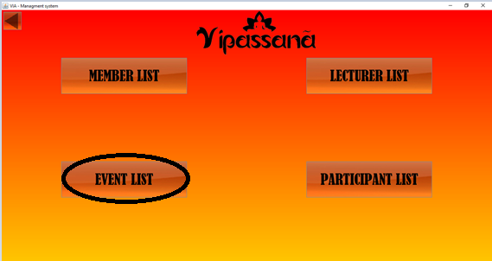

1. Click on the field “Search” to look for events depending on the title of them.

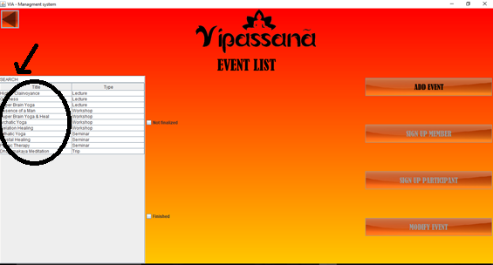

1. Click on the check boxes to screen the events depending on if they are not finalized or finished.

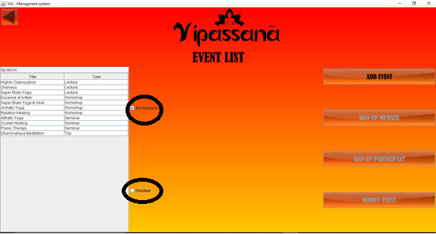

1. To add a member, click on the button “Add Event”, and follow the steps explained in “EVENT”.

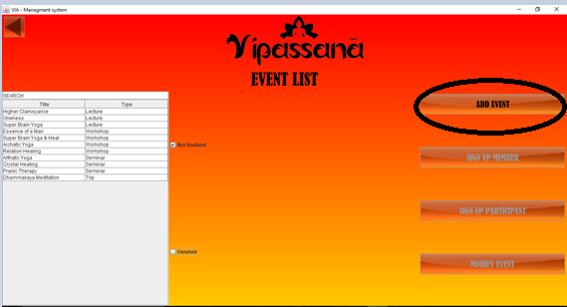

1. To add a member to an event:

5.1 Click on an event.

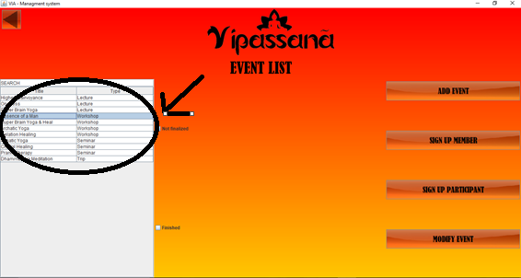

5.2 Click the button “Sign Up Member”.

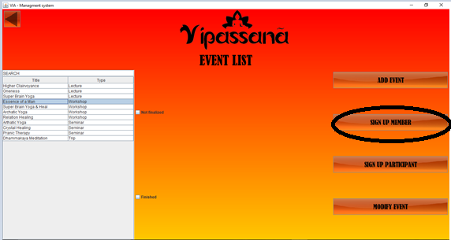

* 1. Add a member (following the instructions explained in “Sign Up-Member”).

1. To add a participant to an event:

6.1 Click on an event.



6.2 Click the button “Sign Up Participant”.

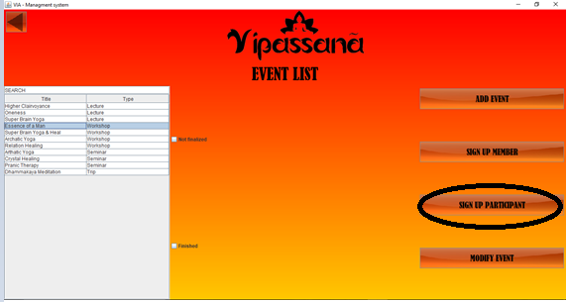

6.3 Add a participant:

6.3.1. Fill the fields “Name” and “E-mail”.

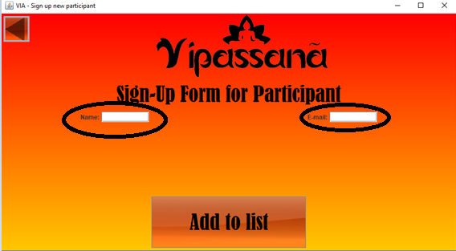

6.3.2. Press the button “Add to List”.

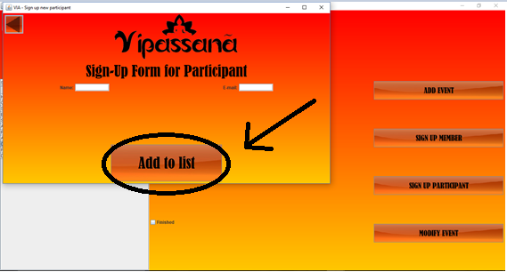

1. To modify an event:

7.1 Click on an event.



7.2 Click on “Modify Event”.

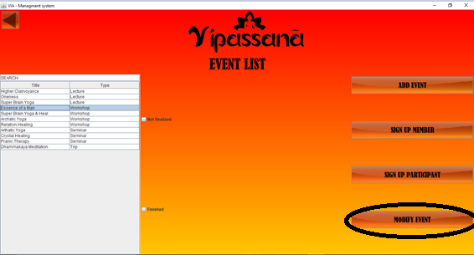

7.3. Make the changes required (following the instructions explained in “EVENTS”).

1. Double click on the events to get more information about them.

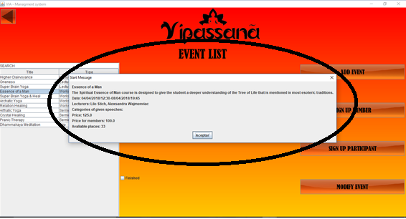

**PARTICIPANT LIST:**

1. Click on the button “Participant list” to access to the list of participants.

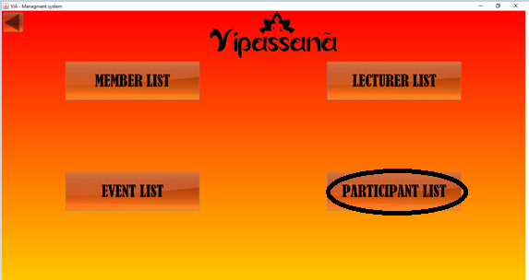

1. Click on the titles of the events.

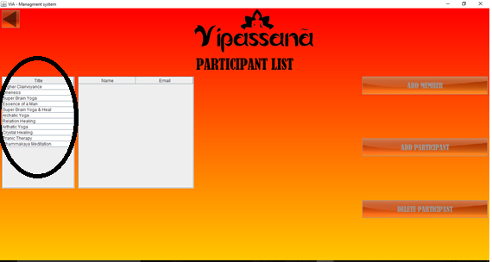

1. Click on the button “Add Member” to access to the general list of members:

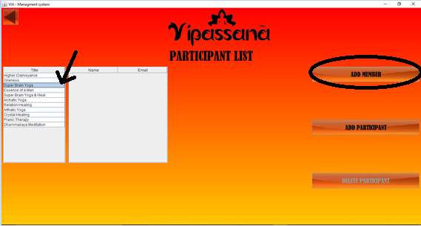

3.1 Click on the checkboxes of members.

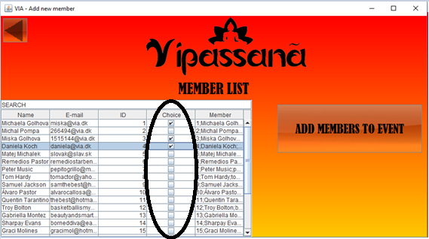

3.2 Click on the button “Add Members To Event”.

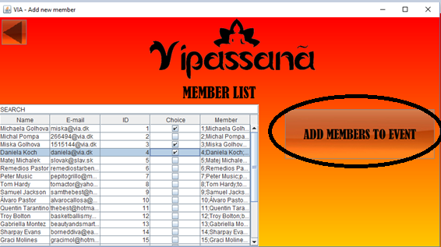

1. To add a participant, click on the button “Add Participant” and follow the instructions explained in “5.3 Add Participant”.

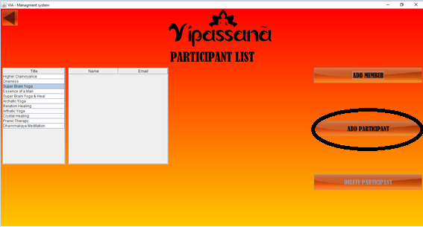

1. To delete a participant, click on the participants of the event and press the button “Delete Participant”.

