CREATE EVENTS:

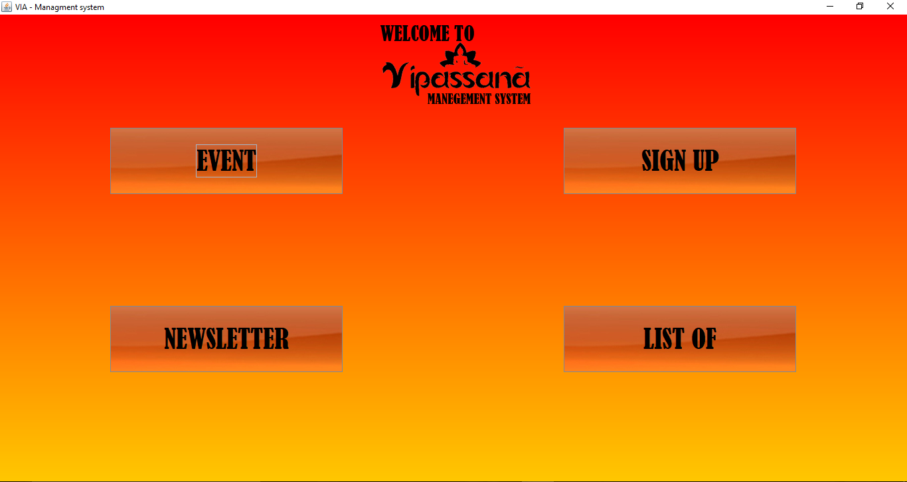

1. Click on the bottom “EVENT”.

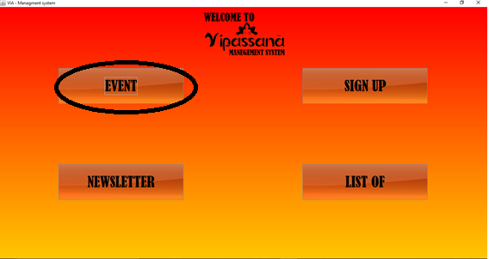

1. Choose the option of the event requested.

Depending on the event which wants to be created, click on the options “Lectures”, “Seminars”, “workshop” or “trips”.

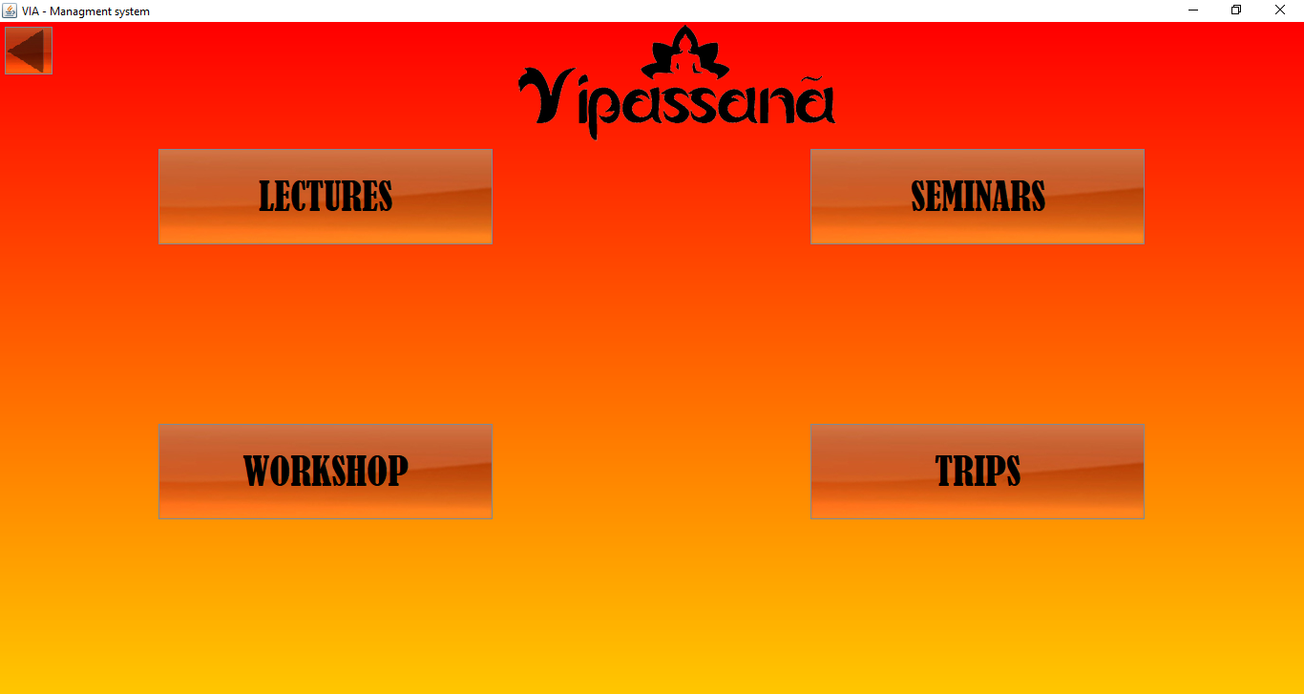

1. Click on the bottom “Lectures”.

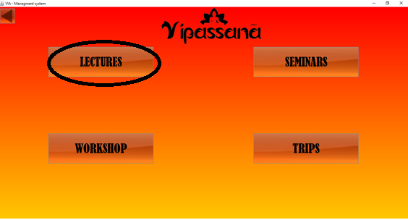

1. Fill the fields “Title”, “Price”, “Nº of Places”, “Start date”, “End date” and “Description”.

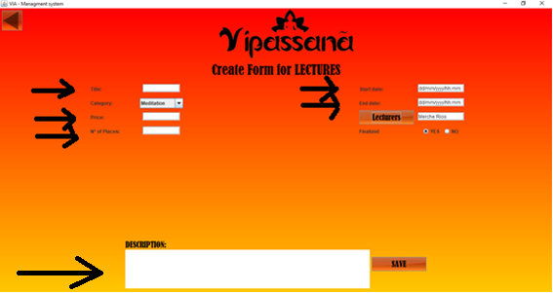

1. In the field Category, choose the option which corresponds to the lecture.

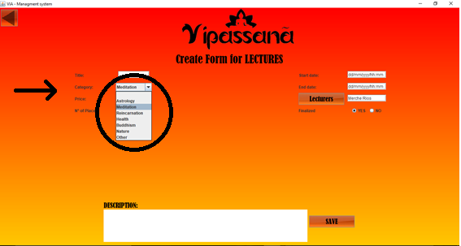

1. In the field “Lecturers”, click the bottom “Lecturers” to choose the guide.

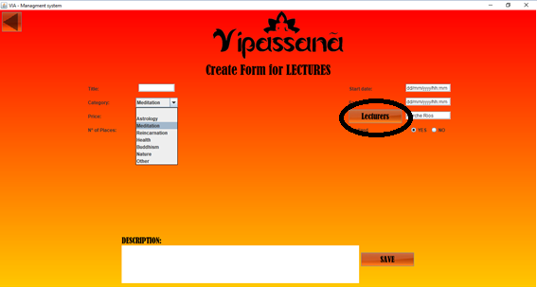

* 1. Once the lecturer is chosen, click on the bottom “Choose Lecturer”.

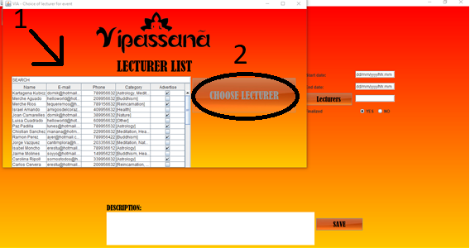

1. In the field “Finalized”, click on the option “Yes” or “No”.



1. Click on the bottom “Save” to complete the creation of a new Lecture.

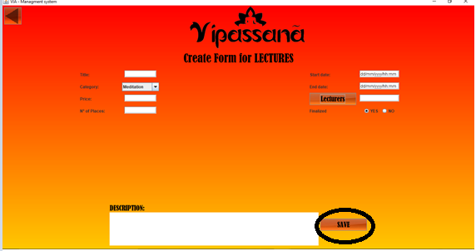

1. Click on the bottom “Seminars”.

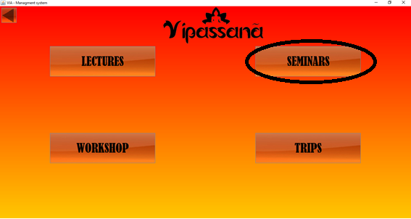

1. Fill the fields “Title”, “Price”, ”Nº Places”, ”Start date”, “End date” and “Description”.

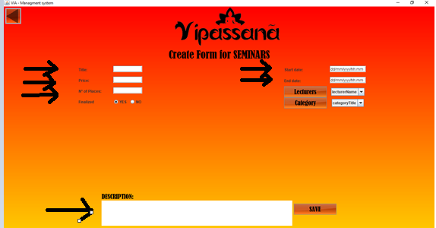

1. In the field “Lecturers”, click the bottom “Lecturers” to choose the guide.

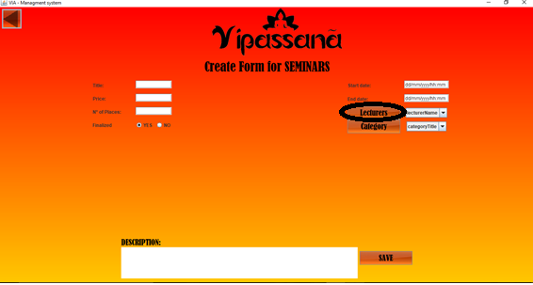

* 1. Once the lecturer is chosen, click on the bottom “Choose Lecturer”.

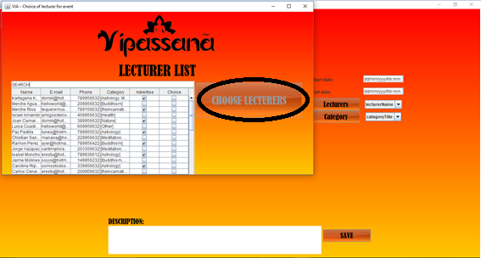

1. In the field “Category”, click the bottom “Category”. 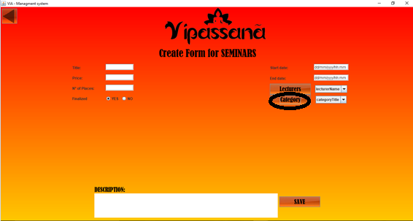
   1. Choose the categories which will sum up the seminar by clicking on the check bokes.
   2. Once the categories are chosen, click on the bottom “Choose Lecturer”.

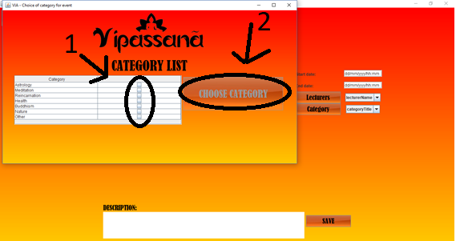

1. In the field “Finalized”, click on the option “Yes” or “No”.



1. Click on the bottom “Save” to complete the creation of a new Seminar.

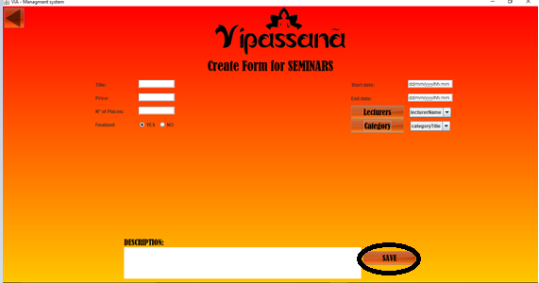

1. Click on the bottom “Workshop”.

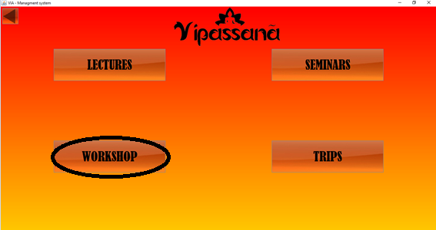

1. Fill the fields “Title”, “Price”, ”Nº of Places”, ”Start date”, “End date” and “Description”.

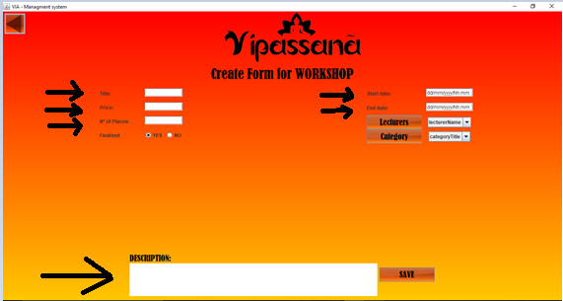

1. In the field “Lecturers”, click the bottom “Lecturers” to choose the guide.

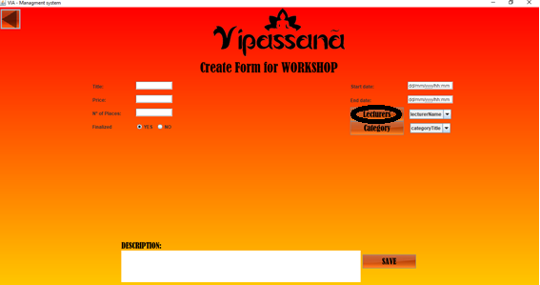

* 1. Once the lecturer is chosen, click on the bottom “Choose Lecturer”.



1. In the field “Category”, click the bottom “Category”.

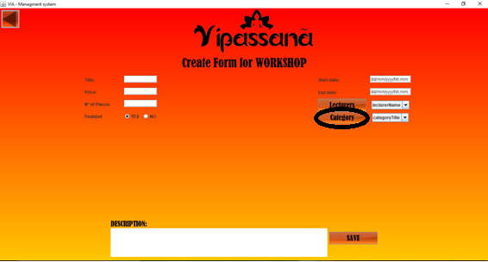

* 1. Choose the categories which will sum up the seminar by clicking on the check boxes.
  2. Once the categories are chosen, click on the bottom “Choose Lecturer”.



1. In the field “Finalized”, click on the option “Yes” or “No”.



1. Click on the bottom “Save” to complete the creation of a new Workshop.

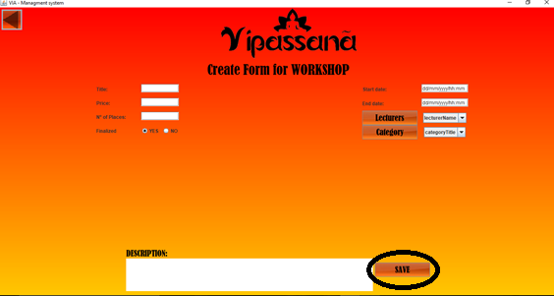

1. Click on the bottom “Trips”.

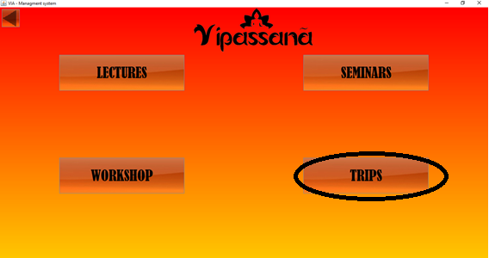

1. Fill the fields “Title”, “Location”, “Price”, ”Nº of Places”, ”Start date”, “End date” and “Description”.

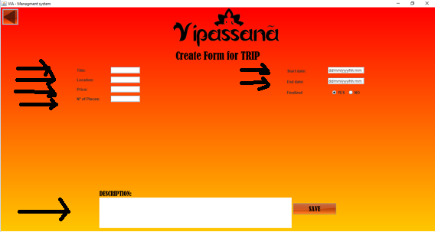

1. In the field “Finalized”, click on the option “Yes” or “No”.



1. Click on the bottom “Save” to complete the creation of a new Workshop.

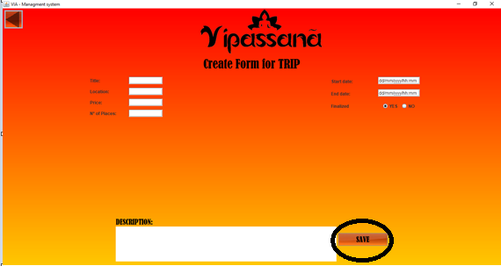

SIGN UP:

1. Click the bottom “Sign Up”.

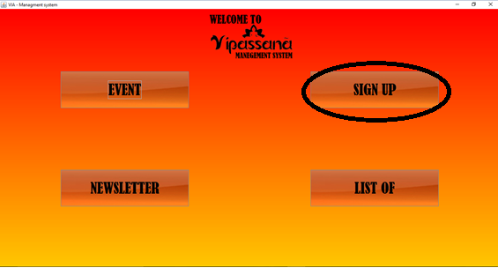

1. Click on the bottom “Member”.

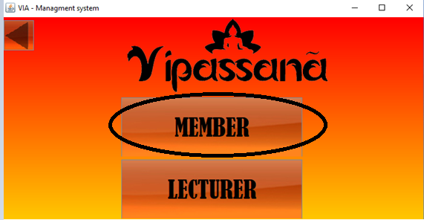

1. Fill the fields “Name”, “E-mail”, “Address”, “Phone” and “Date of Membership” of the person who will joy Vipassana.

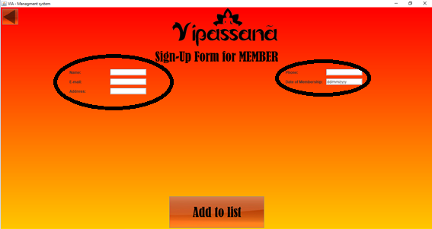

1. Click the bottom “Add to list” to complete the form of a new member.

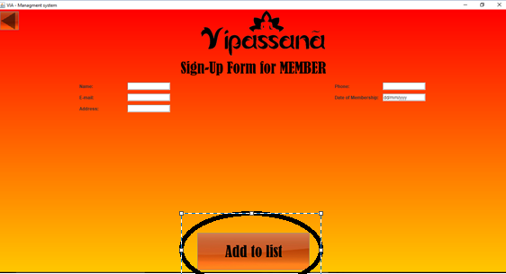

1. Click the bottom “Sign Up”.



1. Click on the bottom “Lecturer”.

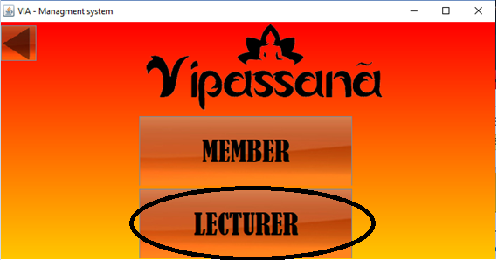

1. Fill the fields “Name”, “E-mail”, and “Phone” of the person who will joy as a lecturer.

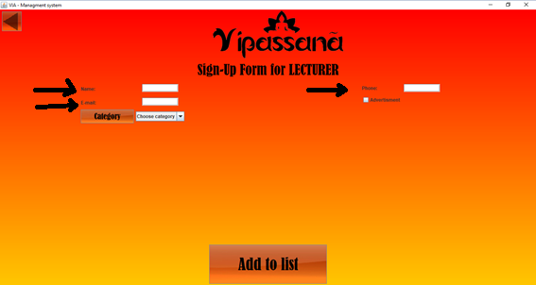

1. In the field “Category”, click the bottom “Category”.

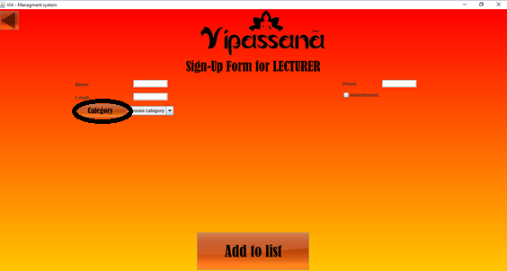

* 1. Choose the categories which the lecturer is specialized at.
  2. Once the categories are chosen, click on the bottom “Choose Lecturer”.

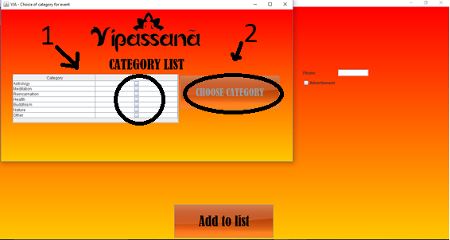

1. Click the check box if the lecturer request for receiving advertisement.



1. Click the bottom “Add to list” to complete the form of a new member.

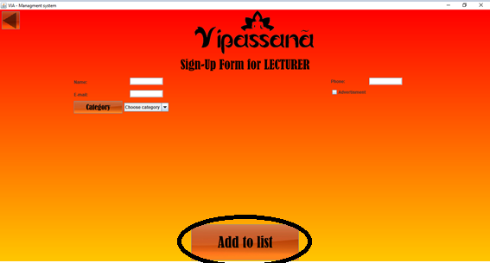

**NEWLETTER:**

1. Click the bottom “Newsletter”.

**LIST OF:**

1. Click the bottom “Lis of” to look for the participants .
2. Choose the option of the list requested.

Depending on the event which wants to be created, click on the options “Member List”, “Lecturer List”, “Event List” or “Participant List”.