Our group consists of five persons: two Slovaks: Michaela and Matej, two Poles: Daniela and Michał and one Spaniard: Remedios. We started as a four-member True Slav Group and increased in number in the end of November by being joined by Reme and becoming an Almost True Slav Group. Even though it may seem as if Poland and Slovakia are very similar due to the fact that they are in a short distance from each other, it turns out that Poland and Spain are closer in the cultural aspect. It is shown on the figure below:

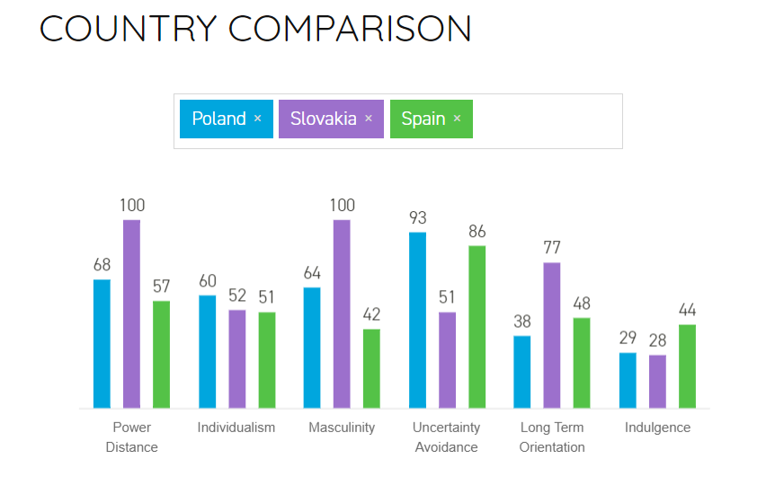However, the differences were not that evident and they didn’t have any negative influence on our work. We are a well-cooperating group and the cultural differences were more often a reason to laugh together then a reason of an disagreement.

Figure 1 Country comparison from https://www.hofstedeinsights.com/product/compare-countries/

What make our group well-cooperating and well-balanced are our Belbin roles. Having taken the Team Role Inventory Test (<https://studienet.via.dk/Class/IT-CSE1V-A17/_layouts/15/WopiFrame.aspx?sourcedoc=/Class/IT-CSE1V-A17/Session%20Material/Belbin%20Team-roles.xls&action=default>), we compared the results with our experience, basing on assignment work in class and the work on the first stadium on the Semester Project. What we found out is as follows:

|  |  |  |
| --- | --- | --- |
| Member/ Belbin roles | The Team Role Inventory Test | The reality |
| Daniela | Shaper, plant | Shaper, team worker, plant |
| Michaela | Everything balanced | Everything balanced |
| Remedios | Team worker, resource investigator | Team worker, resource investigator |
| Matej | Team worker, complete finisher, implementer | Team worker, complete finisher, monitor evaluator |
| Michał | Coordinator, resource investigator, complete finisher | Coordinator, complete finisher, specialist (in case of IT) |

As the table shows, we are a well-balanced group, containing out of almost every possible team role and without many repetitions. What that means, is that we have someone who comes up with new ideas, someone who motivates us, someone who helps resolving problems, someone who provides technical knowledge, someone who double checks the done work, etc. Knowing our Belbin roles helped us also to understand our roles in the group and some of our behaviors. To take an example, knowing that shapers and coordinators usually argues provided us the reason of the arguments between Michał and Daniela.

Having stated the Belbin roles, we entered the initiation part of the project, containing out of creating risk assessments, formulating a group contract and writing the project description. The risk assessments are presented in the table below:

|  |  |  |  |  |  |
| --- | --- | --- | --- | --- | --- |
| RISK | PROBABILITY | IMPACT | EFFECT | RISK REDUCTION ACTIONS | RESPONSE |
| Group member’s illness | Medium | Medium | Time | Divide group work in small tasks | Redistribute group work |
| Technical  breakdown | Medium | Medium | Time, completion of key tasks | Work with reliable technical equipment, Backup important files | Replace with alternative equipment |
| Group member’s sabotage | Low | Medium | Time, concord among group members | Team-buildings | Redistribute group work |
| Unrealistic planning and scheduling | High | High | Time, full project completion | Detailed pre-analysis of time schedule | Postpone deadline |

The reason we made them, was to first of all prevent them from occurring and secondly to be prepared and know how to handle the situation, in the event that any of them occurred. However, another risks came across, to take an example getting a new member. Fortunately it didn’t cause any troubles and just made our group stronger. More of the risks we came across are described further in the document.

The next task we focused at was formulating the group contract (see appendix). It was important to state the ground rules and prevent procedural conflicts. It also helped us to realize what we should do to stay motivated and how to create a friendly work environment. (Developed further in the document)

The last part was writing the project description. It was the first ‘real’ project assignment, i.e. it was the first assignment truly concerning the subject of the project. This was the moment to start discovering our working methods and finding out what works for us the best. From the very beginning we were attaching a great importance to group work. What worked out very well for us was to gather together and brainstorm ideas for the background description, as well as creating the general structure of the text. However, we had to have one person writing it and another taking care of the technical parts and layout. The final point was having it checked by everyone and sharing our opinions on each part. Having received the feedback, we had everyone together correcting the content of the document and one person cutting the background description. Writing the project description did not only teach us how to write a good one in the future (we need to focus on narrowing the information while stepping into a new part), but also it enabled us to start establishing our working methods.

Following the initiation phase was the project execution period. This was when we established our final working methods. Basing on what we’ve learned in the previous stage, they were determined as follows:

1. Gather ideas and formulate the main goals and overall structure together,
2. Divide the work for groups consisting of 1-3 persons,
3. Having everything checked by everyone, i.e. leaving feedback and discussing about individual parts.

Even though the work was divided, we were still meeting together and working at one place. It was one of the undertaken actions to keep us motivated. In order to be productive, staying motivated is required.