**Process report**

**Group 3**

Daniela Koch, 266502

Matej Michalek, 266827

Michaela Golhova, 266099

Michal Karol Pompa, 266494

Joseph Okika

Ib Havn

20 925 characters

Information and Communication Technology Engineering

2nd semester

June 2018

**Table of content**

1 Group Description 2

1.1 Cultural background 2

1.2 Belbin roles 3

2 Project Initiation 5

2.1 Risk assessments 5

2.2 Group contract 6

2.4 Project Description 6

3 Project Execution 7

3.1 Formulating requirements 7

3.4 Technical tools 11

3.6 List of tasks and responsibilities 12

4 Personal Reflections 13

4.1 Michał 13

4.2 Michaela 13

4.3 Matej 13

4.4 Daniela 13

5 Conclusions 14

6 References 15

Appendices

# Group Description

## Cultural background

Our group consists of four persons: two Slovaks: Michaela and Matej and two Poles: Daniela and Michał. It originated in the first semester and because it was believed to be working well, stayed almost unchanged until now. One of the reasons of that are the similarities in the cultural backgrounds of the two countries (Hofstede Insights, 2017). The difference in each aspect differs between 1 and 42 points out of 100 what undoubtedly proves that we come from similar cultures. It is shown on figure 1:

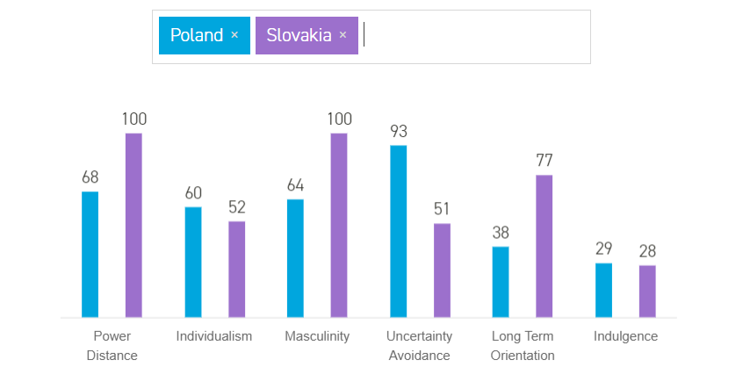

**Figure SEQ Figure \* ARABIC 1 - Country comparison**

**Figure 1**

## Belbin roles

Not only the cultural background, but also the individual characteristics are what make a group work well. In this case, what made us a well-cooperating and well-balanced group were our Belbin roles. Having taken the Team Role Inventory Test (Studynet 2017), we compared the results with our experience, basing on assignment work in class, the work on the first Semester Project and the team role descriptions (Belbin, 2012). What we found out is as follows (Table 1):

|  |  |  |
| --- | --- | --- |
| **Member/**  **Belbin roles** | **The Team Role Inventory Test** | **The reality** |
| Daniela | Shaper, plant | Shaper, team worker, plant, resource investigator |
| Michaela | Plant, everything else balanced | Plant, everything else balanced |
| Matej | Team worker, complete finisher, implementer | Team worker, complete finisher, monitor evaluator |
| Michał | Coordinator, resource investigator, complete finisher | Coordinator, complete finisher, specialist (in case of IT) |

**Table 1 - Belbin roles**

As the table shows, we are a well-balanced group, containing almost every possible team role and without many repetitions. Knowing our Belbin roles helped us to understand our roles in the group and some of our behaviours. To take an example, knowing that shapers and coordinators usually argue provided us the reason of the arguments between Michał and Daniela.

The importance of being well-balanced is that everyone has an unique function they execute and no one has to perform a role not suiting one.

Basing on the Belbin roles and our experience from working together in the first semester, our group roles were defined.

Michał, because he is a coordinator and specialist, was the one coordinating the work: defining the tasks that had to be done and the one who helped when anyone had a problem. He was also keen on gaining new knowledge and using unconventional and more advanced ways of solving tasks and overcoming difficulties. Basing on those behaviours, he was chosen to be the product owner. He was the one writing down the questions and passing them further to the company. Moreover, he had the biggest input on creating the project backlog and sprint backlogs.

Together with Matej, Michał is also a complete finisher, what could have been noticed by how the boys paid attention to details, searched and fixed bugs with determination and were eager to double-check everything one thousand times before hand ins. Matej being a monitor evaluator had those practices even stronger and needed time while making his mind up but his decisions and ideas were always thoughtful.

As Michaela’s top role was plant, she preferred to work alone. She was also the artistic soul in our group and took care of all the visual aspects. On the other hand Daniela being a plant externalized it in a different way. She would challenge most of Michał’s ideas, because she had her own thoughts about how to do particular tasks. It was escalated by the fact that they were a coordinator and a shaper. However, they always eventually came to agreement and chose the option with better arguments, so the disagreements were constructive. What else could be seen of a shaper in Daniela was her pushing herself and others and suggesting to work as much and as productively as possible. This together with the worship of planning and being organised resolved in nominating her the scrum master.

# Project Initiation

## Risk assessments

Having stated the Belbin roles, we entered the initiation part of the project, containing creating risk assessments, updating the group contract, contacting the company and writing the project description. The risk assessments are presented in the table below (Table 2):

|  |  |  |  |  |  |  |
| --- | --- | --- | --- | --- | --- | --- |
| RISK | PROBABILITY | IMPACT | EFFECT | RISK REDUCTION ACTIONS | RESPONSIBLE PERSON | RESPONSE |
| Misunderstanding of needs of the customer | High | High | Time, full project completion | Maintain a constant communication with the customer, detailed analysis | Michał (product owner) | Implement project change |
| Change  in user requirements | Low | High | Time, full project completion | Agreed requirements before | Michał (product owner) | Implement project change |
| Group member’s illness | Medium | Medium | Time | Divide group work in small tasks | Daniela (scrum master) | Redistribute group work |
| Technical  breakdown | Medium | Medium | Time, completion of key tasks | Work with reliable technical equipment, backup important files, backup constantly | Daniela (scrum master) | Replace with alternative equipment |
| Group member’s sabotage | Low | Medium | Time, concord among group members | Team-buildings | Daniela (scrum master) | Redistribute group work |
| Unrealistic planning and scheduling | High | High | Time, full project completion | Detailed pre-analysis of time schedule | Daniela (scrum master) | Take out features |

**Table 2 - Risk assessment**

The reason we made them, was to first of all prevent them from occurring and secondly to be prepared and know how to handle the situation, in the event that any of them occurred.

## Group contract

The next task we focused on was updating the group contract (see appendix 1). We have made it at the beginning of the previous semester and we decided to leave it as it was and just add one statement. The statement was concerning the stressful situation we ended in the previous semester. To avoid it this time, we came up with penalties for ourselves for not sticking to the deadline.

* 1. **Contacting the company**

The most important part of the initiation phase was coming up with an idea for our project. We were lucky enough to be contacted by a real company that needed a system for their school. The following stages were establishing the contact with the company and getting to know firstly about their school and working methods and secondly about their needs. The one responsible for that was our product owner. However, he was not the only one contacting them, as the owners of the company were relatives of one of our team members.

# Project Description

Having established the contact and got to know a bit more about eNTe (which is the school's name) we were able to write the Project Description. As we have discovered the previous semester who is “the master of words” in our group, that person got the job. That was another reason why not only the product owner was contacting the company. Our writer had to gain proper knowledge in order to write a valuable background description and describe the situation and struggled problems correctly, to derive an accurate purpose for the system. The remaining parts of the document were created by the whole group.

# Project Execution

## Formulating requirements

Following the initiation phase was the project execution period. The essential task during this period was formulating the requirements. They were discussed with the customer and changed a few times, as new information were occurring or the vision of the company was clarifying/ changing a bit.

* 1. **SCRUM**

During the project execution period we worked using the scrum approach. Before the SEP period started, each of our sprints was one week long, due to having lectures and other responsibilities and not being able to assign all of our time to the project. That is why the actual time spent on working on the project in this phase was approximately the same as during 3 days during the SEP period. Prior to each sprint there was a sprint planning meeting where the tasks for the next week were being selected. Moreover, each sprint was followed by a sprint review meeting, during which the work done by each member was being discussed. For organising and keeping track of the tasks, Trello has been used. The tasks in the “to do” and “in progress” lists created sprint backlogs and the points assigned to the backlogs that were done were being added to the burndown chart. The daily scrum meeting was made at Facebook and was not made daily, as we did not have enough time to work everyday. As the scrum approach was new to us, we were learning it throughout the whole semester. In the beginning we were not taking notes from the meetings nor helding retrospective meetings and we implemented those to our process later during working.

Our working methods during the SEP period were different than the ones used before. One of the reasons was that we had more time to allocate for the project. That resolved in having 3 day long sprints instead of one week long (so that the actual work time spent on it remained almost the same). We also increased the number of meetings, including daily scrum meetings and retrospective meetings after each sprint. What is more, during some days we were working at one place on our tasks in order to stay more motivated and be able to discuss encountered problems quicker.  
Another reason for changing our working methods was the knowledge we gained about scrum and things discussed during one of the retrospective meetings. The most important change was replacing Trello with YouTrack. There were a few reasons for that. First of all, we had to update the backlog and we would have to change it on Trello either way. Furthermore, we realized that the way we are making our burndown chart is incorrect. We were only assigning points to backlog stories and not to each task separately as well. So at first we wanted to make a new Trello board for the SEP period, but then we were also told by one of the supervisors, that we should not make the burndown chart manually, but use a tool for it. Moreover, Trello started looking a bit messy. That is why we chose to switch to YouTrack. YouTrack is not ideal either, but it generates burndown charts, divides tasks into sprints in separate boards and allows adding tasks inside backlog stories. We changed also our backlog and decided to focus only on the critical stories, moving the medium and extra tasks into delimitations, in order to focus more on the documentation.

* + 1. **SCRUM meetings**

At first we did not do documentation from SCRUM meetings, but we had a “daily/ weekly log”. It is shown in Appendix X. Right before the SEP period our SCRUM master realized that a more proper documentation from the meetings is needed. The documentation is attached as Appendix Y. Having started to document all the meetings, we understood how important it was. It organized both the meetings and our recognition of the work done. Moreover, having the retrospective meetings written down made them more important and actually led to making changes in our working methods.

* + 1. **Burndown chart**

The burndown charts for the SEP period are shown below:

**Sprint 1**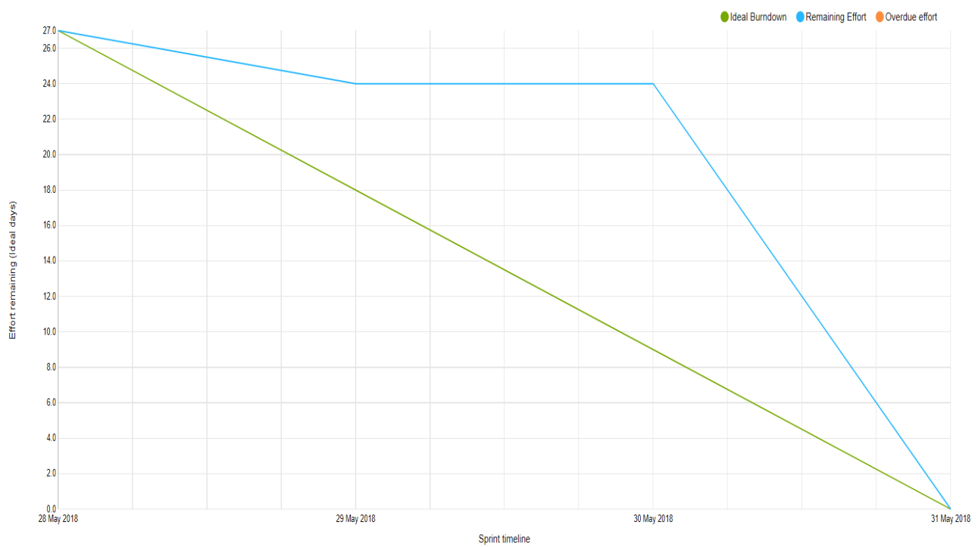

**Sprint 2**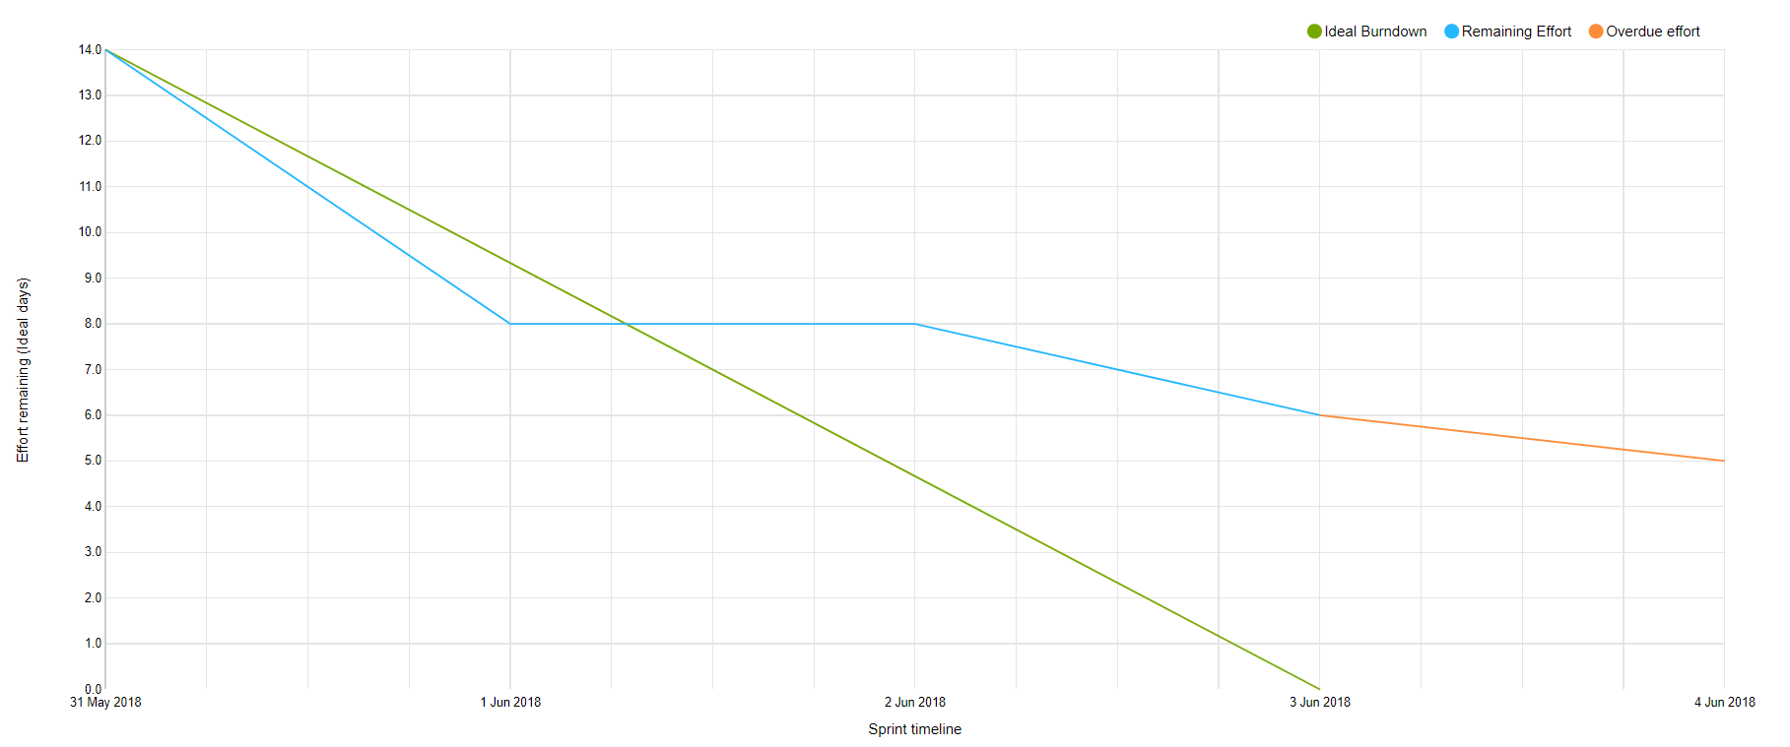

**Sprint 3**

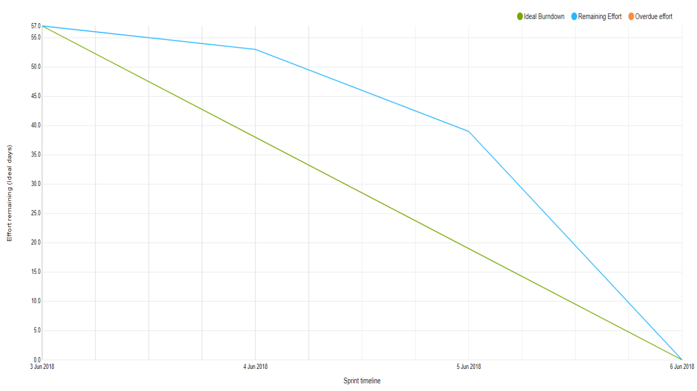

**Sprint 4**

The burndown charts present that we were usually behind at the beginning, but eventually (besides sprint 2) we were meeting the expectations. However, some tasks were usually moved to the next sprint to be finished. The reason why sprint 2 is showing “overdue effort” is the fact, that sprint 3 did not have dates assigned at the beginning, so the tasks were counted still to sprint 2, instead of 3. One of the reasons of being behind on the beginning of the sprints was storing the done tasks in the division “to verify” and waiting for the product owner or SCRUM master to verify them until assigning the points to the charts.

**General**

**Before SEP period**

Before the SEP period, the burndown chart was created and updated manually. It was not a good idea. First of all it was easy to forget to update it and get lost in what already has been added and what not. Moreover, the chart looked messy. Another issue was assigning story points only to specific backlog stories and not each task separately. As a result, the development could not be seen properly. The burndown chart is shown below:

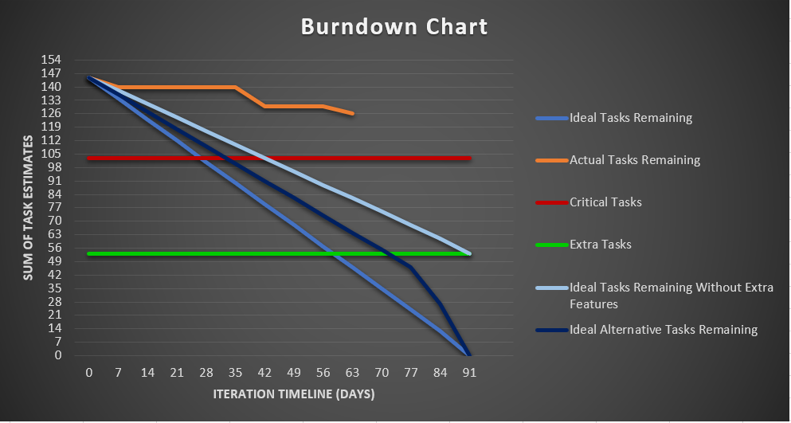

**Figure xxx**

* 1. **Encountered risks**

The working process was not always looking sunny for us. We encountered one third of the risks we were prepared for. First of all, we had a technical breakdown. A keyboard of one of the team member’s laptops was not working properly, what disabled using it. The prime solution was connecting an external keyboard. However, that was not very convenient, especially when it has to be carried. Fortunately, our SCRUM master was going to Poland for the weekend, so she was able to take the laptop with her and get the keyboard replaced.

Another risk we encountered was unrealistic planning and scheduling. As the risk assessment table shows, we took out features and focused only on the critical tasks from our project backlog.

## Technical tools

In the project execution phase we were also using technical tools helpful in working in groups. As mentioned before, we were using first Trello and then YouTrack in the terms of using SCRUM and having a global overview of what needs to be done, who does what and how the work is progressing. Moreover, YouTrack was also used to generate burndown charts. Another tool was Git, which not only has eased working at the same time and making the system consistent, but also was the solution for our ‘technical breakdown’ risk. We went for Google docs while working on and checking text documents, with the same reason as using Git.

* 1. **Working with the company**

As we had a real company, working for us looked slightly different than for most of the groups. On one hand it was easier, in the terms of being able to ask them how they would like a feature to be, when in doubt, but on the other one, it was more complex in the case of them changing their mind on some features, us having to adjust to their vision of the system and us having to understand precisely what they want and what they actually mean by it. One example of a disadvantage of working with a company faced our view designer. She had a view designed that she loved, but the company turned it down and made her change the whole view entirely. Even though she was not keen on the vision of the company, she had to adjust to the customers needs. However, we were glad for the opportunity of making a system that will actually be used and getting the experience of working with a real client.

## List of tasks and responsibilities

# Personal Reflections

## Michał

## Michaela

## Matej

## Daniela

# Conclusions

# References

Hofstede Insights, 2017. COMPARE COUNTRIES. [online],

Available at: https://www.hofstede-insights.com/product/compare-countries/

Studynet, 2017. The Team Role Inventory Test. [online],

Available at: https://studienet.via.dk/Class/IT-CSE1V-A17/_layouts/15/WopiFrame.aspx?sourcedoc=/Class/IT-CSE1V-A17/Session%20Material/Belbin%20Team-roles.xls&action=default

Belbin, 2012. BELBIN. [online],

Available at: https://studienet.via.dk/Class/IT-CSE1V-A17/Session%20Material/Belbin%20reading%20material.pdf

**Appendices**

Appendix 1: Group Contract

Appendix 2: Project Description