17.05.

1. Review meeting:
   * Managing accounts almost done (will be finished next sprint)
   * Documentation of this sprint has to be finished (corrected, organized, by UP)
   * Junit tests from this sprint need to continued next sprint
   * Problems with the adapter discussed
   * Sending emails with passwords almost done (needs to be finished when the user forgot his/her password and the adapter)
2. Retrospective meeting:
   * Tests have to be reviewed, a Junit testing workshop has been scheduled
   * Documentation will be at first in separate docs on google drive divided by UP and at last put together
   * Requirement tests needs to start being written and done
   * Backlog stories should be numerated, to have clean sprint tasks
   * Methods in the class diagram should be added (update)
   * Ask supervisor: doc from meetings (are all tasks done and to do needed to be mentioned?; project report: “divide by scrum”, by main parts of the system; diagrams- methods that don’t have to be shown
   * Focus on finishing tasks from the previous sprint
3. Planning meeting:
   * Finish tasks from the last sprint
   * After the tasks have been finished- start a new backlog story- *As a student I want to be in my class so that I can access information which belongs to my class*
   * How the class works: enum class, each student has a class as a field and the posts have ArrayLists of the type of class, while creating posts- assign to class, when a student wants to see his/her classes posts, the system goes through all posts and checks the field class
   * Descriptions for requirement tests (how the system will behave, what will happen)
   * Sprint backlog:
     + document how the login works (analysis, design, implementation, test) see also description (finish)
     + Doc View (finish)
     + Sequence diagram for (?)(finish)
     + document builder (finish)
     + document why family was needed (finish)
     + Correct backlog
     + Finish all Junit tests
     + update adapter to handle managing users (finish)
     + ADAPTER: load database data (finish)
     + doc to managing users
     + document connection
     + Communication for families
     + Numerate backlog stories
     + Doc Communication
     + Update class diagram with methods
     + upgrade MyDate with minutes and hours
     + Rename classs to classNo
     + Requirement test descriptions

24.05.18

1. Review
   * document why family was needed
   * document builder
   * communication for families
   * updated tests - family, builder, users
   * doc View part I
   * Analyze cases in connections in terms of data
   * Numerate backlog stories
   * Correct backlog
   * Rename classs to classNo
   * Update class diagram with methods
   * tests to managing users
   * Requirement test descriptions- started, showed that backlog stories and use cases will have to be updated
   * update adapter to handle managing users
   * ADAPTER: load database data
   * test adapter
   * document managing users in DB
   * document connection to DB
   * the rest of the tasks will have to be finished during the next sprint
2. Retrospective
   * idea concerning separating done in each sprint in trello has good reviews
   * we need to move tasks to delimitations and focus on the most important features
   * we need to plan work for the project period- when to meet, how to work, what to do
   * not using trello during the next project, finding another tool
   * we need to update the class diagram every time we do anything in code!!!
   * we need to focus on updating all diagrams (class diagram, use cases, backlog stories, activity diagrams, requirements, everything :) )
3. Planning (until Monday or for Monday, on Monday a new backlog for SEP period):
   * update diagrams - together on Monday
   * Requirement test descriptions
   * a new burndown chart for the SEP period - Monday
   * a SEP period backlog - Monday
   * document how the login works (analysis, design, implementation, test) see also description - finish
   * finish tests
   * doc to managing users
   * Sequence diagram - log in
   * Communication with sockets - document
   * upgrade MyDate with minutes and hours
   * Core for project report (maybe together design it and then Daniela continue with words) - Monday
   * Update process report concerning docs from SCRUM meetings and burndown chart issues
   * Start homework

31.05.18

1. Review
   * The done tasks are presented in the photo below:

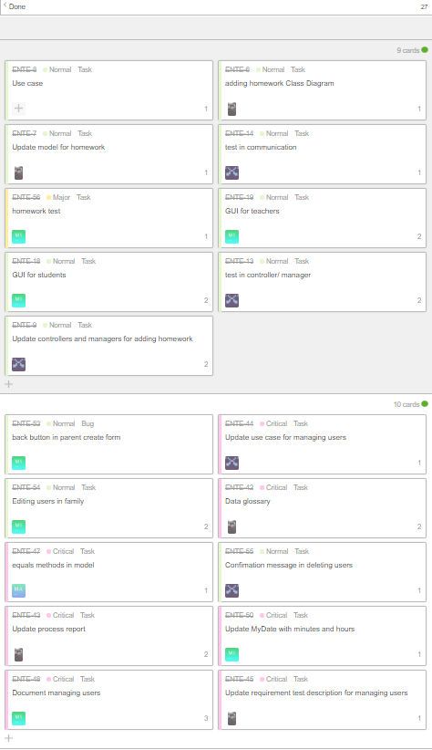

* + Adapter has to be finished in the following sprint
  + The other tasks that were not finished was the documentation due to deciding to do it after having done the core of the project report and making it there

1. Retrospective
   * YouTrack is a better tool than Trello, every member appreciates the change. The solution with burndown charts there is also very convenient
   * One of the good things was finishing all tasks from previous sprints (besides the documentation)
   * Both working together and separately was tried, separately is more appreciated, cause our apartments are too small. However, we are more motivated and concentrated while working together, but sometimes we are also distracted by each other. The solution may be working together and after a specific period of time (when we get tired) taking a break for some air and movement.
   * The amount of tasks was not distributed properly, some members spent more time than others. A good option may be working together on one task and one person may do implementation, while the other does the documentation and the members communicate with each other
   * Cooking together while working together was a good idea, it saves time
2. Planning (until Monday or for Monday, on Monday a new backlog for SEP period):
   * The core for the project report (31.05)
   * Inputting the done documentation into the project report (31.05)
   * Sequence diagrams for managing users
   * Starting backlog story: “As a student I want to see the homework for my class so that I can submit it” (1-2.06)
   * Start the User Guid

3.06.

1. Review
   * core and beginning of the project report (most of analysis and design input and adjusted, introduction, requirements copied)
   * GUI homework reply for students and teachers
   * updated process report
   * database updated (homework and homework reply)
   * adapted hasn’t been updated (homework and homework reply)
   * class diagram has started to be updated (design and verifying)
2. Retrospective
   * updating db was forgotten
   * problems with testing the adapter (if the data is casted correctly) - mock Database class
   * more attention should be paid to naming files
3. Planning (until Monday or for Monday, on Monday a new backlog for SEP period):
   * updating the db
   * update the manual
   * delete unused GUI
   * add activity diagrams
   * add sequence diagrams
   * work on the project report
   * update the process report
   * finish adapter
   * continue with updating the class diagram

6.06.

1. Review meeting
   * The done tasks are as follows:

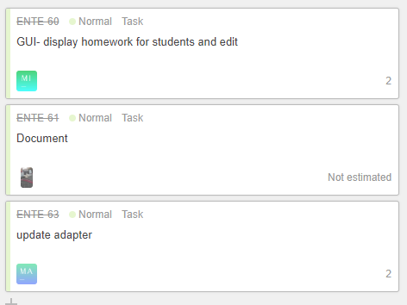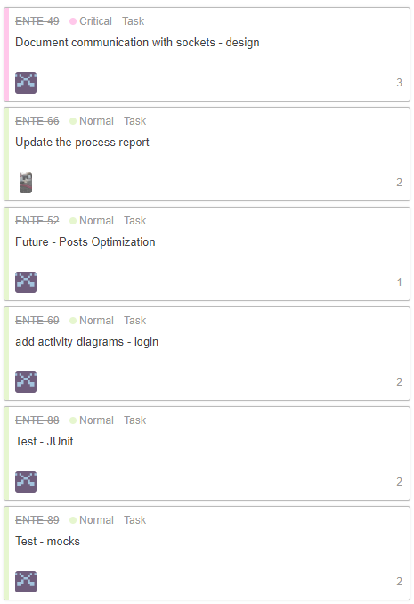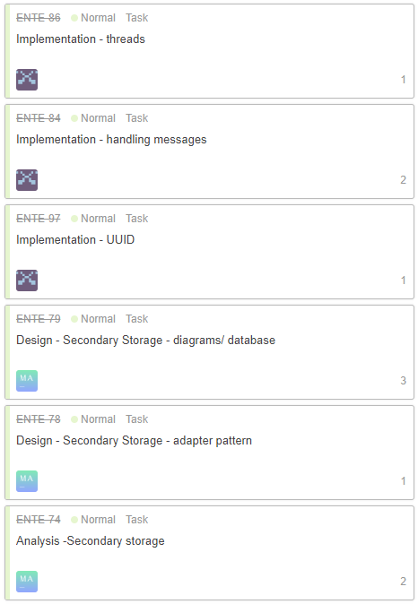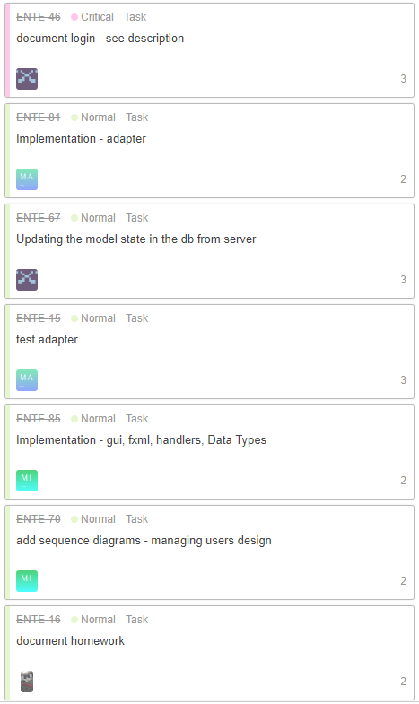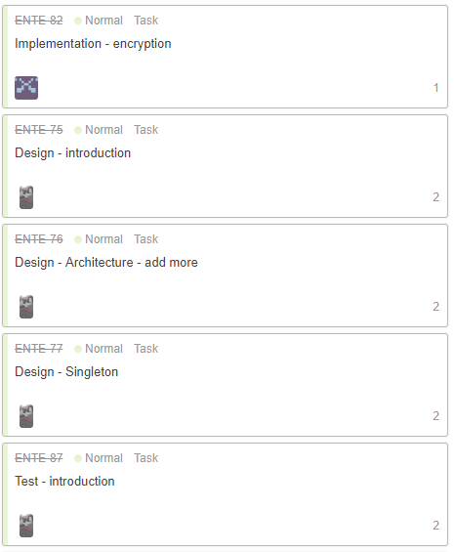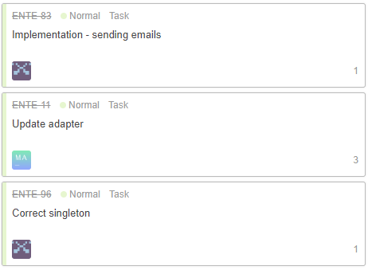

* + Not all tasks have been completed and will be finished today

1. Retrospective meeting
   * This sprint was a good sprint, everyone did a lot
   * The fact that the tasks were separated a lot, it seemed that there is more to do and we were more motivated
   * The documentation is almost finished what is very positive
2. Planning meeting
   * Create a teacher’s account in the system
   * Create a parent’s account
   * Finish req test desc
   * Check the not tested req test desc
   * Write personal reflections
   * Write conclusion for process report
   * Write conclusion for project report
   * Input burndown chart in process report and comment it
   * Write result and discussion
   * Write abstract
   * Finish future
   * Finish checking the class diagram and code
   * Making jars from code
   * Inputting all docs in layout
   * Example of use cases in requirements