|  |
| --- |
| **eNTe**  **User Manual** |

**[Michaela Golhova 266099]**

**[Michal Pompa 266494]**

**[Matej Michalek 266827]**

**[Daniela Koch 266502]**

**Table of content**

1. INTRODUCTION 3

2. LOGIN TO SYSTEM 4

3. HOME PAGE FOR STUDENT AND HOMEWORK 5

3.1. HOME PAGE FOR STUDENT AND DISCUSSION 6

4. HOME PAGE FOR PARENT 7

5. HOME PAGE FOR TEACHER 8

5.1. CREATE A HOMEWORK 9

5.2. CREATE A DISCUSSION 10

5.3. CREATE AN ANNOUNCEMENT 11

6. HOME PAGE FOR ADMINISTRATOR 12

6.1. CREATE NEW STUDENT/PARENT 13

6.2. EDIT USER 14

6.3. DELETE USER OR FAMILY 15

1. INTRODUCTION

This document contains all information about an usage of **ente application**. Following descriptions will guide you through whole software and its functionalities.

Before you start using this application, please, read following instruction carefully.

**WARNING:**

This application is made for all students, parents and teacher of ente school. Do not try to entry to the application if :

* you are not a student/parent/teacher of the mentioned school
* yours account is not created yet

In case of any problem with usage of the application, please contact administrator.

Note that system doesn’t provide every functionality yet. From that reason, they are not explain in this manual. They will be added later.

1. LOGIN TO SYSTEM

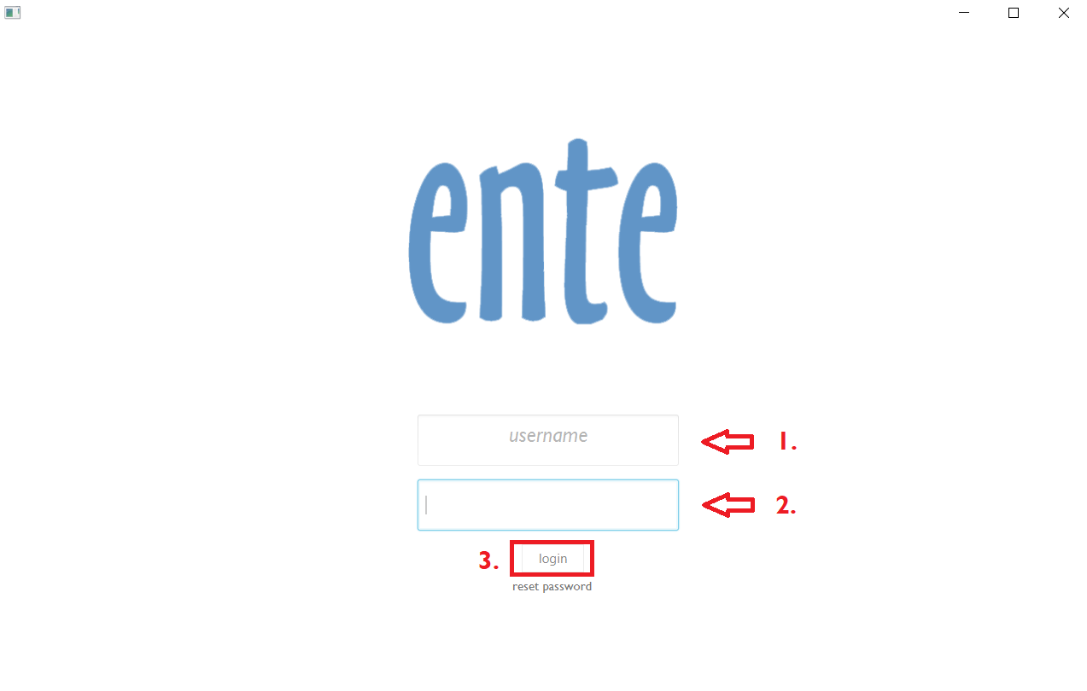

For login to the system you need to fill following information : **1.username**(which is your email address) and **2.password.** Then press the button **3.login.**

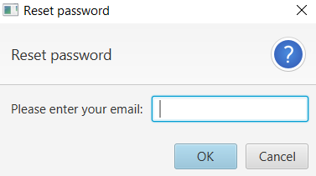

If you forgot your password, click **reset password** which is under *login button.*

Then write your email address to an empty text field and you will received an email with a new password.

1. HOME PAGE FOR STUDENT AND HOMEWORK

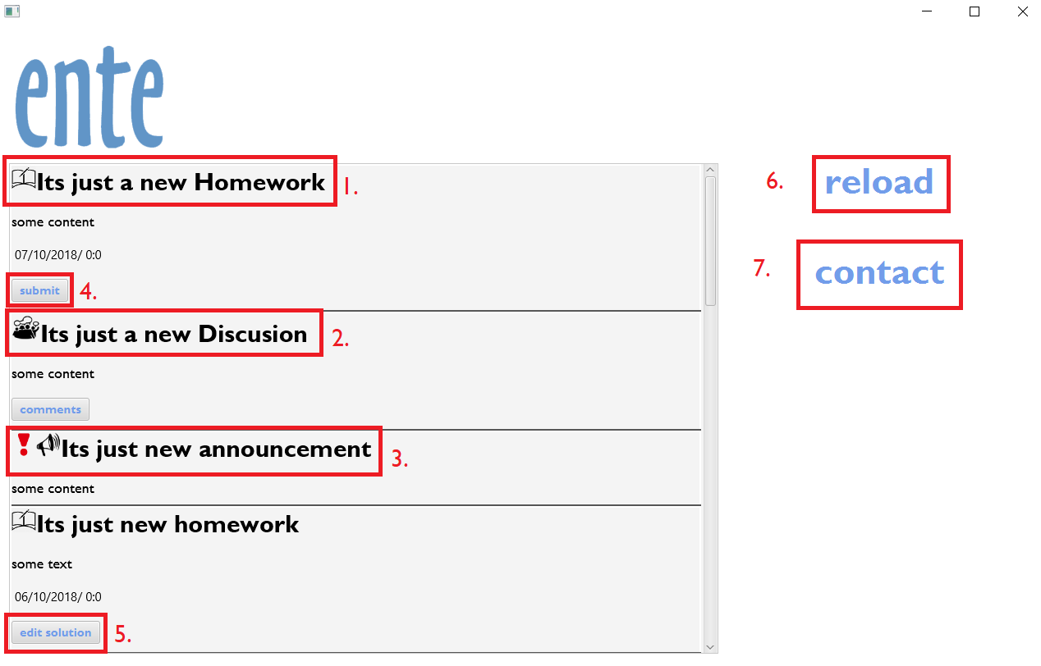  
The student main page contains panel with **1.homework, 2.discussion** and **3.announcement**. (**Red exclamation mark** means that announcement is important). Homework has **title, content, deadline** and **4.submit button.** As a student you must submit your homework until deadline above the *button submit*

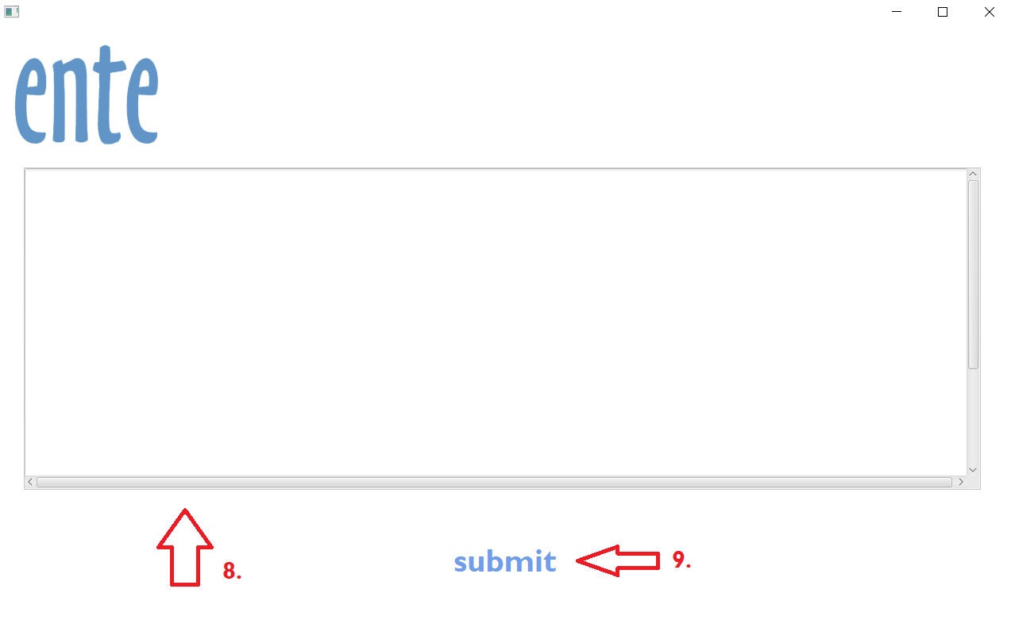After pressing **7.submit button**, the new window will be open with **8.text area** where you can write your solution. Then click **9.submit** and your homework will be added to the system. The **9.submit button** will be changed to **edit button** and you can change your solution until the deadline! If you want to go back, click ente logo.

**6.reload button** is refreshing a main panel and **7.contact** is displaying a message with contact information.

* 1. HOME PAGE FOR STUDENT AND DISCUSSION

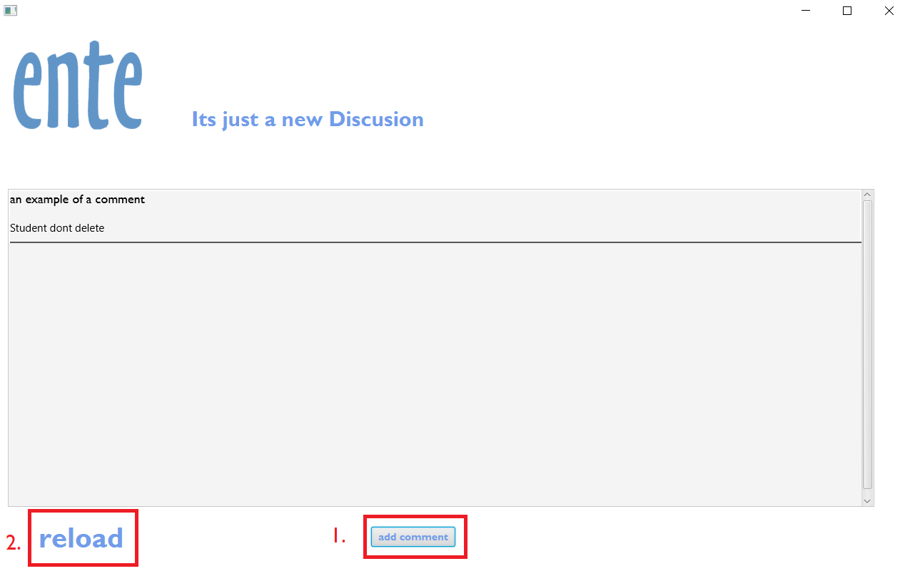

Each discussion**(pic 2. in previous page)** has a button comments. After pressing it a new window with the list of comments will be displayed. If you want to add a new comment, click button **1.add comment**. A new empty text area will show up where you can write your comment. When your comment is done, press button save.

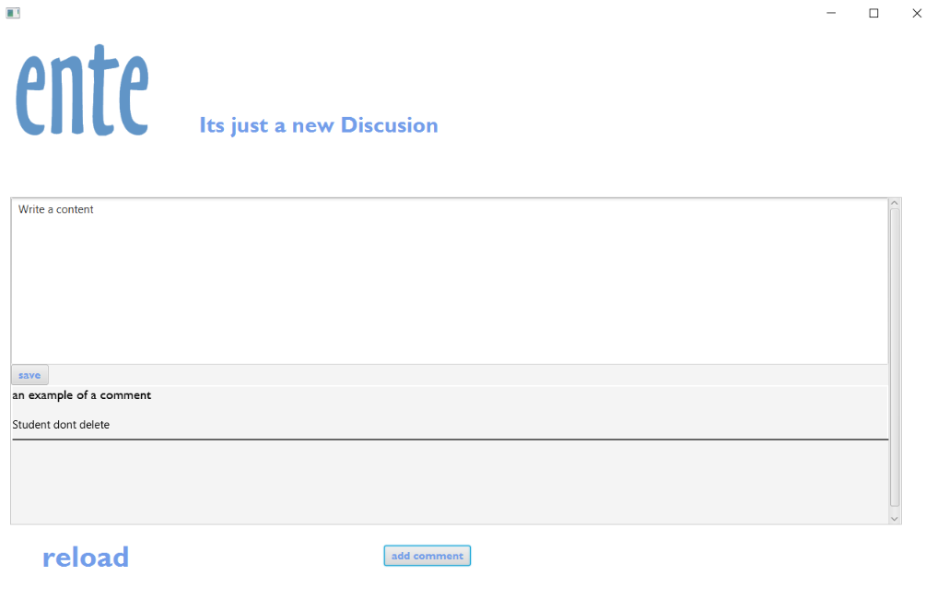If you want to see new comments, press **2.reload** button for refreshing the page.

1. HOME PAGE FOR PARENT

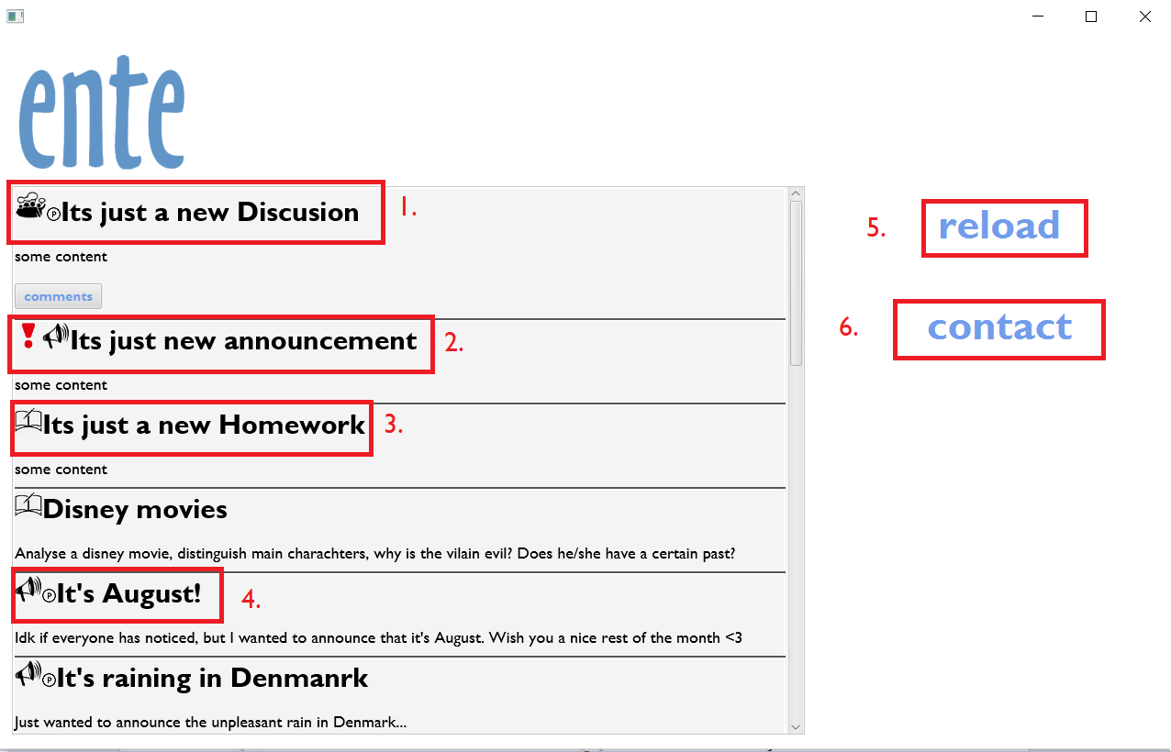

The parent main page contains panel with **1. discussions**, **2. announcements** (**Red exclamation mark** means that announcement is important and **4. P in the circle** means that announcement is parental), content of **3. homework** without child’s solution. **1.** **Discussion** can be commented in discussion panel. More information in precious page.

**5.reload button** is refreshing a main panel and **6.contact** is displaying a message with contact information.

1. HOME PAGE FOR TEACHER

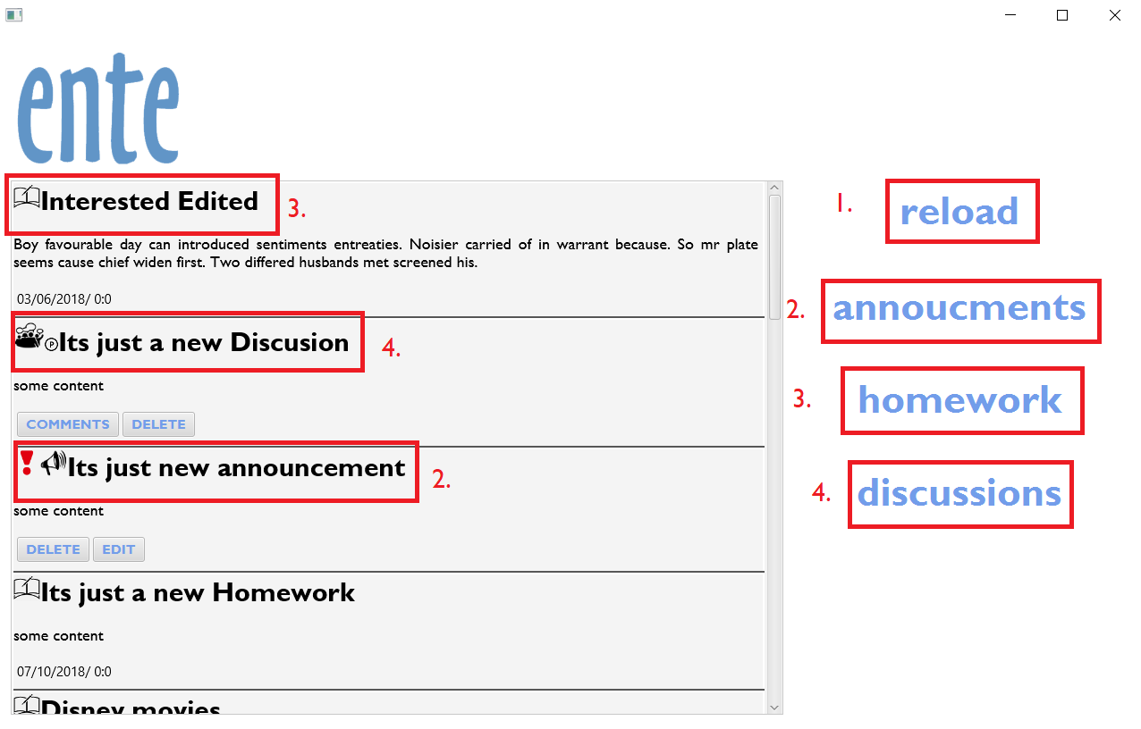The teacher main page contains a panel with **2.announcements**(**Red exclamation mark** means that announcement is important and **P** in the circlemeans that announcement is parental), **3.homework**, **4.discussions** (can be commented in discussion panel. More information in the page 6).

After pressing **button 2/3/4**, a new window will be displayed with an option to **6.create a new homework/announcement/discussion**. In already exist homework you can check **7.who done** homework, or **8.edit** created homework and **9.delete** homework**.** **1.reload button** is refreshing a main panel. If you want to go back, click ente logo.

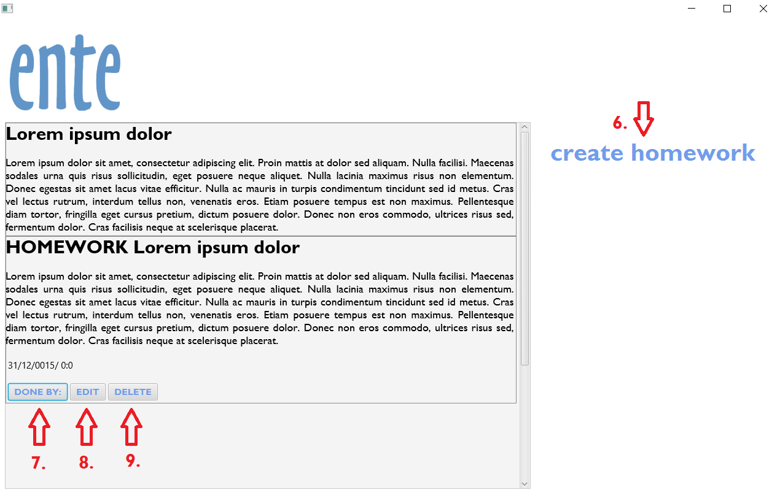

* 1. 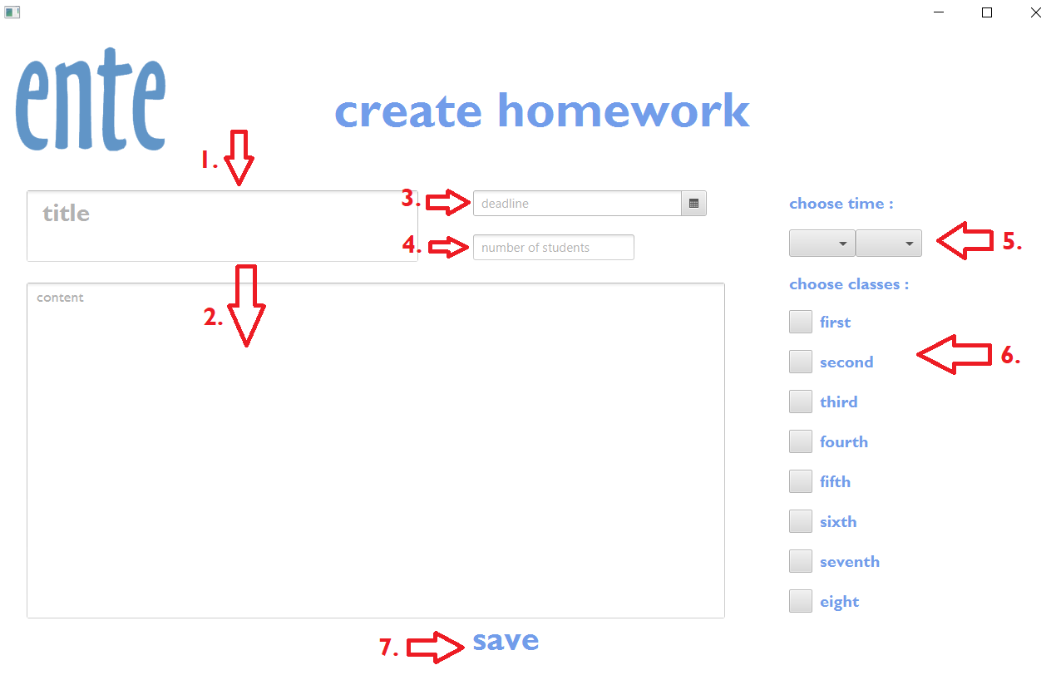CREATE A HOMEWORK

In creating homework window every field has to be filled!

**1.title** of homework, **2.content** criteria of homework, **3.deadline** with **5. ending time**. **4.number** **of students** to delivered and **6.class**.

If every field was filled, then you are able to save a new homework by clicking button **7.save**. The homework will be added to the system and displayed in teacher’s and student’s main panel.

If you want to go back, click ente logo.

* 1. 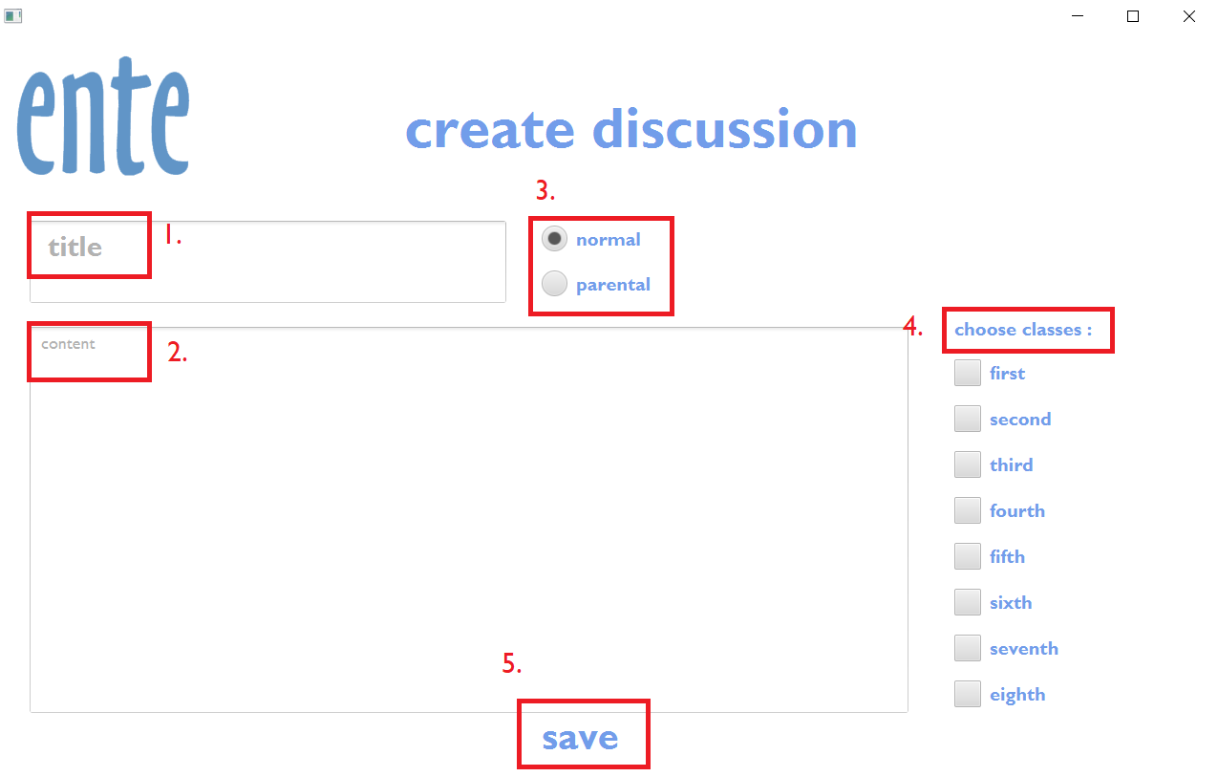CREATE A DISCUSSION

In creating discussion window every field has to be filled!

**1.title of homework, 2.content** criteria of homework, **3.normal** or **parental** discussion

and to which **4.class** it should be delivered.

If every field was filled, then you are able to save a new discussion by clicking button **5.save**.

If you want to go back, click ente logo.

* 1. CREATE AN ANNOUNCEMENT

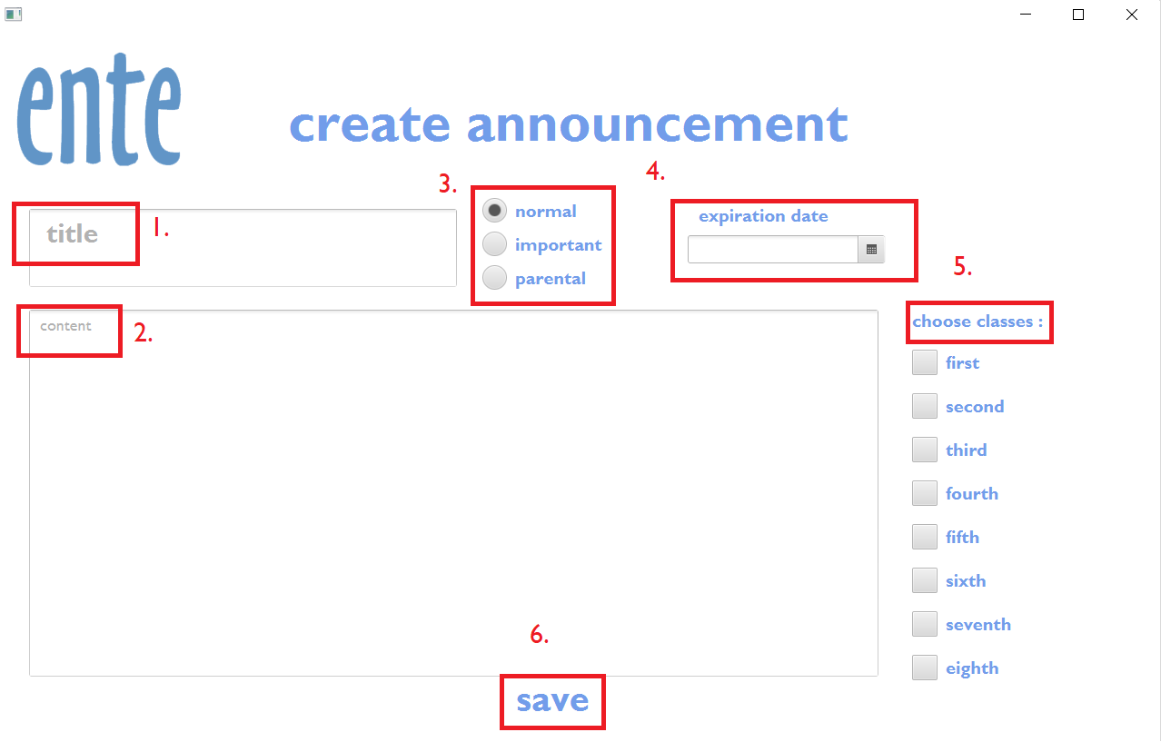

In creating announcement window every field has to be filled!

**1.title** of homework, **2.content** of announcement, **3.normal/parental/important** announcement, **4. expiration date** and to which **5.class** it should be delivered.

If every field was filled, then you are able to save a new announcement by clicking button **6.save.**

If you want to go back, click ente logo.

1. HOME PAGE FOR ADMINISTRATOR

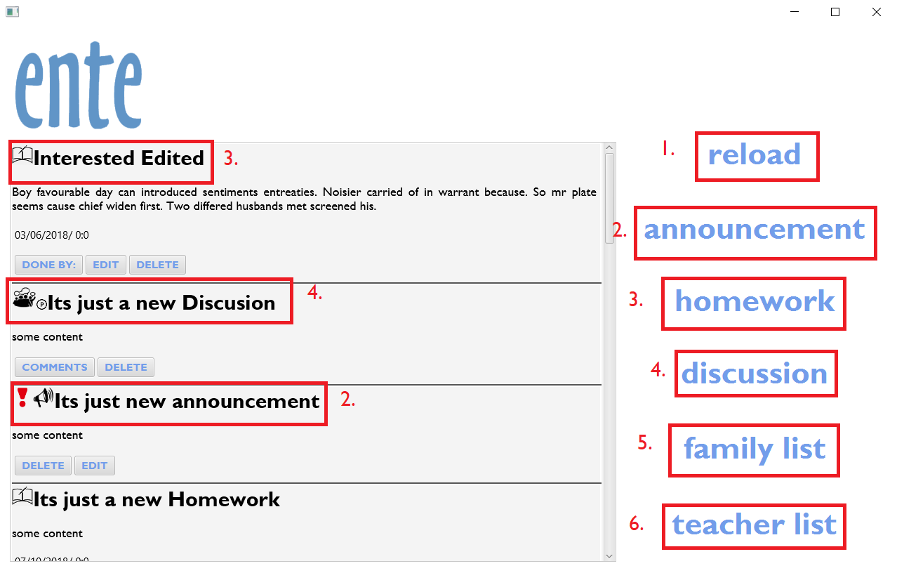

The administrator main page contains more functionality. Panelwith **2.announcements**(**Red exclamation mark** means that announcement is important and **P** in the circlemeans that announcement is parental) **3.homework**, **4.discussion,** **6.family list** and **6.teacher list** where are all information about users. After pressing **button 2/3/4**, a new window will be displayed with an option to **create a new homework/announcement/discussion**. (Instruction how to create a new homework/announcement/discussion can be found on pages 9-11).

**1.reload button** is refreshing a main panel. If you want to go back, click ente logo.

* 1. CREATE NEW STUDENT/PARENT

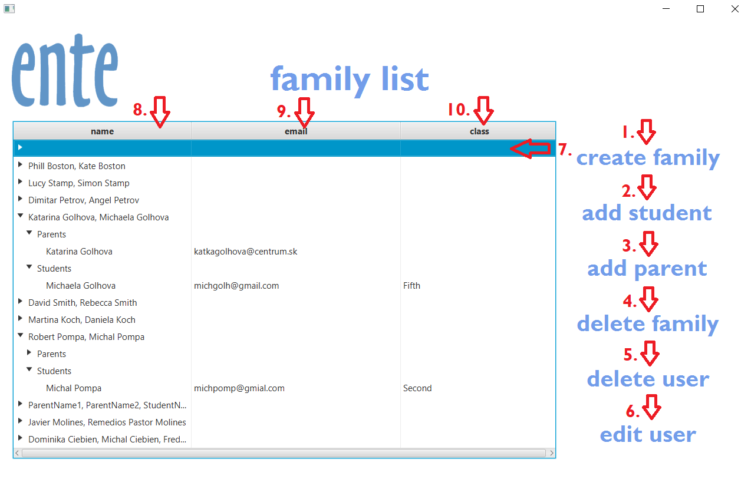The administrator is only type of user with privilege of creating a new users. The family list is located in the administrator main page.

In order to create a student or parent, their family has to be created first! First, press button **1.create family**. In the table will appear an **7.empty row**. Before you click **2.add student** or **3.add parent**, be sure that **7.empty row** is selected. (If it’s selected, it changes color to blue). 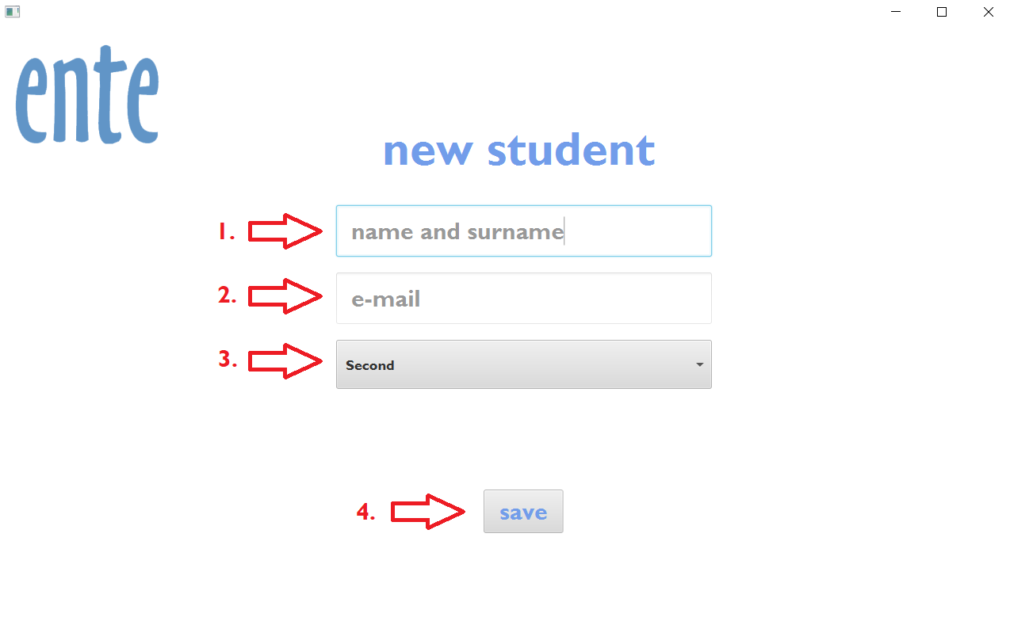

In case of new student, fill **1.name and surname, 2.email address, 3.class.** Then click button save. A new student will be added to the system and displayed in family table. In case of new parent fill **1.name and surname** and **2.email address.** If you want to go back, click ente logo.

* 1. EDIT USER

Open **8.family name**, in family choose an user with **9.email** (and **10.class** in case of student) . Then click **6.edit user**. A new window will be open with old informations of chosen user. After rewriting informations, click a button save. The user will be overridden in the system and changed user will be displayed in the family table. If you want to go back, click ente logo.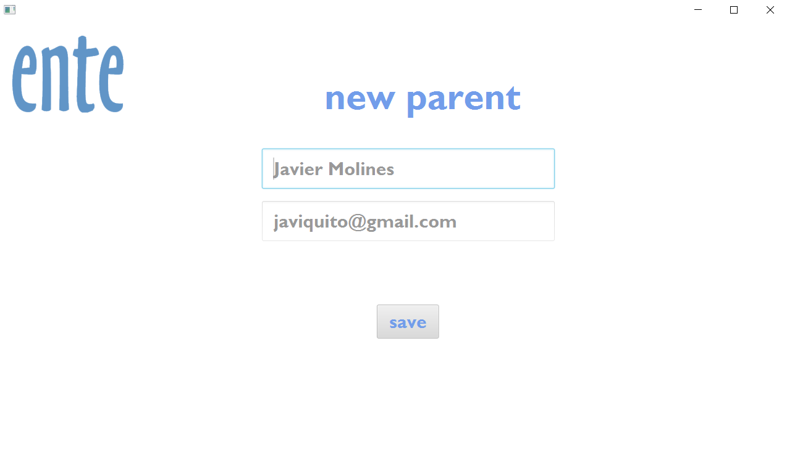

* 1. DELETE USER OR FAMILY

**Delete user:**

Open **8.family name**, in family choose an user with **9.email** (and **10.class** in case of student) . Then click **5.delete user**. A dialog window will be open with question if you are sure that you want to delete chosen user. Confirm it by pressing button YES. Then user will be deleted from the database.

**Delete family:**

Click on family row where is displayed just family name. Then click **4.delete family**. A dialog window will be open with question if you are sure that you want to delete chosen user. Confirm it by pressing button *YES.*

In case of deleting family, every member of family will be deleted from the system!

If you want to go back, click ente logo.