**Process report**

**Group 3**

Daniela Koch, 266502

Michał Ciebień, 266908

Matej Michalek, 266827

Michaela Golhova, 266099

Michał Karol Pompa, 266494

Jakob Knop Rasmussen

Jan Munch Pedersen

23 283 characters

Information and Communication Technology Engineering

3nd semester

December 2018

**Table of content**

1 Group Description 3

1.1 Cultural background 3

1.2 Belbin roles 4

2 Project Initiation 6

2.1 Risk assessments 6

2.2 Group contract 7

2.3 Contacting the company 7

2.4 Project Description 7

3 Project Execution 8

3.1 Formulating requirements 8

3.2 SCRUM 8

3.2.1 SCRUM meetings 9

3.2.2 Burndown chart 10

3.3 Encountered risks 13

3.4 Technical tools 13

3.5 Working with the company 14

3.6 List of tasks and responsibilities 14

4 Personal Reflections 16

4.1 Michał 16

4.2 Michaela 17

4.3 Matej 17

4.4 Daniela 18

5 Conclusion 20

6 References 21

Appendices

1. Group Description
   1. Cultural background

Our group consists of five persons: two Slovaks: Michaela and Matej and three Poles: Daniela, Michał P and Michał C. It originated in the first semester and because it was believed to be working well, stayed almost unchanged until now. A big change was Michał C joining us in the 3rd semester. One of the reasons of why our group is working well are the similarities in the cultural backgrounds of the two countries (Hofstede Insights, 2017). The difference in each aspect differs between 1 and 42 points out of 100 what undoubtedly proves that we come from similar cultures. It is shown on figure 1:

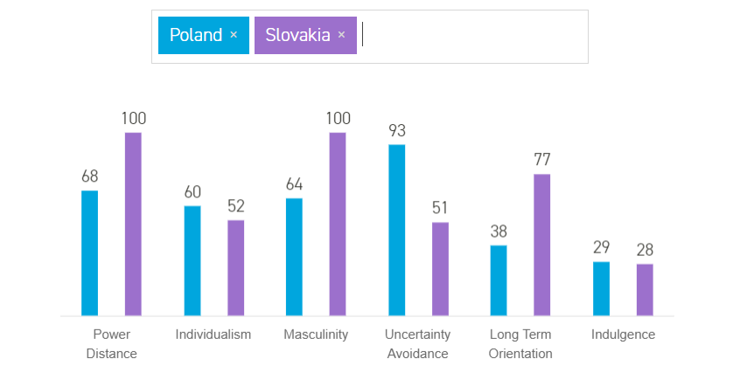

**Figure SEQ Figure \* ARABIC 1 - Country comparison**

**Figure 1**

* 1. Belbin roles

Not only the cultural background, but also the individual characteristics are what make a group work well. In this case, what made us a well-cooperating and well-balanced group were our Belbin roles. Having taken the Team Role Inventory Test (Studynet 2017), we compared the results with our experience, basing on assignment work in class, the work on the first and second Semester Project and the team role descriptions (Belbin, 2012). What we found out is as follows (Table 1):

|  |  |  |
| --- | --- | --- |
| **Member/**  **Belbin roles** | **The Team Role Inventory Test** | **The reality** |
| Daniela | Shaper, plant | Shaper, team worker, plant, resource investigator |
| Michaela | Plant, everything else balanced | Plant, everything else balanced |
| Matej | Team worker, complete finisher, implementer | Team worker, complete finisher, monitor evaluator |
| Michał P | Coordinator, resource investigator, complete finisher | Coordinator, complete finisher, specialist (in case of IT) |
| Michał C | Monitor evaluator, plant | Monitor evaluator, plant |

**Table 1 - Belbin roles**

As the table shows, we are a well-balanced group, containing almost every possible team role and without many repetitions. Knowing our Belbin roles helped us to understand our roles in the group and some of our behaviours.

The importance of being well-balanced is that everyone has an unique function they execute and no one has to perform a role not suiting one.

* 1. 16personalities

To understand ourselves even more we took the 16personalities test (source). It turned out that both Michał’s are in the analyst category: Michał P is the architect and Michał C the debater, Matej belongs to the sentinels: he is the defender and Daniela and Michaela are not only both diplomats, but also the same personality type: advocates.

We found the descriptions of ourselves very relatable and could see examples of how we actually behave in the described way. What is said about Michał P*: Professional competence is often the area in which INTJs shine most brilliantly. Their capacity for digesting difficult and complex theories and principles and converting them into clear and actionable ideas and strategies is unmatched by any other type. INTJs are able to filter out the noise of a situation, identifying the core thread that needs to be pulled in order to unravel others’ messes so that they can be rewoven into something at once beautifully intricate and stunningly simple in its function. (…) As their careers progress further and their reputation grows, so will the complexity of INTJs’ tasks and projects. INTJs demand progress and evolution, new challenges and theories, and they often accomplish this by pushing into more active strategic positions. While they don’t care for the spotlight, INTJs do enjoy controlling their ideas, and will often expand into low-profile but influential roles as project managers, system engineers(…).*(source)   
We could not describe Michał P better. He always strives to find the perfect solution, which he will usually call beautiful (especially if it is a simple solution to a complex problem) and is always able to divide complicated tasks into smaller subtasks to make the task easier. It is also strictly connected to his Belbin roles (Coordinator, complete finisher, specialist). What else can be seen from the description and his Belbin roles is that he always craves to find new solutions, more advanced and challenge both himself and his team. There is nothing he would give up on just because it is difficult to do and beyond the curriculum. What is also remarkable is that the perfect positions for him is project manager and system engineer.

//experience in working with each other

1. Project Initiation
   1. Risk assessments

Having stated the Belbin roles, we entered the initiation part of the project, containing creating risk assessments, updating the group contract and writing the project description. The risk assessments are presented in the table below (Table 2):

|  |  |  |  |  |  |  |
| --- | --- | --- | --- | --- | --- | --- |
| **RISK** | **PROBABILITY** | **IMPACT** | **EFFECT** | **RISK REDUCTION ACTIONS** | **RESPONSIBLE PERSON** | **RESPONSE** |
| **Group member’s illness** | Medium | Medium | Time | Divide group work in small tasks | Michaela(scrum master) | Redistribute group work |
| **Technical**  **breakdown** | Medium | Medium | Time, completion of key tasks | Work with reliable technical equipment, Backup important files | Michaela (scrum master) | Replace with alternative stuff |
| **Group member’s sabotage** | Low | Medium | Time, concord among group members | Team-buildings | Michaela (scrum master) | Redistribute group work |
| **Unrealistic planning and scheduling** | High | High | Time, full project completion | Detailed pre-analysis of time schedule | Michaela (scrum master) | More conservative estimation, usage of SCRUM, take out features |

**Table 2 - Risk assessment**

The reason we made them, was to first of all prevent them from occurring and secondly to be prepared and know how to handle the situation, in the event that any of them occurred.

* 1. Group contract

The next task we focused on was updating the group contract (see appendix 1). We have made it at the beginning of the first semester and we decided to leave it as it was.

* 1. Project Description

Alongside were we facing the challenge of choosing an idea for the project. We had a few of those and ended up with two: a cinema system and book storage system. Basing on the rules of democracy we made a voting and the book storage system passed the finals. Having chosen, we were able to write the Project Description. We discussed in detail what we want to do and why and afterwards our “group writer” put it into words. Afterwards we created the remaining parts of the document together.

1. Project Execution
   1. SCRUM

Last semester we learned the scrum approach for developing projects and as we really liked it, we decided to use it also this time. Basing on our requirements, we created a product backlog (see Appendix 5). Prior to the SEP period, each of our sprints was one week long, due to having lectures and other responsibilities and not being able to assign all of our time to the project. That is why the actual time spent on working on the project in this phase was approximately the same as during 3 days during the SEP period. Before each sprint we had a sprint planning meeting, where we chose a backlog story, divided it into tasks and assigned story points and people to the tasks. Moreover, we had daily sprint meetings- before the SEP period once a week on Sundays and during SEP period every day. What is more, are sprint review meetings, where we discussed what has been done and what still has to be finished and sprint retrospective meetings, where we took our working methods under consideration, those included e.g. the amount of tasks, how specific tasks should be or if we should work at one place or everyone separately.

* + 1. SCRUM roles

For the scrum master we chose Michaela. There were plenty of reasons for that, some of them are that she is organised, motivated, engaged, wiling to learn and also did not have any role last semester and wanted to try herself in this role. The reason can also be derived from the description of her personality from the 16 personalities test, where it says that she strives to make her work meaningful and just fulfilling tasks is not enough for her. Moreover, this personality type is strongly people-oriented and by being a scrum master, one focuses on the working process and motivation of members.

For the product owner we chose Daniela. The reason can be derived from the description of her personality from the 16 personalities test, which states that what she does needs to be meaningful. That means that as a product owner she always thought from the perspective of a user of the system and what she would like to do in it, it was not enough to meet the requirements for the project, but to really do something purposeful that she would like to use.

Michaela’s main responsibility was ensuring the scrum process, organising scrum meetings, documenting them and generating burndown charts, as well as analysing them in order to have an overview of the development of the project. Daniela’s main responsibility was maintaining the product backlog, supporting Michaela and having the final decision in the features of the system.

* + 1. Working methodology

Prior to the SEP period (learned from retrospective meetings, worked a lot tgether (at least pairs), changing amount and quality of tasks, assigning more people to an area))

* + 1. Burndown chart

The burndown charts for the SEP period are shown below:

**Sprint 1**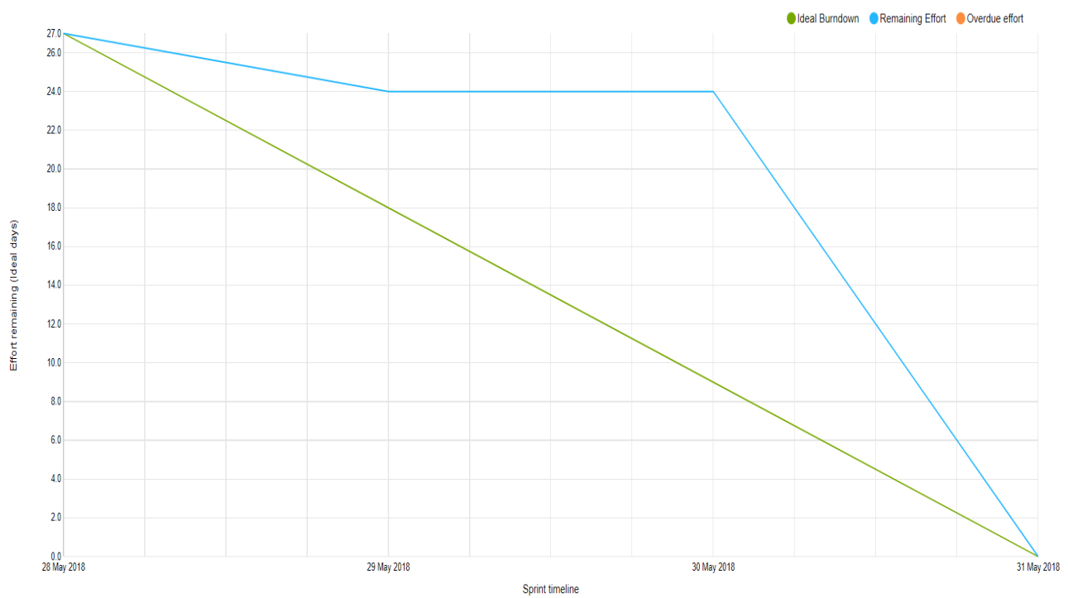

**Figure 2**

**Sprint 2**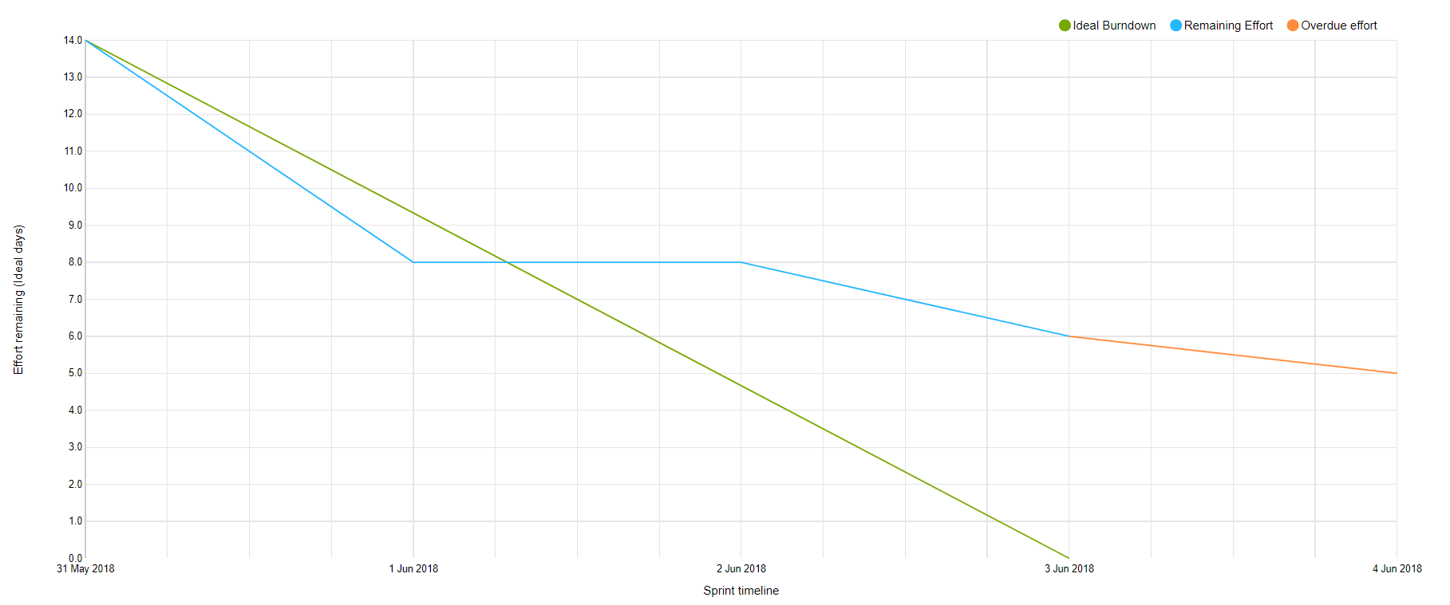

**Figure 3**

**Sprint 3**

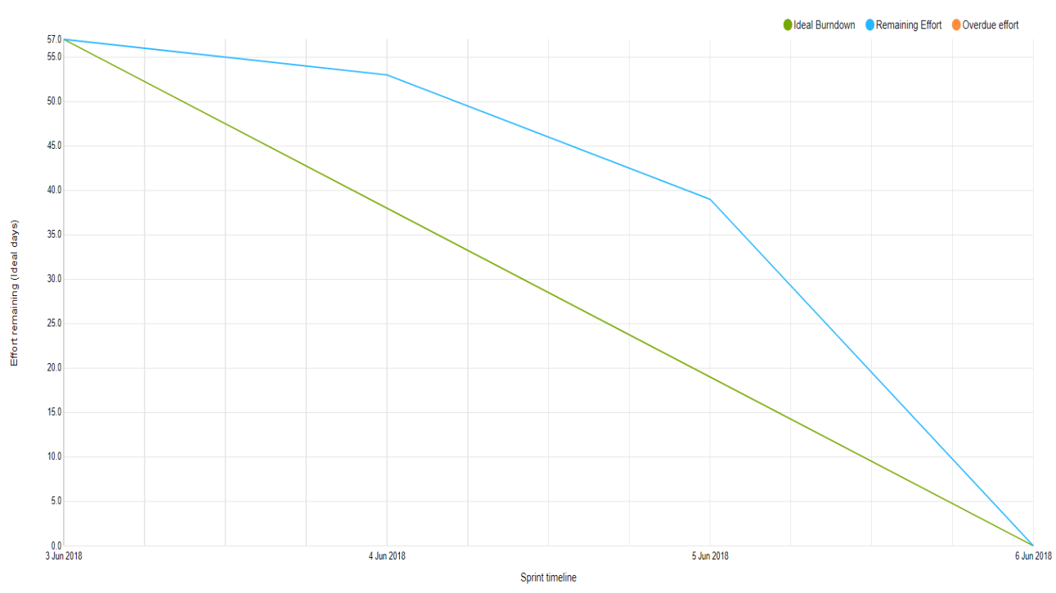

**Figure 4**

**Sprint 4**

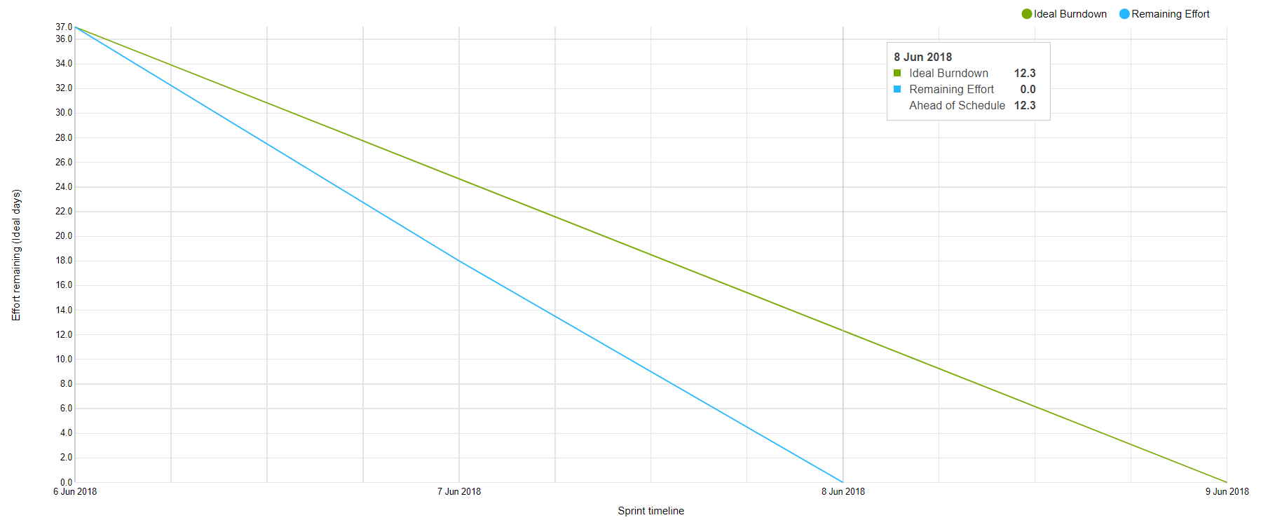

**Figure 5**

The burndown charts present that half of the times we were behind at the beginning, but eventually we were meeting the expectations. However, some tasks were usually moved to the next sprint to be finished. The reason why sprint 2 is showing “overdue effort” is the fact, that sprint 3 did not have dates assigned at the beginning, so the tasks were counted still to sprint 2, instead of 3. One of the reasons of being behind on the beginning of the sprints was storing the done tasks in the division “to verify” and waiting for the product owner or SCRUM master to verify them until assigning the points to the charts. It can also be seen that we were the most motivated and productive in the last sprint when the deadline was close and we wanted to finish every task before to have enough time to check all documents properly.

**General**

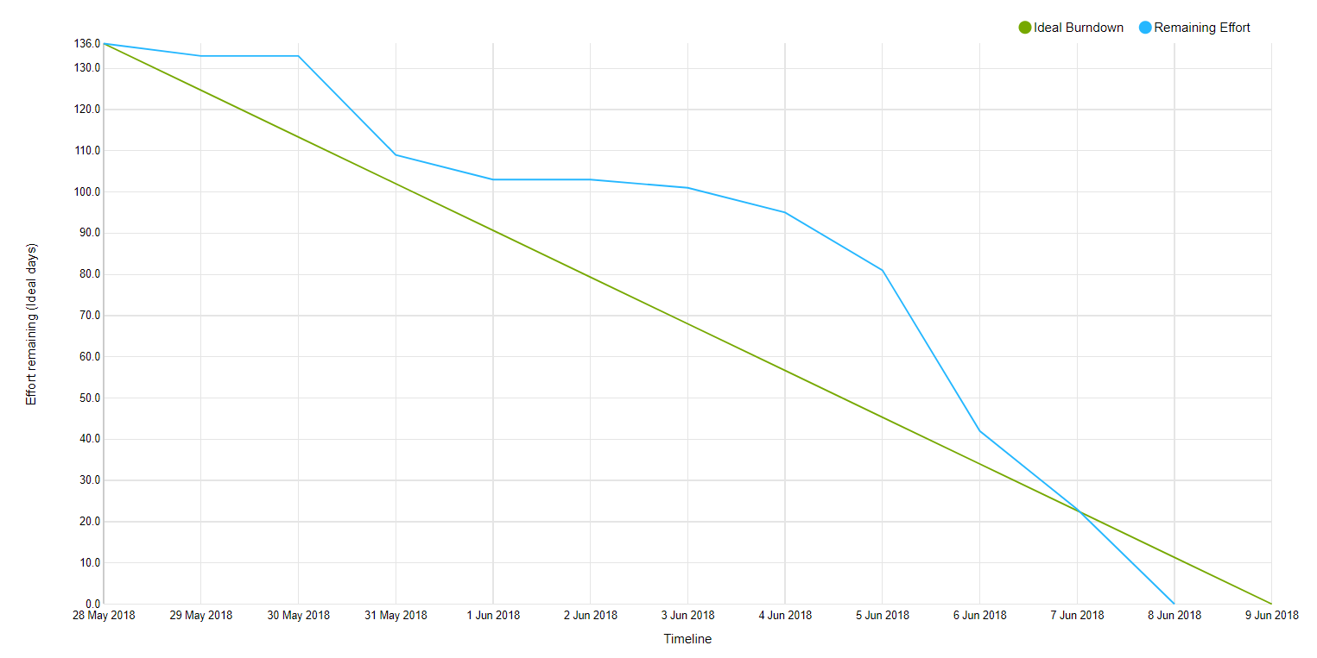

**Figure 6**

The burndown chart shows the effort committed during each day during the SEP period in the meaning of a number of completed story points assigned to tasks. The design of it does not only depend on how much work we did, but also on how we defined our tasks (e.x. how specific they were, if there were a few tasks written as one).

**Before SEP period**

Before the SEP period, the burndown chart was created and updated manually. It was not a good idea. First of all it was easy to forget to update it and get lost in what already has been added and what not. Moreover, the chart looked messy. Another issue was assigning story points only to specific backlog stories and not each task separately. As a result, the development could not be seen properly. The burndown chart is shown below:

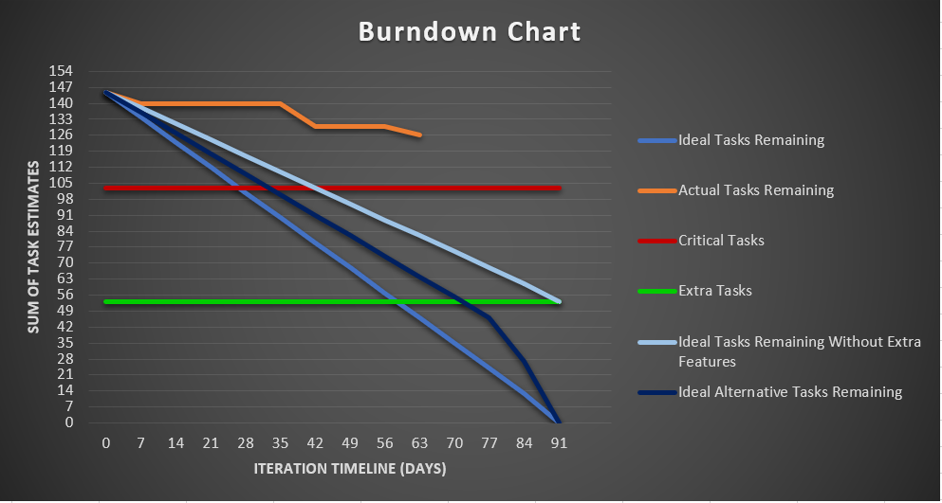

**Figure 7**

* 1. Encountered risks

The working process was not always looking sunny for us. We encountered one third of the risks we were prepared for. First of all, we had a technical breakdown. A keyboard of one of the team member’s laptops was not working properly, what disabled using it. The prime solution was connecting an external keyboard. However, that was not very convenient, especially when it has to be carried. Fortunately, our SCRUM master was going to Poland for the weekend, so she was able to take the laptop with her and get the keyboard replaced.

Another risk we encountered was unrealistic planning and scheduling. As the risk assessment table shows, we took out features and focused only on the critical tasks from our project backlog.

* 1. Technical tools

In the project execution phase we were also using technical tools helpful in working in groups. As mentioned before, we were using first Trello and then YouTrack in the terms of using SCRUM and having a global overview of what needs to be done, who does what and how the work is progressing. Moreover, YouTrack was also used to generate burndown charts. Another tool was Git, which not only has eased working at the same time and making the system consistent, but also was the solution for our ‘technical breakdown’ risk. We went for Google docs while working on and checking text documents, with the same reason as using Git.

* 1. Working with the company

As we had a real company, working for us looked slightly different than for most of the groups. On one hand it was easier, in the terms of being able to ask them how they would like a feature to be, when in doubt, but on the other one, it was more complex in the case of them changing their mind on some features, us having to adjust to their vision of the system and us having to understand precisely what they want and what they actually mean by it. One example of a disadvantage of working with a company faced our view designer. She had a view designed that she loved, but the company turned it down and made her change the whole view entirely. Even though she was not keen on the vision of the company, she had to adjust to the customers needs. However, we were glad for the opportunity of making a system that will actually be used and getting the experience of working with a real client.

* 1. List of tasks and responsibilities
* product owner (constant contact with the company, maintaining the product backlog) - Michał
* SCRUM master (scheduling, leading, documenting SCRUM meetings, generating burndown charts) - Daniela
* creating the product backlog (and sprint backlogs) - together (lead by the product owner verified by SCRUM master)
* database - Matej
* view - Michaela
* model - Michał and Daniela
* adapter - Matej
* rest of code - Michał
* analysis and design - together, everyone
* project description:
  + background description - Daniela
  + rest - together
* user guide - Michaela
* process report - Daniela
* project report:
  + abstract - Daniela
  + introduction - Daniela
  + requirements - Daniela
  + system analysis:
    - different user types and managing them - Michał
    - logging in - Michał
    - posts - Daniela
    - connection - Michał
    - secondary storage - Matej
    - view - Michaela
  + design:
    - architecture - Michał and Daniela
    - singleton - Michał and Daniela
    - managing users - Michał
    - connection - Michał
    - logging in - Michał
    - secondary storage - Matej
    - view - Michaela
  + implementation:
    - connection to the database - Matej
    - encryption - Michał
    - sending emails - Michał
    - UUID - Michał
    - handling messages - Michał
    - GUI - Michaela
    - threads - Michał
  + test - Michał, Daniela and Michaela
  + result and discussion - Daniela
  + conclusion - Daniela
  + project future - Matej and Michał
* correcting documents - Daniela

1. Personal Reflections
   1. Michał

For our group this project was even more challenging than the last one, not only because of technical complexity, but also because of the fact that we were making system for a real customer. It was my responsibility, as a Product Owner, to contact the customer, present our ideas and ask for help with understanding the domain of the system. My duty was to ensure if the way that we are following is leading us to the goal, which was meeting the demands of the customer.  However, at the beginning our point of view at the project was varying from the vision of the customer. Moreover, it resulted in planning and forcing features that are not relevant nor important for the customer. We had that problem until we had a firm grip on the domain model, and we understood what is important in the school environment. As an example of a ideas conflict, I can quote the situation when Michaela, who was responsible for the graphical user interface, could not agree with demands of the customer for minimalistic. It was my duty to resolve this conflict, and convince Michaela that she should not take this decision too personal.

Another important change from the last project was moving from waterfall work methodology to the SCRUM and Unified Processes. In my opinion, it has given our group many benefits, especially during project period, when the work was the most intense. Thanks to the SCRUM, we have solved our biggest problem, the tasks distribution. During the last project it was mostly mine responsibility to coordinate the work, which was at some point difficult, as the skill level in group was not equal and we had to welcome a new group member, when the development was at the highest point. The solution for that, was dividing work time into sprints and sprint planning meeting. During that meetings, all current task were talked through and the tasks were distributed.

As the decisions were made on the group forum, everyone could express their ideas, but also have insight to what is happening in the other parts of the system. However, originally, we had problems with estimating the amount of tasks for each sprint. Only at the end, when we have been already through a few sprints, we started to assign realizable amount of tasks to the sprint. Another thing, that helped a lot during planning sprints is dividing the tasks to smaller ones. Thanks to this, we could track our progress more carefully and our estimation become more accurate. Moreover, using Unified Processes, we could focus only at one task at the time, without having analysed and designed all features. That was extremely important, due to the fact, that the lists of requirements and use cases were much bigger that the last time.

In conclusion, I am very satisfied from the outcome of this project. We have learnt a lot, in the term of the technical skills along with project management techniques and work methodologies. Now we know the importance of the good communication between group members and the group with the customer. Furthermore, we won’t forget the lesson, that have showed us how crucial is to correctly understand the customer needs and the domain of the system.

* 1. Michaela

This semester project was even more challenging than the first one, especially for our group. For the first time we worked with real customer and we had to base whole system on her wishes. Again, I was responsible for the GUI part and this time we choose to work with a new library. So, during whole project I was learning something new. Since beginning it was a bit stressful and I did not agree with customer's vision of the design. My vision was something more suitable for children, with colours and details on buttons. In my opinion it would give to children more enthusiasm for work and usage of the system. Therefore it was demotivating in the beginning, but after time I accepted that customer is always right. I think that this part of work was the hardest one. To put personal feelings on the side. In the end, I can say that I am really thankful for this opportunity. It taught me how to cooperate and listen to others ideas.

* 1. Matej

Even though we were not totally satisfied with the final version of our SEP1, we decided to stay together and continue as a group also for a SEP2. To my mind, this was a good decision as we did not need to go through the stage of getting to know each other. We already knew our own personalities, habits and roles in the team and that is why we could directly enter the stage when all team members are trying to achieve team’s goals.  In my opinion, just these team’s goals were the stumbling block of the current project. The reason why I see it like this is that customer needs did not meet the needs of SEP2. As we wanted to stick to both, sometimes it was difficult to find the best way to satisfy both sides. For instance, on the hand the customer required some feature that we were not able to implement at that moment and it would have taken us too much time to learn it and implement it, so after the dialogue with customer it was decided to move this feature to the future of the project. On the other hand, we could do some stuff that would be interesting for SEP2, but as the customer did not need it, there was no reason to implement it.

Regarding the process of our work, I am sure that every team member has made every effort to build this project. The SCRUM way of controlling the development process helped us a lot. We did not have problems with work organization as we had had during SEP1. I had a feeling that during this project we had it more under control. We knew who is doing what and what is more, thanks to a lot of meetings (review, retrospective and daily meetings) we were totally confident about the progress of our group. In my case, I was responsible mostly for handling the database, the connection to the database and the data transformation to and from the system. As I had not any experience with databases before, during the project I found some difficulties in the realization of my tasks that a few times lead to the postponements of their finalization to another sprint.

To sum up, as it was already the second project that we worked together, as a group we were more confident what semester projects are about, more consistent and mostly more efficient. I do believe that it was definitely a right decision that we worked on this project for eNTe, because it gave us even more clear vision of how are projects going in the real world than we would have acquired if we had decided to make project for an imaginary company.

* 1. Daniela

At the beginning of this semester I felt bad, because, due to having other responsibilities and projects, I wasn’t able to allocate as much work to SEP as the rest of my group. Fortunately, after some time I managed to catch up and contribute properly.

The main learnings for me from this project were about SCRUM and UP. As my role was the SCRUM master, I was the one responsible for making sure that we are organized, tracking the progress and responsible for the meetings. At first I think I was failing a bit in those tasks. Even though we were having meetings each week, I was not taking any notes from them. We were also lacking in retrospective meetings and the planning and review meetings were becoming one and very long with other information involved. The burndown chart was generated manually and the points were only assigned to the backlog stories, so it did not give us much information about the progress. The reasons of all of this were first of all lack of knowledge and experience in SCRUM, but also lack of time from my side. However, having gained more knowledge and having worked already a few weeks in this system, the work started to be more and more organized. I introduced the retrospective meetings, where we were trying to figure out the best working methods and what to change during the next sprint. Taking notes was also helping, as everything became more organized and the meetings more separated and focused on what they should be about. We also found a tool to generate the burndown chart and started assigning points to each task, what was also increasing our motivation. We were also becoming better and better in determining how many tasks we are able to do during one sprint, so we could plan our meetings better.

In conclusion, I enjoyed being the SCRUM master. I like to be organized, have some extra responsibility and keep track of what has been done, what has to be done and how each person is performing. I am also keen on working with people in general and trying to increase the motivation of the people, making sure everyone is fine and satisfied of the working process.

Another main learning was about SCRUM with connection to UP. As last semester was focused on the waterfall approach, this was new to us. At the beginning we were not sure how much of analysis we should prepare at the beginning and what to leave for later. During the semester we were learning more and more about the process and discovering how important it is to follow this approach. Thank to this, I am confident to use SCRUM and to use it properly during the next project, as it saves a lot of time that in the waterfall approach has to be used for verifying and updating documents and diagrams. Moreover, it makes the process in general easier and more consistent.

1. Conclusion

The overall outcome of the process can be stated as positive. Our group did not encounter many problems and those that were encountered were foreseen in the risk assessments. Moreover, we did not have any conflicts and the group was working well. What is more, everyone learned a lot and the learnings were not only code related, but also about SCRUM and UP. All group members appreciate the SCRUM and UP methodology and want to continue working with it in the future. Furthermore, working with a real company was a great opportunity for us and even though the flaws, we are thankful for that and we learned also in this aspect. Each of us developed during this SEP and we also became stronger as a group.

1. References

Hofstede Insights, 2017. COMPARE COUNTRIES. [online],

Available at: https://www.hofstede-insights.com/product/compare-countries/

Studynet, 2017. The Team Role Inventory Test. [online],

Available at: https://studienet.via.dk/Class/IT-CSE1V-A17/_layouts/15/WopiFrame.aspx?sourcedoc=/Class/IT-CSE1V-A17/Session%20Material/Belbin%20Team-roles.xls&action=default

Belbin, 2012. BELBIN. [online],

Available at: https://studienet.via.dk/Class/IT-CSE1V-A17/Session%20Material/Belbin%20reading%20material.pdf

**Appendices**

Appendix 1: Group Contract – Contract.pdf

Appendix 2: Project Description – Project_Description.pdf

Appendix 3: Daily/ weekly log – Daily_weekly_log.pdf

Appendix 4: SCRUM meetings – SCRUMmeetings.pdf

Appendix 5: Product backlog – Product_backlog.pdf