|  |
| --- |
| **Read with Panda**  **User Guide** |

**[Michaela Golhova 266099]**

**[Michal Pompa 266494]**

**[Matej Michalek 266827]**

**[Daniela Koch 266502]**

**[Michal Ciebien 266908]**

**Table of content**

1. INTRODUCTION 3

2. LOGIN TO SYSTEM 4

3. HOME PAGE FOR STUDENT AND HOMEWORK 5

3.1. HOME PAGE FOR STUDENT AND DISCUSSION 6

4. HOME PAGE FOR PARENT 7

5. HOME PAGE FOR TEACHER 8

5.1. CREATE A HOMEWORK 9

5.2. CREATE A DISCUSSION 10

5.3. CREATE AN ANNOUNCEMENT 11

6. HOME PAGE FOR ADMINISTRATOR 12

6.1. CREATE NEW STUDENT/PARENT 13

6.2. EDIT USER 14

6.3. DELETE USER OR FAMILY 15

1. Introduction

This document contains all information about the usage of **Read with Panda** system. Following descriptions will guide you through whole software and its functionalities.

Before you start using this application, please, read following instruction document carefully.

**WARNING:**

Note that the system doesn’t provide every functionality yet. For that reason, they are not explained in this manual.

1. Home page

Every guest of Read with Panda website can visit its home page that is shown below:

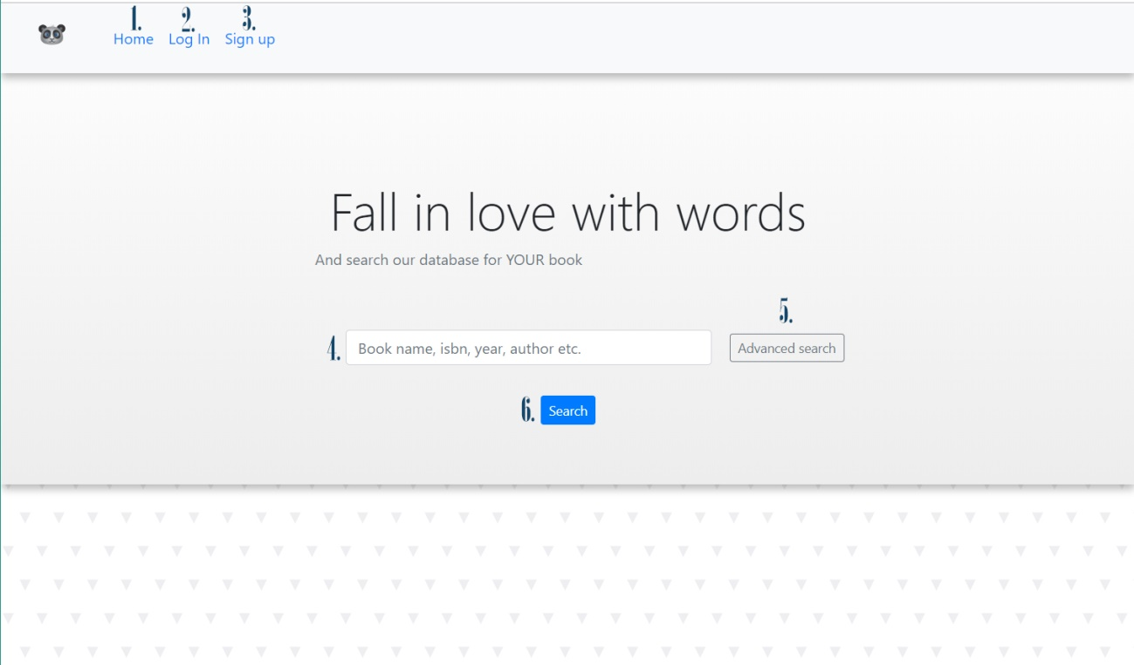

At this home page you have several options:

1. If you want to refresh the home page, click “Home” button in the navbar.
2. If you want to login, click “Log In” button in the navbar and you will be redirected to the login page (go to the section 2.1 - Log in page)
3. If you haven’t created an account yet and you want to become a customer of Read with Panda, click “Sign up” button in the navbar and you will be redirected to the sign up page.
4. If you want to search for a specific book or books, enter the search term into the field and continue to the paragraph f)
5. If you have entered desired search term, click “Search” button in order to search for a book in our system and you will be redirected to the book list page.
6. If you want to use our advanced search functionality where you can search for a book by title, author, isbn, year or category, click “Advanced search” button. Next steps regarding advanced search are described in detail in the section XX
   1. Log in page

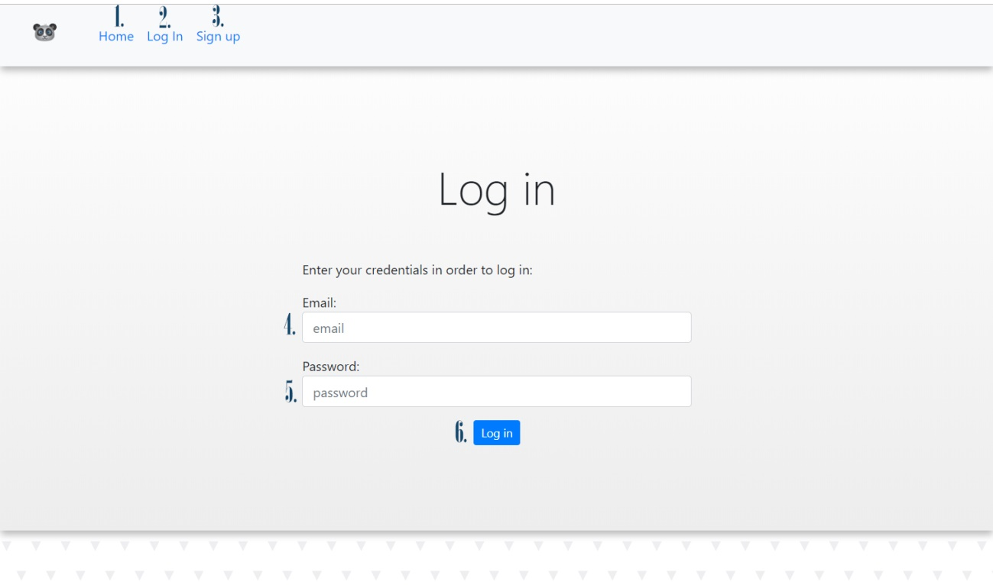

In the login page the guest has these options in the navbar:

1. Click “Home” button in order to get back to the main page.
2. Click “Log in” button in order to refresh current Log in page.
3. Click “Sign up” button, if you are not a customer yet and you want to create an account.

In order to log into the system do the following:

1. Enter your email into the field marked with number 4
2. Enter your password into the field marked with number 5.
3. Click “Log in” button.
   1. If you are authenticated, you are redirected to the corresponding homepage regarding your user type.
      1. If you are a customer, continue to the section XX
      2. If you are a library admin, continue to the section XX
      3. If you are a bookstore admin, continue to the section XX
   2. If you cannot be authenticated, you get an alert that “Your e-mail or password is incorrect.” After clicking “Ok”, you can login with correct credential by going back to the step 4.
   3. Sign up page
   4. Advanced search
4. Booklist page