|  |
| --- |
| **Streamster Project Description** |

**Michał Karol Pompa - 266494**

**Michaela Golhová - 266099**

**Matej Michálek - 266827**

**Software Technology Engineering**

**7th semester**

**17.12.2020**

**Table of content**

1 Background description 3

2 Definition of purpose 5

3 Problem Statement 6

4 Delimitation 7

5 Choice of models and methods 8

6 Test Strategy 9

7 Project Management 10

8 Time schedule 11

9 Risk assessment 14

10 Sources of Information 15

Appendices

# Background description

In February of 2005, a new era of video entertainment started when the YouTube platform was launched. In contrast to traditional television, it offered watching videos at any time from a wide selection of user-created content. It allowed the type of freedom, that perfectly suited new generations, that had grown up surrounded by internet and multimedia. 15 years later, YouTube is the biggest source of video content in the world. Alongside with Netflix, HBO GO, Amazon Prime, and other streaming services. It is dominating over television in attracting user’s attention. As the research made by Defy Media shows, young people between the ages of 13 and 24 are spending around 20 hours a week on online video and streaming platforms, compared to 8 hours spent on watching TV (DEFY Media, 2015). Those statistics clearly show that the future of video entertainment is in the online video streaming platforms and their importance in young people’s life cannot be neglected. Another important factor is the portability of the new media. The freedom of watching your favorite videos wherever you are is superior to a need to take a seat next to a TV set. According to Google, “3 in 4 adults report watching YouTube at home on their mobile devices”. This points out that the mobile part of the audience cannot be overlooked (Google, 2020).

However, the existing platforms are not perfect. Taking into consideration YouTube, it has changed significantly over the past years. It is no longer a platform for sharing videos with friends and family as it was before. Right now, its functionality is focused on earning money on the high-quality content materials made by its community. As the platform started to support the professionals more and more, its function to simply share videos has been moved aside. YouTube started to delete videos from channels that do not fit its policy. However, it is not the humans that are checking the videos, but the algorithm called ContentID. As shown in the article by Maximillian Laumeister, in many cases, the aforementioned algorithm is not treating the videos correctly, deleting or disabling monetization on those videos that are original and do not violate copyrights. He brings up a case of a Music Sheet Boss channel, whose channel was demonetized for the reason of “repetitive content” with no way of appeal (Maximillian Laumeister, 2019). Moreover, its video promotion algorithm is more likely to show you a video that has many views than a video uploaded by your friend, since it is not popular. Other victims of that functionality are small passionates that create content for a certain niche of viewers. They don’t seek great popularity and all they require is a fair way to share their videos, not depending on the number of views they make. In addition, one of YouTube's biggest strengths is also one of its biggest weaknesses. While offering the biggest selection of videos in the world, it does not provide an advanced way of searching for desired content. It does not allow to narrow down the search results using filters or additional criteria. Another issue that disturbs the watching experience is the advertisements that have recently become harsher and more aggressive than ever. In this matter, YouTube gets very similar to traditional TV by serving ads before and during the video.

As shown above, the demand for video streaming platforms is high. However, there is also a room for improvement. A new platform would have to solve the problems of existing solutions to confront the consumer’s needs. Moreover, with a great number of similar platforms, a new platform, to be successful, it must differentiate itself from other solutions existing on the market, offering functionalities that can change the way the people are watching videos online. It is also required that it treats every user equally. No matter how popular their channel is, their videos will always reach its viewers. It must provide a simple and reliable solution for sharing videos within communities. Moreover, it must have a flexible search engine that helps to find desired materials and it should not distract a viewer from watching by playing advertisements. In addition, it should serve as a cross-platform solution that allows usage of the platform on desktop and mobile devices. At last, as the expected audience is counted in millions of viewers, it must be resilient to the great number of users using the platform simultaneously.

# Definition of purpose

The purpose is to improve the experience of video streaming platforms by creating personalized video recommendations, based on the user’s preferences and behavior and guaranteeing that the shared video reaches a selected audience.

# Problem Statement

How to create personalized video recommendations and to guarantee that the shared video reaches a selected audience?

* Based on what video attributes the users make a decision to watch a video?
* What are the user’s actions that can be tracked by the platform?
* How important are user’s actions while using the platform for generating personalized video recommendations?
* What are the ways of organizing the users on the platform that ensures that the shared video reaches the selected audience?
* What are the ways of organizing the users on the platform that ensures that multiple creators reach the same audience?
* What would ensure platform availability with a great number of users using it simultaneously?

# Delimitation

* The application will not stream movies or series
* The platform will not monetize videos
* The live-streaming function will not be provided
* The application will not support iOS

# Choice of models and methods

|  |  |  |
| --- | --- | --- |
| WHAT  problem? | WHY  study this problem? | WHICH  methods/theories are expected to be used to solve the problem? |
| Based on what video attributes the users make a decision to watch a video? | To understand what video attributes should be used for generating personalized recommendations | Survey targeted to the intended users |
| What are the user’s actions that can be tracked by the platform? | To discover what user’s actions can be used for generating personalized recommendations | Contextual Task Analysis on existing similar platform |
| How important are user’s actions while using the platform for generating personalized video recommendations? | To determine which of the user’s actions are significant for generating personalized recommendations | Survey targeted to the intended users |
| What are the ways of organizing the users on the platform that ensures that the shared video reaches the selected audience? | To identify possible ways of organizing the users that ensures that the shared video reaches the selected audience. | Brainstorming? |
| What are the ways of organizing the users on the platform that ensures that multiple creators reach the same audience? | To identify possible ways of organizing the users that ensures that multiple creators reach the same audience. | Brainstorming? |
| What would ensure platform availability with a great number of users using it simultaneously? | To ensure that the platform will be resilient to the high load of users and a large amount of content | Distributed system |

Table 1

# Test Strategy

|  |  |
| --- | --- |
| TEST METHOD | WHAT WILL BE TESTED |
| Unit Tests | Business Logic |
| Integration Tests | API, databases, communication between services |
| Acceptance Tests | User-interface, Manual testing of use cases/requirements |

Table 2

# Project Management

* Process Management: Scrum framework
  + Sprints
  + Burndown chart
  + Meetings – daily stand-up, retrospective, sprint review, and planning
  + Backlogs
* Software development process: UP framework
  + Phases: Inception, Elaboration, Construction, Transition
* Task management: YouTrack
* Continuous Integration and Delivery: TeamCity
* Cloud infrastructure: DigitalOcean/Google Cloud
* Version control: Git
* Reference control: Mendeley
* Documentation: Google Docs / Word
* Roles:
  + Project owner – Michaela Golhová
  + Scrum master – Matej Michálek
  + Tech lead – Michał Karol Pompa

# Time schedule

It is expected to spend approximately 1245 hours in total to elaborate on the project, which corresponds to 415 hours per group member (15 ECTS).

The following chart displays the expected development plan divided into 4 phases such as Inception, Elaboration, Construction and Transition as stated by the UP framework (Unified Process, 2020). There is planned to be 1 milestone (marked by blue flag) at the end of Inception, Elaboration and Construction phase which gives 3 milestones in total. To identify relevant requirements for milestones, the MoSCoW prioritization method is used. According to MoSCoW the requirements are divided into 4 main categories – Must haves, Should haves, Could haves and Won’t haves (Patty Mulder, 2017).

The detailed description of the milestone plan can be found below the chart.

Figure 1

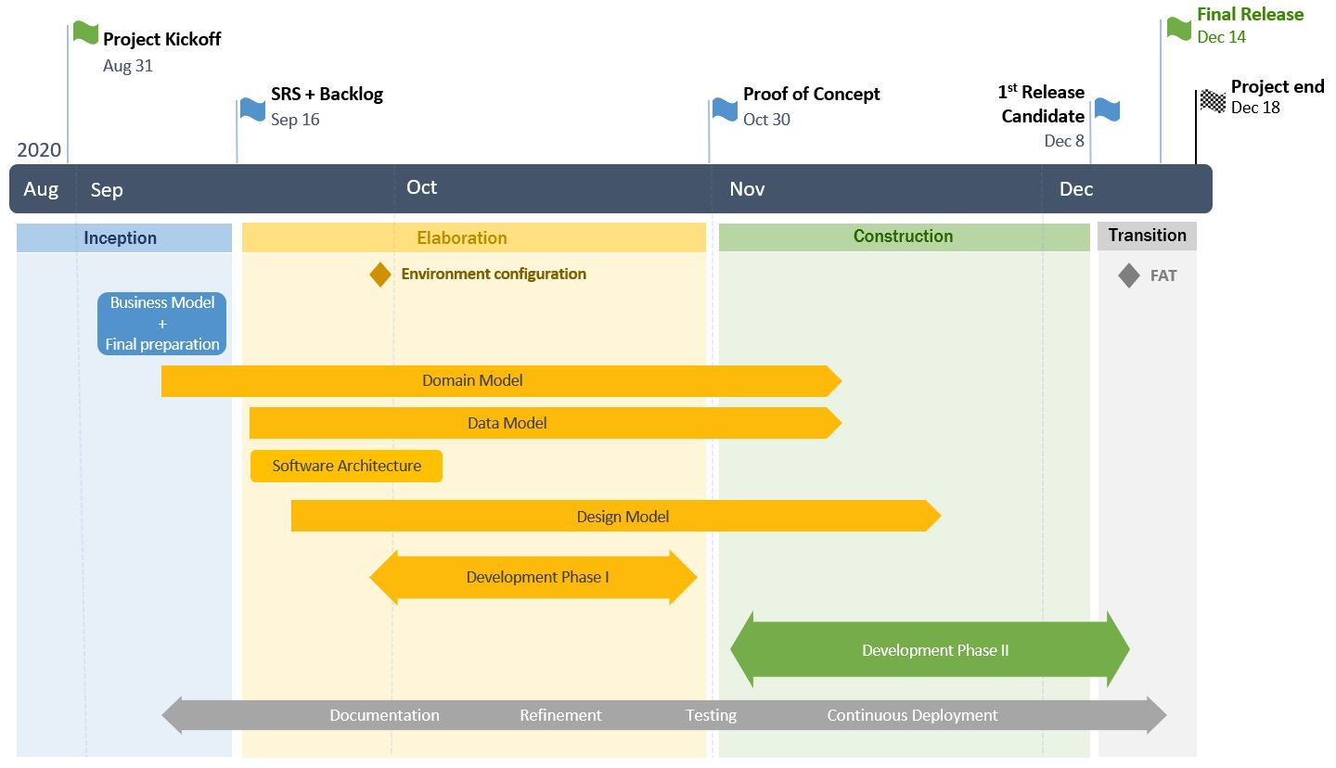

**Phases:**

* Inception (31 August - 16 September)

Focus:

* + Finalize Business Model
  + Process preparation (SCRUM)
  + Complete SRS and Product Backlog
* Milestone #1 (16 September) – SRS + Product Backlog documentation completed (however can be refined later when needed)
* Elaboration (16 September - 30 October)

Focus:

* + Domain Modeling - Domain Model, Use Cases,
  + Data Modeling - Schemas
  + System Architecture
  + Environment configuration - set up of necessary tools and components (end of September)
  + Design Model
  + Development phase I - implement the most critical user stories to be ready for the Proof of Concept
* Milestone #2 (30 October) – Proof of Concept – implemented all Must-have requirements (according to MoSCoW) for all critical features.

* Construction (30 October - 8 December)

Main focus:

* + Development phase II - implement the rest of Must-have and Should-have requirements according to MoSCoW
  + Continuous refinement of requirements and backlog
* Milestone #3 (8 December) – 1st Release Candidate (version 1.0-rc1) – implemented all the Must-have and Should-have requirements according to MoSCoW
* Transition (8 December - 18 December)

Main focus:

* + Final testing – FAT – Factory Acceptance Test
  + Finalize documentation

Final Release (14 December)

Project End (18 December)

# Risk assessment

|  |  |  |  |
| --- | --- | --- | --- |
| DESCRIPTION | LIKELIHOOD (1-5)[1] | SEVERITY  (1-5) | RISK MITIGATION |
| Pandemic virus / sickness | 4 | 3 | Work from home, communicate through social networks |
| Lack of knowledge | 3 | 4 | Research, study, ask teachers for help |
| Technical breakdown | 2 | 4 | Reallocate workload until faulty equipment is fixed |
| Not meeting deadlines / milestones | 2 | 5 | Always reserve few days for checking and reviews before real deadline |
| Inaccurate estimations | 3 | 4 | Make realistic goals for each sprint and task in particular  Use daily stand-ups to communicate about possible delays and redistribute work appropriately or in serious case change sprint’s goal |

Table 3

# Sources of Information

Anon 2020. *Unified Process*. [online] Available at: <https://en.wikipedia.org/wiki/Unified_Process> [Accessed 27 Mar. 2020].

DEFY Media, 2015. *Acumen Report Constant Content*. [online] Available at: <https://web.archive.org/web/20170417135757/http://sandbox.break.com/acumen/Acumen Constant Content__ExecSum Booklet_Final2.pdf>.

Google, 2020. *The latest YouTube stats on when, where, and what people watch*. [online] Available at: <https://www.thinkwithgoogle.com/data-collections/youtube-stats-video-consumption-trends/> [Accessed 20 Mar. 2020].

Maximillian Laumeister, 2019. *YouTube is Deleting Your Favorite Videos, And They Won’t Say Why*. [online] Available at: <https://www.maxlaumeister.com/articles/youtube-is-deleting-your-favorite-videos/> [Accessed 20 Mar. 2020].

Patty Mulder, 2017. *MoSCoW Method*. [online] Available at: <https://www.toolshero.com/project-management/moscow-method/> [Accessed 27 Mar. 2020].

**Appendices**

Group Contract – GroupContract.pdf

1. Scale: 1 – Low, 5 - High