# **Exercises**

Exercise 1 – Swapping values

Make a program with two int variables value1 and value2 assigned to two different values after your choice. Print out the values of both variables, swap the values and print out again to see that the value of value1 is now replaced by the value of value2 and vice versa. (Hard mode: don’t use a temporary variable to store one of the values).

Example run:

value1 = 10, value2 = 5

After swapping values:

value1 = 5, value2 = 10

Exercise 2 – Loops

Using loops, calculate the result for the following functions for any given n (read from the keyboard)

a) Result(n) = 1+2+3+…n

b) Result(n) = n!

c) Result(n) = $\frac{1}{1+2}+\frac{2}{2+3}+\frac{n}{2n+1}$

d) Result(n) = $2^{n}$

Exercise 3 – Averages

Read 10 integers from keyboard and calculate and print the average of all positive numbers and the average of all negative numbers. If the average cannot be found, i.e. if there are either no positive or no negative numbers then print a proper message instead.

Exercise 4 Calculate a sum

Look at the following sum calculating Z(n) with n being a whole number representing number of terms:

Z(n)= $\frac{1}{2}+\frac{1}{4}+\frac{1}{8}+…+\frac{1}{2^{n}}$

Calculate the sum Z(10) in a main method, i.e. n = 10. Change the number of terms to 25 and see the result.

# Exercise 5 – Power function

c) Calculate x n without using Math.pow(). Example: if n is 7 then x n can be calculated as:

pow = x*x*x*x*x*x*x

Exercise 6 – Divisors

Calculate all the divisors of any given number read from the keyboard.

Exercise 7 – Diamond Lover

Try to write a program that will print **10 diamonds like figures** in the console. The i-th diamond has the size of 2 * i - 1.

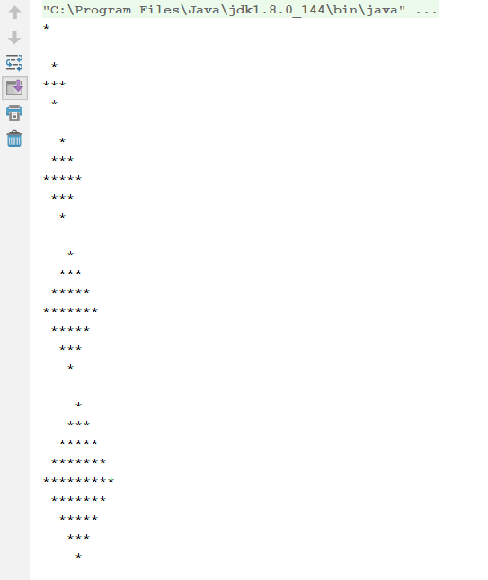

This is just a part of what the output should look like, you have to have **10 diamonds.** As you can see the first diamond is the smallest and each time the diamond grows bigger and bigger.

Hint: You may need some pen and paper to do this task. ;)

# Exercise 8 – Strings

Write a program that for a given string **“ABadvDdaDlfyaaBdlpoaAFeabrABCpsdlfaldbgbkdv”** prints the number of letters ‘a’,’b’, ‘c’ and ‘d’ in this string, when counting the frequency of those letters doesn’t matter if the letter is upper case or lower case.

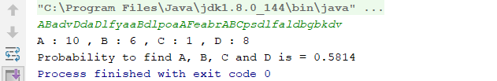

This is how the output should look like, also you have to compute the probability to find a letter of those 4 in this string. This is equal with (noA + noB + noC + noD) / (string length).

Note **noX** where X is ‘a’, ‘b’, ‘c’ or ‘d’ is equal with the frequency of letter X in the string.

**IMPORTANT:** You must display the probability so it has only 4 digits after the decimal point.

# Exercise 9 – Fibonacci

Write a program that for a given int x prints x next numbers of Fibonacci series.

Fibonacci series is defined by the recurrence relation:

F(n) = F(n-1) + F(n-2)

Try to solve this task in recursive and iterative way.

# Exercise 10 – Prime numbers

Write a program that for a given int x prints all prime numbers smaller than x.

Come up with your own idea or read about Sieve of Eratosthenes.

Try to optimize your solution (limit number of loops iteration).

# Exercise 11 – Array sorting

Write a program that reads 10 ints form keyboard and stores it in an array. Sort an array (Array.sort() is banned!) and print it.

To sort an array, come up with your own idea or/then read about Bubble sort and Selection sort.