Note: Red boxes are added as a visual guide to important features on the pages shown.

Step 1: Open up your email and find an email from Cloud 9 to sign up

Step 2: Click the sign up button.

Step 3: Enter your Name in the box provided

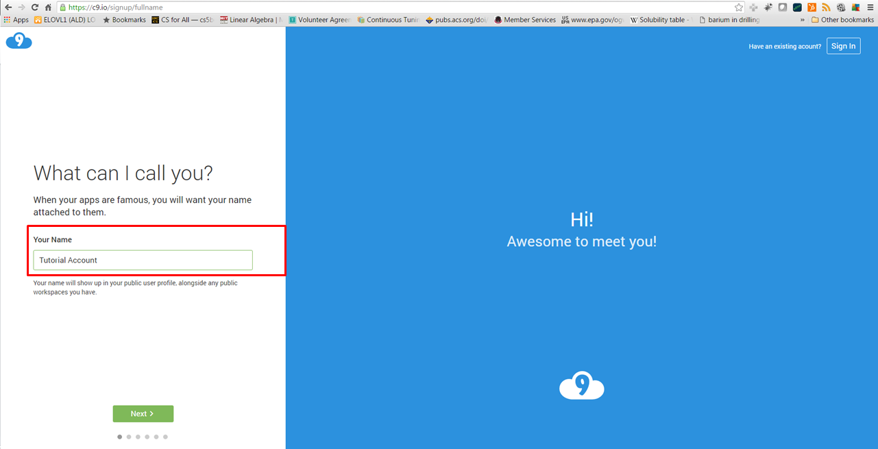

Step 4: Create a username FirstnameLastName (All in lowercase)

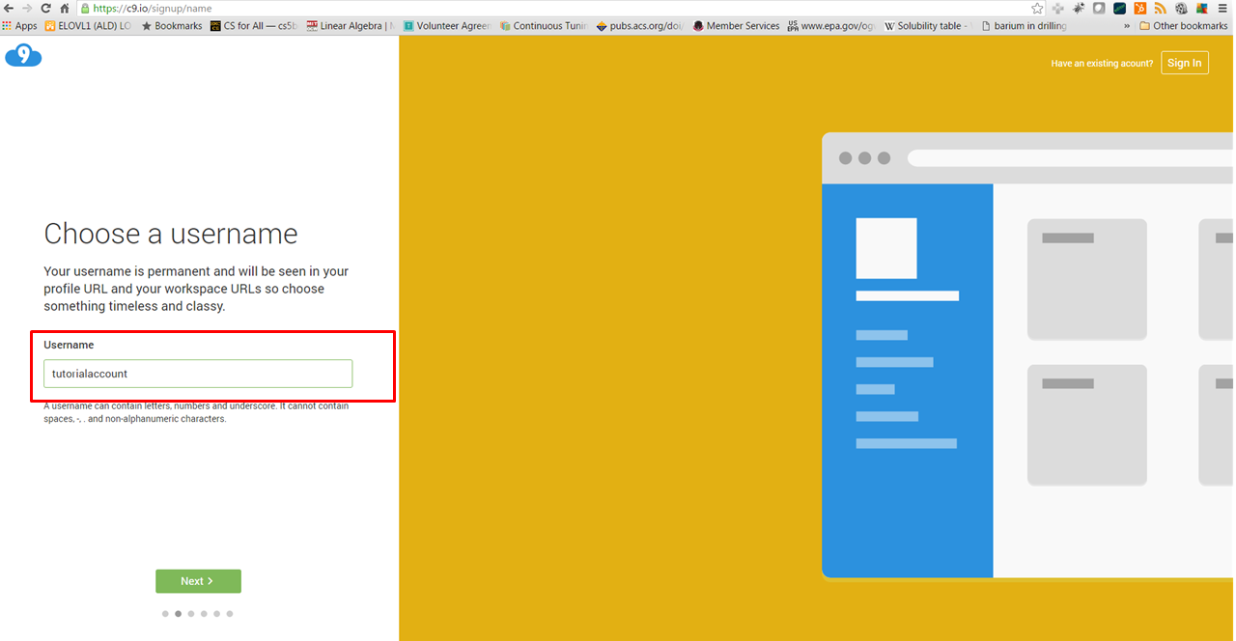

Step 5: Select that you are a Student Developer

Step 6: Select that you will use Cloud9 for Course work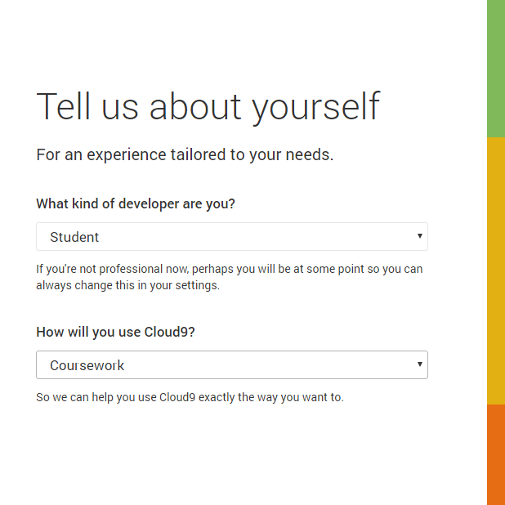

Step 7: Confirm account details on the next page (Just click next)

Step 8: Confirm that you are not a robot

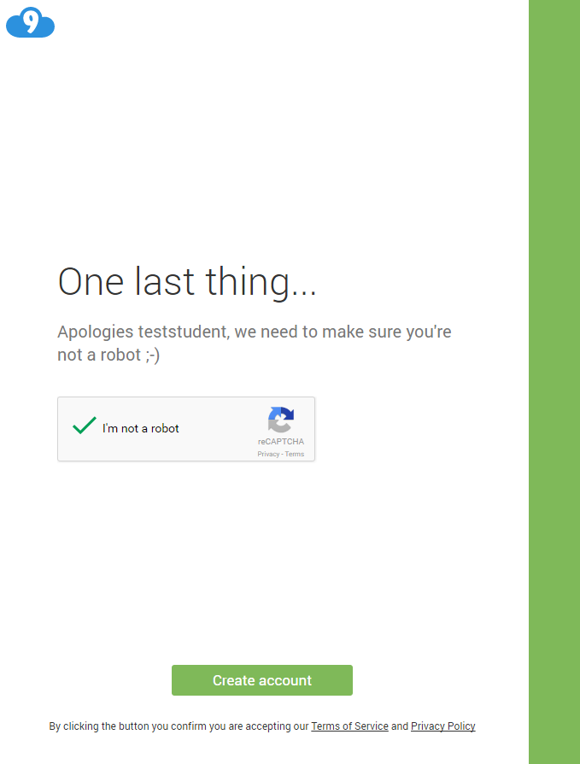

Student *should have access to shared team workspace:*

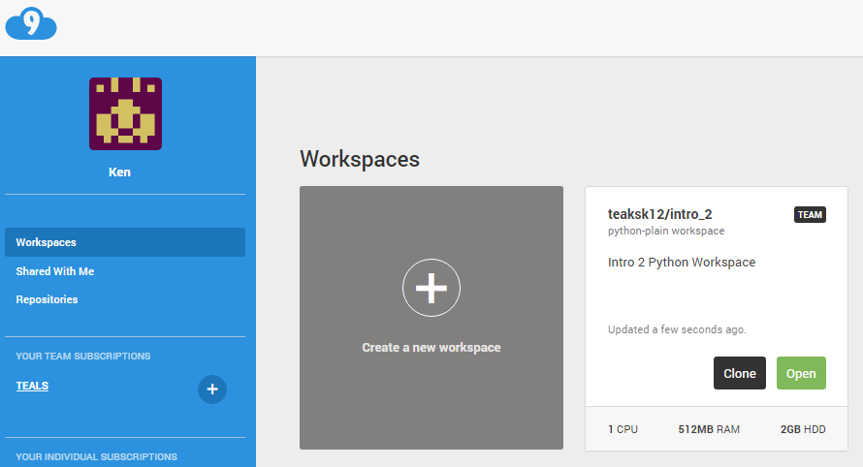

Step 9: Click **Create a new workspace**

Step 10: In “Workspace name” field enter “**mypythonworkspace**”

Step 11: Give it a description of “**This is my example workspace”**

Step 12 Make sure that the team is selected and the workspace is set to “**Private**”

Step 13: Select “**Python**” Template button

Step 14: Click “**Create Workspace**”

