**Create a Cloud9 teacher account**

1. Navigate to Cloud9: <https://c9.io/login>.

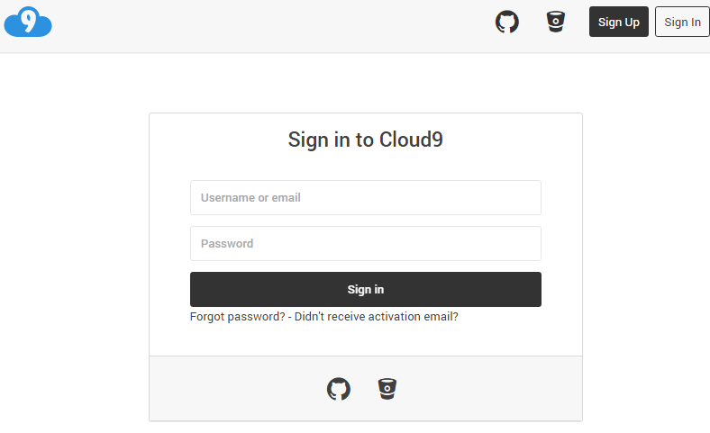

1. Click “Sign Up” in upper right corner.

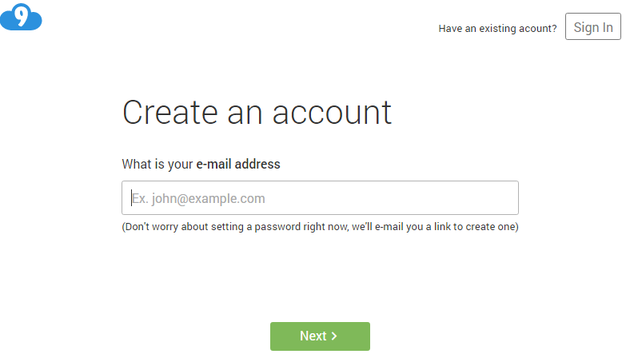

1. Enter e-mail address, click “Next >”

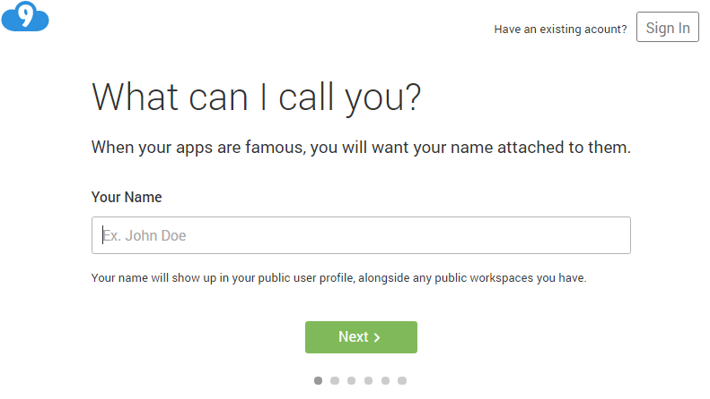

1. Enter “Your Name” and click “Next >”

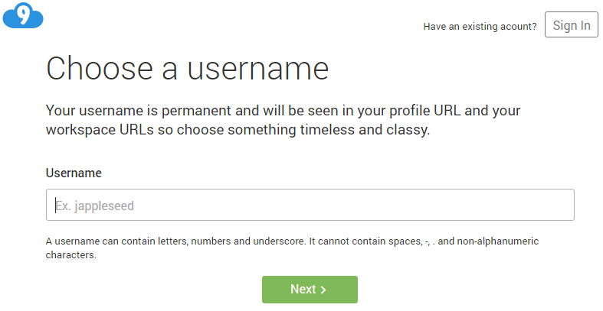

1. Enter “Username”, click “Next >”

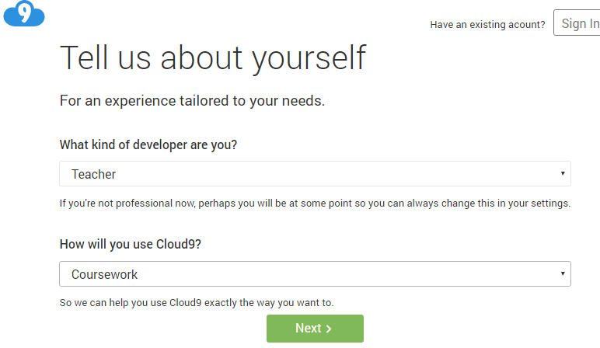

1. Select “Teacher” and “Coursework”, click “Next >” twice to verify

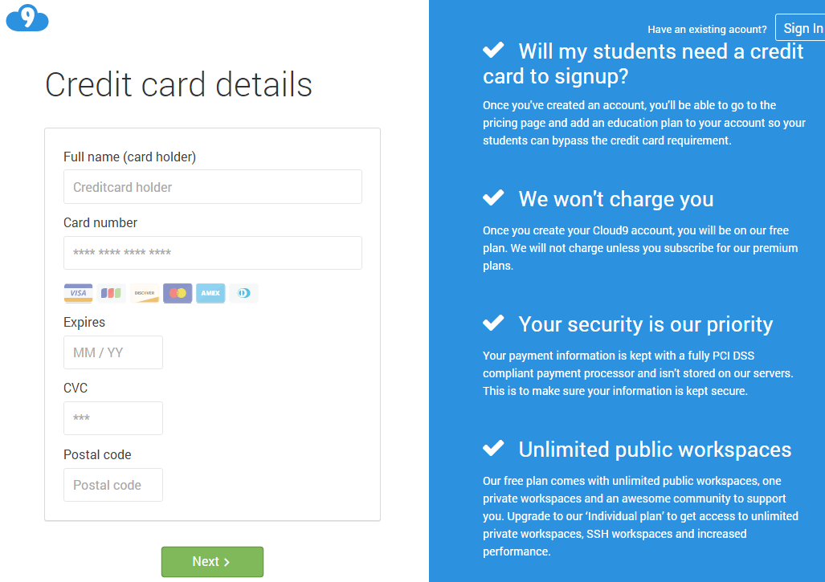

1. Enter credit card verification for free account.

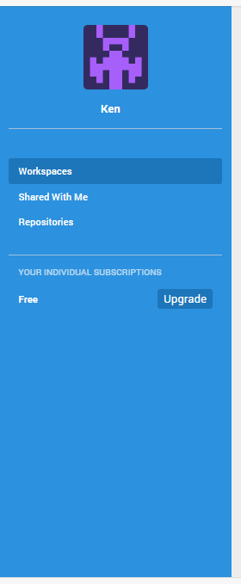

1. Click “Upgrade” to sign up for school plan.

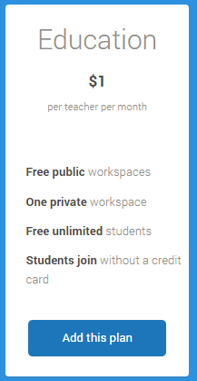

1. Click “Education - Add this plan”

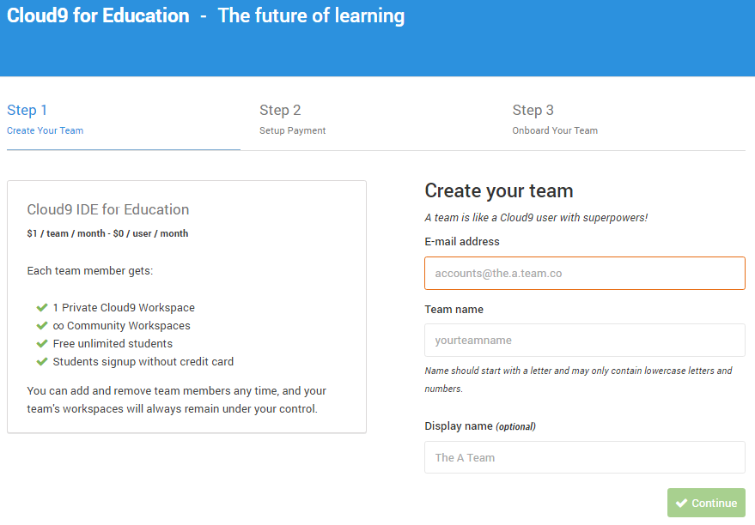

1. Enter e-mail address and Team name and click “Continue”.

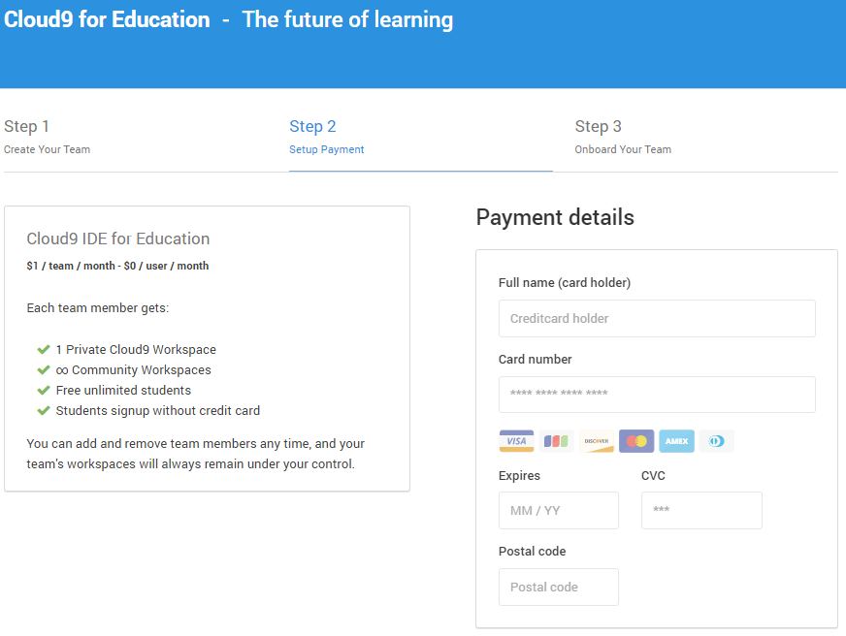

1. Enter Payment details

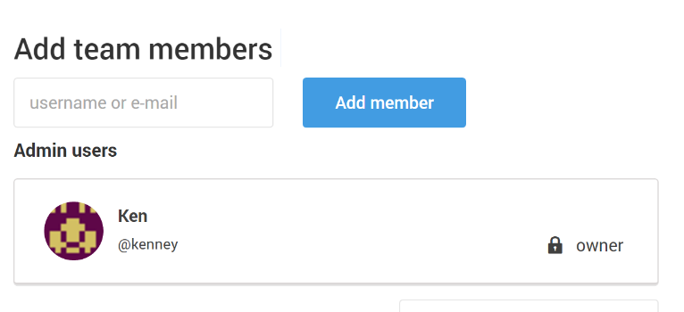

1. Add team members, click “Add member”

**Adding students to Team workspace**

1. Log into cloud9: <https://c9.io/login>.  
     
   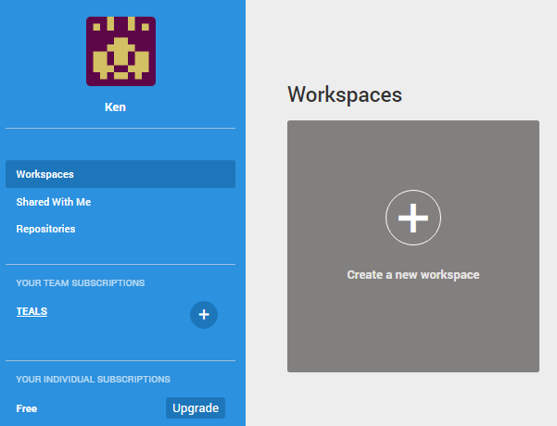
2. Click “+” Create a new workspace  
     
   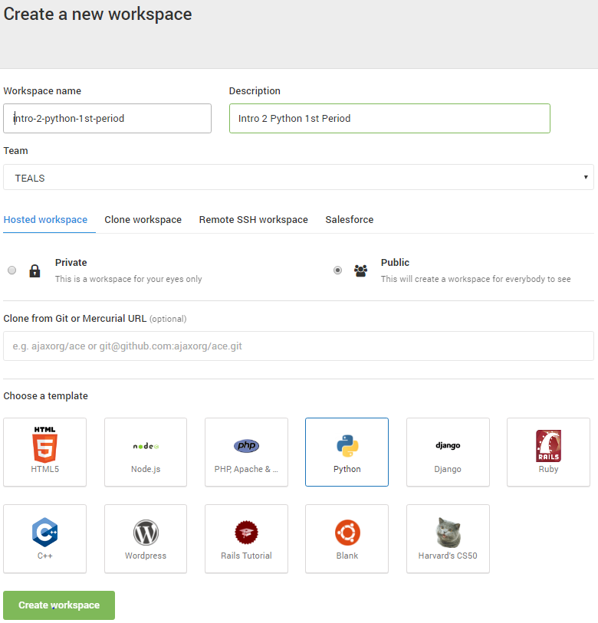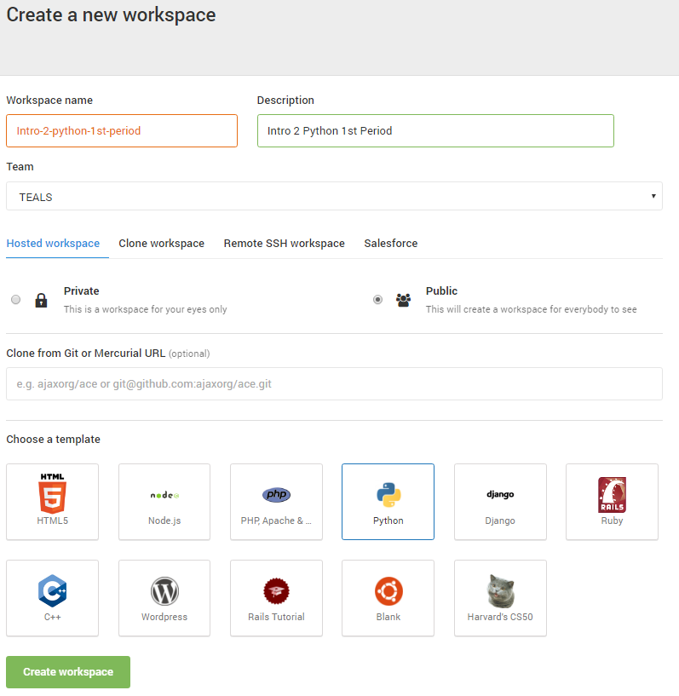
3. Fill in “Workspace name” (all lower case), “Description,” select “Team” (created when School plan was added), select “Public”, and “Python” template.

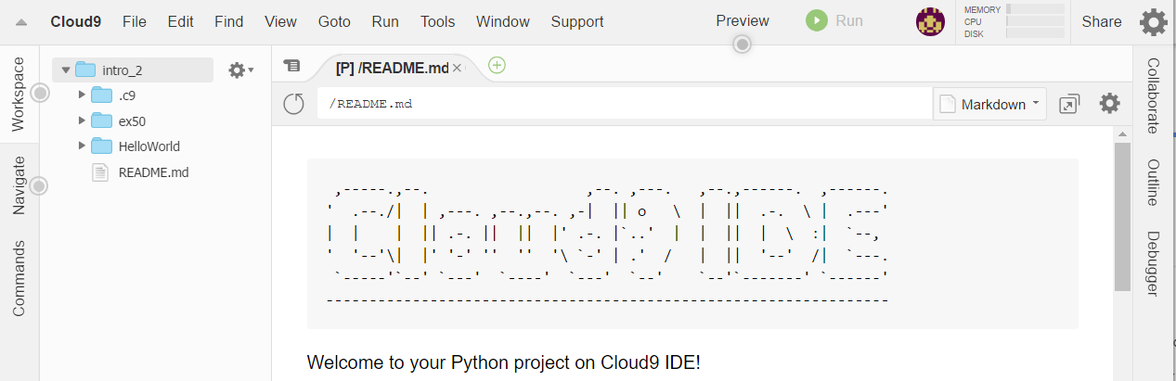

1. Navigate back to Dashboard by clicking Cloud9 -> Dashboard in upper left hand corner:  
     
   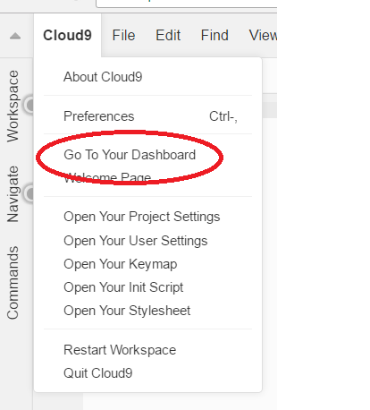
2. From the Dashboard click the “Setting” icon in upper right corner:  
     
   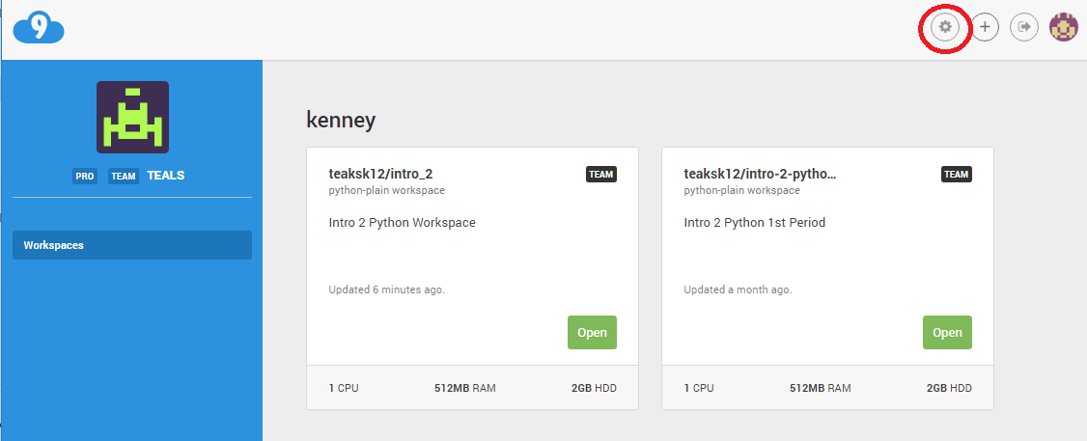
3. From the “Setting” window click “Admin” on lower left corner:  
     
   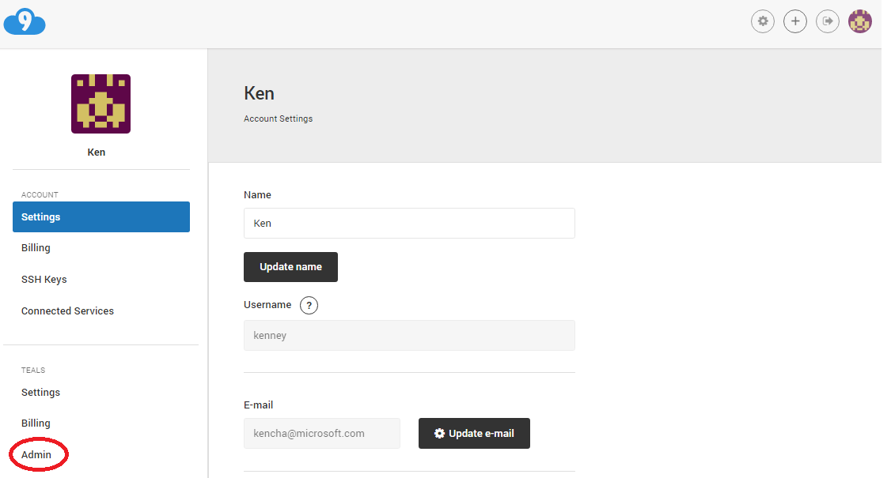
4. From “Admin” window enter e-mail address and click “Add Member”:  
     
   