**Create a repl.it teacher account**

1. To create a repl.it account to use with Python, navigate to <https://repl.it/>.
2. Create an account by clicking the "Sign Up" in the upper right corner:  
     
   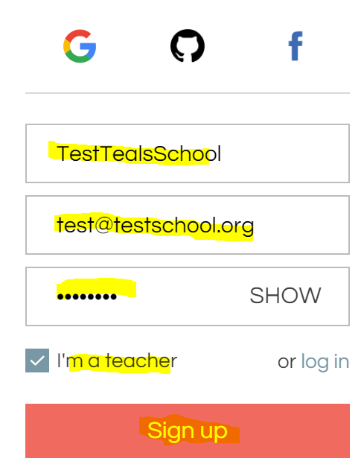
3. Enter your information for the account by filling out the "username", "email", "password", select "I'm a teacher" and click "Sign up"  
     
   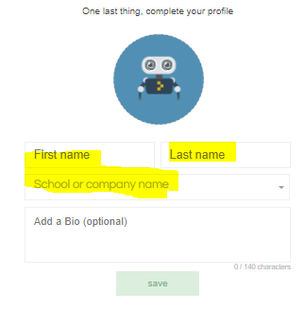
4. Enter "First name", "Last Name", and new "School or company name", **press enter key** in "School or company name" to create new school. Your students will search for the "School or company name" when they create their accounts.  
     
   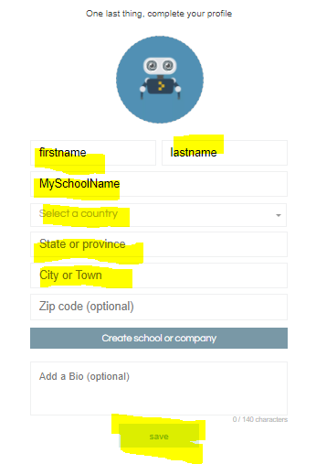
5. Enter "Select a country", "State or province", "City or Town" and click "save"  
     
   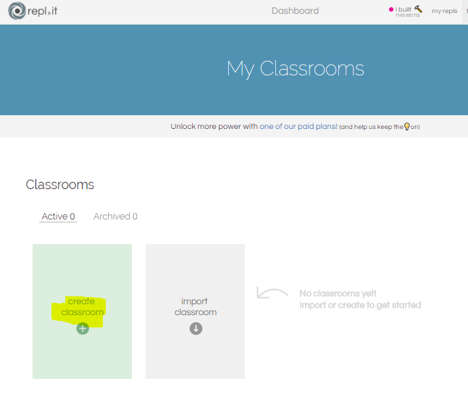
6. Click "create classroom"  
     
   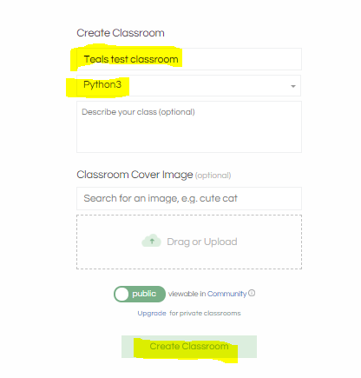
7. From the Classroom page, you can create assignments and invite students  
     
   