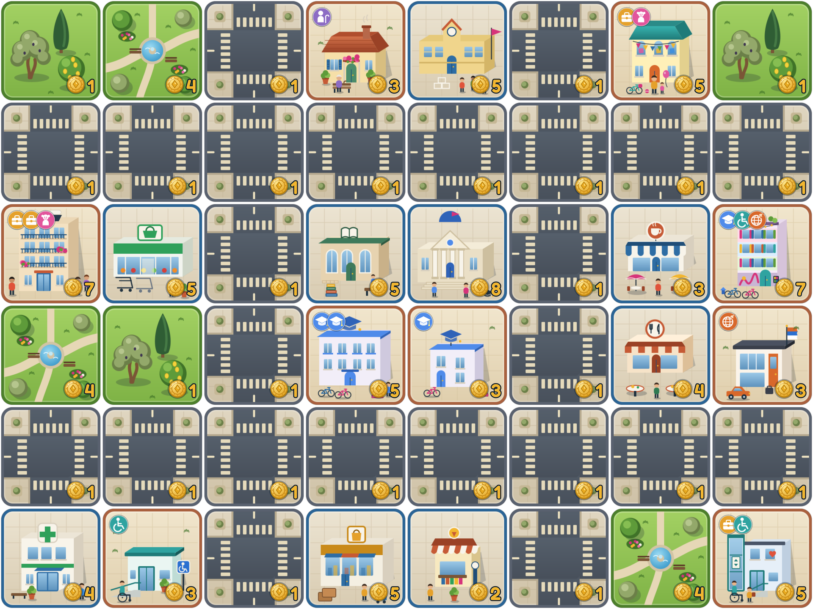
Egkomi City
How to play
A board game about streets, shade and green space in Nicosia.
For 1 to 4 players.

Welcome to Egkomi
In Egkomi City you plan a neighbourhood of Nicosia. Each round you buy tiles from a shared shop and build them on your own city board. Homes bring citizens to your city. Each citizen wants to reach certain places by road, to live near greenery and to breathe clean air. The happier your citizens are at the end of the game, the more points you score.
Players | 1 to 4
Length | 8 rounds
On your turn | Buy 4 tiles and build them
Your city | A board of 7 × 7 spaces
Money | 100 gold each, with no income
Goal | The most points after round 8
What is in this book
Getting started | Setting up | 3
 | How a round works | 4
 | Buying and building | 5
Tiles | Homes | 6
 | Services | 7
 | Green space and streets | 8
Citizens | The six groups of citizens | 9–10
Scoring | Reaching places | 11
 | Green space and pollution | 12
 | Scoring a citizen | 13
 | Your final score | 14
 | Example: scoring a finished city | 15–16
Cards | Event and penalty cards | 17
 | Circumstance cards | 18–19
The end | The end of the game | 20
 | Score sheet | 21
Why the game exists
Egkomi City was made to show how movement, greenery, accessibility and public space shape everyday life in a real neighbourhood. Every rule follows from that: people need to get to places, long walks in the sun are hard, and parks make a street better to live on.
The computer version of the game does all the scoring for you. This book explains the printed version, which uses exactly the same rules and numbers.

Setting up
What you need, and how to get the table ready.
What you need
Item | Amount | Notes
Shop tiles | 222 | The tiles players buy: 66 homes, 101 services, 17 parks and trees, and 38 roads. Each tile is 4 × 4 cm.
Free tiles | 29 | Tiles that are never sold: 19 plain roads, plus 10 tiles that event cards give away (2 parks, 2 coffee shops, 1 trees tile, 1 kiosk, 1 parking place, 1 shaded street, 1 pedestrian street and 1 bike lane).
Event cards | 64 | Good news. Green backs with a star.
Penalty cards | 64 | Bad news. Red backs with a warning sign.
Circumstance cards | 32 | Changes that affect everyone. Dark blue backs with a sun. Each game uses only 8.
City boards | 1 per player | A grid of 7 × 7 spaces, each 4 × 4 cm. You can draw one, print one, or just lay your tiles out in a square.
Gold | 100 per player | Coins, tokens or paper money.
Loan tokens | A few | Anything you can count, to show how many loans each player has taken.
A coin | 1 | For the coin flip at the start of every turn.
Score sheets | As needed | Photocopies of page 21. Each player needs one per round.
Before the first round
1 | Hand out the basics  Give each player a city board, 100 gold and 4 free roads. Put the other free tiles to one side.
2 | Set up the shop  With 4 players, use all 222 shop tiles. With fewer players, shuffle the tiles face down first and put 55 back in the box for each missing player, without looking at them: 55 with 3 players, 110 with 2 and 165 with 1. Then sort the remaining tiles face up into piles of identical tiles, so that every type of home, service and street has its own pile.
3 | Shuffle the cards  Shuffle the event cards and the penalty cards into two separate face-down piles.
4 | Deal the circumstance cards  Shuffle the circumstance cards and deal 8 of them face down into a pile, without looking at them. This is the round pile. Put the other 24 back in the box.
5 | Choose who starts  Pick a starting player at random. In round 1, play goes in this order.

Playing alone? Use the same rules and try to beat your own best score.

How a round works
The game lasts 8 rounds. In each round, every player takes one turn.
At the start of every round |  | On your turn
  1 | Decide the order  In round 1, use the order chosen during setup. From round 2, the player with the lowest score goes first (see below).
  2 | Turn over a circumstance card  Take the top card of the round pile and read it out. It affects every player. If it gives or takes gold, do that now. Its other effects last until the end of the game.
  3 | Play your turns  Each player takes a turn, in order.
  1 | Flip the coin  Heads: draw an event card. Tails: draw a penalty card. Read it out and do what it says straight away (page 17).
  2 | Buy and build  Buy 4 tiles from the shop and place each one on your city board (page 5).
  3 | Finish  Once your 4 tiles are placed, the next player starts their turn.
Deciding the order
From round 2, every player works out their score as it stands, using a score sheet (page 21). Count everything: loans, points from cards and every circumstance card turned over so far. Do this before you turn over the new circumstance card.
- The player with the lowest score goes first, then the next lowest, and so on. Scores can be below zero.
- If two players have the same score, the one who played later in the previous round goes first.
This gives the player who is behind the first pick from the shop, so the leader cannot take the best tiles every round.
The end of the game
The game ends when the last player finishes their turn in round 8. Everyone then works out their final score (pages 13, 14 and 20).

Buying and building
What you can do with your gold, your tiles and the spaces on your board.
Buying
- You must buy exactly 4 tiles on each turn. You can only buy fewer if the shop runs out.
- Choose any tile in the shop and pay its price to the bank. The price is the number on the gold coin printed on the tile.
- Before you buy a home, look at the badges in its top corner. They show who will move in.
- You never earn money during the game. Your 100 gold has to last all 8 rounds, and you can never have less than 0 gold.
Building
- Place each tile on an empty space of your board as soon as you buy it. Once a tile is placed, it stays there.
- You start with 4 free roads. You can place them on any empty space during any of your turns. They cost nothing and are not one of your 4 buys.
- Free tiles from event cards work the same way.
- If a penalty card makes you lose a tile, remove it from the game. The space is empty again and you can build on it.

Replacing a tile, once per game
Once in the game, you may build a new tile on a space that already has a tile on it. Put the old tile back on its pile in the shop. The new tile counts as one of your 4 buys and you pay its full price. It must be a different tile from the one it replaces, and you cannot replace free roads or other free tiles.
Loans
If you cannot afford the tiles you still have to buy this turn, you may take a loan: you get 20 gold from the bank and a loan token. You can take more than one. At the end of the game every loan costs points, and each loan costs more than the one before.
1st loan | 2nd loan | 3rd loan | 4th loan | 5th loan
−6  6 points in total | −9  15 points in total | −12  27 points in total | −15  42 points in total | −18  60 points in total
Every further loan costs 3 points more than the one before. You may only borrow when your gold is less than the total price of the cheapest tiles that would complete your turn.
A loan can still be worth it. A large apartment holds 3 citizens, and if all three are completely happy they score 15 points, far more than the 6 points the first loan costs.

Homes
Each home tile houses a fixed group of citizens. The badges in its top corner show who lives there, one badge per citizen.
Small apartments 3 gold each. 1 citizen. 18 tiles in the shop.
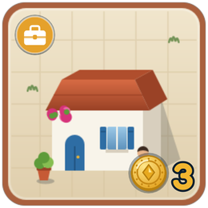  Worker    4 in the shop | 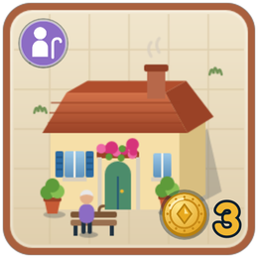  Older person    4 in the shop | 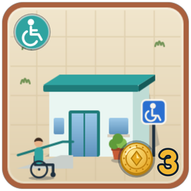  Resident with a disability    5 in the shop | 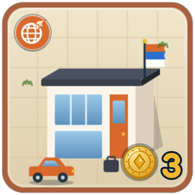  International resident    5 in the shop
Medium apartments 5 gold each. 2 citizens. 18 tiles in the shop.
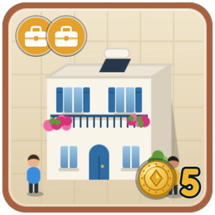  Working couple  3 in the shop | 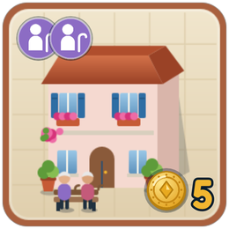  Older couple  3 in the shop | 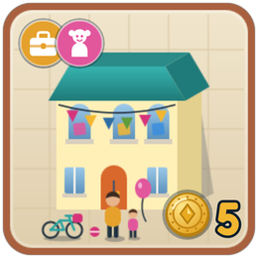  Parent and child    4 in the shop | 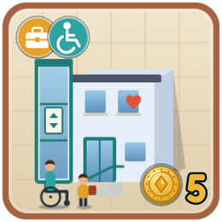  Carer and resident  4 in the shop | 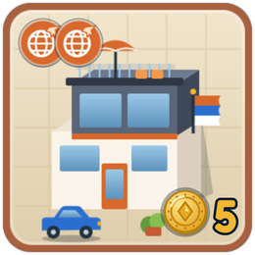  International couple  4 in the shop
Large apartments 7 gold each. 3 citizens. 14 tiles in the shop.
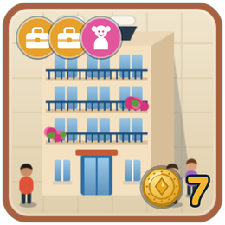  Family  4 in the shop | 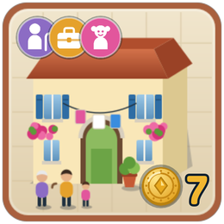  Three generations  4 in the shop | 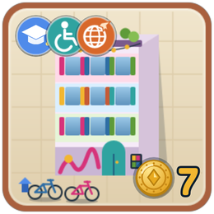  Shared house    3 in the shop | 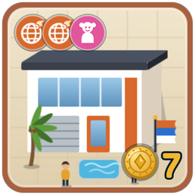  International family  3 in the shop
Student residences Small: 3 gold, 1 student. Large: 5 gold, 2 students. 8 tiles of each in the shop.
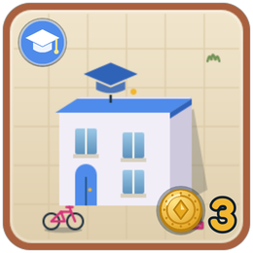  Small residence  8 in the shop | 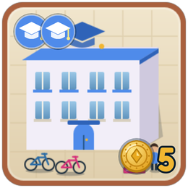  Large residence  8 in the shop

Student Worker Child Older resident Resident with a disability International resident
Students only live in student residences and in the shared house.

Services
Services are the places citizens go to. A citizen can only use a service if a road connects it to their home (page 11).
 | Service | Gold | In shop | Needed by | Liked by | Notes
Study
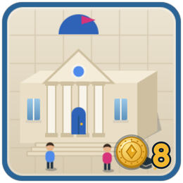 | University | 8 | 5 |  | –
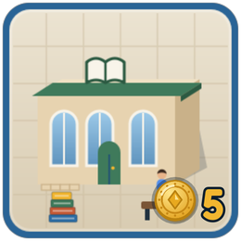 | Library | 5 | 8
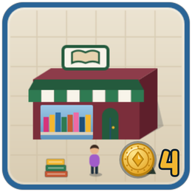 | Bookshop | 4 | 5 | –
 | Print shop | 3 | 5 | –
Health and school
 | Hospital | 8 | 5 |  | – | Gives +1 happiness to every citizen whose need it meets.
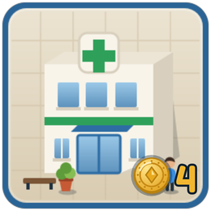 | Clinic | 4 | 6 |  | – | Meets the same need as a hospital, without the bonus.
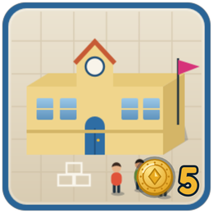 | School | 5 | 8
Work and shopping
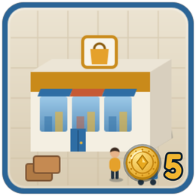 | Commercial area | 5 | 10 |  | – | Shops and offices: this is where people work.
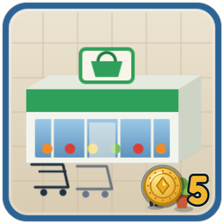 | Supermarket | 5 | 8 |  | – | Gives +1 happiness to every citizen whose need it meets.
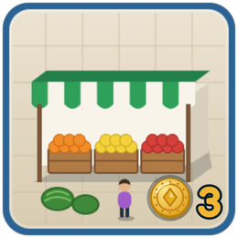 | Market | 3 | 5 |  | – | Meets the same need as a supermarket, without the bonus.
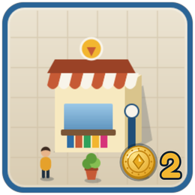 | Kiosk | 2 | 8 | –
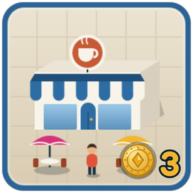 | Coffee shop | 3 | 10 | –
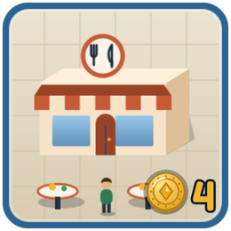 | Restaurant | 4 | 8 |  |  | Older residents dislike living right next to one.
Parking
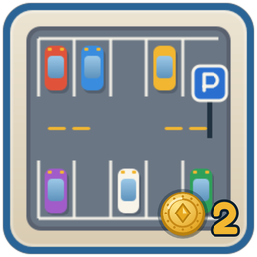 | Parking place | 2 | 10 | – |  | Children dislike living right next to one.

Student Worker Child Older resident Resident with a disability International resident

Green space and streets
Parks and trees make citizens happier and the air cleaner. Streets connect everything together.
 | Tile | Price | In shop | What it does
Green space
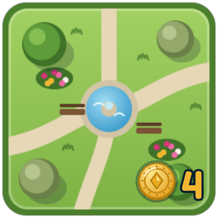 | Park | 4 gold | 8 | Reduces pollution by 3. Counts as nearby greenery for every home in the 8 spaces around it. Meets the park need of children and residents with a disability. Shades the roads next to it.
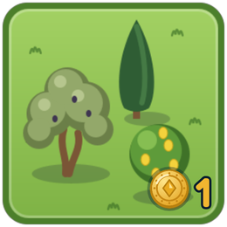 | Trees | 1 gold | 9 | Reduces pollution by 1. Counts as nearby greenery for the homes on its 4 sides. Shades the roads next to it.
Streets
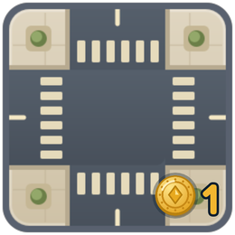 | Road | 1 gold | 24 | Connects tiles, so that citizens can get from one place to another.
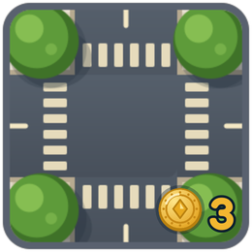 | Shaded street | 3 gold | 5 | A road lined with trees. It connects like a road and also works like a trees tile: it reduces pollution by 1, counts as nearby greenery for the homes beside it, and is always in the shade. Liked by
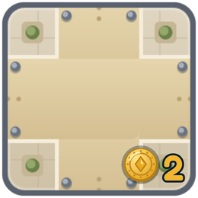 | Pedestrian street | 2 gold | 5 | Connects like a road. Liked by
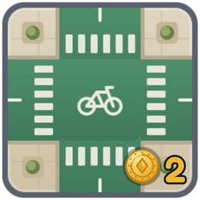 | Bike lane | 2 gold | 4 | Connects like a road. Liked by

Every street is a road
The shop holds 38 road tiles: 24 plain roads, 5 shaded streets, 5 pedestrian streets and 4 bike lanes. Every printed road is a crossroads, so it connects to roads on all four sides. All types of street connect to each other. Free roads are always plain roads.

Page 12 explains how greenery and pollution are counted.

The six groups of citizens
Every citizen belongs to one of six groups. Each group needs two things, likes a few others and sometimes dislikes something. Every citizen scores their own happiness (page 13).
Students
Studies in Egkomi and lives in student housing.
Live in | Small and large student residences, and the shared house.
Need | University Library
Like | Coffee shop Print shop Bookshop Parking Bike lane
Dislike | Nothing in particular.
Long walks | A long walk without shade costs them 1 happiness.
Tip | One university and one library can serve every student home that is connected to them by road.

Workers
Goes to work every day and does the shopping.
Live in | The worker's small apartment, working couple, parent and child, carer and resident, family, and three generations.
Need | Commercial area Supermarket or market
Like | Coffee shop Restaurant Kiosk Parking Bike lane
Dislike | Nothing in particular.
Long walks | A long walk without shade costs them 1 happiness.
Tip | Workers need two different places, so make sure your roads reach both a commercial area and a food shop.

Children
Goes to school and needs somewhere to play.
Live in | Parent and child, family, three generations, and international family.
Need | School A park in the 8 spaces around the home
Like | Library Bookshop Pedestrian street
Dislike | A parking place right next to the home, because of the traffic
Long walks | A long walk without shade costs them 1 happiness.
Tip | The park does not need a road. It only has to be in one of the 8 spaces around the home.

Older residents
Retired, and finds long walks in the heat hard.
Live in | The older person's small apartment, older couple, and three generations.
Need | Clinic or hospital Supermarket or market
Like | Coffee shop Kiosk Parking Shaded street Pedestrian street
Dislike | A restaurant right next to the home, because of the noise
Long walks | A long walk without shade costs them 2 happiness instead of 1.
Tip | Build the clinic close by, or put trees along the way. Keep restaurants away from their front door.

Residents with a disability
Needs health care and green space close to home.
Live in | The small apartment for a resident with a disability, carer and resident, and the shared house.
Need | Clinic or hospital A park in the 8 spaces around the home
Like | Kiosk Parking with reserved spaces Pedestrian street Shaded street
Dislike | Nothing in particular.
Long walks | A long walk without shade costs them 2 happiness instead of 1.
Tip | They only have two needs, but a long walk without shade costs them twice as much.

International residents
Moved to Egkomi to work for an embassy or an international company.
Live in | The international resident's small apartment, international couple, international family, and the shared house.
Need | Commercial area Restaurant
Like | Coffee shop Parking School Bike lane
Dislike | Nothing in particular.
Long walks | A long walk without shade costs them 1 happiness.
Tip | Once work and a restaurant are in reach, a school nearby makes them even happier.

Reaching places
A citizen can only use a place if they can walk there along roads. Being next door is not enough.
How a route works
- The route starts on a road that touches the home on one of its four sides. Corners do not count.
- It continues along roads that touch each other on their sides. All types of street connect to each other.
- It ends on a road that touches the place the citizen wants to reach.
- The length of a route is the number of road tiles on it. Citizens cannot walk through homes or other buildings.
- If several places can meet the same need, the citizen uses the nearest one. If two are equally near, they prefer the one with a shaded route, and then a hospital or supermarket over a clinic or market.

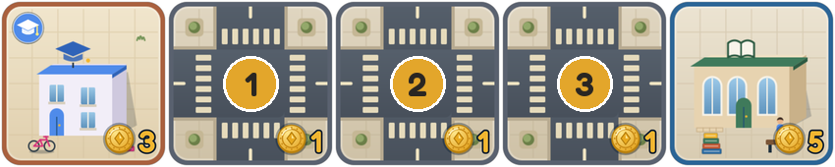 | Reached in 3 roads  The student can reach the library along 3 road tiles. The need is met and the route is 3 roads long.
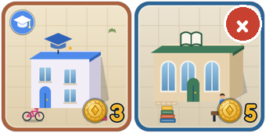 | Not reached  The two buildings touch, but there is no road between them, so the student cannot use the library.
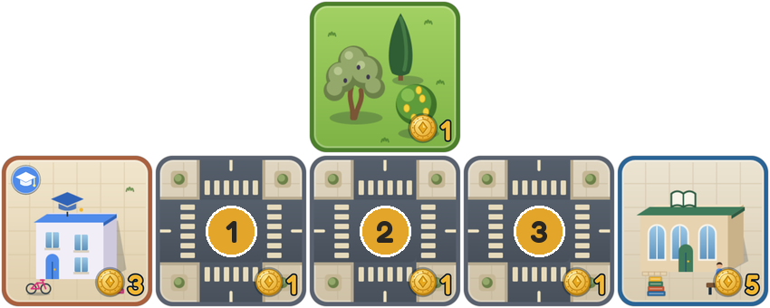 | A shaded route  The trees shade the road next to them. One shaded road is enough to make the whole route shaded.
Shade and long walks
When is a road in the shade?  A road is shaded if it is a shaded street, or if a park, a trees tile or a shaded street touches one of its sides.  A route is shaded if at least one of its roads is shaded. |  | When is a walk too hot?  When the route to something a citizen needs is 3 or more roads long and none of it is shaded. The citizen loses 1 happiness, or 2 if they are an older resident or a resident with a disability.  This only counts once per citizen, however many long walks they have. The park need never counts as a walk.

Green space and pollution
Greenery cheers up the people who live next to it. Pollution affects everyone in your city.
Nearby greenery
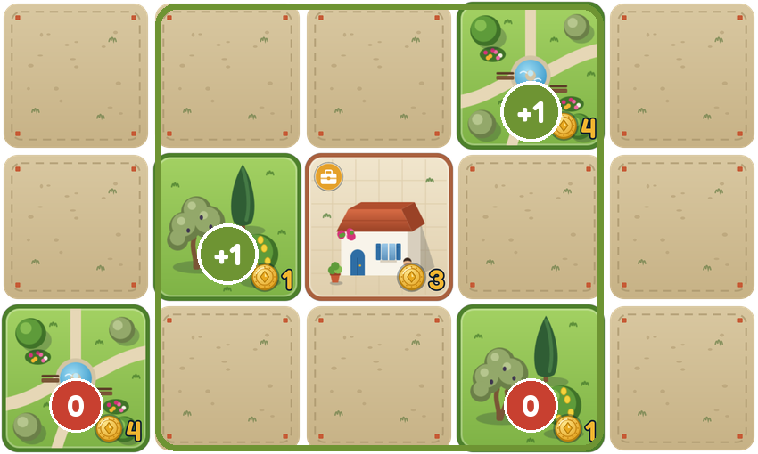 | A home has nearby greenery when there is:  - a park in one of the 8 spaces around it, or  - trees or a shaded street on one of its 4 sides.  Each one gives every citizen in the home +1 happiness, up to a maximum of +2.  In the picture, the home gets +2: one for the park on its diagonal and one for the trees on its left. The trees on the other diagonal do not count, and the park in the bottom-left corner is too far away.
Pollution
Every city starts with a pollution level of 16. For each park in your city, take away 3. For each trees tile and each shaded street, take away 1. The level can never go below 0. At the end of the game it affects every citizen in your city:
0 to 7  No effect. |  | 8 to 12  Every citizen loses 1. |  | 13 to 16  Every citizen loses 2.
The cheapest ways to lower it
Goal | Tiles you need | Cost | Result
Pollution of 12 or less | 1 park and 1 trees tile | 5 gold | Citizens lose 1 instead of 2
Pollution of 7 or less | 3 parks | 12 gold | No effect on citizens
 | 2 parks and 3 trees tiles | 11 gold | No effect on citizens
 | 1 park and 6 trees tiles | 10 gold | No effect on citizens
 | 9 trees tiles | 9 gold | No effect on citizens
Trees are the cheapest, but the shop only has 9 of them, and parks make more homes happier.

Scoring a citizen
At the end of the game, work out the happiness of each citizen in turn and write it on your score sheet. Go through these steps in order.
 | Step | How to count it | Points
1 | Needs | Both needs met: +2. One need met: 0. Neither met: −2. A need is met when the citizen can reach the right place by road. The park need is met by a park in one of the 8 spaces around the home, with no road needed. | +2, 0 or −2
2 | Hospital or supermarket | +1 for each need that is met by a hospital or a supermarket rather than a clinic or a market. | +1 each
3 | Something they like | +1 if the citizen can reach at least one place they like, however far away, or has a street they like on one of their routes or next to their home. This only counts once. | +1
4 | Nearby greenery | +1 for each park or trees tile that counts as nearby greenery (page 12), up to +2. | +1 or +2
5 | Long hot walk | −1 if the nearest place for one of their needs is 3 or more roads away and the route has no shade. Older residents and residents with a disability lose 2. | −1 or −2
6 | Pollution | Depends on the pollution level of your city (page 12). | 0, −1 or −2
7 | Something they dislike | −1 if something they dislike touches one of the home's sides: a parking place for children, a restaurant for older residents. | −1
8 | Circumstance cards | Apply each circumstance card that has been turned over, in the order they came up (pages 18 and 19). | Varies
9 | Limits | If the total is below −5, it counts as −5. If it is above +5, it counts as +5. | −5 to +5

A citizen with happiness above 0 is happy. Below 0, they are unhappy. Happy citizens count towards the variety bonus (page 14).

Your final score
Your final score is the total happiness of your citizens, plus some bonuses and minus some penalties.
+ | Citizens | The happiness of all your citizens added together. This can be a negative number.
+ | Variety bonus | Count how many of the six groups have at least one citizen with happiness of +1 or more, and look up the bonus in the table below.
+ | Circumstance points | +1 for each place that earns a point from a circumstance card, such as New attractor (page 18).
± | Card points | The points you won or lost from event and penalty cards.
− | Loans | 6 points for the first loan, 9 for the second, 12 for the third, and so on (page 5).
− | Unreachable services | 1 point for each service that no home in your city can reach by road.
Gold you have left at the end is not worth any points. It is only used to break ties.
The variety bonus
A city with many different kinds of citizen is worth more, because they all need different places at the same time.
0  1 group |  | +3  2 groups |  | +7  3 groups |  | +12  4 groups |  | +19  5 groups |  | +27  6 groups

Which tiles are services?
Commercial areas, universities, libraries, bookshops, print shops, hospitals, clinics, schools, supermarkets, markets, kiosks, coffee shops, restaurants and parking places. Homes, parks, trees and roads are not services.

Example: scoring a finished city
Here is a city at the end of the game. Try to score it yourself first, then check your answers.
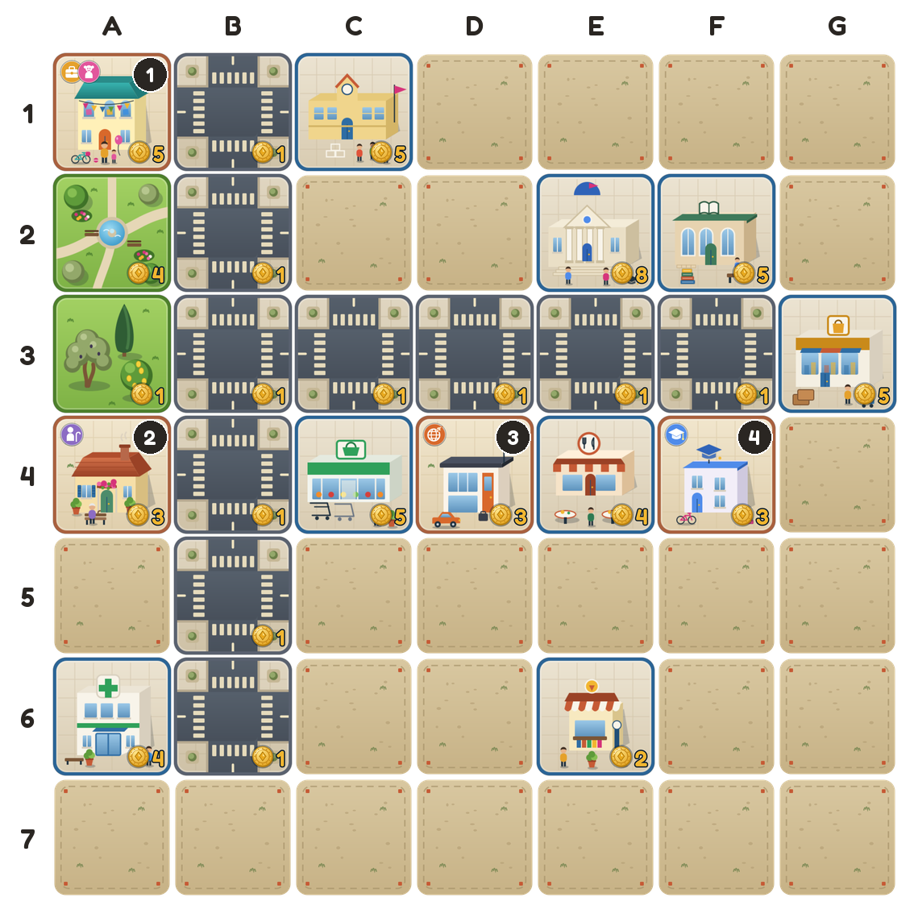 | What is on the board  - 4 homes with 5 citizens: a parent and child (1), an older person (2), an international resident (3) and a student (4).  - 1 park and 1 trees tile, so pollution is 16 − 3 − 1 = 12. Every citizen loses 1.  - The roads at B2 and B3 are shaded, because they touch the park and the trees.  - The kiosk at E6 is not connected to any road.  - The player took 1 loan. No cards have been played yet.
Citizen by citizen
Citizen | Needs | Hospital or supermarket | Like | Greenery | Hot walk | Pollution | Dislike | Total
Worker  Home 1 | +2 | +1 | +1 | +1 | 0 | −1 | 0 | 4
Child  Home 1 | +2 | 0 | +1 | +1 | 0 | −1 | 0 | 3
Older resident  Home 2 | +2 | +1 | 0 | +1 | −2 | −1 | 0 | 1
International resident  Home 3 | +2 | 0 | +1 | 0 | −1 | −1 | 0 | 1
Student  Home 4 | +2 | 0 | 0 | 0 | 0 | −1 | 0 | 1
All citizens together |  |  |  |  |  |  |  | 10

Example: the final score
How each citizen's score was worked out, and what the city scores in the end.
Worker  Home 1 | Reaches the commercial area at G3 (7 roads) and the supermarket at C4 (4 roads). Both routes pass the shaded road at B2, so neither walk is hot. The supermarket adds +1. Likes the restaurant at E4. The park at A2 is nearby greenery.
Child  Home 1 | Reaches the school at C1 (1 road). The park at A2 is next to the home. Likes the library at F2.
Older resident  Home 2 | Reaches the supermarket at C4 (1 road), which adds +1. The clinic at A6 is 3 roads away with no shade, which costs 2. The trees at A3 are nearby greenery. The kiosk they would like is not connected to any road.
International resident  Home 3 | Reaches the restaurant at E4 (2 roads). The commercial area at G3 is 3 roads away with no shade, which costs 1. Likes the school at C1.
Student  Home 4 | Reaches the library at F2 (1 road) and the university at E2 (2 roads). Nothing they like is in reach, and there is no greenery nearby.
The city's score
Citizens | 4 + 3 + 1 + 1 + 1 | 10
Variety bonus | Five groups have a citizen at +1 or more: students, workers, children, older residents and international residents. | +19
Loans | 1 loan | −6
Unreachable services | The kiosk at E6 | −1
Card points | None | 0
Final score |  | 22
What if two cards had come up?
Suppose the circumstance card Heatwave had been turned over in round 3, and the player had drawn the event card Civic pride, which gives 2 points.
- Heatwave takes 1 more from every citizen who already has a hot walk. The older resident and the international resident both drop from 1 to 0, so the citizens now add up to 8.
- The variety bonus shrinks. Only students, workers and children still have a citizen at +1 or more. Three groups are worth +7 instead of +19.
- Civic pride adds 2 points. The final score is 8 + 7 − 6 − 1 + 2 = 10.

One tree would have saved 9 points
A trees tile at A5 costs 1 gold. It would shade the road to the clinic and give the older resident's home a second source of greenery. With the same two cards, the older resident would end at +4, four groups would count for the variety bonus, and the city would score 19 instead of 10.

Event and penalty cards
At the start of your turn, flip the coin. Heads, you draw an event card, which helps you. Tails, you draw a penalty card, which hurts you.
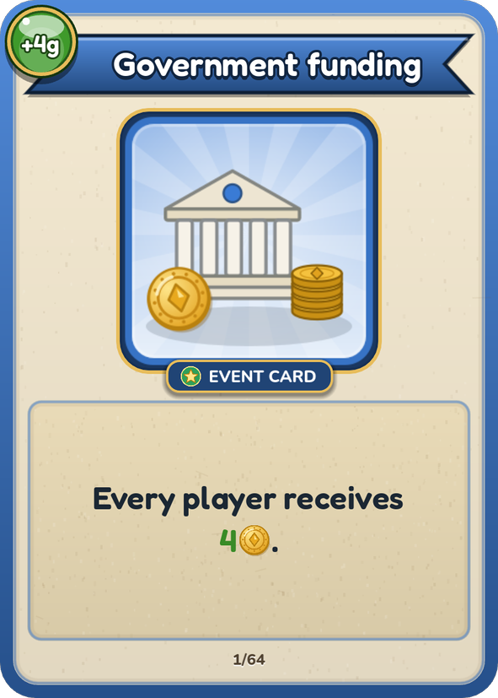 | 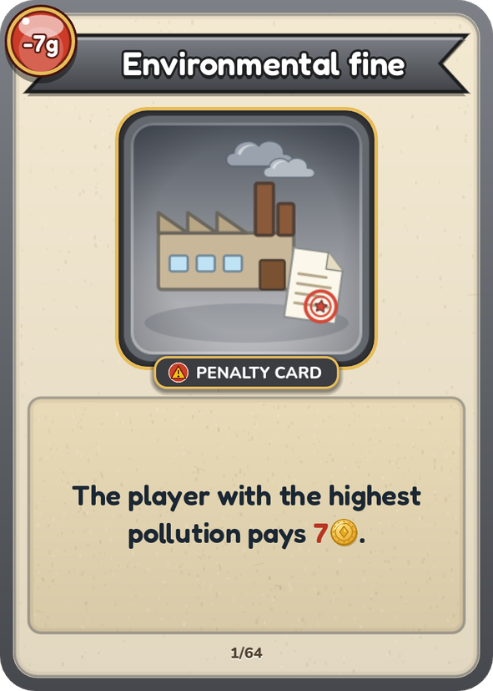 | Event cards give gold, points, free tiles, cheaper tiles or an extra tile. One even cancels a loan.  Penalty cards take gold, points or tiles, make tiles more expensive, or let you buy one tile fewer.  Read the card out loud and do what it says straight away. Then put it on a discard pile: each card is used only once per game.
How to carry out a card
Gold | Nobody's gold can go below 0. If you have to pay more than you have, pay everything you have. If a card offers a choice, you cannot choose an option you cannot afford.
Points | Keep a tally of the points you win and lose from cards. They count towards your final score and towards the turn order.
The player with the most | If several players are tied for the most or the fewest, the card affects all of them. Cards about loans or unhappy citizens only affect a player who actually has some.
Choices | Some cards give you two options. Pick one and carry out all of it.
Prices and buys | Changes to prices, or to how many tiles you buy, only apply to your current turn. A price can never go below 0, and you always buy at least 1 tile.
Free tiles | Take them from the free tiles. Place them on any empty space during any of your turns. They are not one of your 4 buys.
Losing tiles | You choose which of your tiles to lose. If you do not have enough, lose all you have. “Lose a road” means any road tile on your board. “Lose free roads” means free roads you have not placed yet.
Up to | “Up to 4” means you count no more than 4 tiles, however many you have.
Words used on the cards
Services | The tiles listed on page 7.
Unused service | A service that no home in your city can reach by road.
Your roads connect every home | You have at least one home, and every home can reach at least one service by road.
Unhappy citizens | Citizens with happiness below 0, counting the circumstance cards turned over so far.
Roads | All road tiles on your board, of any type.

Circumstance cards
At the start of each round, one circumstance card is turned over. It applies to every player.
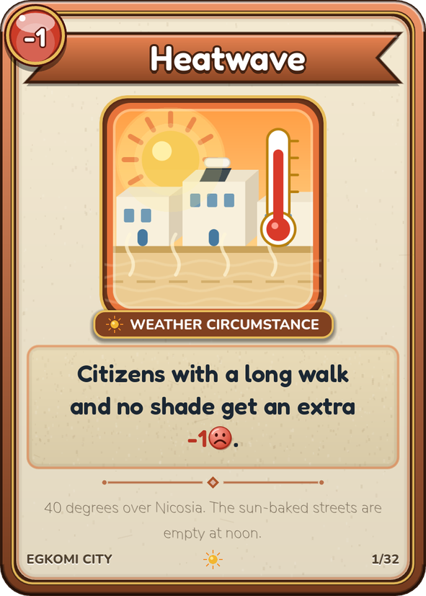 | - There are 32 cards. Each game uses 8 of them, one per round, so nobody knows which ones will come up.  - Cards that give or take gold do so once, as soon as they are turned over.  - All other cards stay in play until the end of the game. Remember to apply them when you score.  - Circumstance cards never add or remove tiles.  - If several cards affect the same citizen, apply them in the order they were turned over. Population growth always comes last.
Words used on the cards
Within reach | The citizen can get there by road, however long the route.
Within 2 roads | The route is 1 or 2 road tiles long.
Long walk | A route of 3 or more road tiles.
Nearby greenery | A park in one of the 8 spaces around the home, or trees or a shaded street on one of its 4 sides.
Serves a home | The home can reach the place by road. A home counts once, however many citizens live in it.
Cards that change gold
Budget cut | Every player loses 8 gold.
Green grant | Every player gets 6 gold, plus 2 gold for each park, trees tile and shaded street in their city.
Business boom | Every player gets 2 gold for each commercial area.
Tax refund | Every player gets 8 gold.
Road subsidy | Every player gets 1 gold for each road tile of any type, up to 8 gold.
Pipe repairs | Every player pays 1 gold for each home, up to 6 gold.
Cards that give points
New attractor | +1 point for each service that 3 or more of your homes can reach.
Tourist season | +1 point for each coffee shop or restaurant that 3 or more homes can reach.
Health campaign | +1 point for each clinic or hospital that 3 or more homes can reach.
Science fair | +1 point for each school that 3 or more homes can reach.
Open day | +1 point for each university that 2 or more homes with students can reach.

Circumstance cards that change happiness
These cards change a citizen's happiness by 1. Apply them in step 8 of a citizen's score (page 13).
Citizens lose 1
Heatwave | A citizen who already has a hot walk loses 1 more.
Flash flood | Citizens with no nearby greenery lose 1 if any place they can reach is 3 or more roads away.
Dust storm | If your pollution is 9 or more, every citizen loses 1.
Road works | Citizens lose 1 if even the closest place they can reach is 3 or more roads away. Citizens who cannot reach anything are not affected.
Exam season | Students who cannot reach a library lose 1.
Flu wave | Older residents, children and residents with a disability who cannot reach a clinic or hospital lose 1.
Supply shortage | Workers and older residents with no supermarket or market within 2 roads lose 1.
Back to school | Children who cannot reach a school lose 1.
Parking shortage | All citizens except children lose 1 if they cannot reach a parking place.
Traffic jam | Citizens whose home touches a parking place on one of its sides lose 1.
Drought | Citizens with nearby trees or a shaded street, but no park in the 8 spaces around their home, lose 1.
Smog alert | If your pollution is 6 or more, citizens with no park in the 8 spaces around their home lose 1.
Cold snap | Older residents, children and residents with a disability with no nearby greenery lose 1.
Bus strike | Citizens who can reach a place 3 or more roads away, but cannot reach a parking place, lose 1.
Citizens gain 1
Nice weather | Citizens with at least one shaded route gain 1.
Bike week | Citizens whose routes use a bike lane gain 1.
Street festival | Citizens whose routes use a pedestrian street gain 1.
Remote work wave | Workers who can reach a coffee shop or kiosk gain 1.
Autumn rain | Citizens with a park in one of the 8 spaces around their home gain 1.
Farmers’ market | Citizens with a supermarket or market within 2 roads gain 1.
Population growth | Citizens whose happiness is above 0 after all the other cards gain 1. Apply it last. The limit of +5 still applies.

The end of the game
After the last turn of round 8, everyone works out their final score.
1 | Score each citizen  Go through every home with your score sheet (page 13). Include every circumstance card that has been turned over.
2 | Add up your city  Add the variety bonus, circumstance points and card points, and take off loans and unreachable services (page 14).
3 | Find the winner  The player with the highest score wins.
Ties
If two or more players have the same score, the one with more happy citizens (above 0) wins. If that is also a tie, the one with more gold left wins. If they are still tied, they share the win.
Complaints
Each unhappy citizen (below 0) has one main complaint. If they are missing something they need, that is always their complaint. Otherwise it is whichever of the other problems costs them the most. If two cost the same, take the one higher up in this list.
Complaint | What is wrong | How to fix it
Accessibility | They cannot reach something they need by road. | Connect the home by road to the places its citizens need.
Walkability | They have a walk of 3 or more roads with no shade. | Shade the route with trees or a park, or make it shorter.
Greenery | There is no park or trees near their home. | Build a park nearby, or trees beside the home.
Pollution | The pollution level is 8 or more. | Build parks (−3) and trees (−1) to bring it below 8.

One last thing
After scoring, each player names the one change that would have added the most points to their city. Every citizen below +5 and every unreachable service could have been better, so there is always something to name.

Score sheet
Player ____________________________ Round ________
 | Home and citizen | Needs | Bonus | Like | Green | Heat | Pollution | Dislike | Cards | Total
1
2
3
4
5
6
7
8
9
10
11
12
13
14
Bonus: hospital or supermarket. Green: nearby greenery. Heat: long hot walk. Cards: circumstance cards. Total: between −5 and +5.
A All citizens' happiness added together
B Variety bonus (1 group 0, 2 groups +3, 3 groups +7, 4 groups +12, 5 groups +19, 6 groups +27)
C Circumstance points
D Points from event and penalty cards
E Loans (1 loan 6, 2 loans 15, 3 loans 27, 4 loans 42, 5 loans 60)
F Unreachable services (1 point each)
Final score A + B + C + D − E − F
For ties: happy citizens ________ gold left ________

