**Mini Crossword (11/28/17)  
  
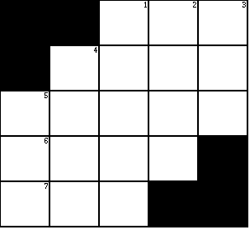**

|  |  |  |
| --- | --- | --- |
| lol 0 | lol 1 | lol 2 |
| lol 0 | lol 1 | lol 2 |
| lol 0 | lol 1 | lol 2 |