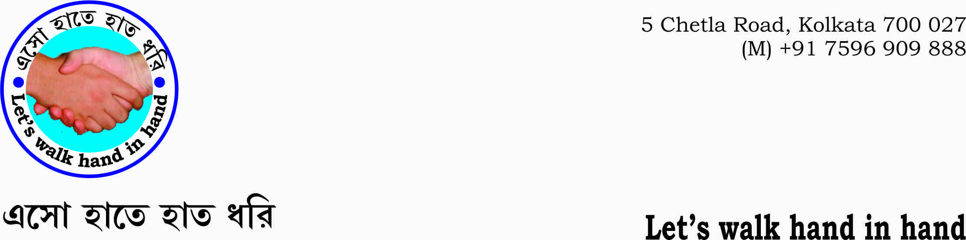

E: handinhand2018@gmail.com
(M) +91 7596 909 888/ 94322 35171

Meeting to be held on 04 december 2018 at Bauddha Dharmankur Sabha at 5 PM.
Dear Mr. Hemendu B Chowdhury, Mr. Pallav Goswami, Mr.Amalesh Dasgupta, Mr. Gopi Kanta Ghosh, Mrs. Madhusree,
As advised I have tried to mention the points/agenda to be discussed in the meeting with a view to taking decisions for the smooth functioning of the organization. I would also appeal to all our fellow members to propose points that he or she feels worth to be discussed.
Activities:
- To decide the contents of the next the cultural programme to be held in say,2-4 weeks time including the venue of the programme.
- To organize talk upon ‘how to arrest cultural degradation and begin regeneration of values that Bengal had had in the past’.
- To organize different video programmes/ talks on the issue of regeneration of culture. in schools along with Shyamali.
- To organize performances like drama, songs, recitations etc.
Sharing of responsibilities:
- Mr. Amalesh Dasgupta – Co-ordination and networking in all the areas given below.

- Co-ordination with different individuals and like-minded organizations.
- Supporting and giving appropriate intelligent man power to the areas of organizing drama, tele-film, lecture, presentations etc.
- Making documentaries and short films according to our ideals that could be spread all throughout the country.
- Supporting Event Organizer to host programmes smoothly.
- Setting up a team of orators, 10 – 15 in number, that could deliver their talks at a periodic interval say, 3- 4 weeks time continuously. In one specific event let 2 or 3 persons deliver their talks upon the subject as said above. Different aspects of the subject could be dealt in specific events.

- Mr.Pallav Goswami –

- To be made ‘spokesman’ of the organization. In his absence Mr. Amalesh Dasgupta could serve the purpose.
- Leading the team in liasing with government departments on different issues, help us book auditorium to host lectures, presentations etc.
- Giving new ideas upon the subject.
- Setting up an administrative structure as to help smooth functioning of the organization.
- Supporting events.

- Mr. Gopi Kanta Ghosh –

- Could give ideas so that Hand-in-hand work for the toiling masses and make strong rural bases to boost morals.
- Initiate rural and non-rural projects along with Mr. Goswami and mr. dasgupta.
- To attach hand-in –hand with the existing rural work of Mr. Ghosh.
- Help the advisory body and guide the members.

- Mr. Hemendu B Chowdhury –

a.To host meetings and advise all the members as to help smooth functioning of the organization.

- Mrs. Madhusree –
a.To create and organize performing teams in the areas of dance, song, recitation, drama etc. along with Shyamali and Dwipanwita.
b. To organize video shows and talks in the schools along with Shyamali and Dwipanwita.
- Kalyan Bhattacharya-
To help members of the organization.

Kalyan Bhattacharya (M) 7596 909 888

