**Software Requirements**

1. SQL Server: <https://www.microsoft.com/en-us/sql-server/sql-server-downloads>

* 1. Microsoft SQL Server Management Studio (click Install SSMS when installing SQL Server )

1. Python Version 3.7 or later
   1. Required library: pyodbc 🡪 pip install pyodbc
2. Apache Kafka Scala 2.12 or 2.13: <https://kafka.apache.org/downloads>

1. Apache Zookeeper 3.9.3: <https://zookeeper.apache.org/releases.html>

**Setup Kafka**

Instructions found here: <https://www.geeksforgeeks.org/how-to-install-and-run-apache-kafka-on-windows/>

1. Extract Apache Kafka your desired directory.
2. Copy the path of the Kafka folder. Now go to *config* inside kafka folder and open *zookeeper.properties* file. Copy the path against the field *dataDir* and add */zookeeper-data* to the path.

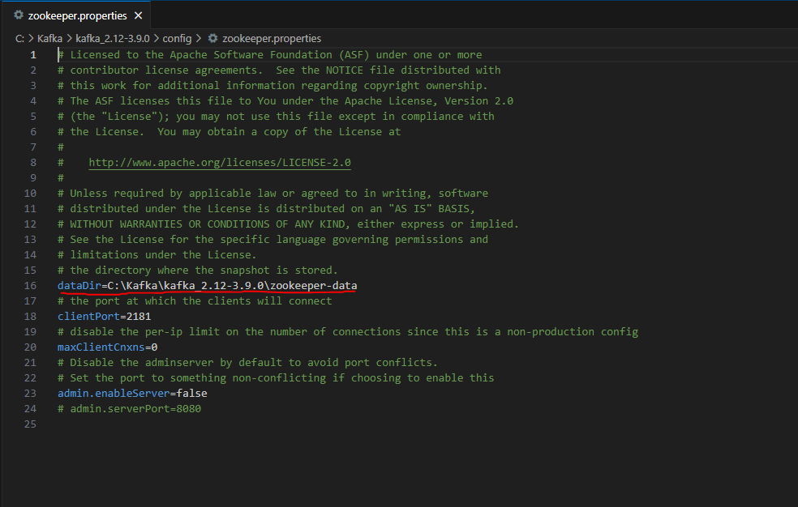

1. Now in the same folder *config* open *server.properties* and scroll down to *log.dirs* and paste the path. To the path add */kafka-logs*

1. Now open command prompt and change the directory to the kafka folder. First start zookeeper using the command given below:

.\bin\windows\zookeeper-server-start.bat .\config\zookeeper.properties

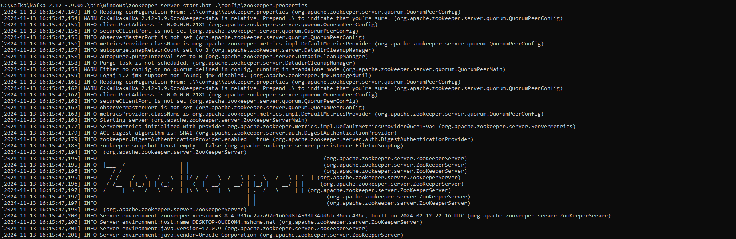

1. Now open another command prompt and change the directory to the kafka folder. Run kafka server using the command:

.\bin\windows\kafka-server-start.bat .\config\server.properties

Kafka Server Screenshot


**Setup Microsoft SQL Server Management Studio**

1. Launch Microsoft SQL Server Management Studio

1. Take note of the Server name and connect.
2. Create a new database, right click on ‘Databases’ and click create new ‘Database’…

1. Name your database and click OK

1. Refresh to see your database.

1. Expand your database you created by double clicking it, or by clicking the + next to your database
2. Create three new tables by right clicking ‘Tables’, clicking ‘New’ and then Table…
3. Each table will have the same column names and data types.
   1. bus_id: int
   2. happened_at_time: smalldatetime
   3. latitude: float
   4. longitude: float
   5. ecu_speed_mph: int
   6. gps_speed_mph: int
   7. heading_degrees: int

1. Setup for Microsoft SQL Server Management Studio is complete, take not of what the Sever Name is, what your database name is, and the name of your three tables.

**Running the Source Code**

1. Copy and Paste the Source Code from ‘BusDataGenerationAndInsertion.py’ save and name your file.
2. Adjust the names of the server and the database to match your own.

1. Adjust the names of the databases to match your own.

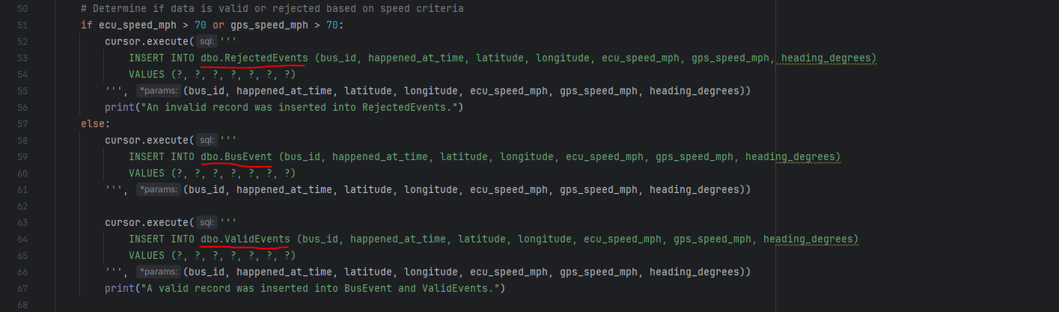

1. The program will now run properly when zookeeper and a Kafka server are running.