Social8
The Community Operating System

Investor Overview
July 2026

Executive Summary
Social8 is a white-label Community Operating System built as a Software-as-a-Service (SaaS) platform, enabling any organisation to launch, manage and monetise its own fully branded online community in minutes. By combining content, events, networking, competitions, gamification and monetisation within a single platform, Social8 eliminates the need for multiple disconnected products while creating a highly scalable recurring revenue business.
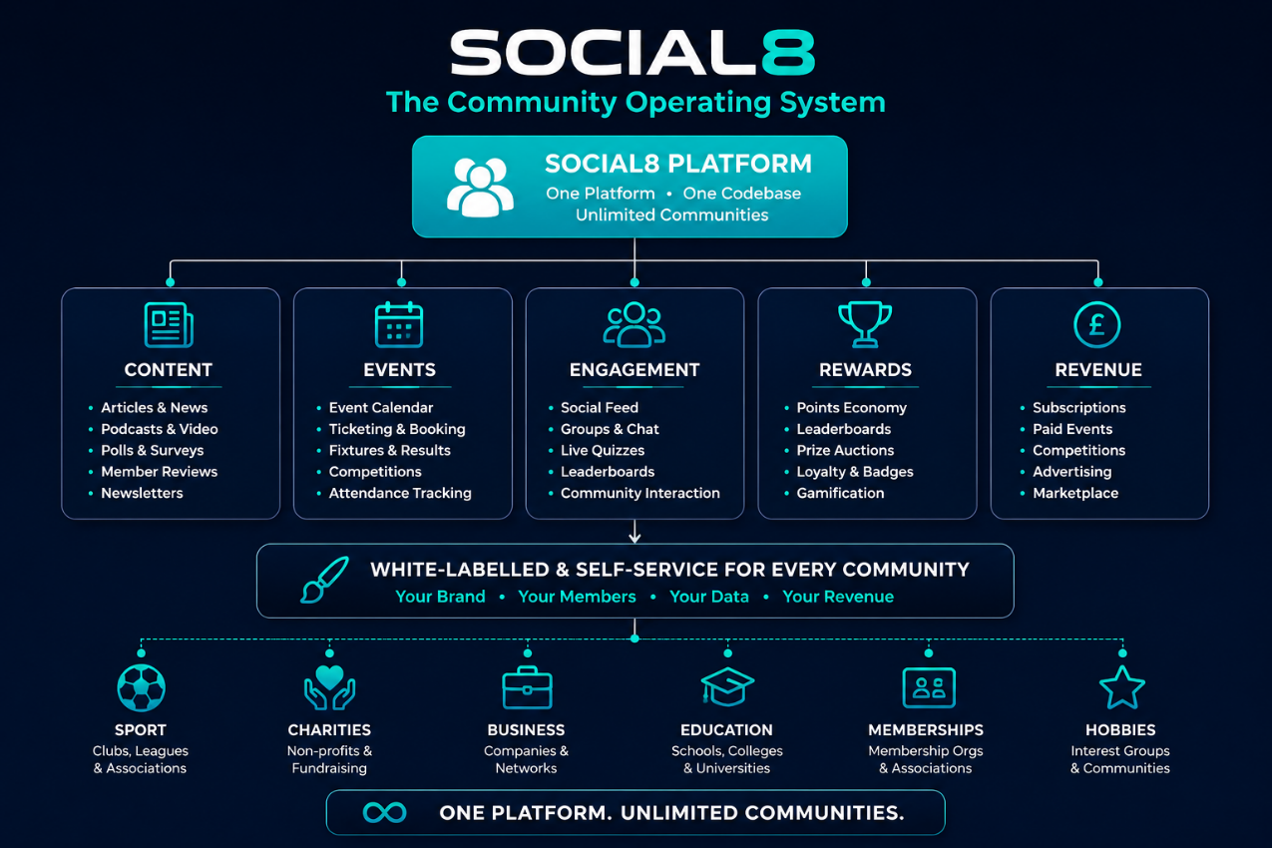

Organisations can register through the Social8 website and automatically launch their own branded web platform, mobile experience and administration portal within minutes, ready to customise and launch under their own identity.
The platform has been designed around three core principles:
- True Multi-Tenancy – Every community operates as a completely isolated, branded environment with its own members, content, data and administration while benefiting from a shared, secure and highly scalable infrastructure.
- Zero-Friction Onboarding – New communities can launch within minutes, while members join in seconds through a simple sign-up process. Automated provisioning keeps onboarding costs low and enables rapid, scalable growth.
- Complete Self-Management – Community owners have full control over branding, content, members, events, competitions, monetisation and engagement through an intuitive administration portal, with no ongoing involvement required from Social8.
Designed as a Community Operating System, Social8 gives organisations everything they need to build, engage and monetise thriving online communities from a single platform,
creating a highly scalable Software-as-a-Service business with the potential to serve thousands of organisations across multiple industries worldwide.

Multi-Tenancy
One Platform, Unlimited Communities.
- Every community runs as its own tenant: isolated data (part of a single platform but data isolated to their community), own domain or subdomain, own membership base — all on shared infrastructure.
- Per-tenant branding applied live across the entire product: platform name, logo, brand colours, hero content, social links, terms and privacy pages.
- Per-tenant customisable email templates for every automated email the platform sends.
- Automated onboarding provisions a new branded community, administrator account and starter content within seconds, enabling near-zero onboarding cost for every new customer.
- Super-admin tooling to oversee and manage all tenants from one place.
- Per-tenant pricing: each community can run its own subscription plans and paid events.
- A single mobile app where users can join and access multiple platforms.

Zero-Friction Signup
- Community members can join in seconds — simple email signup with one-time-code verification, or single sign-on.
- No approval queues, invitations or paywalls required to get started: the platform is open by default, with premium tiers optional.
- Organisation accounts (clubs, venues, businesses) have their own streamlined signup with an optional owner-approval workflow.
- New communities launch with sensible defaults (branding, categories, homepage content) so they are usable from day one.

Fully Managed by the Users
- Community owners run their entire instance through a comprehensive admin panel — no technical skills and no vendor involvement needed.
- Content control: articles, podcasts, polls, reviews, events and homepage sections, all created and moderated in-app.
- Member administration: roles and granular admin permissions, subscriptions, password resets and blocking.
- Site control: section visibility, naming, branding, legal pages and email templates.
- Approval workflows where administrators want them: member reviews, event suggestions and organisation accounts.
- Modular by design: quizzes, auctions, reward points and other engagement modules can be switched on or off per community.

Community & Content
- Editorial articles with categories, rich text and embedded video streaming.
- Podcast listings with in-platform media playback.
- Member reviews with owner approval workflow.
- Community polls with member voting.
- Social feed with community posts, comments, replies and reactions.
- Public and private groups.
- Newsletter subscriptions.

Events & Competitions
- Event listings with categories, rich media, attendance tracking and a personal "My Calendar" view.
- Member-suggested events with owner approval.
- Competition engine: individual, team and knockout formats with entries, team assignment, guest participants and live leaderboards.
- Live results can be entered by competition participants from their phones, with real-time verification and results locked once confirmed.
- Paid event and competition entries via Stripe or cryptocurrency.

Live Quizzes
- Owner-scheduled live quiz events: members pre-register, then everyone plays the same questions at the same time, synchronised by the server — a shared appointment-to-play moment that brings the whole community online together.
- Rich question formats: multiple choice (text or image), true/false, put-in-order, guess-who photo rounds, first-letter clues and progressive photo reveal, where an image is uncovered tile by tile as the clock runs.
- Speed matters: correct answers earn points, and the three fastest correct answers on every question earn tiered speed bonuses — driving repeat play and friendly rivalry.
- Instant feedback after every question, a live post-game leaderboard, and a personal answer-by-answer review showing each member exactly where they won or lost points.
- Fully self-service: owners build, schedule and price question sets in the admin panel with per-quiz timing and scoring controls.

Earn Points & Leaderboards
- A platform-wide points economy: members earn points for taking part — voting in polls, having reviews published, playing quizzes and participating in other community activities — the more members engage, the more points they earn.
- Owner-configurable earning rules: each community decides which activities earn points and how many, from the admin panel.
- Monthly leaderboards reset the race every month, keeping newer members competitive and giving everyone a reason to come back.
- Members see their live points balance in the site header and a full personal statement of every point earned and spent.
- Built as an auditable, append-only ledger: every award is tamper-resistant, so balances are always trustworthy.

Redeem Points
- Reward Community Engagement – Members earn points through active platform participation.
- Fully Customisable Rewards – Community administrators control their own rewards catalogue, selecting from environmental initiatives, digital vouchers, local partner offers or bespoke member benefits.
- Instant Digital Redemption – Members redeem points directly within the app for immediate rewards, eliminating physical fulfilment, postage and administration costs.
- Drive Member Retention – Gamified rewards encourage repeat engagement, increased event participation and stronger long-term member loyalty.

Prize Auctions
- Members spend their earned points bidding on real prizes in owner-run auctions — closing the engagement loop by making points genuinely worth earning.
- Multiple auctions run concurrently with independent start and end times, multi-image prize galleries, live countdowns and automatic bid increments that scale with the bid level.
- Points are held in escrow while a bid is live and refunded instantly if a member is outbid — with in-app notifications for outbid and auction-won moments.
- Winners submit delivery details in-app and owners track fulfilment through a simple claim workflow.
- Auctions convert engagement into rewards without cash prizes — the currency is participation itself.

Members & Networking
- Member profiles with photos and fully customisable profile fields (defined per community).
- Member search with advanced filters across members and organisations.
- Connection requests, acceptance flow and a connections hub.
- Administration accounts with a dedicated management dashboard.
- Within each community, clubs (for example golf clubs in a golf community) can optionally create their own profile and publish exclusive offers to members. For example, a golf club could advertise discounted tee times to the community.
- Members and clubs have their own wallets to manage points and cryptocurrency (if applicable)

Monetisation
- Stripe and cryptocurrency payments supported, where appropriate.
- Premium community membership subscriptions.
- A central Social8 marketplace accessible across participating communities, supporting payments through Stripe, cryptocurrency or earned points.
- Paid event and competition entries with automated payment verification.
- Transactional email infrastructure supporting confirmations, cancellations and other paid customer journeys.
- Platform commission earned on qualifying transactions.
- Advertising revenue shared between Social8 and participating communities.
- Paid polls providing clients with aggregated demographic insights.
- Optional revenue-sharing mechanisms that reward users according to engagement.

Technology & Architecture
- Modern cloud-based architecture built using industry-standard technologies.
- API-first platform powering both web and mobile applications.
- Enterprise-grade security with encrypted authentication and tenant-level data isolation.
- Scalable cloud infrastructure supporting thousands of independent communities.
- Integrated payments, transactional email and media delivery.
- SEO-optimised architecture with responsive web and mobile experiences.

Why It's Investable
- Scalable B2B SaaS Model – Recurring subscription revenue from branded communities, complemented by premium memberships, transaction fees, advertising and marketplace commissions.
- Community Operating System – A complete end-to-end platform that combines content, events, networking, competitions, gamification and monetisation, reducing the need for organisations to purchase multiple separate products.
- Highly Scalable Growth – Automated onboarding enables new communities to launch within minutes with minimal operational overhead, allowing the business to scale efficiently.
- High Gross Margin Business – Communities are fully self-managed through an intuitive administration portal, enabling revenue growth without a proportional increase in support or staffing costs.
- Multiple Revenue Streams – Income is generated through community subscriptions, user upgrades, paid events, advertising, marketplace transactions, competitions and future premium services.
- Powerful Engagement & Retention – Points, leaderboards, live quizzes, competitions, rewards and auctions encourage frequent member participation, increasing retention and customer lifetime value.
- Single Codebase, Multiple Markets – One platform serves thousands of communities across multiple industries, allowing new market sectors to be targeted without significant additional development.
- Proven Investment Already Made – More than £120,000 of development value has already been invested, significantly reducing technical execution risk for new investors.

Go-to-Market Strategy
The marketing strategy focuses on acquiring communities quickly, cost-effectively and at scale. The platform has been designed so that any organisation can create and launch its own branded community in minutes, making the sales process simple and highly repeatable.

Target Markets
Our initial focus will be on communities that already have engaged audiences, including:
- Sports clubs and supporter groups.
- Golf clubs and societies.
- Charities and non-profit organisations.
- Business networking groups.
- Local community organisations.
- Schools, colleges and universities.
- Hobby and special interest groups.
- Membership organisations and associations.

Customer Acquisition
Over time, we will use a combination of digital marketing, partnerships and direct outreach to attract new communities, including:
- Social Media Marketing – Targeted advertising across Facebook, Instagram, LinkedIn and TikTok aimed at community leaders and administrators.
- Search Engine Optimisation (SEO) – Creating valuable content to attract organisations searching for community platform solutions.
- Referral Programme – Existing customers will receive incentives for introducing new communities.
- Strategic Partnerships – Working with governing bodies, membership organisations and commercial partners that can introduce multiple communities.
- Email & Direct Sales – Targeted outreach to clubs, associations and organisations with personalised demonstrations.
- Case Studies & Testimonials – Demonstrating success through real customer stories to build trust and credibility.

Low-Friction Onboarding
A key competitive advantage is the simplicity of onboarding. Communities can create their own platform within minutes without requiring technical knowledge, reducing sales costs and allowing rapid scaling.

Growth Strategy
The platform has been designed as a scalable Software-as-a-Service (SaaS) business. As the customer base grows, each successful community becomes a showcase for others, generating referrals and reducing customer acquisition costs.
Our objective is to establish a strong presence within selected verticals before expanding into additional markets, creating a platform capable of supporting thousands of communities across the UK and internationally.

Revenue Growth
Revenue will be generated through recurring subscriptions, premium features, advertising opportunities, transaction fees on selected services, and marketplace functionality. This provides multiple income streams while increasing customer lifetime value and long-term business sustainability.

24-Month Customer Acquisition Plan
Our strategy is to establish a strong presence within selected market sectors before expanding into additional verticals. The platform has been built to scale rapidly, enabling new communities to launch in minutes with minimal onboarding and support.
Because communities can self-register and launch within minutes, growth is driven by scalable digital acquisition and strategic partnerships rather than a traditional implementation-led sales model.
Time Period | Communities | Total Users | Community Subscriptions | User Revenue (15% × £2.00) | Total Monthly Revenue
Month 6 | 50 | 7,500 | £2,500 | £2,250 | £4,750
Month 12 | 250 | 37,500 | £12,500 | £11,250 | £23,750
Month 18 | 750 | 131,250 | £37,500 | £39,375 | £76,875
Month 24 | 2,000 | 400,000 | £100,000 | £120,000 | £220,000

Revenue Assumptions
The financial forecast is based on two primary revenue assumptions:
- An average recurring community subscription of £50 per month.
- Fifteen per cent of registered members purchasing premium features or services, generating an average of £2 per participating member per month.
Additional upside is expected from premium memberships, advertising, marketplace commissions, competitions, partner offers and future monetisation features.
These projections exclude future enterprise licensing, sponsorship opportunities, white-label deployments and additional premium services, providing further potential for revenue growth beyond the figures shown.
At month 24, this equates to:
- Monthly Recurring Revenue (MRR): £220,000
- Annual Recurring Revenue (ARR): £2.64 million

Key Growth Drivers
- Expand from early adopter communities into larger sectors including sport, education, charities and business networks.
- Generate referrals through satisfied customers and community ambassadors.
- Build strategic partnerships with governing bodies and membership organisations.
- Invest in targeted digital marketing campaigns with measurable customer acquisition costs.
- Continuously enhance the platform with new features to improve retention and encourage upgrades.
By the end of the first 24 months, our objective is to support approximately 2,000 communities with over 400,000 registered users, providing a strong foundation for continued UK expansion and future international growth.

Platform Status
The core Social8 platform is approximately 90% complete, with the full commercial launch scheduled for the end of August 2026.
Over £120,000 of development value has already been invested into the platform, significantly reducing technical and execution risk for incoming investors.
Investment from this round will primarily accelerate customer acquisition, commercial launch and continued feature development, rather than fund an unproven concept.

Market Opportunity
Every organisation has a community. Sports clubs, charities, membership organisations, educational institutions, businesses and special interest groups all need to engage members, organise events, share content and generate revenue. Social8 has been designed as a single Community Operating System capable of serving all of these markets through one scalable platform.
Communities can launch their own fully branded platform within minutes, with no technical expertise required. As a fully managed SaaS solution, Social8 removes the complexity of hosting, security, maintenance and software updates, allowing organisations to focus entirely on growing and engaging their communities.
With a highly scalable, multi-tenant architecture and multiple recurring revenue streams, Social8 has the potential to support thousands of organisations across the UK and internationally, creating a significant long-term Software-as-a-Service (SaaS) business.

Competitive Landscape
Unlike traditional community platforms, Social8 combines community management, engagement and monetisation within a single white-label Software-as-a-Service platform.
Rather than solving one aspect of community management, Social8 manages the entire community lifecycle—from member acquisition and content management through to events, competitions, engagement and revenue generation.
Its principal competitive advantages include:
- A comprehensive all-in-one platform – Content, events, networking, competitions, gamification and monetisation delivered within a single solution.
- Automated self-service onboarding – Organisations can launch their own branded community within minutes, with minimal implementation or support costs.
- Multiple recurring revenue streams – Communities can generate income through subscriptions, events, advertising, marketplaces, competitions and premium services, while Social8 earns recurring SaaS and transaction revenue.

Founder
Social8 has been conceived, designed and developed by Paul Morgan, a technology executive with more than 30 years' experience delivering software platforms across web, mobile and cloud technologies.
Having led the design and delivery of numerous large-scale software platforms throughout his career, Social8 combines extensive technical expertise with first-hand experience of building and scaling digital products.

Investment Requirement
The business is seeking an investment of £40,000 in exchange for a 50% equity stake, creating an equal long-term strategic partnership.
Alternatively, the business would consider an initial investment of £25,000 for a proportionately adjusted equity stake, subject to the investor becoming an active strategic partner and supporting future fundraising and commercial growth.
The business intends to apply for SEIS advance assurance ahead of future funding rounds, enabling qualifying investors to benefit from the associated tax reliefs.

Platform Preview
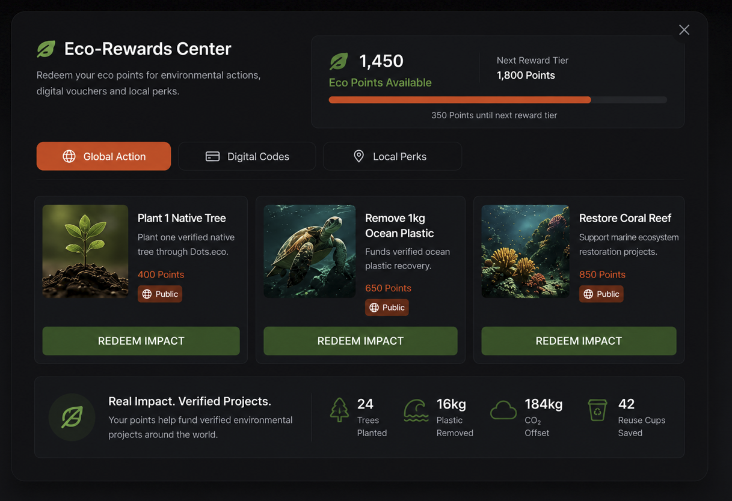
Rewards marketplace

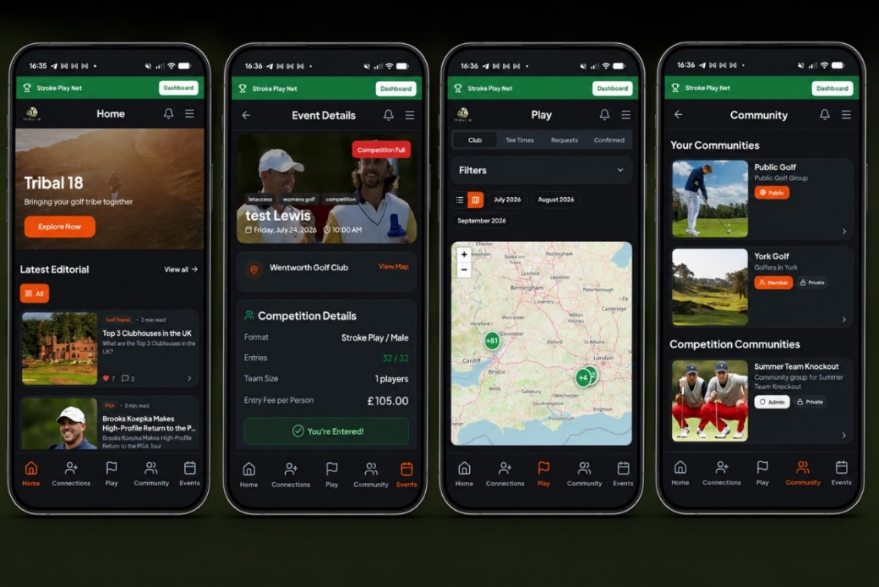
Editorial • Events • Tee Times • Community

