23BD1A1216 GAMPA ANUPAMA
WEEK-10 - Elasticbeanstalk

Prerequisites
- A web application ready (e.g., .war, .zip, or code)

Steps to Create Elastic Beanstalk Application
Step 1: Open Elastic Beanstalk
- Login to AWS Console
- Under Compute section ->Search for Elastic Beanstalk
- Click Create Application

Step 2: Create Application
- Enter Application Name (e.g., MyApp)
- Add description (optional)
- Click Create

Step 3: Create Environment
- Click Create Environment
- Choose:
  - Web Server Environment (for web apps)
- Click Select

Step 4: Configure Environment
- Enter Environment Name
- Choose Platform:
  - Java (for .war)
  - Node.js / Python / PHP / etc.
- Under Application Code:
  - Select Upload your code
  - Upload your .war or .zip file

Step 5: Configure Service Access
- Service Role → Select existing -àLabRole
- EC2 Key Pair → Optional (for SSH)
- EC2 Instance Profile → select (e.g., LabInstanceProfile)

Step 6: Configure Network
- Select VPC (default is fine)
- Select Subnets
- Enable Public IP

Step 7: Instance & Scaling Setup
- Choose Instance type (e.g., t2.micro – free tier)
- Set:
  - Min instances: 1
  - Max instances: 2 (or more)
- Load Balancer → Enabled (optional but recommended)

Step 8: Review & Create
- Click Review
- Click Create
  - Open it in browser → Your app will run
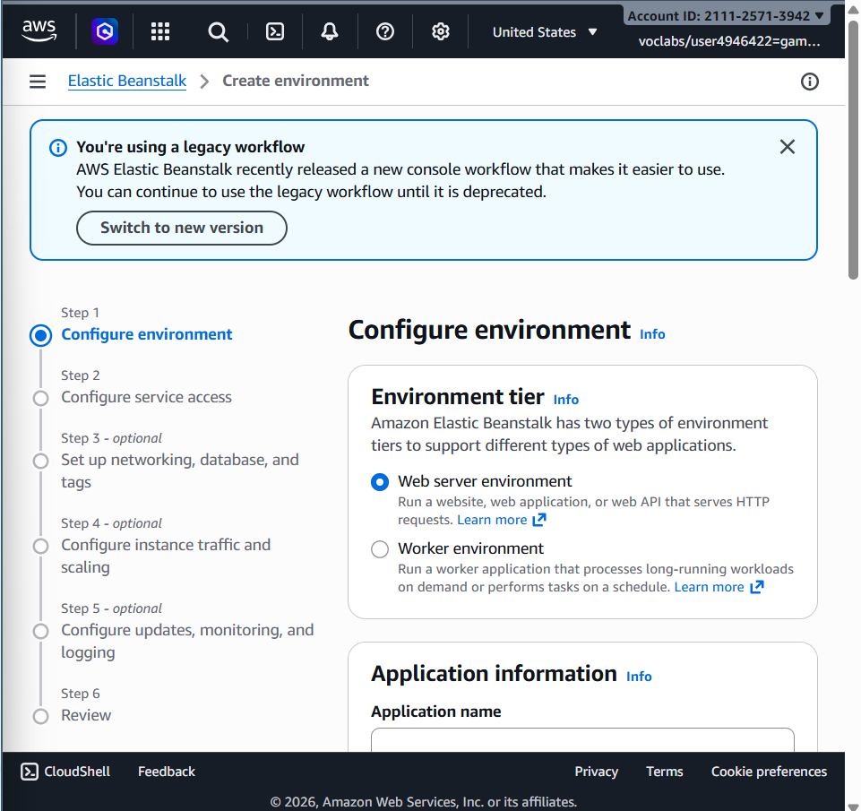

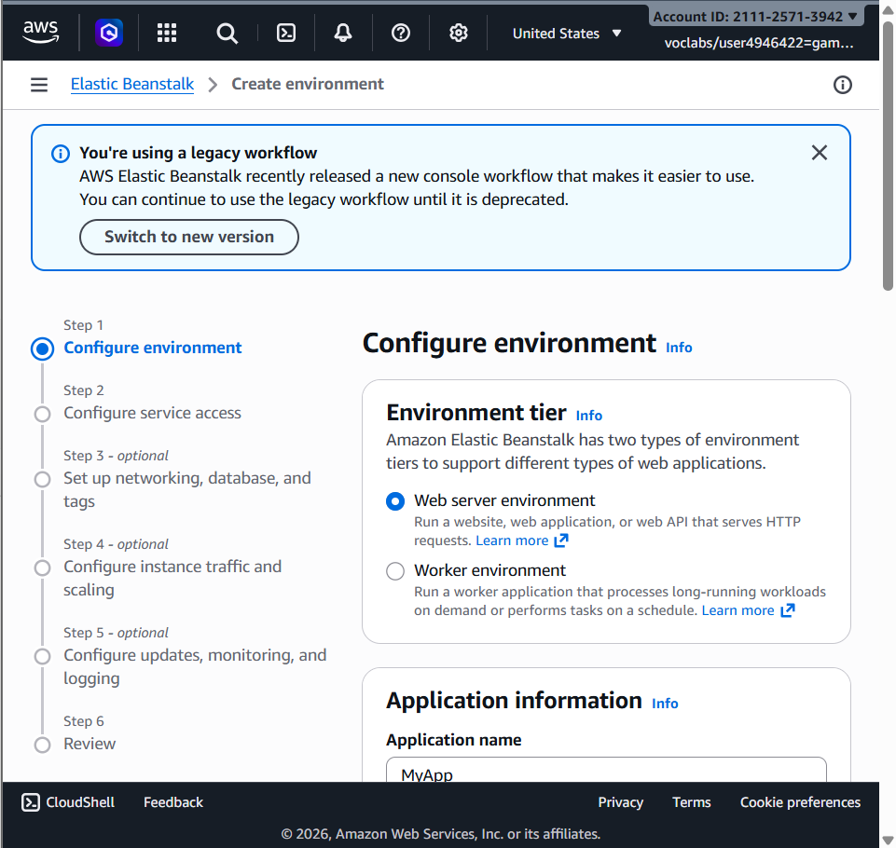
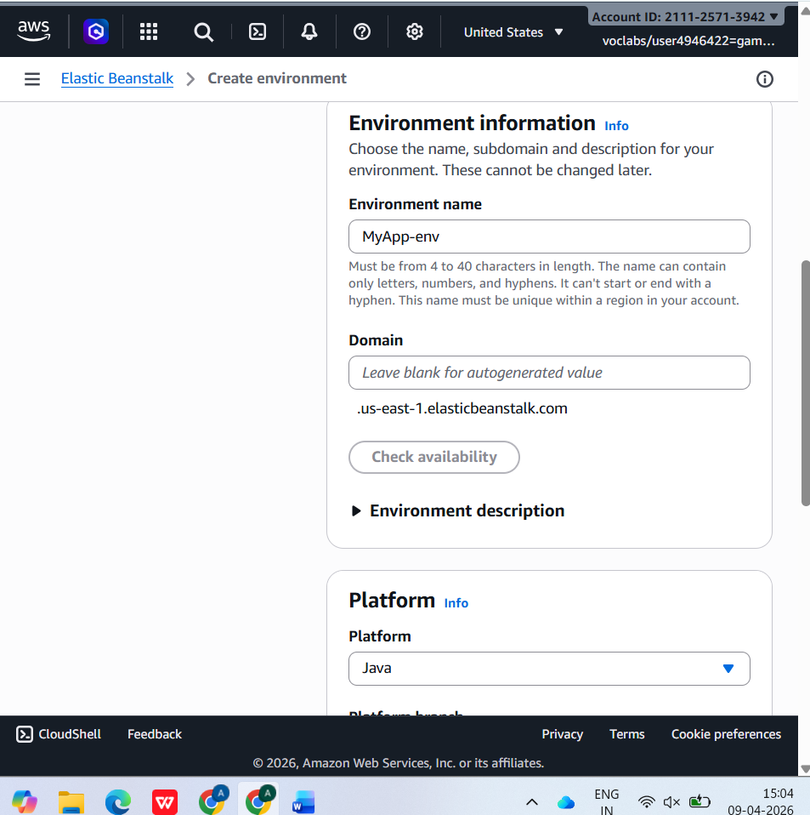
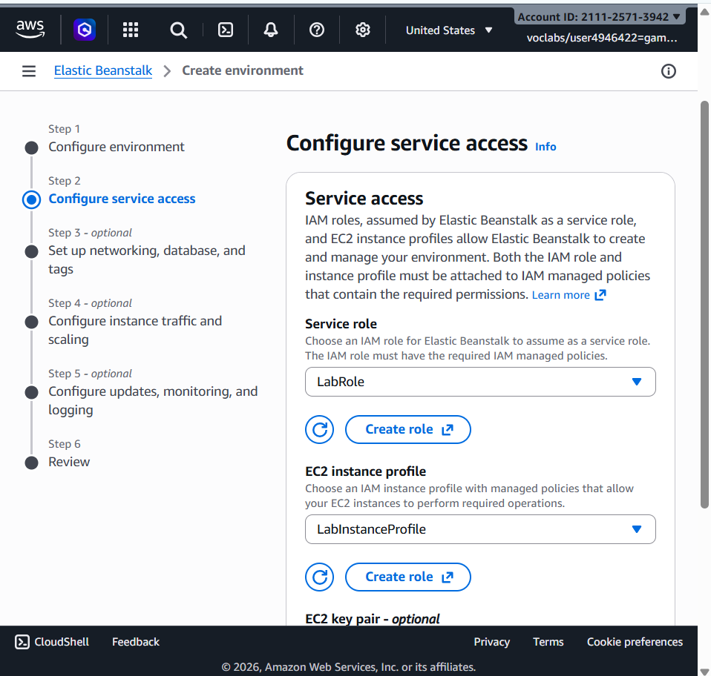
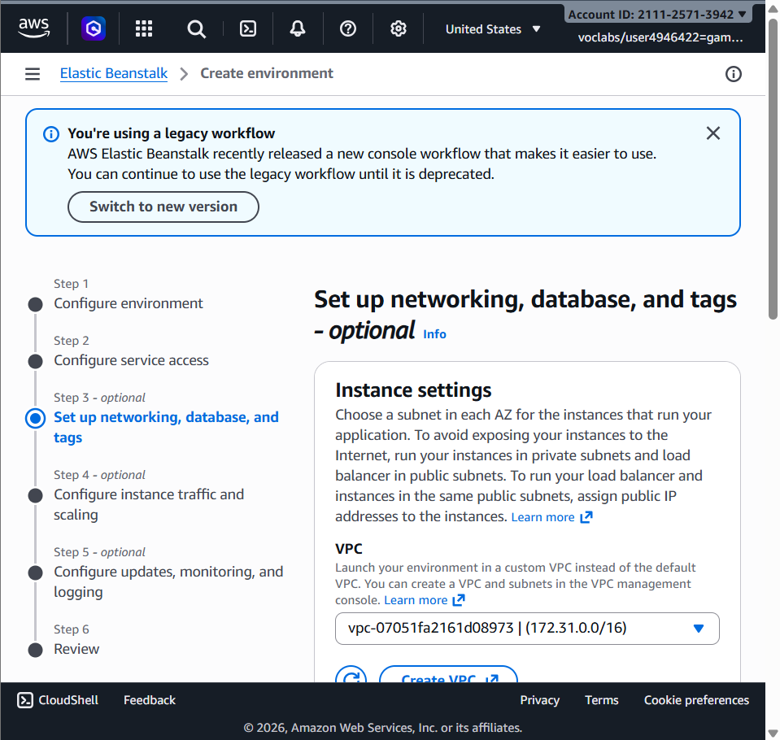

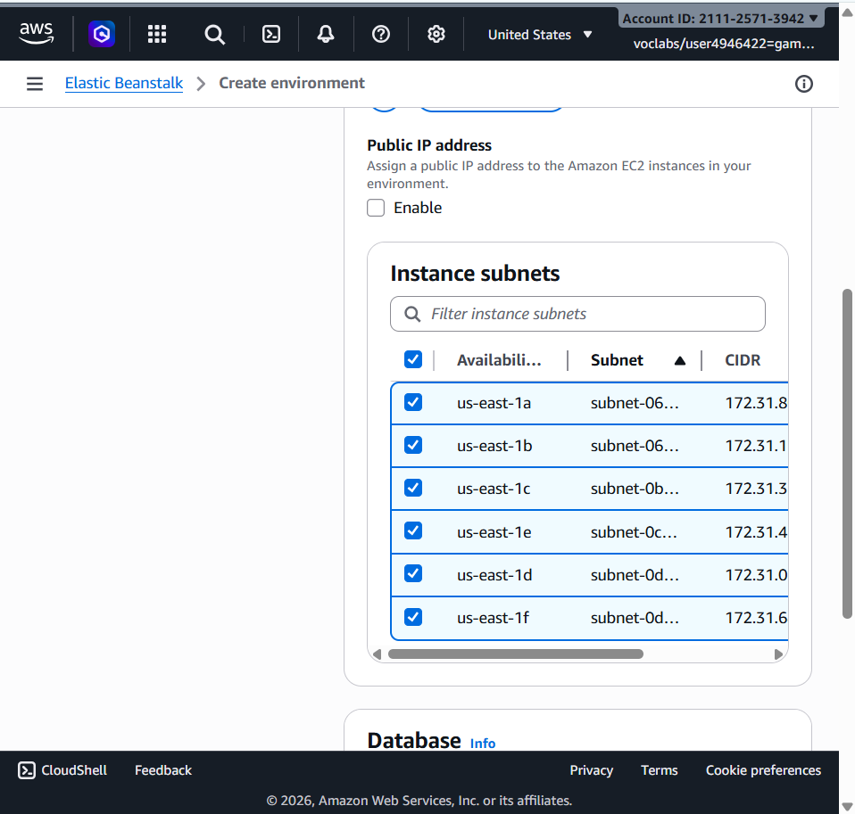
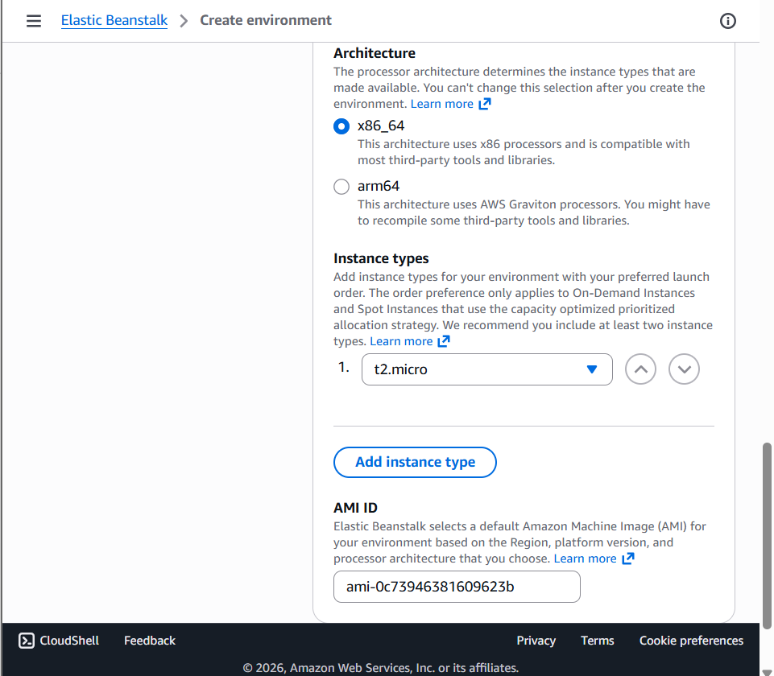
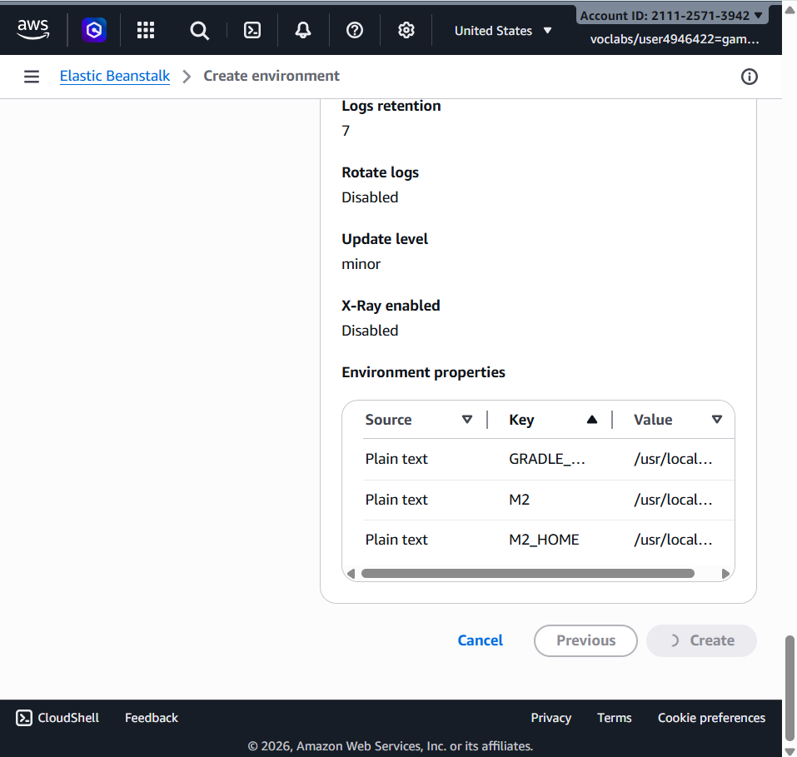

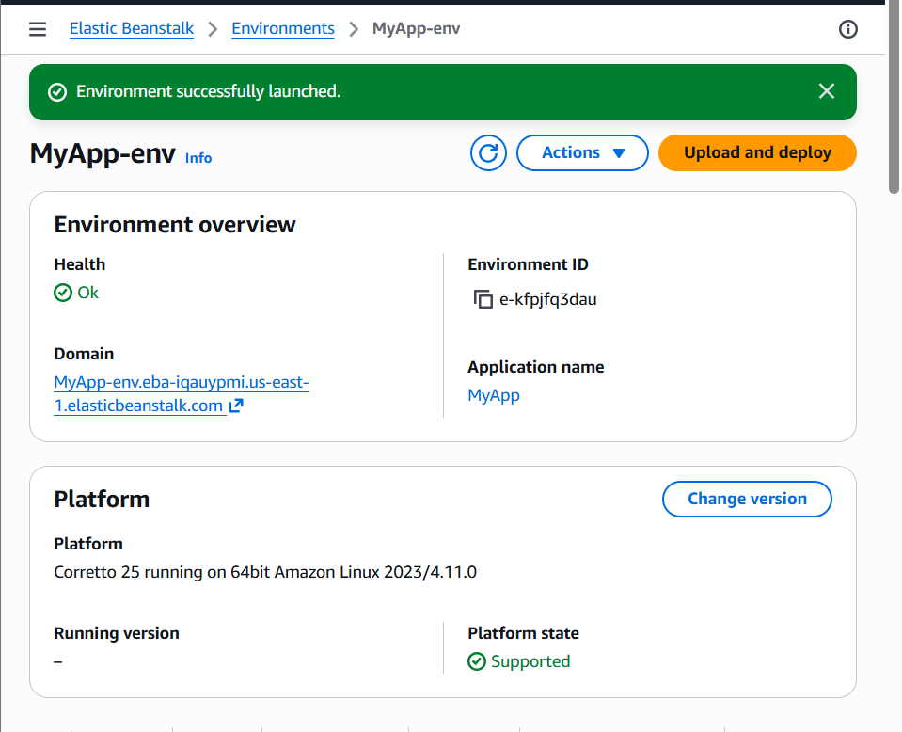

Deployment Process
- AWS automatically creates:
  - EC2 instances
  - Load Balancer
  - Auto Scaling Group
  - Security Groups

Access Your Application
- After deployment:
  - You will get a URL (domain link)

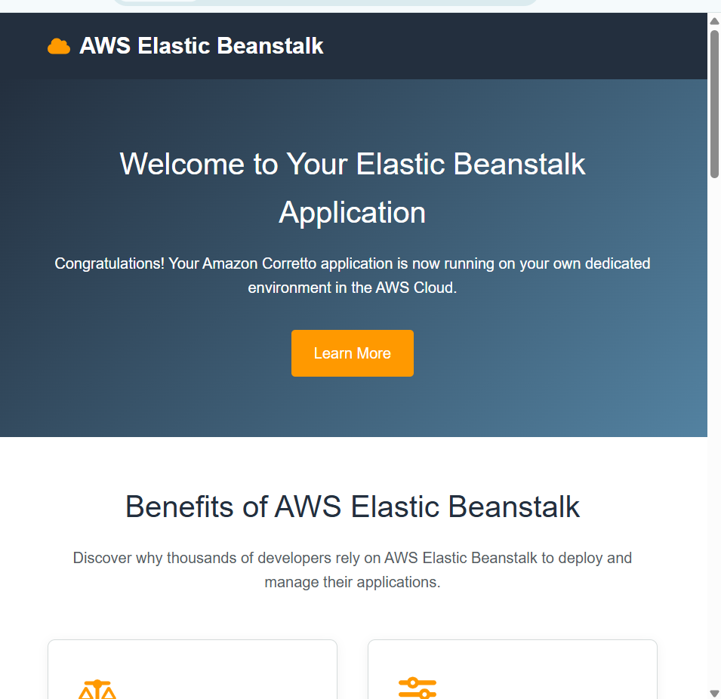
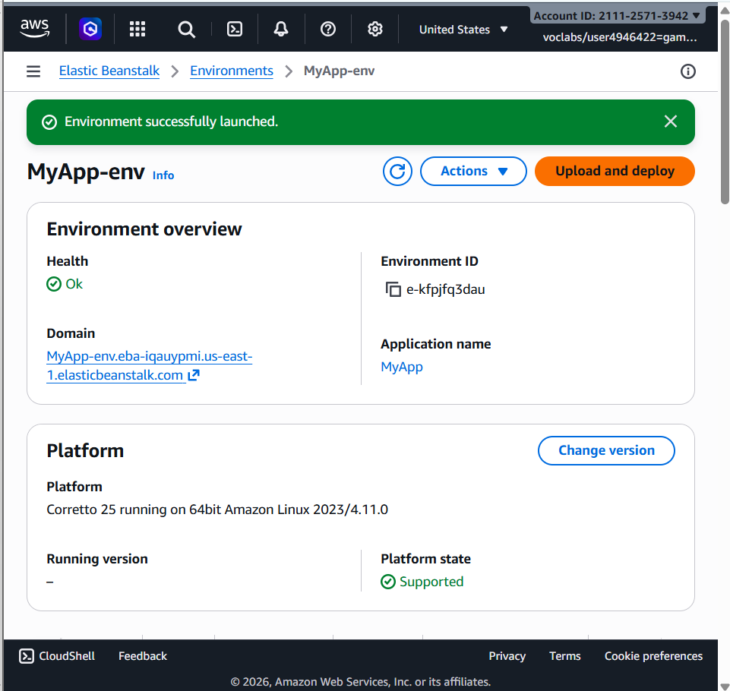

Updating Application
- Go to your environment
- Click Upload and Deploy
- Upload new version

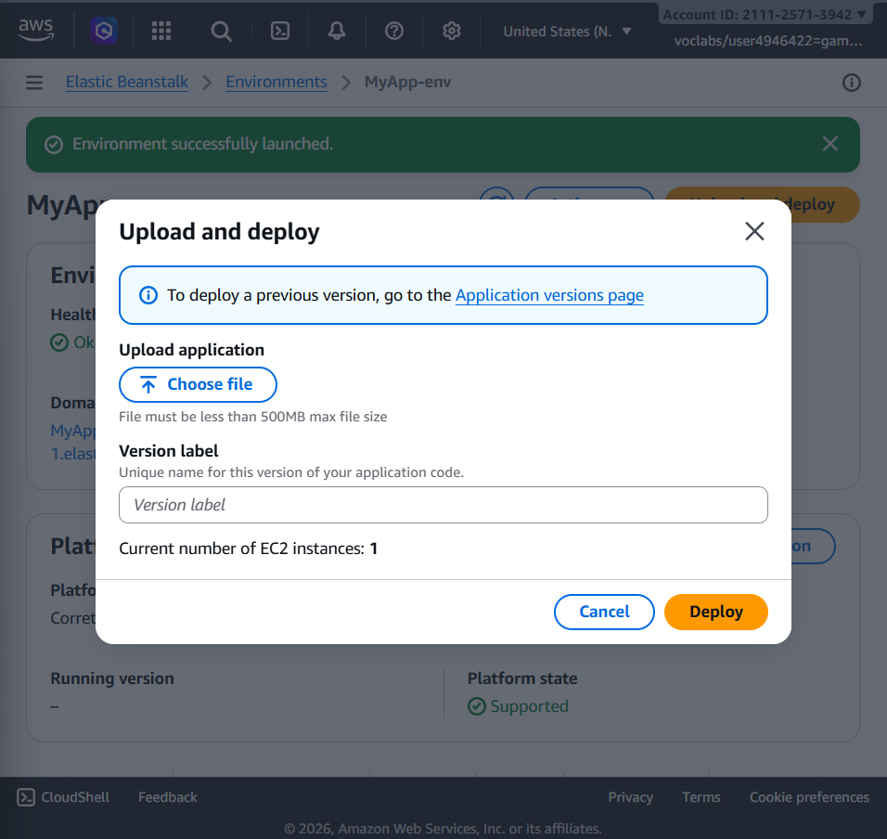
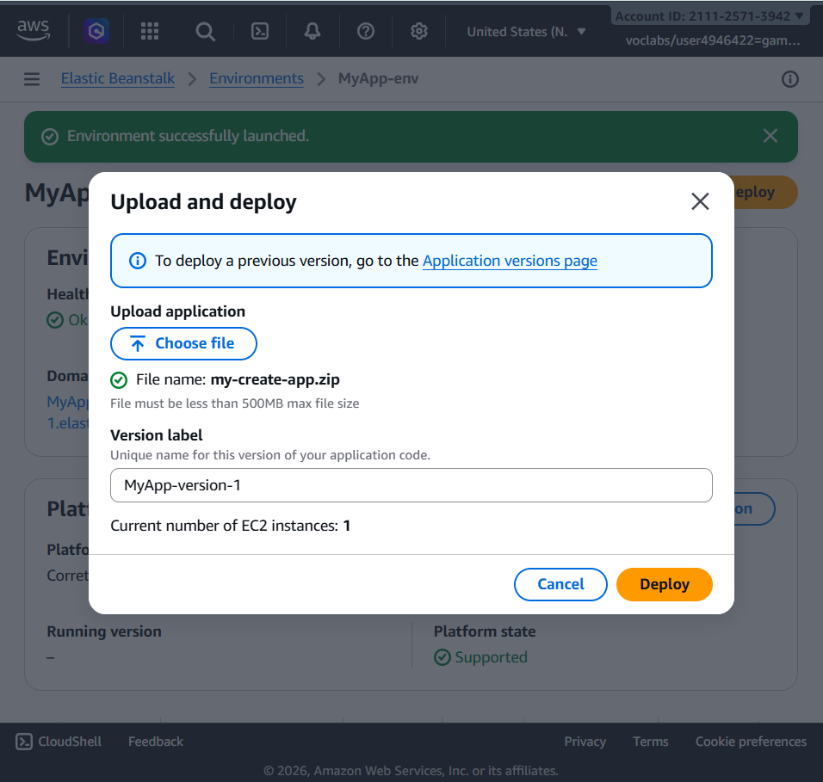
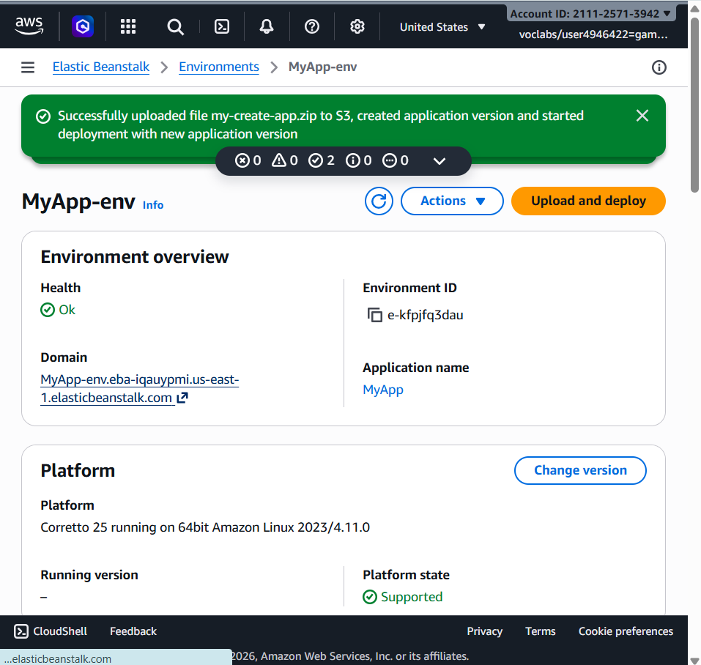
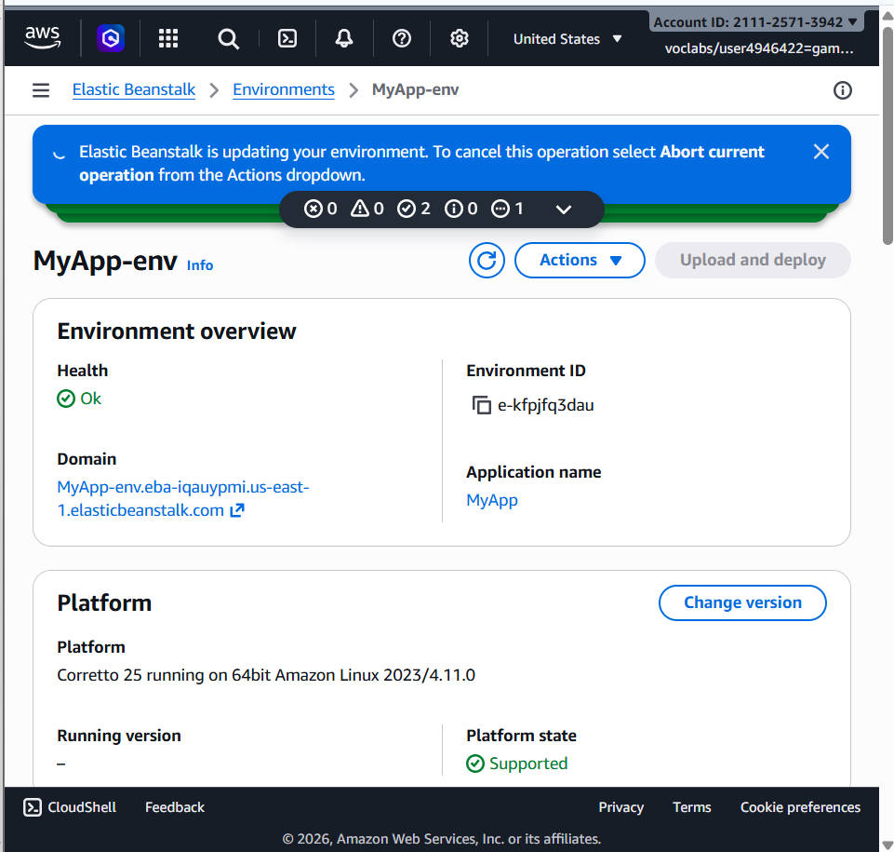
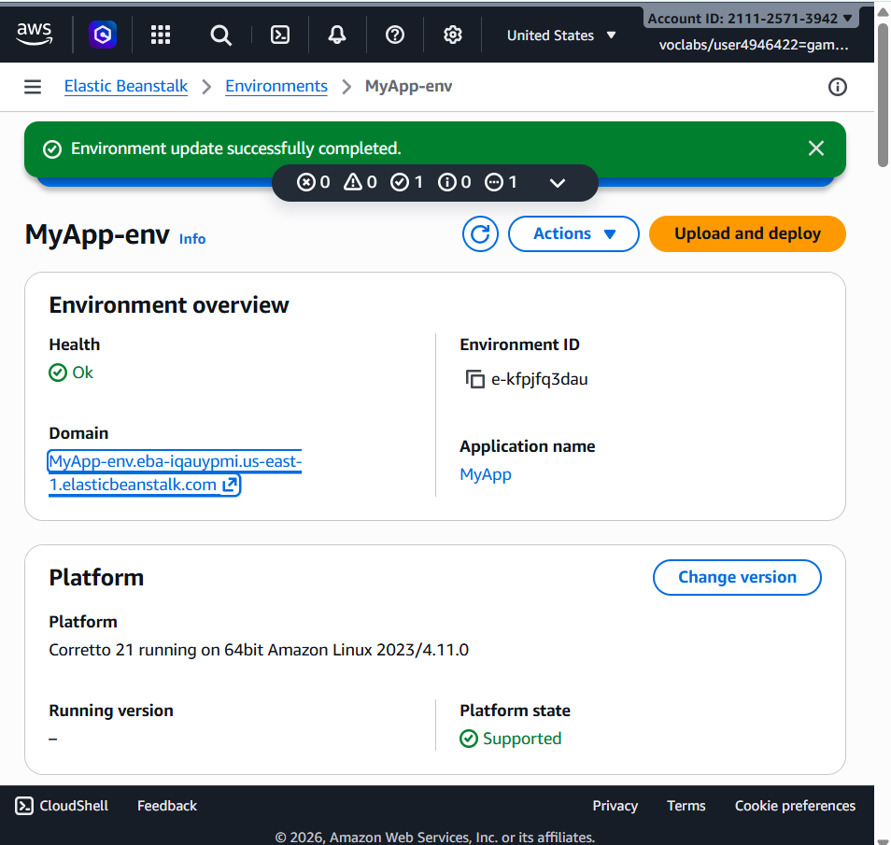



Scenario 1: Application Not Loading
Q: Why does Elastic Beanstalk show an error page after deployment?
A: Possible reasons are wrong configuration, failed deployment, missing dependencies, or app startup failure. Yes, deployment settings may be incorrect. Troubleshoot by checking Events, Logs, Health status, and application error logs.

Scenario 2: Incorrect Application Structure
Q: Why is the expected output not displayed after deployment?
A: If files are inside an extra folder in the ZIP, Elastic Beanstalk cannot locate the main app files. Application structure is important because root files must be directly inside ZIP. Fix by repackaging files correctly without extra nested folders.

Scenario 3: Wrong Platform Selection
Q: What happens if the wrong platform is selected?
A: Platform selection decides runtime environment like Java, Python, Node.js, etc. Wrong platform causes startup errors or unsupported file execution. Correct it by creating a new environment with the proper platform.

Scenario 4: Environment Health Warning
Q: Why is environment health yellow instead of green?
A: Warning may occur due to failed health checks, high CPU usage, slow response, or app errors. First check Events, Logs, and Metrics tabs. Resolve by fixing app errors and restarting environment if needed.

Scenario 5: Application Errors in Logs
Q: What do frequent application errors indicate?
A: They indicate runtime failures, missing resources, database connection problems, or misconfiguration. Yes, incorrect settings may cause this. Analyze logs carefully to identify repeated error patterns and root causes.

Scenario 6: Deployment Failure
Q: Why does deployment fail during upload?
A: Deployment package may be corrupted, missing required files, or incorrectly zipped. Check deployment logs and EB activity logs. Packaging errors prevent Elastic Beanstalk from extracting and running the application.

Scenario 7: Works Locally but Not on Cloud
Q: Why does the app work locally but fail on AWS?
A: Cloud and local environments may differ in OS, dependencies, environment variables, or file paths. Missing libraries may cause failure. Debug by checking cloud logs and comparing configurations.

Scenario 8: Blank Output
Q: Why does the app load but show blank output?
A: Possible causes are runtime exceptions, broken routes, missing templates, or server misconfiguration. Yes, runtime errors may stop rendering. Logs help identify hidden backend failures causing blank pages.

Scenario 9: Application URL Not Accessible
Q: Why is the application URL not opening?
A: Environment may still be launching, deployment may have failed, or security rules may block access. Check environment status as Ready/Healthy. Events help identify startup or network issues.

Scenario 10: Resource Management Issue
Q: What happens if AWS resources are not terminated after lab completion?
A: Running resources continue generating charges. EC2, Load Balancer, Elastic IP, and storage may still run in background. Terminate Elastic Beanstalk environment to remove all related resources.

Scenario 11: High Traffic Handling
Q: How does Elastic Beanstalk handle sudden high traffic?
A: It uses Auto Scaling to launch more EC2 instances automatically. Enable scaling policies and load balancing. Without scaling, the application may slow down or crash under heavy load.

Scenario 12: Application Update Not Reflected
Q: Why are users still seeing the old version after update?
A: Causes include failed deployment, browser cache, CDN cache, or incomplete update rollout. Caching may show old content. Ensure successful deployment and refresh cache or redeploy latest version.

