WEEK-11—Amazon LEX

Step 1: Open Amazon Lex
- Login to AWS Console
- Search Amazon Lex
- Click Create bot
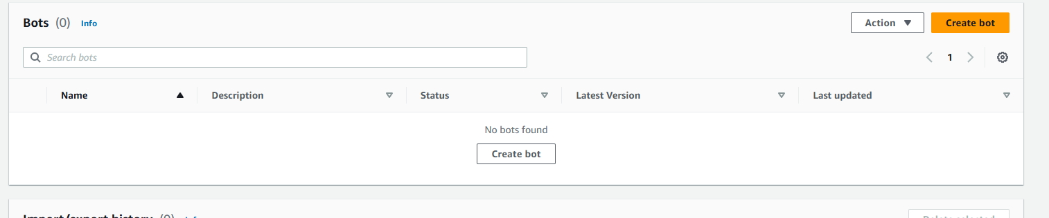

Step 2: Create Bot
- Choose:
  - Create a blank bot
- Enter:
  - Bot name: HotelBookingBot
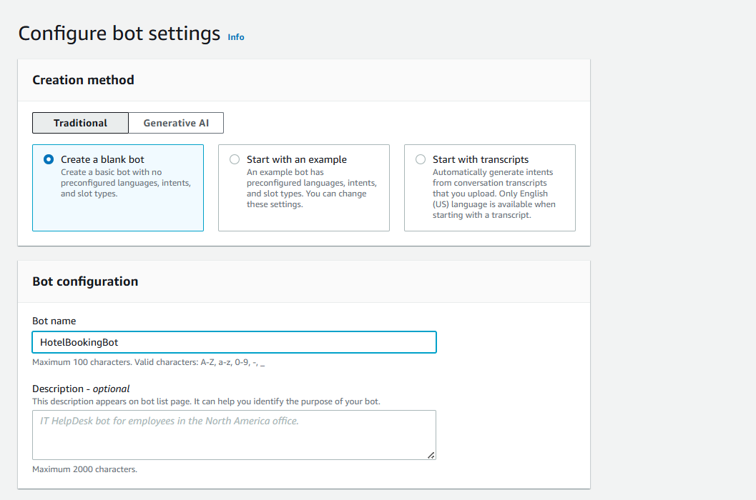
- IAM role → Create new role
- Remaining defaultnext
- Language: English
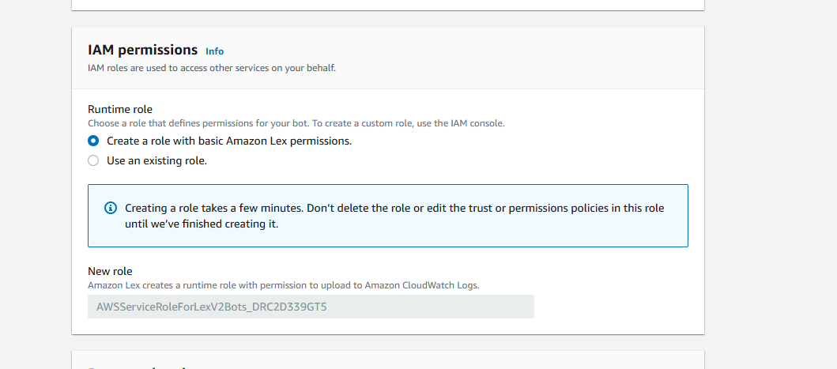
- Voice (optional)
- Click Done
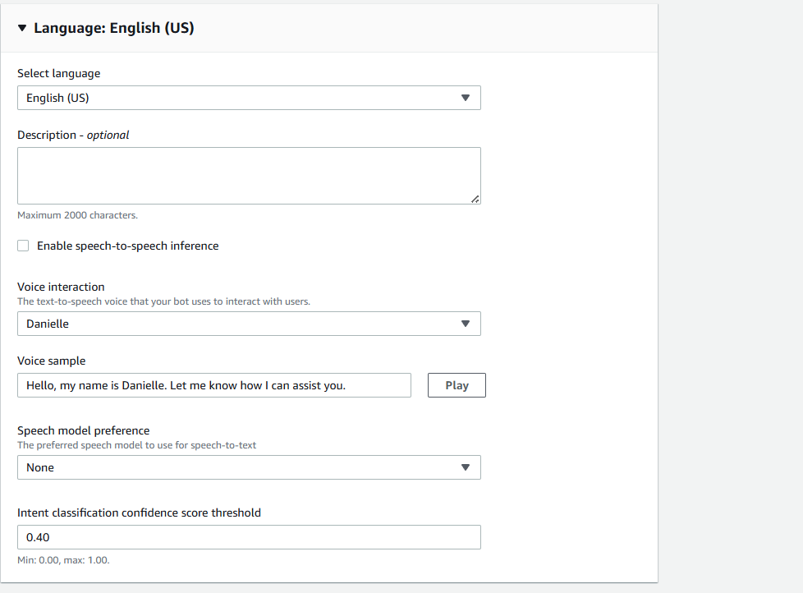

Step 3: Create Intent
- Go to Intents
- Name: BookHotel
- Click Create

Step 4: Add Sample Utterances
Add user sentences (how user talks):
I want to book a hotel
Book a room
Reserve hotel
I need a room
These are Utterances
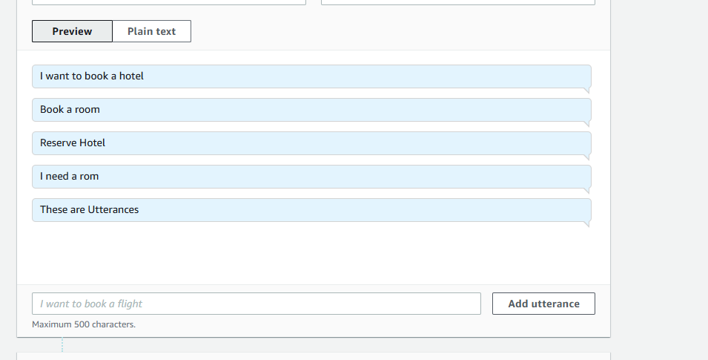

Step 5: Create Slots (User Inputs)
Slots collect user information.
Add Slot
- Click Add slot
- Fill:
  - Slot name: age
  - Slot type: AMAZON.Number
  - Prompt: Which city do you want?
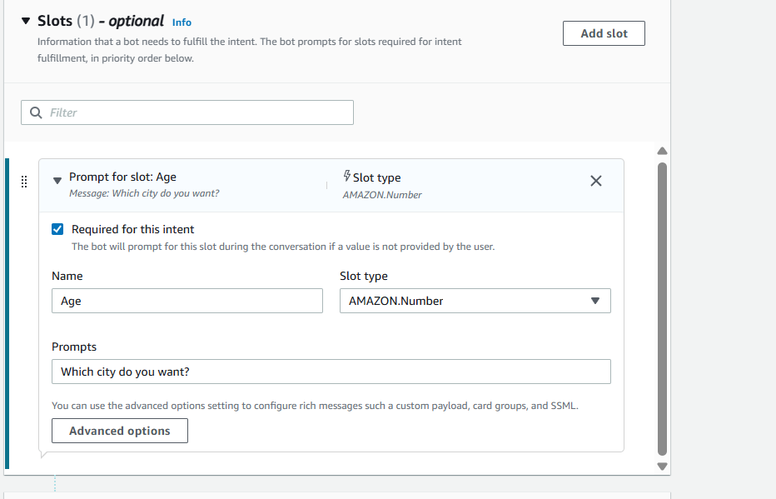
Mark as Required
Add IF Conditions (Conditional Logic)
Used to control flow based on slot values
Example Condition:
If {age} < 18
Steps:
- Go to Intent → Slots -> under Advance options
- Scroll to Slot capture: success response ->Conditional branching
- Click Add condition

Example:
Condition:
If {age} < 18
Response:
Your not eligible for hoot booking?
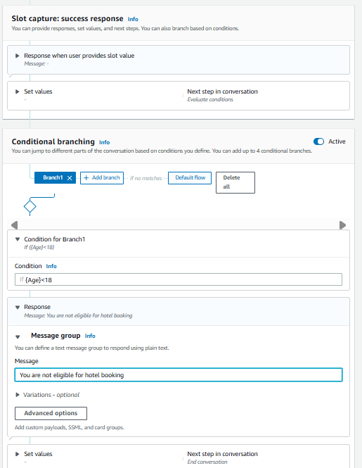

Step 6: Create Slots (User Inputs)
Slots collect user information.
Add Slot
- Click Add slot
- Fill:
  - Slot name: location
  - Slot type: AMAZON.City
  - Prompt: Which city do you want?
- Mark as Required
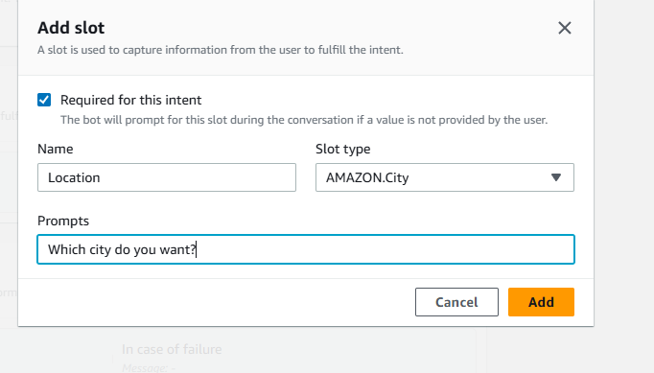
Repeat for other slots.
- Click Add slot
- Fill details:
  - Slot name: checkin
  - Slot type: AMAZON.Date
  - Prompt:
"What is your check-in date?"
- Mark as Required
(Optional but recommended)
  - Add Retry prompt:
"Please provide a valid date (e.g., 2026-03-25)"
- Click Save
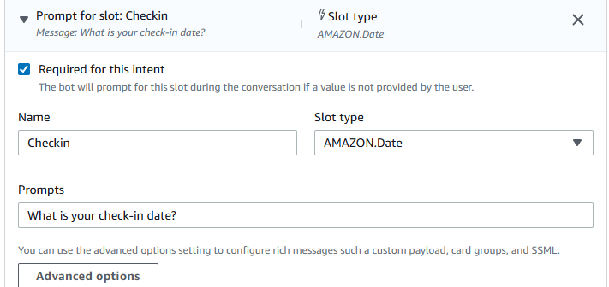

Slot 7: Number of Nights (nights)
Steps:
- Click Add slot again
- Fill details:
  - Slot name: nights
  - Slot type: AMAZON.Number
  - Prompt:
"How many nights will you stay?"
- Mark as Required
- Click Save
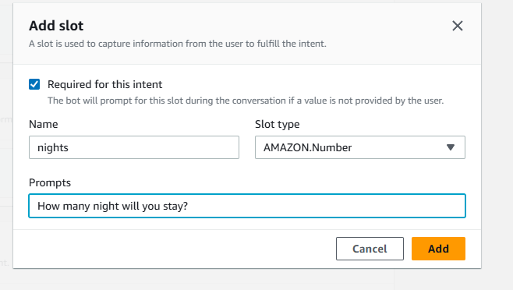

Step 7: Create Custom Slot Type

Save intent

Click on Back to intents
If you want custom values:
- Go to Slot Types
- Click Add slot type ->add blank slot type
- Name: RoomType
Add values:
Single
Double
Suite
Save slot type
Now use this in slot: go back to intent
- Slot name: RoomType
- Slot type: RoomType
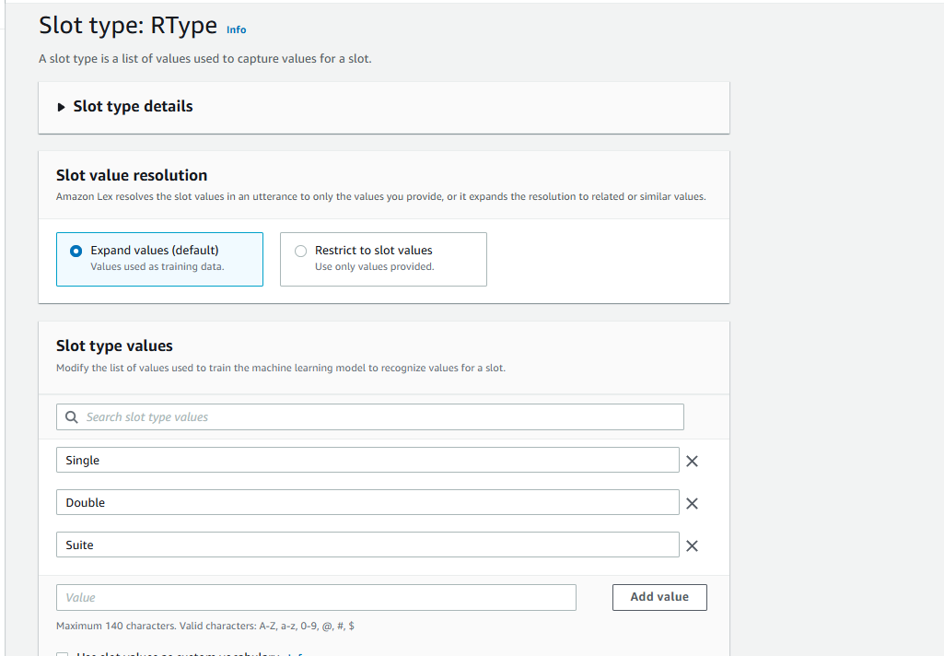

Step 9: Add Response Cards (Card Groups)
Used for buttons (quick replies)
Steps:
- Go to slot prompts -> more prompt options
- Click Add -> add card groups
Example:
Card Title: Select Room Type
click on add Buttons:
- Single → "Single"
- Double → "Double"
- Suite → "Suite"
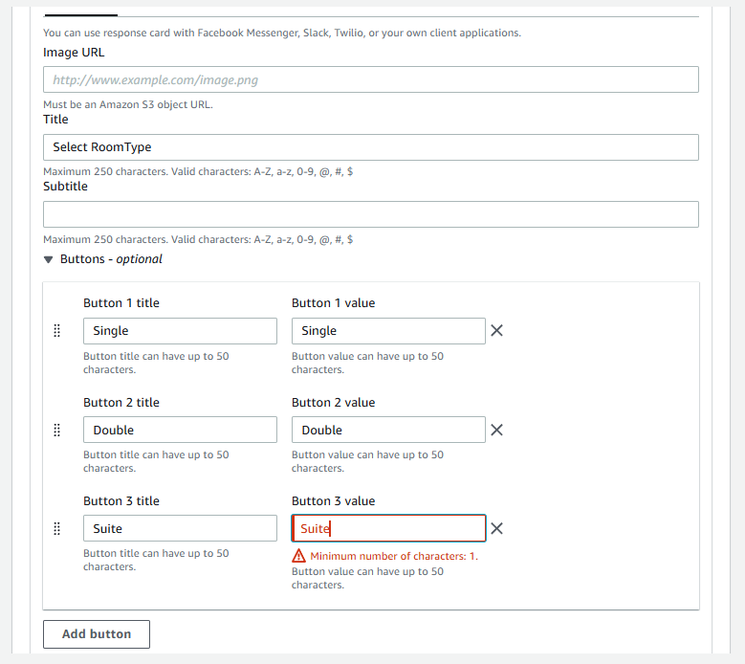

Step 10: Configure Responses
Initial Response:
Welcome to Hotel Booking! What is your name?
Confirmation:
Do you want to confirm booking in {location} for {nights} nights?
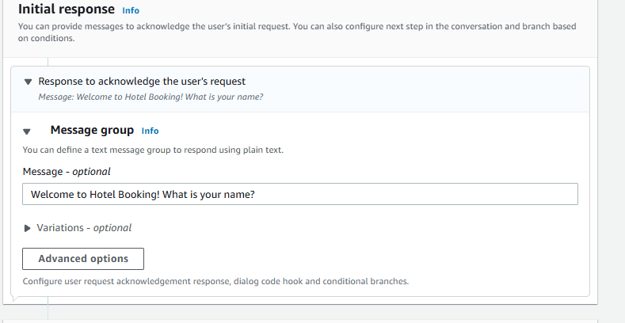
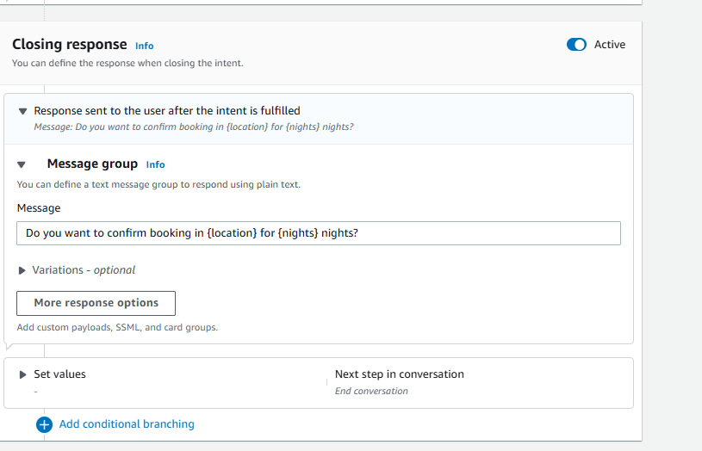

Step 11: Build & Test
- Click Build
- Use Test chatbot panel
- Try:
Book a hotel
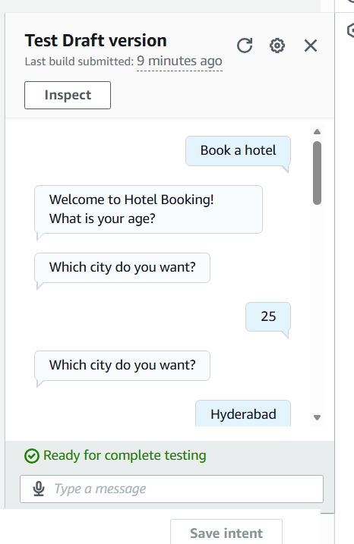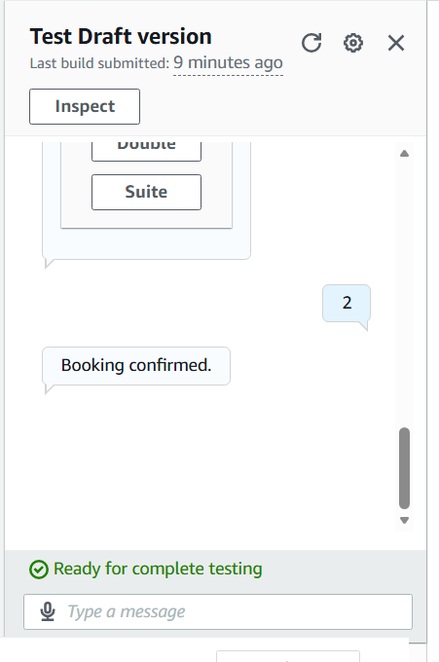

Sample output
User: Book a hotel
Bot: What is your age?
User: 25
Bot: Which city do you want?
User: Hyderabad
Bot: Check-in date?
User: Tomorrow
Bot: Number of nights?
User: 2
Bot: Select room type
User: Double
Bot: Do you want to confirm booking in Hyderabad for 2 nights?
User: Yes
Bot: Booking confirmed.

