WEEK-12
IAM
1. Administrative Setup (Root User)
Step 1: Log in to the AWS Management Console as the Root User.
Step 2: Search for IAM under the "Security, Identity, & Compliance" category. Step 3: Navigate to Users and click Create user.

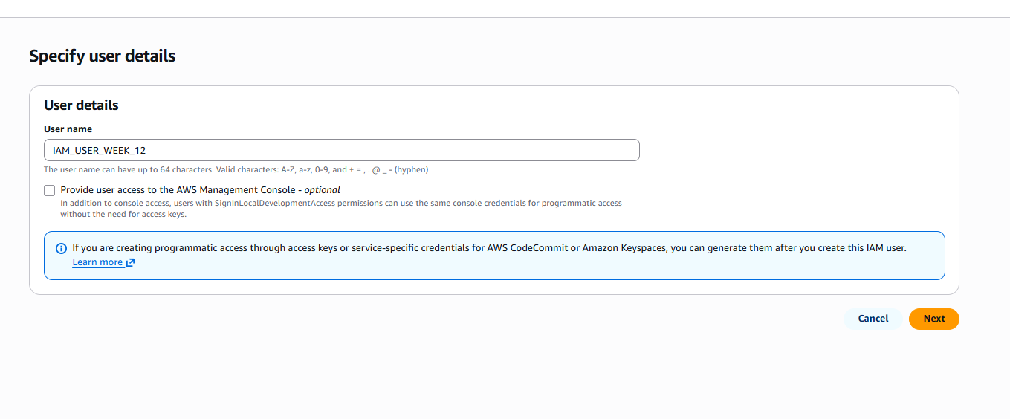
Step 4: User Details: Enter a name (e.g., S3_Specialist). Check the box for "Provide user access to the AWS Management Console." – custom password.

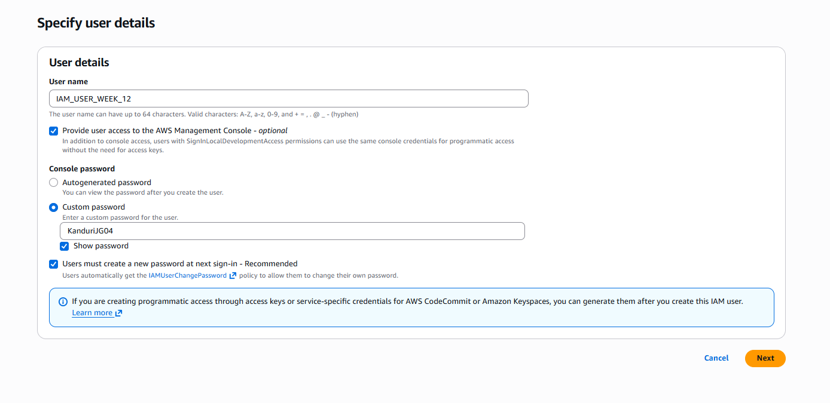
Step 5: Set Per
missions: Select "Attach policies directly." Search for and select AmazonS3FullAccess.
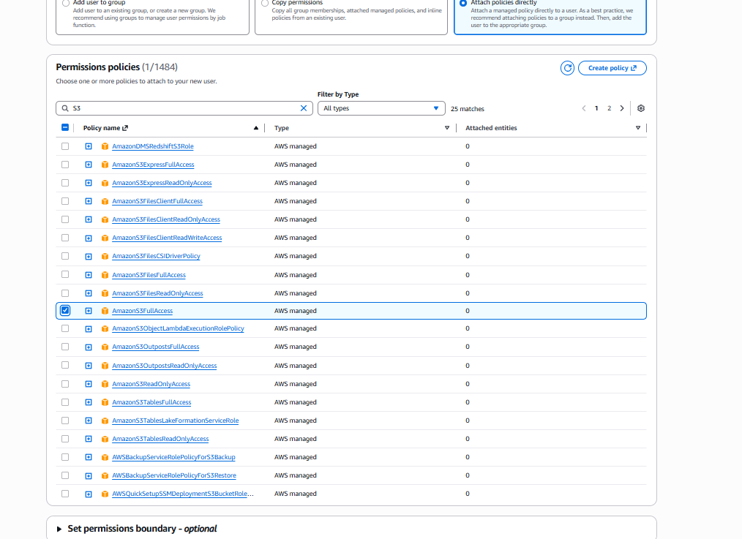

Step 6: Review & Create: Complete the wizard. On the final page, click Download .csv file.
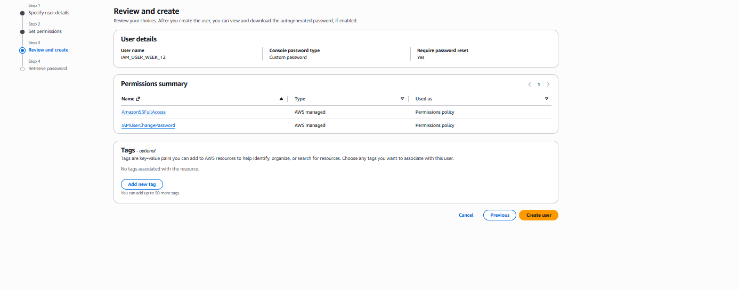

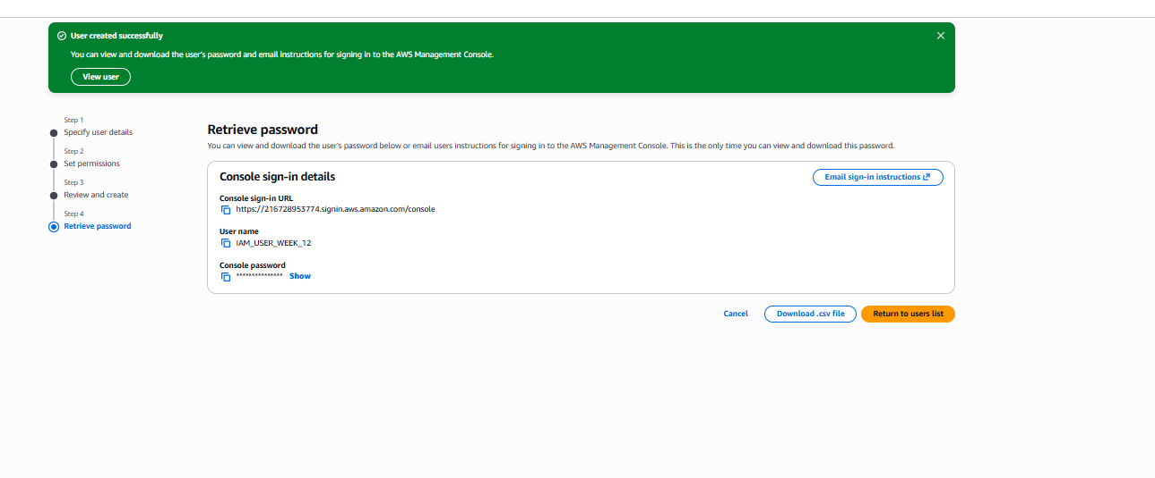

Now you see CC-LAB user created

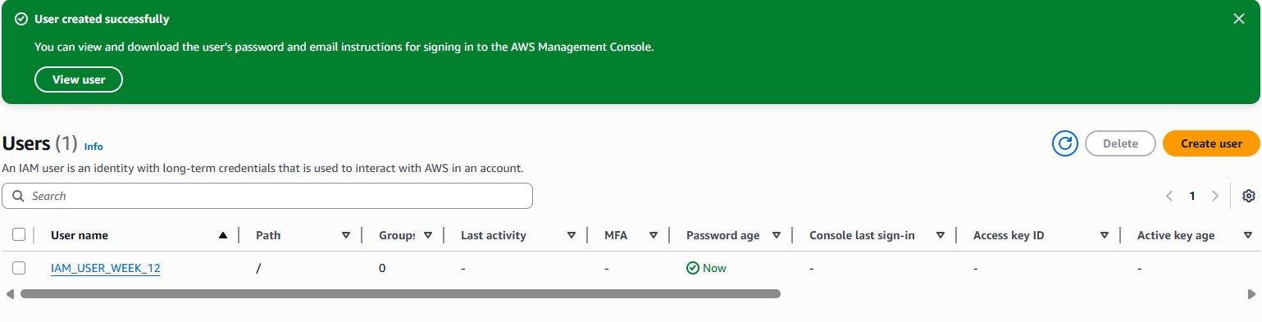

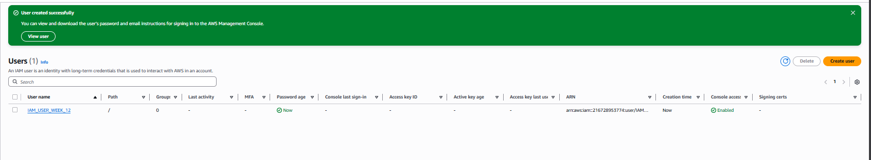

Step 7: Copy your 12-digit Account ID (found in the top-right dropdown or the .csv) and Sign Out.

Account ID: 216728953774
Step 8: Use the Sign-in URL from the .csv (or go to the AWS sign-in page and select IAM User).
Step 9: Enter the Account ID, then the IAM Username and Password from the .csv.

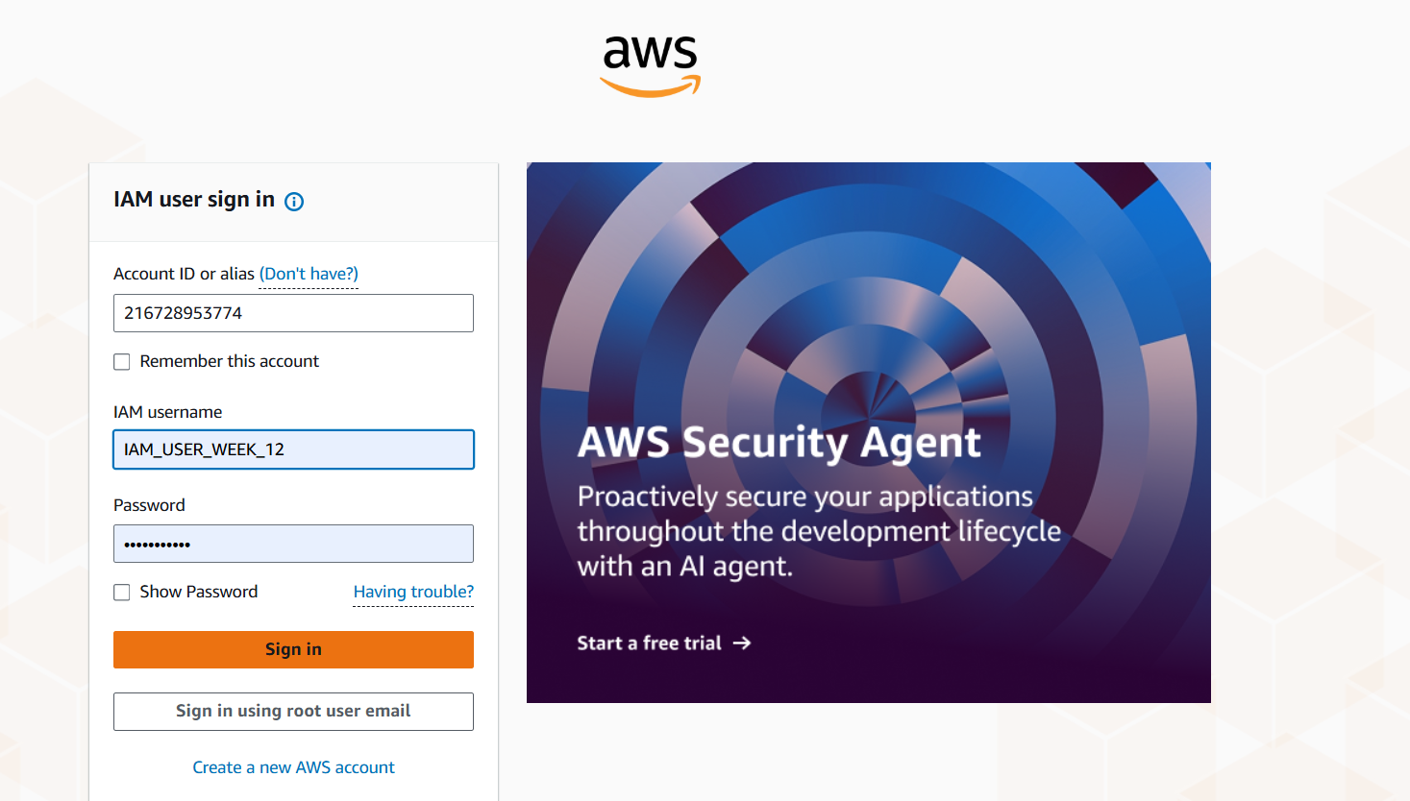
Test 1 (Failure): Navigate to EC2. Try to view instances. You will see "API Error" or "Access Denied." This proves the user is restricted.
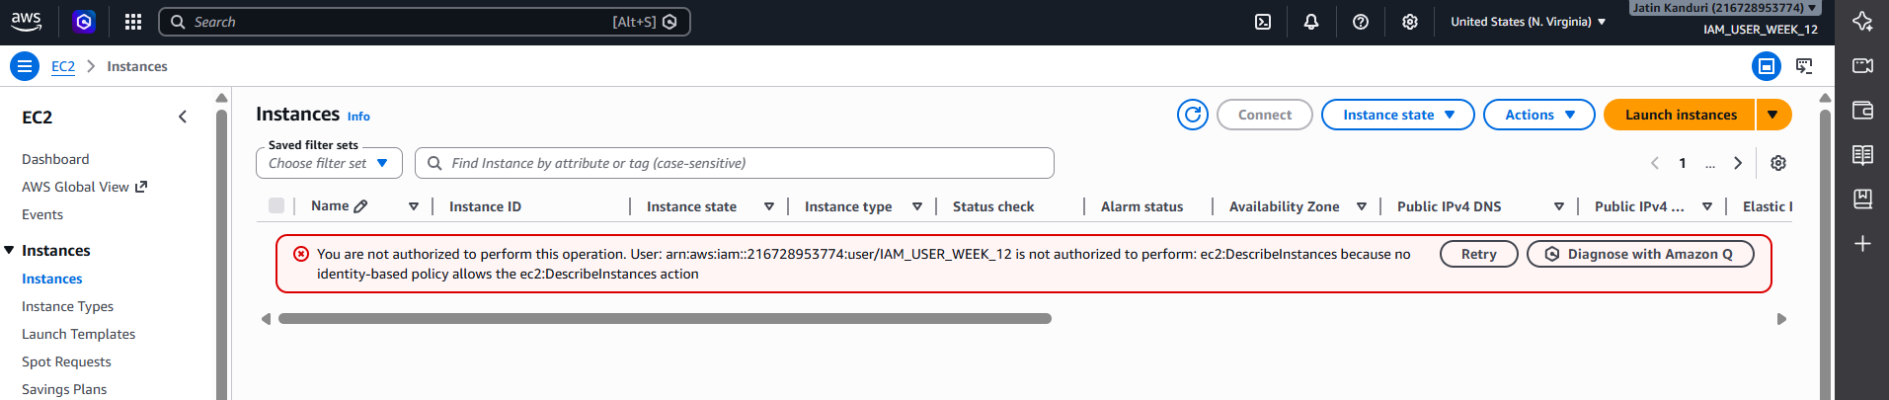
Test 2 (Success): Navigate to S3. Create a new bucket. It will work perfectly because of the attached policy.
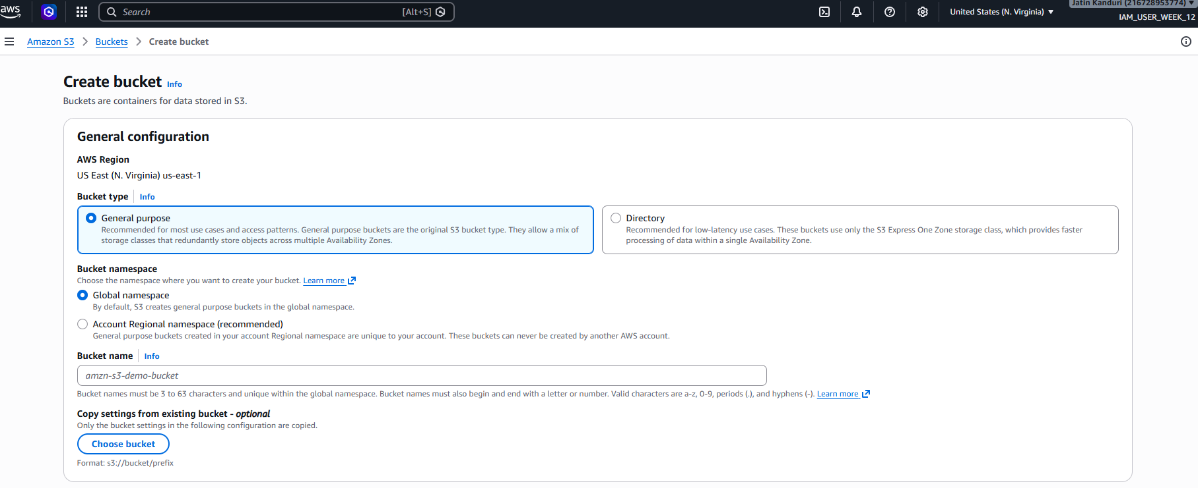

Part B: CLI Access (Programmatic Access)
Objective: Access AWS resources from a standalone system (CMD/Terminal) using security keys.
- Credential Generation
Step 1: While logged in as an Admin/Root, go to IAM > Users and click on your user.
Step 2: Go to the Security credentials tab. Scroll to Access keys and click Create access key
Step 3: Select Command Line Interface (CLI). Acknowledge the warning and click Next.
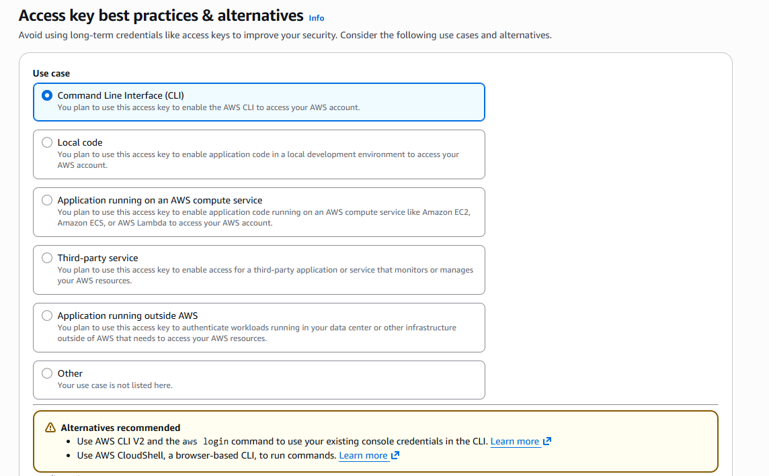
Step 4: Download the .csv file. > Critical: This contains the Access Key ID and Secret Access Key. If lost, you must delete and recreate them.

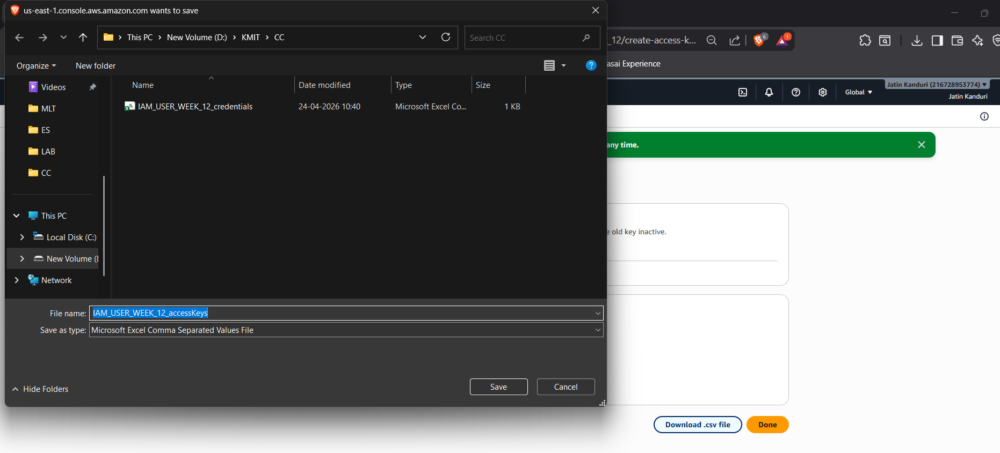

- Standalone System Configuration
Step 5: Install the AWS CLI Tool from google on your computer

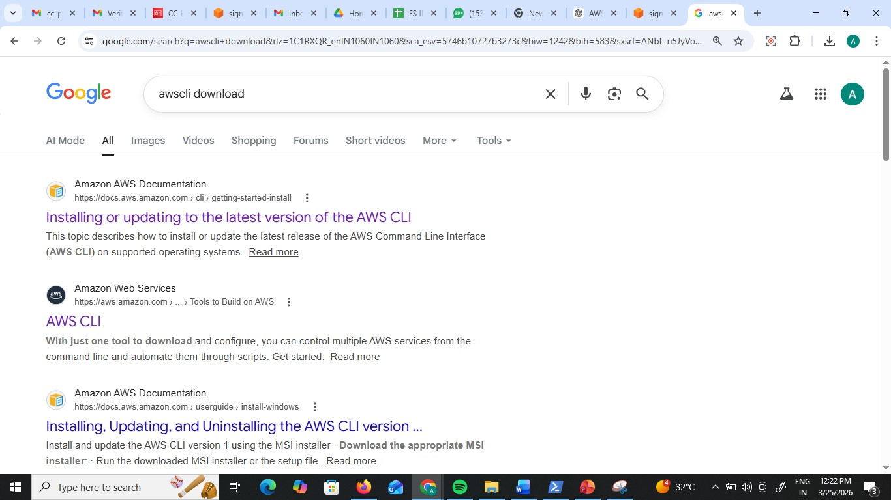

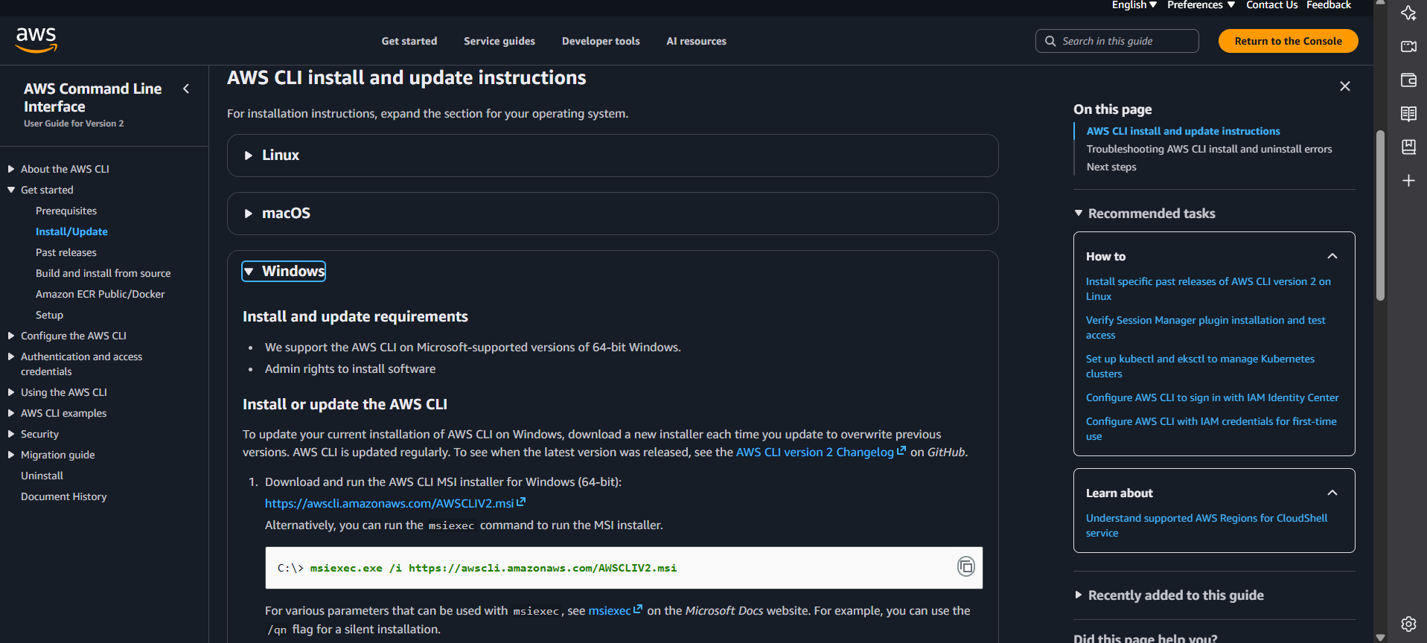
Download https://awscli.amazonaws.com/AWSCLIV2.msi

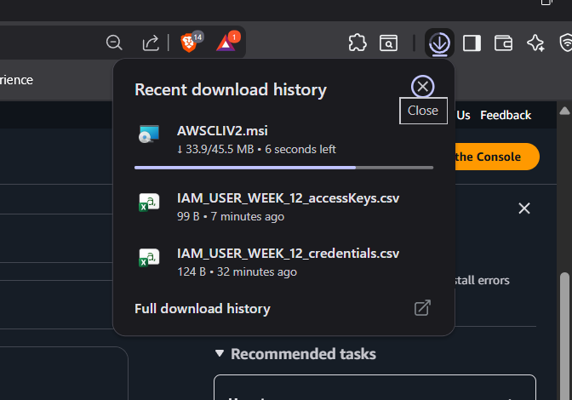

Step 6: Open your Command Prompt (CMD) or Terminal.
Step 7: Type aws configure and press Enter.

Step 8: Provide the following from your .csv: Access Key ID
Secret Access Key
Default region: (e.g., ap-south-1)
Default output: json
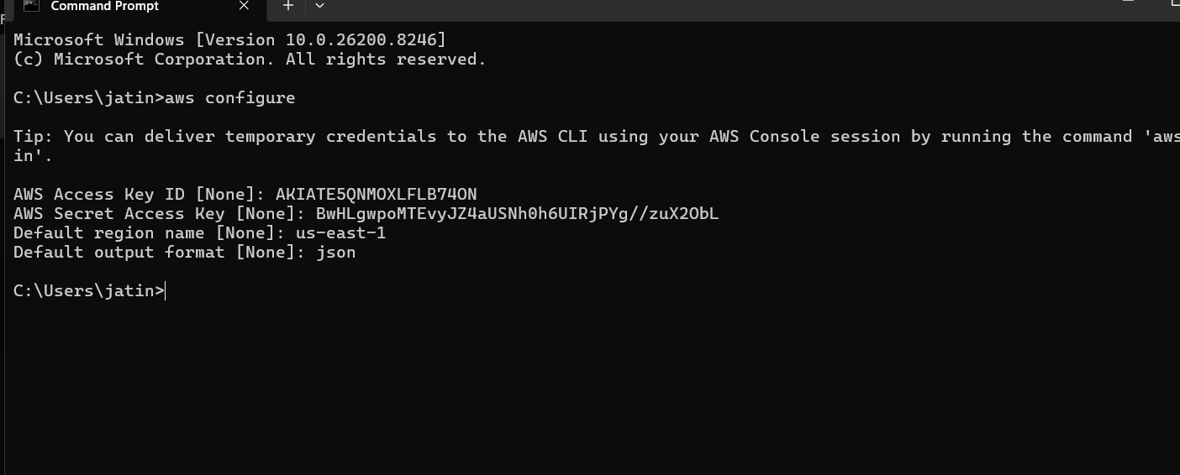
Run aws ec2 describe-nstances.
Result: You will get an (AccessDenied) error.

This confirms that the CLI is respecting the same IAM policy as the GUI.
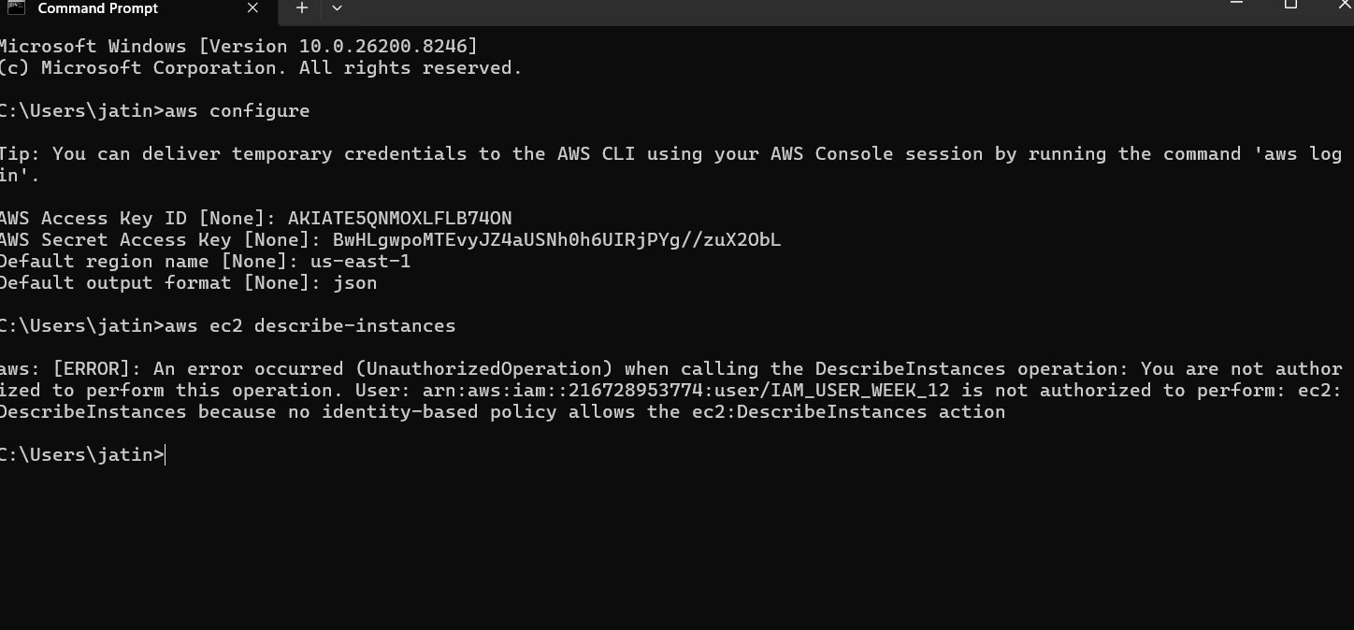

- Verification via Commands
Step 9: Run aws s3 ls. This should list your buckets

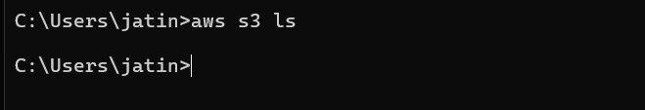
Step 10: Run aws s3 mb s3://your-unique-bucket-name. (Success)

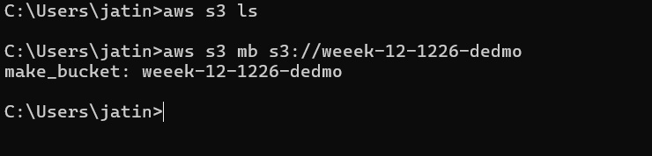

Check in console you see the bucket created from CLI

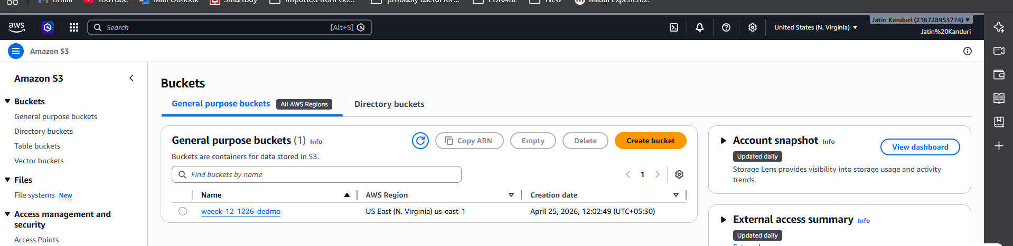

Scenario 1: Security Risk
Q: You logged into AWS using the root user for daily work. What’s wrong here?
- Using root for daily work is unsafe—full access means any mistake or breach = total account compromise.

✅ Scenario 2: Account Compromise
Q: Your AWS bill suddenly increases and you suspect root user compromise. What steps will you take?
A) Immediately enable MFA, rotate root credentials, disable suspicious resources, check billing, and audit logs (CloudTrail)

✅ Scenario 3: Root Credentials Lost
Q: What if you forgot root user password?
A) Use “Forgot Password” on AWS root login and reset via registered email.
✅ Scenario 4: Root Access Keys
Q: Why should you avoid creating access keys for root user?
- Root access keys give unrestricted API access—highest risk if leaked.

✅ Scenario 5: New Developer Joining
Q: A new developer joins your team. How do you give access?
- Create an IAM user, assign to group with required permissions, enable MFA.

✅ Scenario 6: Least Privilege
Q: A user needs only S3 read access. What will you do?
- Attach a policy with only S3 read access (e.g., AmazonS3ReadOnlyAccess).

✅ Scenario 7: Temporary Access
Q: A contractor needs access for 2 weeks.
A) Create IAM user/role with temporary credentials and set expiration (or use STS).

✅ Scenario 8: Access Denied Error
Q: User gets “Access Denied” while accessing EC2. Why?
A) User lacks required IAM permissions or policy explicitly denies access.

✅ Scenario 9: Multiple Users Same Permissions
Q: 50 users need same access. What is best practice?
A) Use IAM groups and assign a common policy to the group.

✅ Scenario 10: Configure CLI
Q: You installed AWS CLI. How do you configure it?
- Run aws configure and enter Access Key, Secret Key, region, output format.

✅ Scenario 11: Create IAM User via CLI
Q: How to create IAM user using CLI?
A) aws iam create-user --user-name username

✅ Scenario 12: Attach Policy via CLI
Q: Give S3 read access to user using CLI
A) aws iam attach-user-policy --user-name username --policy-arn
arn:aws:iam::aws:policy/AmazonS3ReadOnlyAccess

✅ Scenario 13: Create Access Keys via CLI
Q: How to generate access keys for IAM user?
A) aws iam create-access-key --user-name username

✅ Scenario 14: List IAM Users
Q: How to check all users using CLI?
A) aws iam list-users

✅ Scenario 15: Delete IAM User via CLI
Q: How to safely delete a user?
A) Detach policies → delete access keys → delete user.
1Q: CLI command fails with AccessDenied. What to check?
A) CLI AccessDenied Fix, Check IAM permissions and policies.

