**DAY 1 Assignment Questions**

**Practice question**

**Que 1**. Create a Database with Name “Test”

Sol1: Create Database Test;

**Que 2**. Create a Schema under the Database Test with Name “TestSchema”

Sol2: Create Schema TestSchema

**Que 3**. Create a Table with Name “Students” in “Test” Database with scheme “TestSchema”. Table will should have following columns – StudentId, Name, DOB, AdmissionDate.

Sol3: Create Table TestSchema.Students (StudentId int primary Key Not Null,

Name varchar(50) Not Null, DOB Date Not Null, AdmissionDate date not null);

**Que 4**.

1. Create Table Employee Containing Columns EmployeeId, Name, Salary, ManagerId, JobRole and insert the data.
2. Add Columns in Employee Table Mail_id and Grade and insert the data for two newly added columns.
3. Truncate the Employee Table.
4. Delete a specific record from a table.
5. DROP the Employee Table.

Sol4:

1. Create Table Employee(EmployeeId int primary Key Not Null Default 0,

E_name varchar(50) not null, Salary int not null, ManagerId int Not Null,

JobRole varchar(20) not Null);

Insert into Employee (EmployeeId,E_name, Salary, ManagerId,JobRole)

values

(1,'Ram' ,10000,3,'Intern'),

(2,'shyam',8000,1,'Junior_intern'),

(3,'Mohan',15000,4,'Developer'),

(4,'Jon',20000,0,'head');

2.

Alter table Employee

add Mail_id varchar(50), Grade char;

UPDATE Employee SET Mail_id = 'ram@g.com', Grade = 'C' WHERE EmployeeId=1;

UPDATE Employee SET Mail_id = 'syam@g', Grade = 'C' WHERE EmployeeId=2;

UPDATE Employee SET Mail_id = 'moh@g.com', Grade = 'B' WHERE EmployeeId=3;

UPDATE Employee SET Mail_id = 'jon@g.com', Grade = 'A' WHERE EmployeeId=4;

3.

Truncate Table Employee

4.

Delete from Employee where EmployeeId=1;

5.

Drop table Employee

**Que 5.** Write an Update statement change the Supplier_name to google for id 600,700 and 800

**Input**

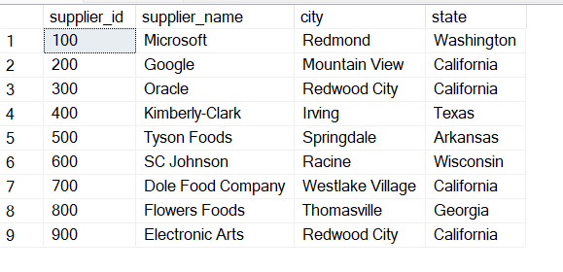

Sol5:

Update Employee Set supplier_name = ‘Google’ where supplier_id = 600

Update Employee Set supplier_name = ‘Google’ where supplier_id = 700

Update Employee Set supplier_name = ‘Google’ where supplier_id = 800

**Que 6**. Write a query that prints a list of employee names (i.e.: the *name* attribute) for employees in Employee having a salary greater than $200 per month who have been employees for less than 10 months. Sort your result by ascending *employee_id*.

**Input-** The **Employee** table containing employee data for a company is described as follows:

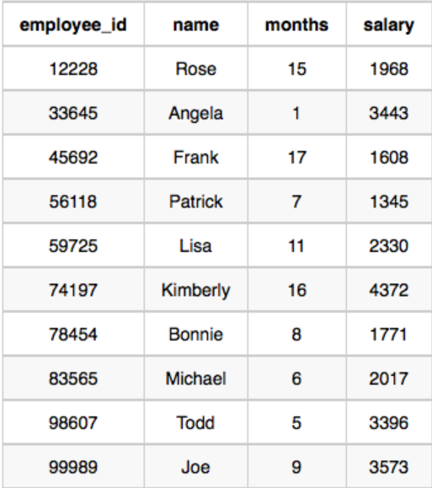

Sol6:

**Solve these Following Queries by Using Adventure Works Database**

1. List of all customers
2. list of all customers where company name ending in N
3. list of all customers who live in Berlin or London
4. list of all customers who live in UK or USA
5. list of all products sorted by product name.
6. list of all products where product name starts with an A
7. List of customers who ever placed an order.
8. list of Customers who live in London and have bought chain.
9. List of customers who never place an order.
10. List of customers who ordered Tofu.
11. Details of first order of the system
12. Find the details of most expensive order date.
13. For each order get the OrderID and Average quantity of items in that order
14. For each order get the orderID, minimum quantity and maximum quantity for that order.
15. Get a list of all managers and total number of employees who report to them.
16. Get the OrderID and the total quantity for each order that has a total quantity of greater than 300.
17. list of all orders placed on or after 1996/12/31.
18. list of all orders shipped to Canada.
19. list of all orders with order total > 200
20. List of countries and sales made in each country.