

Faculty of Engineering and Technology Department of Electrical and Computer Engineering
Introduction to Graduation Project ENCS5200

AI Powered Platform for Regulation Compliance Mid-Project Report

Prepared By: Osama Aabed 1201164

Arkan Jayyousi 1163018
Section: 49

Supervisor: DR. Samah Alaydi
Date: December 19, 2025

Abstract

Electronic waste (e-waste) has become a rapidly growing environmental challenge due to the continuous increase in the consumption and disposal of electronic devices. Improper handling of e-waste leads to environmental pollution, health risks caused by hazardous materials, and the loss of valuable recyclable resources. In many regions, the absence of structured and technology-supported management systems limits effective classification and recycling processes. This graduation project aims to design a structured, technology-based system for managing electronic waste through efficient classification and data-driven workflow design. The project focuses on system analysis, architectural design, and implementation planning to support sustainable recycling practices and improve decision-making in e-waste management

Introduction

The rapid growth of electronic devices has led to a significant increase in electronic waste (e-waste), which includes discarded computers, phones, batteries, and other electronics. Improper disposal of e-waste poses environmental and health risks due to hazardous materials such as lead and mercury. In many regions, including Palestine, the absence of structured e-waste management systems results in informal disposal, pollution, and loss of valuable resources. This project aims to design a technology-based system for classifying and managing electronic waste to improve recycling efficiency and promote sustainable practices.

Problem Statement

The increasing use of electronic devices has generated a growing amount of electronic waste (e-waste) from computers, printers, lab equipment, and other devices. Improper disposal of e-waste poses environmental and health risks and results in the loss of valuable materials. While e-waste management is a global challenge, many locations lack structured systems for collecting, classifying, and managing it efficiently. This project aims to design a technology-based system that can be applied in any location but will be implemented and tested specifically for Birzeit University’s devices. The system seeks to improve classification, collection, and recycling processes, reducing environmental impact and promoting sustainable practices.

2.1 Main Problem Question

How can a structured and technology-based system be designed to classify and manage electronic waste of electronic devices efficiently to reduce environmental impact and improve recycling processes?

2.2 Sub-Questions

- What types of electronic devices contribute most to e-waste?

- Common contributors include computers, laptops, printers, monitors, and other labs electronic equipment. These devices often become obsolete quickly and contain both recyclable materials and hazardous components.

- How can electronic waste be classified effectively for recycling or safe disposal?

- E-waste can be classified by device type, material composition (plastic, metal, circuit boards), or recyclability. AI-based classification systems can automate this process, reducing errors and manual labor.
- What technical components are required for an automated or semi-automated system?
- Key components include AI/machine learning algorithms for classification, databases for tracking, barcode or RFID tagging or camera for device identification, and user interfaces for staff/students to input or monitor devices.

Literature Review

Electronic waste (e-waste) continues to grow rapidly as technology advances and consumer electronics become ubiquitous. Improper disposal of e-waste, which contains hazardous materials such as lead, mercury, and cadmium, poses significant threats to human health and the environment, while also representing a loss of valuable materials if not properly recycled. Research consistently emphasizes the need for structured and technology-enabled e-waste management systems to improve recycling outcomes and reduce environmental harm.

Several recent studies focus on the application of artificial intelligence (AI) and machine learning (ML) to automate key aspects of e-waste management. For example, deep learning-based classification systems have been developed to sort e-waste components with high accuracy, improving the efficiency of recycling processes and reducing manual intervention. One such system, which uses sequential neural networks and convolutional models, demonstrated significant potential by achieving effective classification with reduced human exposure to hazardous waste [turn0search0]. Another approach, EWasteNet, used a two-stream transformer model to achieve over 96 % accuracy in classifying e-waste images, underscoring the potential of advanced vision-based methods in automated sorting .

Research has also investigated object detection models like YOLO for real-time e-waste identification, highlighting improvements in detection efficiency and training performance that can support automated sorting in practical applications . Additional work explores federated learning and deep classifiers to optimize both classification and planning in e-waste collection, demonstrating performance improvements over traditional methods .

In addition to classification technologies, several studies have explored the integration of IoT and cloud-based systems to enhance monitoring, data collection, and decision-making in e-waste workflows. These approaches support real-time tracking of waste streams, optimize collection routes, and improve overall system responsiveness . Research on IoT-enabled frameworks highlights both the efficiency gains and sustainability benefits of combining connected sensors, real-time analytics, and cloud services in waste management.

Beyond classification and monitoring, systematic reviews stress the importance of comprehensive strategies that incorporate multiple technologies and policy considerations. For example, a prominent review of sustainable waste management discusses collection, pre-treatment, and recycling challenges, noting that technological, regulatory, and social factors must be aligned to achieve effective outcomes .

Another systematic review on AI for printed circuit board recycling highlights the role of datasets, component recognition techniques, and bottlenecks in practical deployment, pointing to key areas for future advancement .

Despite promising technological innovations, . Most AI-based and IoT solutions are developed for large-scale industrial or urban contexts, with limited research addressing localized environments such as universities or smaller institutional settings. Many approaches also depend on well-structured data, robust infrastructure, or specialized datasets, which may not be readily available in all contexts. Furthermore, the environmental benefits of these technologies must be balanced with challenges related to implementation cost, data quality, and infrastructure limitations.

In summary, existing research demonstrates the value of integrating AI, machine learning, IoT, and data-driven decision support in e-waste management. However, there is a clear need for systems that are adaptable, resource-efficient, and suitable for implementation in smaller environments such as Birzeit University. The proposed project builds on these insights by designing a structured, technology-driven e-waste management system that improves classification, collection, and sustainability in a localized context while maintaining potential for broader application.

Project Objectives

The primary goal of this project is to design and implement a technology-based system for efficient classification and management of electronic waste at Birzeit University. This system aims to enhance recycling processes, reduce environmental impact, and provide a scalable solution adaptable to other institutions.

The specific objectives are as follows:

- Assessment of E-Waste Sources: Identify and categorize the types of electronic devices generating e-waste at Birzeit University.
- Design of Classification System: Develop an AI-based classification mechanism capable of accurately sorting electronic waste by type and material.
- Implementation of Management Workflow: Create a structured workflow for collection, tracking, and disposal of e-waste within the university.
- Integration of Data Management: Establish a database and reporting system to monitor e-waste volumes, classification results, and recycling efficiency.
- Evaluation and Optimization: Test the system’s performance, optimize classification accuracy and workflow efficiency, and assess its scalability for other institutions.
- Environmental Impact Reduction: Ensure that the system supports sustainable practices, reducing hazardous waste exposure and promoting resource recovery.

Methodology

The methodology for this project is designed to develop and implement a structured, technology-based e-waste management system at Birzeit University. The approach integrates data collection, system design, AI-based classification, workflow optimization, and evaluation. The methodology consists of the following steps:

- Data Collection and Analysis
  - Conduct an inventory of electronic devices across the university, including computers, printers, lab equipment, and other electronics.
  - Identify the quantity, type, and current disposal methods of e-waste.
  - Analyze challenges and inefficiencies in the existing e-waste handling system.

- System Design
  - Develop a framework for e-waste classification using AI-based methods.
  - Define system requirements, including hardware, software, and database components.
  - Design workflows for collection, classification, and disposal of electronic devices.

- Implementation Planning
  - Prepare a localized implementation plan tailored to the university environment.
  - Integrate IoT or sensor-based monitoring (if applicable) for tracking e-waste in real time.
  - Develop a database system for logging device information, classification results, and recycling status

- System Testing and Evaluation
  - Test the AI-based classification system using sample e-waste data.
  - Evaluate the system’s accuracy, efficiency, and sustainability.
  - Optimize the workflow based on testing outcomes to improve performance and resource utilization.

- Documentation and Reporting
  - Record all findings, workflow designs, and system outputs.
  - Prepare reports detailing classification accuracy, collection efficiency, and environmental benefits.
  - Provide recommendations for scaling the system to other universities or similar institutions.

6. Data Sources
The data for this project will be collected from multiple sources to ensure a comprehensive understanding of e-waste generation and management at Birzeit University. The primary and secondary data sources include:

- University Records and Inventories
  - Lists of electronic devices in use across labs, offices, and classrooms.
  - Maintenance, replacement, and disposal records for computers, printers, lab equipment, and other electronics.

- Published Research and Reports
  - Academic papers, journals, and conference proceedings on e-waste classification, recycling technologies, and AI-driven management systems.
  - Industry reports and case studies on sustainable e-waste handling practices and technology adoption.

- Expert and Stakeholder Input
  - Interviews and feedback from university staff, facility managers, and IT personnel regarding current practices and challenges.
  - Insights from environmental specialists and researchers on best practices for e-waste management.

These diverse data sources will provide the necessary information to analyze current challenges, design the classification system, and implement an efficient workflow, ensuring that the project is evidence-based, practical, and aligned with both academic and regulatory standards.

7. System Design

The system design defines the architecture and components of the e-waste management system at Birzeit University. It explains what the system is, how its modules interact, and the technical rationale behind each component.
Core Components:

- E-Waste Input and Inventory Module – Captures detailed information about devices, including type, model, condition, and location. Prepares data for classification.

- AI Classification Engine – Uses machine learning models (CNNs, transformer-based networks) to classify devices by type and recyclability. Incorporates image recognition and sensor data.

- Data Management and Tracking Module – Centralized database stores device data, classification results, and tracks each item’s lifecycle
.
- Workflow Module – Defines procedures for collection, storage, and disposal.

- Analytics Module – Evaluates performance, provides reports, and identifies areas for optimization.

Key Features:
- Adaptable for different institutions.
- Automated classification and tracking.
- Supports sustainable e-waste management.
- Provides data-driven decision support.

8. Implementation Plan

The implementation plan describes how the system will be developed, deployed, and evaluated. It shows the steps, current progress, and the roadmap for completion.
Phases:
- Data Collection and Preparation (waiting for Dr. Eyad Tumar approval)
  - Inventory of university electronic devices completed.
  - Data on device type, model, condition, and current disposal practices gathered.
- System Development (Planned)
  - AI classification engine design underway.
  - Database for device tracking under development.
  - Initial prototypes of the user interface created.

- Workflow Integration (Planned)
  - Set up collection points across campus.
  - Implement standard procedures for handling and transferring e-waste.
  - Integrate AI engine with database and workflow modules.
- Testing and Optimization (Planned)
  - Test system with sample e-waste.
  - Optimize classification, collection, and reporting processes.
- Deployment and Monitoring (Planned)
  - Train staff and fully deploy the system.
  - Monitor performance and track environmental impact.

9. System Flowchart

The system flowchart provides a visual representation of the workflow, showing how data moves through the system from collection to reporting.
Workflow Steps:
- Device Collection – E-waste collected from labs, offices, and classrooms.
- Data Entry / Inventory Input – Device information recorded into the system.
- AI Classification Engine – Devices categorized by type, material, and recyclability.
- Data Management & Tracking – Classification results stored and lifecycle tracked.
- Workflow / Collection Routing – Items directed to appropriate recycling/disposal channels.
- Analytics & Reporting – Performance, recycling efficiency, and environmental impact reported.
- Evaluation & Feedback Loop – Feedback used to improve AI models and workflow.

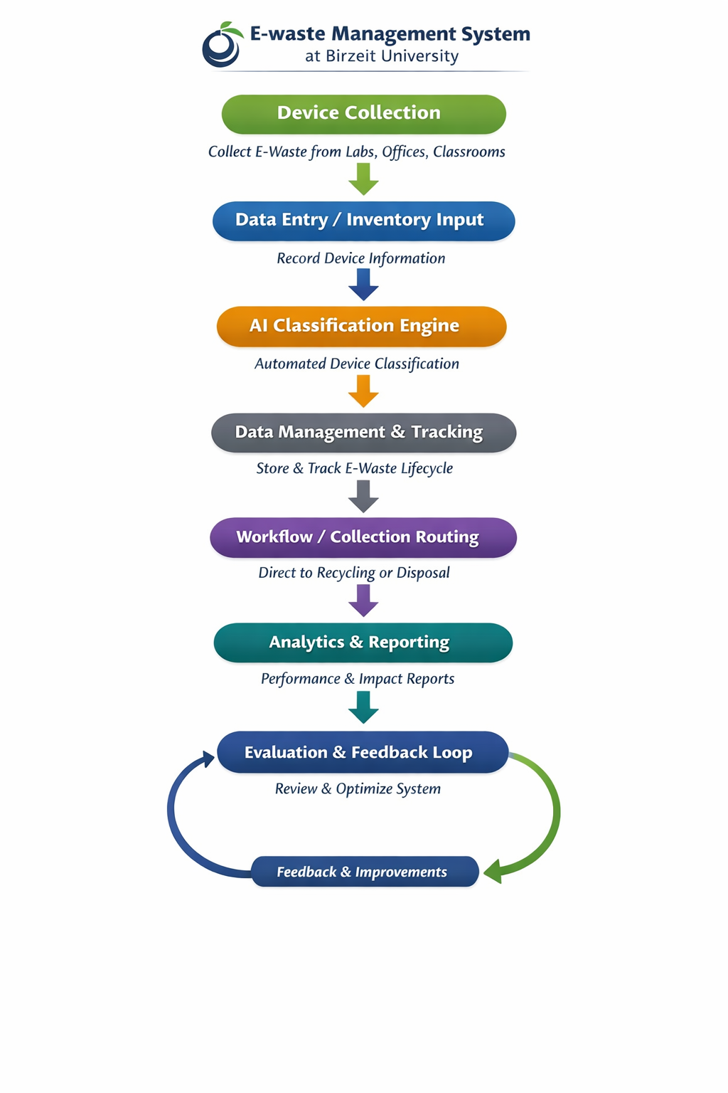

10. Expected Results
The proposed e-waste management system at Birzeit University is expected to achieve the following outcomes:

- Reduced Effort and Time
  - The system will automatically classify electronic devices, reducing manual work and saving significant time in managing e-waste.
- Cost and Resource Savings
  - Efficient organization of collection, classification, and storage will lower operational costs and make better use of available resources.
- Green Environment and Sustainability
  - By increasing recycling rates and reducing improper disposal, the system will contribute to a cleaner campus and a greener environment.
  - Supports the university’s sustainability goals and promotes environmentally responsible practices.

- Support for Decision-Making and Process Improvement
  - Provides accurate data on classification, workflow efficiency, cost savings, and environmental impact.
  - Helps administrators optimize operations and make informed, environmentally conscious decisions.

11. Conclusion

This project aims to create an efficient and sustainable system for managing electronic waste at Birzeit University. Throughout the report, we have explored the challenges of e-waste, reviewed existing research, and designed a system that uses AI and data management to classify, track, and recycle electronic devices.
The system is expected to reduce manual effort, save time, and lower costs, while also contributing to a cleaner and greener environment. By providing accurate data and reports, it helps the university make better decisions and improve recycling practices.
Although the project focuses on Birzeit University, the system is adaptable and scalable, meaning it can be applied to other universities or organizations in the future. This makes it not only a practical solution for today but also a step toward long-term environmental sustainability.
In short, the project combines technology, efficiency, and environmental responsibility, showing how smart systems can make managing e-waste easier, cheaper, and greener for everyone.

12. References

[1] “AI-Optimized Circular Economy Models For E-Waste Management In The Tech Industry: A Data-Driven Approach,” Int. J. Environ. Sci., pp. 1104–1112, Aug. 2025.

[2] V. S. Malagitti, M. C. Elemmi, J. S., and L. Bhajantri, “A Survey of IoT and Blockchain Solutions for Advancements in E-Waste Management,” Int. J. Environ. Sci., May 2025.

[3] S. Menaka, N. M. Shrirao, H. L., P. S. Palpandi, G. V. Devi, R. Senthamil Selvan, and S. Rohini, “Reclaiming Resources With IoT and Cloud-Based E-Waste Management and Data-Driven Decisions,” Int. J. Environ. Sci., Jan. 2025.

[4] B. I. Oladapo, M. A. Olawumi, and F. T. Omigbodun, “AI-Driven Circular Economy of Enhancing Sustainability and Efficiency in Industrial Operations,” Sustainability, vol. 16, no. 23, 10358, Nov. 2024.

[5] “Artificial Intelligence and the Circular Economy: How AI Advances Waste Reduction,” Green Environmental Technology, vol. 1, no. 2, Nov. 2024.

[6] “Energy-Efficient Green AI Architectures for Circular Economies Through Multi-Layered Sustainable Resource Optimization Framework,” Discover Sustainability, vol. 6, article 1031, Oct. 2025.

[7] “Example paper on AI and ESG performance relationships in Saudi Arabia (RePEc summary) — sustainability + AI adoption ’’

