**1. Spec for SIMLOCK**

Network providers use SIMLOCK to restrict the use of the phones to specific countries and network providers. As the spec 3GPP TS 22.022 descriibed, there are five features to personalise Mobile Equipment (ME) for UMTS & LTE systems.

 Network

 Network subset

 Service Provider (SP)

 Corporate

 SIM

Generally, phones can be locked to accept only SIM cards with certain IMSIs

|  |  |
| --- | --- |
| **SIMLOCK level** | **Codes** |
| NW | MCC + MNC |
| NS | MCC + MNC + digit 6, digit 7 of IMSI |
| SP | MCC + MNC + first byte of GID1 |
| CP | MCC + MNC + first byte of GID1 + first byte of GID2 |
| SIM | 8 bytes of IMSI |

**Table 1-1 Codes used by each SIMLOCK level**

**2. XTT for SIMLOCK**

The Simlock xtt can be found at *C:\Program Files (x86)\Qualcomm\QDART\XTT\SubSysServiceProgramming\NewSimlock* from QDART(V4844 or later). It supports all level of Simlock

Following is the process of Simlock.

1. Connect DUT and read the Serial Number from it.

2. Check the lock status of DUT, if it’s locked, unlock it first with the key which can be searched by Serail Number.

3. Generate the lock data according to the lock category.

4. Generate the Random CK.

5. Lock the DUT with the CK and lock data.

6. Get the lock info from DUT to see if it’s locked correctly or not.

7. If locked successfully, save the CK to the file, which can be used to unlock the DUT.

8. Disconnect DUT.



**Figure 2-1 SIMLOCK tree**

**2.1 Connect to DUT**

It needs to connect to DUT before testing.



**Figure 2-2 Connect to DUT**

ConnectToPhone_SP –– Connect to DUT with SubsysServerPrograming_NET.dll

ConnectToPhone_Utils –– Connect to DUT with QDART_MFG_Utils.dll

GetVersion –– Get Modem verson from device, check the modem is working normally or not.

WriteTrackingInfoSerialNumber –– Write SN if there is no one in DUT, it’s unselected by default.

ReadTrackingInfoSerialNumber –– Read SN from DUT, to track the lock info

**2.2 Unlock the DUT**

The unlock test items will detect the lock status of DUT.

If it’s not locked, the unlock test items will be skiped.



**Figure 2-3 Skip Unlock if the device is not locked**

Otherwise if the DUT is locked, it will unlock it first

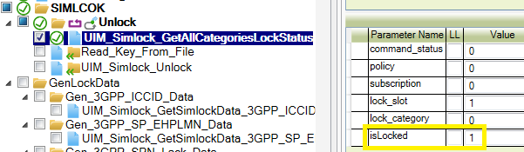

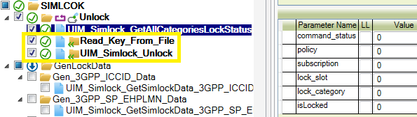

**Figure 2-4 Unlock the DUT if it’s locked**

Read CK from file named with SN. ( C:\temp\E002H9969707RO)

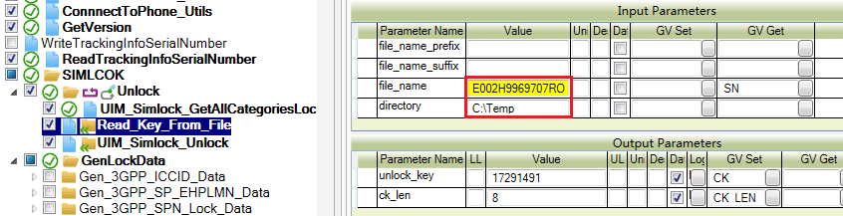

**Figure 2-5 Read CK from file to unlock DUT**

**2.3 Generate lock data**

It needs to configure the lock data according to the different categories. 

**Figure 2-6 Generate lock data**

**NOTE:** Only one of the test items to generate the lock data can be selected.

Set Global Variable with the generated lock data which will be used to lock DUT.

 Using input value of MCC/MNC

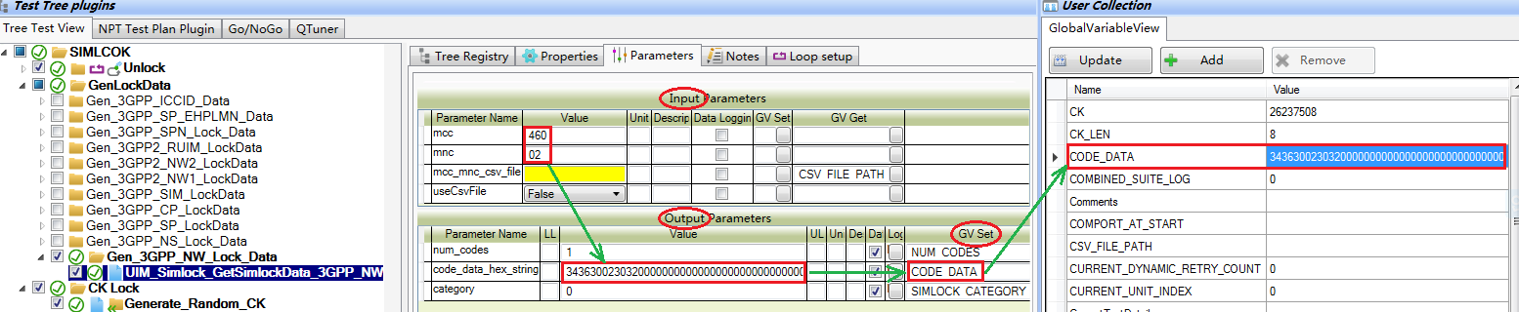

**Figure 2-7 Set GV with the lock data**

 Using csv file

If the device supported more than one network, it needs to add more than one MCC/MNC pairs in the csv file.

For example, if the MCC/MNC pairs are {460, 02}, {460, 00}, {460, 01}. They are added as the following csv file. the first parameter is MCC, the second one is MNC, and the third one is the length of MNC. Sometimes the initial number of MNC is 0, and it will be ignored by csv file. so it needs to add the length of MNC.

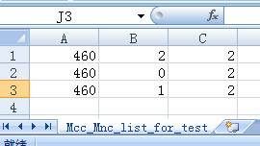

**Figure 2-8 Add MCC/MNC in csv file**

Setup the csv file path and set the useCsvFile to True

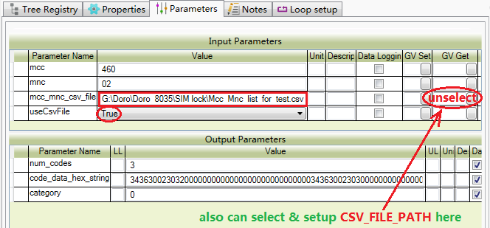

**Figure 2-9 Setup the csv file path**

**2.4 Lock DUT**



**Figure 2-10 Lock DUT**

Generate_Random_CK –– Generate a random CK which will be used to lock DUT

Uim_Simlock_SetPolicy –– Setup Simlock policy, for multi-slots, just keep the default.

UIM_Simlock_CKLOCK –– Lock DUT with the CK and lock data generated in previous nodes.

UIM_Simlock_GetLockinfo ––Get lockinfo from specific SIM slot and category**.**

Save_Key_To_file –– Save CK to file named with SN, which can be used to unlock DUT.

UIM_Simlock_GetCategoryDataExt –– Get cagegory data which can be used to cofirm the lock data has been provisioned correctly or not.

【Generate_Random_CK】

Setup the length of CK and generate random CK then save it to GlobalVariable.

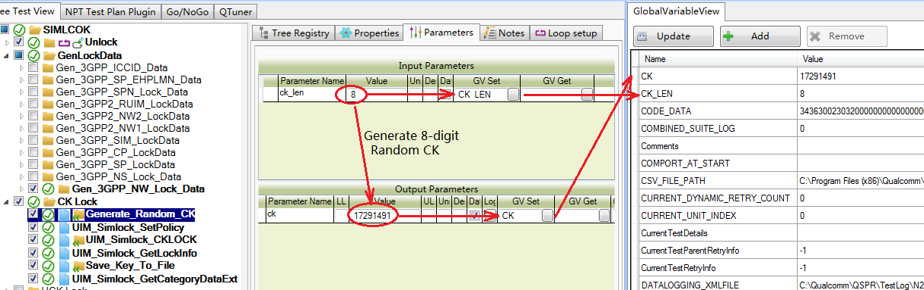

**Figure 2-11** **Setup the length of CK and generate random CK**

【UIM_Simlock_CKLOCK】

Lock DUT with the CK and lock data generated in previous nodes, also need to setup the Max of retry count & the number of iterations.

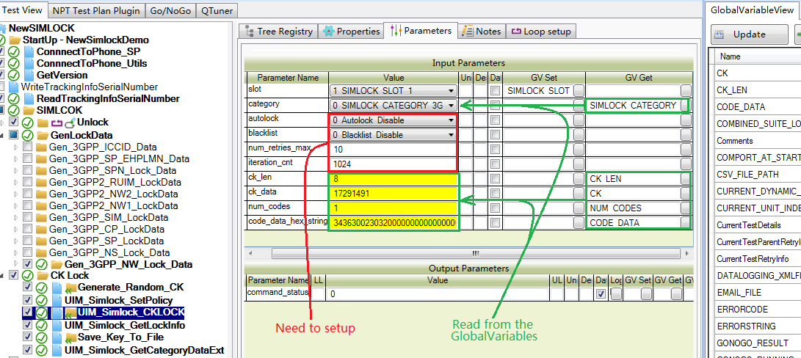

**Figure 2-12 Lock DUT with the CK and lock data**

【Save_Key_To_file】

Save CK to file named with SN(read from DUT) C:\temp\E002H9969707RO

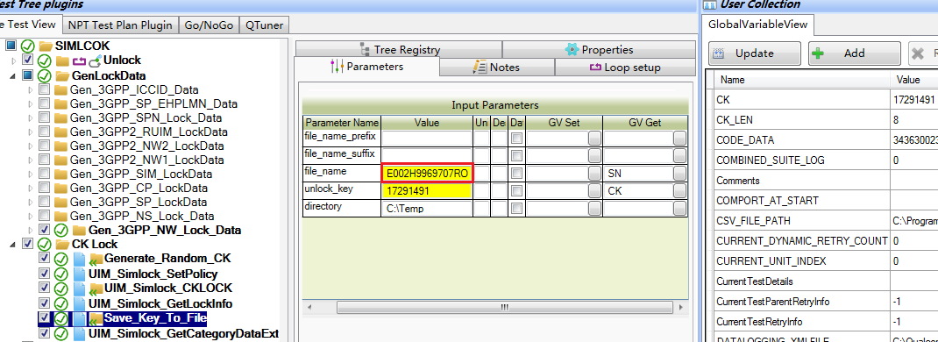

**Figure 2-13 Save CK to file named with SN**

【UIM_Simlock_GetCategoryDataExt】

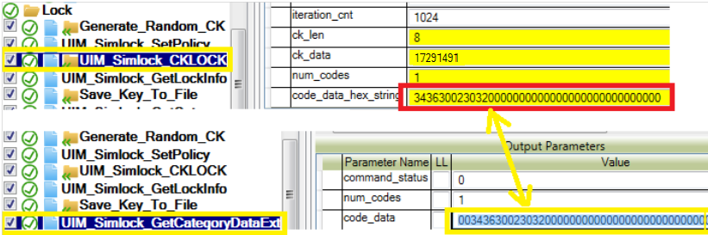

**Figure 2-14 Get category data compared with lock data**

The code_data output parameter definition in UIM_Simlock_GetCategoryData are shown below.

|  |  |
| --- | --- |
| **Output parameters** | **Comments** |
| 00 | White list |
| 343630 | ASCII cods of “4” “6” “0” which is MCC. |
| 2 | The length of the MNC |
| 3032 | ASCII codes of ‘0’ ‘2’ which is MNC |

**Table 2-1 Code_data output parameters definition**

**2.5 Disconnect DUT**

Disconnect DUT is required at the end of test. So the tool is ready to test next DUT



**Figure 2-15 Disconnect DUT**

DisconnectPhone_Utils – Disconnect DUT from QDART_MFG_Utils.dll

DisconnectPhone_Utils – Disconnect DUT from SubsysServerPrograming_NET.dll